Name:

Grade 1 Date:

Based on the Writing for Understanding Approach, Vermont Writing Collaborative

My Group Research Project on
How Adult Animals Protect Their Offspring.

Research Question:
How do adult animals help their offspring to survive?

Becoming an Expert
Group Research Packet
An expert is someone who knows a lot about a particular thing. Your teacher will help you to read this packet and follow these steps to become an expert.

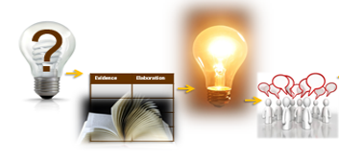
Becoming an Expert
Check each step as you finish. | Steps
 | Where Am I Going?
 | First Read
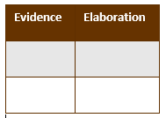 | Reading for Evidence
 | Recording Evidence
 | Focus Statement
 | Working with Evidence

Where Am I Going?
Work with your group to discuss the questions below.

?
Read the research question below.
How do adult animals help their offspring to survive?

With your partner, look through the source your teacher has given you.

Then, 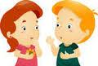turn and talk about these questions:

What is the name of your source?
How will this source help you answer your research question?

First Read
With your group, read the source aloud.

Ideas for a First Read:
- Listen carefully as your teacher reads aloud.
- Take turns reading; have each person read a sentence.
- Choose one person to read aloud. The rest of the group reads along silently while listening.
- Listen to a recording of your book, reading along silently while you listen.

Reading for Evidence
Work as a group to gather and share information that will help you answer your research question.

With your group, look at the new public note chart that your teacher has made for the class. Discuss these questions:
What is your Research Question?
What information do you need?
Carefully, read or listen to your source again. Find information that will help you answer the research question.

Recording Evidence
With your group, add to the public note chart.

With your group, talk about what words or pictures you should put on the public notes. When your group is ready, your teacher will help you fill in the appropriate row on the class chart.

THE FOCUS STATEMENT!
What is the “big idea”?

A focus statement tells the big idea you have learned from your research in a single sentence.
Look carefully at all of the evidence you the class has gathered. What is the “big idea” that came out of your research?
Turn and talk to a partner.

More Evidence (optional)
On your own or with a partner, find more information for the public notes.

Work with a new source. Find information about how animals protect their offspring. Explain what you have found to the group and add to the public note chart.

Working with Evidence
Work with your group to better understand the information you found.

Your teacher will lead you in a making-meaning discussion.
You will use evidence to discuss the focus question:
How do adult animals help their offspring to survive?
Remember to:
  - Look at the speaker
  - Quiet hands and body
  - Share and listen
  - Stay on topic

Now you are ready to write!
Use your Writing Resource Packet to write about your research. Check off each step when you complete it.
Sharing Your Expertise Record Sheet

Use this record sheet with your Writing Resource Packet.
Finished | Steps
 | Learn from a Model
 | Write a Focus Statement | Write the First Piece of Evidence
 | Add More Evidence
 | Write a Conclusion | Revise/Edit
 | Share and Celebrate!

