3 Steps to Figuring Out the Meanings of Words

- Morphology (inside word clues)
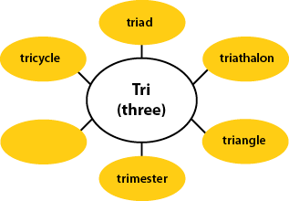
- Do you know any roots, prefixes, or suffixes in the word and what they mean?
- Does the spelling of this word remind you of the spelling of any other words you know (in English or another language?)
- Can your knowledge help you guess a meaning for this word? If the answer is no or you are not sure, move to step 2.

- Context (outside word clues)
- What does it seem like this word could mean from the words and sentences before and after it?
- Do the words and sentences around the word confirm the meaning you guessed when you looked at the word parts?
- Are there enough clues around the word for you to understand its meaning? If the answer is “no” or you are not sure, move on to step 3.

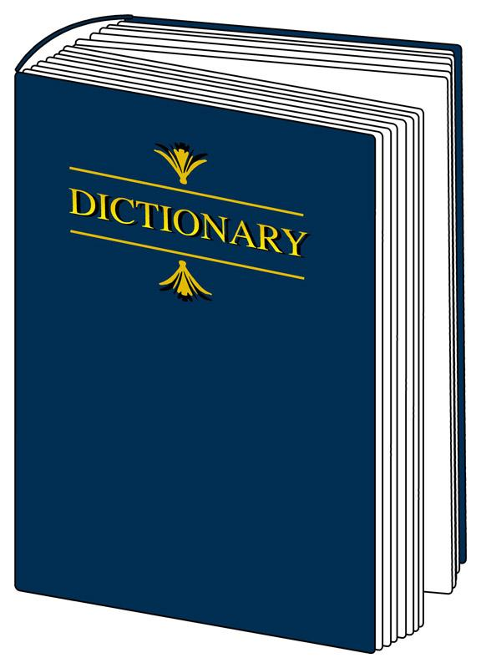
- Resource (outside text help)

- What does the dictionary (print or online) say? Does a thesaurus help you understand its meaning?
- Do any of your classmates know the meaning?
- Does your teacher know the meaning?
- Does anyone in your family know this word?

