Unit 4/Week 2
Title: Hottest, Coldest, Highest, Deepest
Suggested Time: 5 days (45 minutes per day)
Common Core ELA Standards: RI.3.1, RI.3.2, RI.3.4, RI.3.7; W.3.2, W.3.4; SL.3.1; L.3.1, L.3.2

Teacher Instructions
Refer to the Introduction for further details.
Before Teaching
- Read the Big Ideas and Key Understandings and the Synopsis. Please do not read this to the students. This is a description for teachers, about the big ideas and key understanding that students should take away after completing this task.
Big Ideas and Key Understandings
Earth is one of a kind. Earth’s unique, fascinating natural features are found across continents.
Synopsis
“Hottest, Coldest, Highest, Deepest” takes the reader on a journey around the world to various continents found on Earth that contain unique natural features. Whether the features are the hottest temperatures found on Earth or the highest mountain. Through the use of text and illustrations, readers are able to grasp the unique diversities found on Earth.
- Read entire main selection text, keeping in mind the Big Ideas and Key Understandings.
- Re-read the main selection text while noting the stopping points for the Text Dependent Questions and teaching Vocabulary.

During Teaching
- Students read the entire main selection text independently.
- Teacher reads the main selection text aloud with students following along. (Depending on how complex the text is and the amount of support needed by students, the teacher may choose to reverse the order of steps 1 and 2.)
- Students and teacher re-read the text while stopping to respond to and discuss the questions and returning to the text. A variety of methods can be used to structure the reading and discussion (i.e.: whole class discussion, think-pair-share, independent written response, group work, etc.)

Text Dependent Questions
Text-dependent Questions | Evidence-based Answers
What type of records the author is speaking about. | The text states that “there are deserts that haven’t seen rain for hundreds of years and jungles where it pours almost every day.” The text goes on to ask “where are the very hottest and coldest, windiest and snowiest, highest and deepest places on Earth?” The author thus, is speaking of nature’s record holders rather than human record holders.
The Amazon River, in South America is not considered to be the longest river, but is considered to be mightier than the other rivers in the world. Why is the Amazon River considered to be mightier than the others? | “It is considered mightier because it carries half of all the river water in the world.”
Look at the illustration of the world in the bottom left hand corner of the page? What does the pink dot represent and what information does this provide? | The pink dot represents the location of the Nile River, which is located in the continent of Africa. The author gives this information on the title, “The Nile, in Africa, is the longest river in the world. It is 4,145 miles long.”
Compare the Nile and the Amazon rivers. Why are these two rivers both noted as being record holders? | The Nile river is 4,145 miles long and the Amazon River is 4,007 miles long. They are both two of the longest rivers in the world.
The author writes about two different lakes, Lake Baikal, in Russia and Lake Superior, in North America. Using the information and evidence given in the text briefly compare and contrast these two lakes. | Both lakes set a natural record. Lake Baikal is the oldest and deepest freshwater lake in the world, and Lake Superior is the largest freshwater lake in the world. In contrast, Lake Baikal contains more water than Lake Superior because of its depth. “In one spot it is 5,134 feet deep.”
According to the text what mountain is the tallest mountain in the world, if we were not considering sea level measurements? | Mauna Kea, in Hawaii. It is 33,476 feet tall. Most of the mountain is located underwater, with only 13,796 feet showing above the water.
What information does the author provide the reader about Mount Everest? What evidence do you have to support this? | The readers gets a better visual picture of what the mountains look like in terms of the sea level measurements. Mount Everest being the tallest mountain in the world, because it is 29,028 feet about sea level. Mount Everest has snow on its top peak. Whereas, Mauna Kea is considered to be the tallest mountain in the world when it is measured from its base, which is on the floor of the ocean to its top (above sea level). The reader sees that Mauna Kea is partially under water.
What information is given about Al Aziziyah? How does the information help you better understand Al Aziziyah? | The information provides various temperatures, such as the temperature in which water freezes, a human’s body temperature, the average room temperature, and the temperature found at Al Aziziyah. The chart organizes these temperatures from coldest to hottest.  The text states that Al Aziziyah has had temperatures of 136’F recorded. The chart allows the reader to see just how very hot 136’F is in relationship to other common temperatures. (freezing water, body temp., etc.)
The author writes about three very different regions found on Earth. Al Aziziyah, Libya found in the Sahara, Vostok, Antarctica, and Tutunendo, Colombia. Find key words and/or phrases from the text that contrast these three regions. | Al Aziziyah is the hottest place on the planet, it has temperatures recorded over 136*F. Vostok, Antartica is the coldest place on the planet, it has temperatures of 129*F below zero. Tutunendo, Columbia is the wettest place on the plant, it receives an average of 463 inches of rain fall a year.
What can be stated about deserts? Use evidence from the text. | Deserts can be very hot and dry places, with little to no plant life or rain fall. The text states that Al Aiziyah, which is found in the Sahara can reach temperatures of up to 136*F. Deserts are also shows lots of sand and very little plant life. The text states that Atacama Desert, in Chile, is the driest place with no rain fall for the past 400 years.
The chart shows the height of an adult man, desert precipitation, as well as Death Valley’s average annual precipitation. According to the information found in the text and the information show on the chart, what does precipitation and annual mean? | Precipitation means rain fall. Annual means yearly. It states in the text “no rain has fallen for 400 years”, it also states that “less than 10 inches of precipitation a year is considered a desert”, and “rain fall every year”.
In this passage, the author states that the Himalayan mountains have peaks that reach the jet stream. What is a jet stream? Explain what a jet stream looks like or feels like in your own words. | A jet stream is a narrow, strong air current that is found above 28,000 feet. A student may say that a jet stream is a bunch of air all moving together.
The author states the windiest spot on Earth is atop Mount Washington, in New Hampshire, but the author goes on to give information about the world’s highest mountains, the Himalayans. Why did the author include information about the world’s highest mountains with the world’s windiest spot on Earth? | The author writes about the Himalayan mountains, the highest mountains in the world because these mountains may not be the windiest spot on Earth, but the mountains do have peaks that reach the jet stream. This gives the two mountains something in common, in terms of wind speeds.

Vocabulary
 | KEY WORDS ESSENTIAL TO UNDERSTANDING | WORDS WORTH KNOWING  General teaching suggestions are provided in the Introduction
TEACHER PROVIDES DEFINITION  not enough contextual clues provided in the text | average  natural  mightier  contains | regularly  considered  contains  combined  narrow
STUDENTS FIGURE OUT THE MEANING  sufficient context clues are provided in the text | pours  peak  depth  active  trench | formed  shore  extreme  overtake
Culminating Task
- Re-Read, Think, Discuss, Write
- The author takes the reader too many different continents and locations throughout the text to discover the unique, fascinating places found on Earth. Create a list of all the places/locations, and interesting facts the author states. Select some of the locations listed to help you write a paragraph that addresses how the Earth is unique and how the author shows this through the text of the story.
Answer: (Note: students may make a list or fill in the map below.)

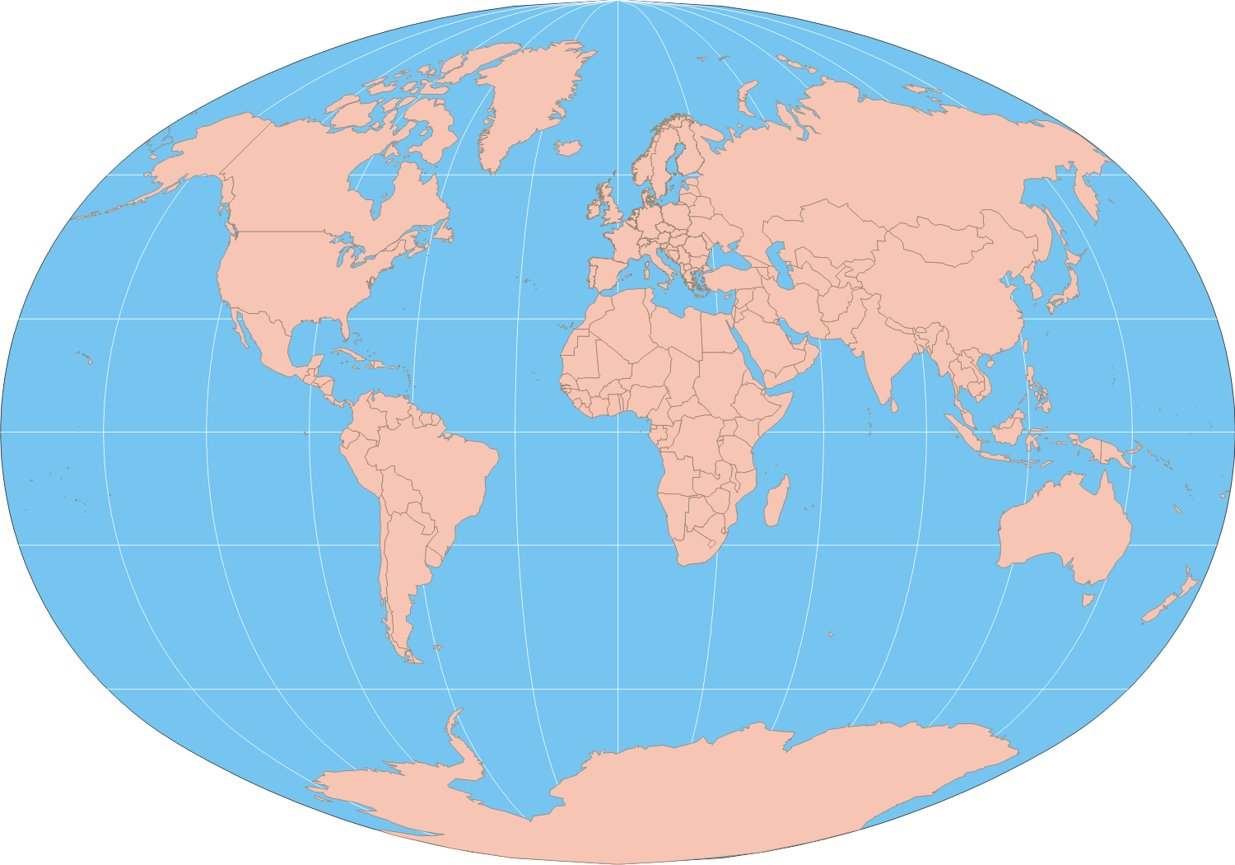
Bay of Fundy, Nova Scotia, Canada: most extreme tides
Mount Rainier, Washington State: snowiest place
Marianas Trench, Philippines: deepest ocean spot
Sangay, Ecuador: most active volcano
Angel Falls, Venezuela: highest waterfall
Mount Washington, New Hampshire: windiest
Al Aziziyah, Libya: hottest
Atacama Desert, Chile: driest
Tutundo, Columbia: wettest
Vostok, Antarctica: Coldest

Mauna Kea, Hawaii: tallest mountain base to top.

Mount Everest, Asia: highest mountain-above sea level
Lake Baikal, Russia: oldest, deepest lake
Nile River, Africa: longest river

Answer: This story discusses many different locations around the world. The author takes you on a journey to some of the windiest, driest, and coldest places on Earth. One such place is Mount Washington, New Hampshire. It is noted as being the windiest place on Earth. Another record holder is Vostok, Antarctica, it is considered to be the coldest place in the world. Throughout the entire story the author address some of the unique qualities found around the world, these diverse locations is what makes our Earth so very unique and interesting.

Additional Task
- Science Connection: Using the world map from the culminating activity, draw the equator and prime meridian on the map. Discuss the regions identified on the map in terms of their relationship and proximity to the equator. See if students can make a generalization or hypothesis about these regions and their climate that are close in proximity to the equator.
Answer: Regions that have a close proximity to the equator tend to have higher temperatures than other regions.

