Appendix A: Central Texts and Links

- Crumple a Watershed. http://www.omsi.edu/sites/all/FTP/files/expeditionnw/4.E.1.Crumple.pdf
- Relief Map of the United States http://www.cr.nps.gov/history/online_books/recreation_use/images/fig16.jpg
- MyWATERS Mapper. U.S. Environmental Protection Agency. http://watersgeo.epa.gov/mwm/
- “Surf Your Shed.” U.S. Environment Protection Agency. http://cfpub.epa.gov/surf/locate/index.cfm
- After the Storm. The Weather Channel and U.S. Environmental Protection Agency. http://www.clu-in.org/asxfiles/afterthestorm.asx
- “What Happens to Rain and Snow Water?” http://beslter.org/products/resources-for-educators/hydro-ecology-handbook/Hydro---Ecology-Handbook---draft-2---Lesson-3.pdf
- “Human Influences on the Water Cycle” http://www.sswm.info/category/concept/water-cycle

“What Happens to Rain and Snow Water?”

Text  This is the text from a Unit of Study created by the Baltimore Ecosystem. The Study is titled “What Happens to Rain and Snow Water?” and can be found here:  http://beslter.org/products/resources-for-educators/hydro-ecology-handbook/Hydro---Ecology-Handbook---draft-2---Lesson-3.pdf | Glossary  Below are simple definitions of words that will be difficult for you to figure out using context clues. Some of these words will be explained before you read and some of these words are here so you can access the definition while you read.
Para 1. Before urbanization, water recharge happened when precipitation fell on pervious surfaces (including grassland and woods) and infiltration occurred. When cities developed and the amount of pervious surfaces decreased, leading to less ground water recharge and a huge increase in surface runoff.  Para 2. Impermeable surfaces tend to become fully saturated very quickly and thereafter all of the precipitation becomes runoff, though some of that runoff may be absorbed by adjacent permeable areas and may not enter any drainage network. Once these impermeable surfaces have been wetted the percentage of runoff does not vary greatly.  Para 3. With the increase in impervious surfaces (roads, rooftops, parking lots and other hard surfaces that do not allow stormwater to soak into the ground), the rate of stormwater runoff increases. This means more water reaches the waterway faster and less water infiltrates into the ground. In streams, more erosion of stream banks and scouring of channels occur because of runoff. This degrades habitat for plants and animals that depend on clear water. Sediment in the water clogs the gills of fish and blocks light needed for plants. The sediment also settles to fill in channels of streams, lakes, and reservoirs.  Para 4. Rainwater will carry chemicals, nutrients, sediments and other substances into local streams (either directly or through storm sewers) if the water is not absorbed by soil and vegetation. The increased runoff can also carry along debris such as litter, cigarette butts, motor oil poured down the storm sewer, air pollutants that settle from car exhaust, and fertilizers, and pesticides from lawn care. The reduced amount of infiltrating water can lower ground water levels, which in turn can stress downstream environments which depend on steadier flows of water. New sources of groundwater can also develop in urban areas, although they are not from the most desirable places (septic tanks, percolation basins, and industrial waste injection wells, agricultural and residential irrigation). | Urbanization: The concentration of buildings and development in cities water recharge: The time it takes for water to soak into the ground water.  Pervious: A surface that can absorb water  Infiltration: When water soaks into the ground.  Surface runoff: Water that does not soak into the ground but flows on the surface.  Impermeable: An area that does not allow water to soak into the ground.  Saturated: ground is saturated when it cannot hold any more water.  Absorbed: Water that soaks into the ground  Impervious: A surface that does not allow water to soak into the ground.  Stromwater: Water that accumulated after a rain.  Scouring: Scrubbing and roughing up the banks.  Sediment: Dirt that falls into to the water  Chemicals: Heavy metals and other pollutants that are in the air and fall to the ground or enter the water.  Nutrients: The chemicals that all organisms need to survive.  Debris: Waste and litter  Ground water: Water that flows under the surface.  Percolation: The process of soaking  Industrial waste injection: Process used by industries to inject waste products and chemicals under the surface.
IMPACTS OF IMPERVIOUSNESS  Para 5. Once an area is cleared of vegetation, graded and compacted, and an impervious surface or partially pervious surface is constructed or installed, the area generally will not return to a naturally vegetated state. New impervious surfaces change natural drainage patterns and impact the environment by affecting the way that stormwater and, in some cases, tidal water moves over the landscape and through the soil. New impervious surfaces can affect the quantity, velocity, and quality of stormwater resulting in impacts to nearby land and water bodies.  Para 6. Permeable surfaces react differently. As the storm progresses the upper layers of the soil become wetter and wetter and when the rainfall exceeds the rate at which it can soak into the ground the rainfall is turned into runoff. When the rainfall intensity drops below the soakage rate the runoff ceases even though rainfall may still continue. Therefore the percentage runoff varies throughout the duration of the storm. | Compacted: Pressed down tightly  Velocity: Speed  Intensity: Amount  Varies: Changes  Duration: Length of time
IS IT PERVIOUS?  Para 7. The table below details the construction materials and surfaces that generate the most frequently asked questions regarding perviousness. The table was developed by considering the following factors: (1) alteration of natural drainage patterns; (2) impeded infiltration; (3) treatment to remove silt, sediment or nutrients; (4) vegetation, and; (5) groundwater discharge. In addition, the practices of local jurisdictions and information from engineers, planners and landscape architects familiar with materials and techniques were incorporated in the evaluations. | Construction: Building  Alteration: Change  Impeded infiltration: Interrupts the ability for water to soak in  Groundwater Discharge: Amount of groundwater that is released  Jurisdiction: legal control
Type of Structure | Impervious | Pervious | Notes
Deck, special construction | - | X | Spaces between boards, 6" gravel under deck, plantings.
Driveway, asphalt | x | - | -
Driveway, bank run gravel | x | - | Use causes gravel to become compacted over time.
Driveway, concrete | x | - | -
Driveway, dirt | x | - | Use causes soil to become compacted over time.
Driveway, oyster shell | x | - | Use causes shells to become compacted over time.
Driveway, pavers (Balcon or other) | - | - | Site-specific evaluation determines perviousness.
Parking lots, gravel | x |  | Use causes gravel to become compacted over time.
Parking lots, "turf block" | x | - | Use causes turf areas to become compacted over time.
Sidewalks, concrete | x | - | -
Sidewalks, brick and mortar | x | - | -
Sidewalks, brick on sand | x | - | -
Sidewalk, wood (boardwalk) | - | x | Spaces between boards, 6" gravel under deck, plantings
Swimming pools | x | - | -
Tennis courts, asphalt or polymer | x | - | -
Tennis courts, clay | x | - | -
Tennis courts, grass | x | - | -
Walkways, gravel | - | - | Site-specific evaluation determines perviousness.
Walkways, wood chip | - | x | -

STORMWATER BASICS  Para 8. Stormwater flows into the stormwater system through storm drains, which are frequently located along the curbs of parking lots and roadways. The grate and holding tank that prevents larger objects from flowing into the storm sewer system is called a catch basin. Once below ground, the stormwater flows through pipes that lead to an outfall where the stormwater enters a stream, river or lake.  Para 9. In some areas, the outfall may lead to a stormwater management basin. These basins control the flow of stormwater and can also improve water quality, depending on how they are designed.  Para 10. In some urban areas, the stormwater and sanitary sewer systems may be combined (not in Baltimore). In this situation, both stormwater and sewage from households and businesses travel together in the same pipes. Both stormwater and sewage are treated at sewage treatment plants except during heavy rains. During these occasions, both the stormwater and untreated sewage exceed the capacity of the treatment plant and this overflow is directed into local waterways untreated. | Stormwater: Rain from a storm  Grate: Metal screen on strom drains  Outfall: Where the water comes out  Management basin: Watershed area that is managed by a specific group  Sewage: the waste that runs from houses and businesses through underground pipes
PERMEABLE PAVING SURFACES  Para 11. One method of reducing stormwater runoff is to minimize the amount of impervious surfaces such as concrete sidewalks and asphalt driveways. These surfaces do not allow runoff to seep into the ground; they are not pervious. Use pervious surfaces instead. A paving surface that allows water to soak in may seem impossible, but there are many materials that provide the durability of concrete while allowing rainwater to filter down into the ground. If you are planning a new patio, walkway or driveway, there are several attractive alternatives to concrete such as wood decking, bricks, interlocking pavers, or flat stones. If used properly these can create a permeable paving surface that is not as harmful to the environment. | Durability: Sturdiness

References:

Impervious Surfaces: Prepared by Mary Owens
http://www.dnr.state.md.us/criticalarea/guidancepubs/impervioussurfaces.html

Rainfall, Runoff and Infiltration Re-visited by Richard Allitt, 2003
http://www.environmental-expert.com/articles/article1252/article1252.htm

New Jersey Division of Watershed Management:
www.nj.gov/dep/watershedmgt

Appendix B: Handouts and Recording Forms

Lesson 1 - After the Storm Recording form

Name:

Date:

Introduction
00:0 – 3:40
Vocabulary Term Organizer | Term | Definition | Examples and Other Ideas
 | insidious
 | watershed | Area of land that drains to a body of water
 | contamination
 | runoff | Water that runs off the ground directly into streams, rivers, bays | Comes from storms, rain, snowmelt
 | pollution
 | Fresh water
 | glaciers
 | EPA | Environmental Protection Agency | Governmental Agency that Protects our Water
 | Watershed approach
 | Cause | Effect | Solution
Santa Monica Bay
3:58 – 7:20
Vocabulary Term Organizer | Term | Definition | Examples and Other Ideas
 | hypoxia | An area that has no oxygen and cannot support life
 | Cause | Effect | Solution
Lower Mississippi River
7:22 – 13:49
Vocabulary Term Organizer | Term | Definition | Examples and Other Ideas
 | hypoxia | An area that has no oxygen and cannot support life
 | Cause | Effect | Solution
Protection and Restoration of Watersheds
18:50 – 21:30
Vocabulary Term Organizer | Term | Definition | Examples and Other Ideas
 | Pervious Surface
 | Impervious Surface
 | Issue |  | Solution
GIST Statement: Describe one strategy that individuals, businesses, or communities are using to reduce impervious surfaces and storm water runoff?

Lesson 2 - My WATERS Mapper Recording form

Name:
Date:

- How might a scientist use a map as a model?

- Go to: http://water.epa.gov/scitech/datait/tools/waters/index.cfm
- Read the description of the Watershed Assessment, Tracking & Environmental Results System (WATERS).
- How are the questions on the description page of the EPA website description of the MyWATERS Mapper related to our Module topic – “Water is Life?”

- Go to: http://watersgeo.epa.gov/mwm/
- Review the three different types of maps and describe what you see:

Streets

Imagery

Topography

- What can these maps tell us about the landforms that determine the movement of water?

- Go to: http://watersgeo.epa.gov/mwm/
- Click on the lower right button that reads: Other EPA Water Data
- Click on the Rivers and Streams, read the description and study the map.
- Click on the Watershed Boundary, read the description and study the map.
- Click on the Legacy Watershed Boundaries:
- Read the description and study the map
- What can these maps tell us about the relationship between the topography of land and how water flows from one watershed to another?

- On the upper left corner type Santa Monica, CA into the “Go To” box.
- Click on “topography.”
- Click on “Other EPA Water Data” button on right side of page.
- Click on Rivers and Streams, Watershed Boundaries, and Impaired Waters.
- Zoom in so you can see the purple watershed boundaries in and around Santa Monica.
- Find the following information:

Name of the Santa Monica watershed

What type of data are scientists collecting in that watershed?

What does the acronym TMDL mean?

After watching the video clip about the watershed issues and concerns in Santa Monica, how does this map help you understand why the issues are so concentrated here?

What is upstream of Santa Monica?

How do these maps help you understand the cause and effect in the Santa Monica Beach-Frontal Santa Monica Bay watershed?

Lesson 2 - Watershed Cause and Effect

Name:

Date:

http://watershedmanagementplan.wikispaces.com/Watershed+Cause+and+Effect

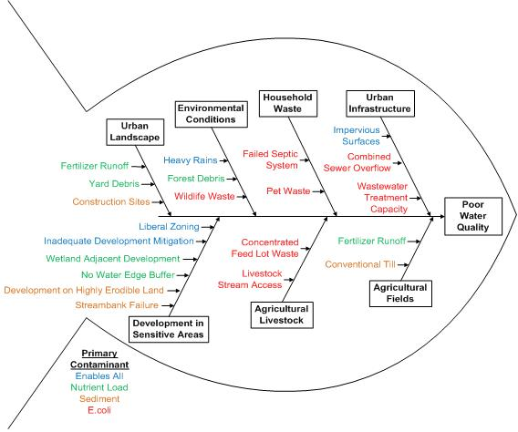

Lesson 3 - MyWATERS Mapper Recording form
http://watersgeo.epa.gov/mwm/

Name:
Date:

- Click on the “Other EPA Water Data” button on right side of page.
- Click on Watershed Boundaries
- Identify the Upper Mississippi and Lower Mississippi River Watersheds
- Where is the water coming from that is flowing into the Lower Mississippi River Watershed?

- What are some of the rivers feeding into the Mississippi River?

- Water flows downhill. What can you say about the slope of the earth from North Dakota to Louisiana?

- Zoom in on the Mississippi River Delta. Are there impaired waters in this region? What types of impairments can you identify?

- Why are there so many water quality issues in the Lower Mississippi River watershed?

- In the “Go To” box, type your city, state, and zip code
- Click on Topography view.
- Click on the “Other EPA Water Data” button on right side of page.
- Click on Rivers and Streams and Watershed Boundaries
- Place your cursor over your city to identify the name of your watershed.

Name of watershed:

- Zoom in further (+ symbol on left side of screen) and watch what happens! Do additional watersheds emerge? If so, what is the name of your sub-watershed?

Name of sub-watershed:

- Continue to zoom in to see how many layers of sub-watersheds you can identify. List each watershed as you find them!

Other sub-watersheds:

- Find the name of the watershed upstream?

Upstream watersheds:

- Downstream?

Downstream watersheds:

- Explain how the water flows through the various watersheds that you have listed.

- Click on Rivers and Stream, Watershed Boundaries, and Impaired Waters buttons.
- Are there any impaired waters in your watershed? What might be the cause of these impairments?

- Click on Storet Water Monitoring Stations.
- Select a station in your watershed.
- Click on one or more of the water quality data markers.
- What type of data is collected at those stations?

- Why is it important to know about the water quality of the water in our watershed and the watersheds upstream from you?

Lesson 3 - Watershed Cause and Effect

Name:

Date:

http://watershedmanagementplan.wikispaces.com/Watershed+Cause+and+Effect

Lesson 4 - “What Happens to the Rain and Snow Water?” Text Dependent Questions

Name:
Date:

- In the paragraphs 2 and 3 of the text, the author uses the terms impermeable and impervious. Are these words the same or different? How?
- In paragraph 5, the author describes the effect of impervious surfaces? Can you name them? Why are they of concern? What happens to water quality when there is an increase in impervious surfaces in a watershed?
- The table on p. 3 of the Student Text lists different surfaces. What are the differences between these two types of surfaces? Why is it important to know whether a surface is pervious or impervious?
- Paragraph 10 discusses methods to reduce storm water runoff. What is one method? Can you think of a place where you could apply that method?

Lesson 5 - The Urban Water Cycle
http://www.grida.no/graphicslib/detail/urban-water-cycle_7401

Name:
Date:

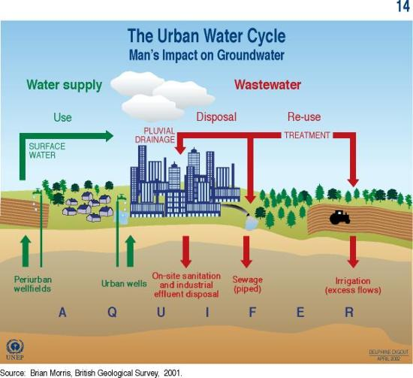

Description:
This graphic illustrates the impact of human activity on groundwater. It shows that groundwater is obtained from periurban wellfields and urban wells, then used and disposed of as wastewater through pluvial drainage, piped sewage and on-site sanitation and industrial effluent disposal. It also shows that wastewater is treated and then reused for irrigation, with excess flows re-entering the aquifers.

Lesson 5 - Wastewater: Contaminants and Their Effects

http://www.grida.no/graphicslib/detail/wastewater-contaminants-and-their-effects_f69b

Name:

Date:

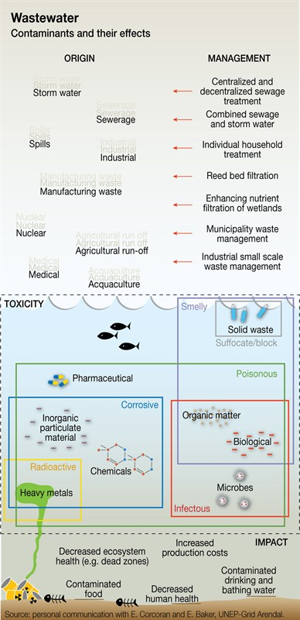

Description:
The contaminants in wastewater come from many different sources and can have cumulative and synergistic effects requiring a multi-pronged response.

Lesson 5 - Impact of Impervious Surfaces in Urban Areas
http://cnx.org/content/m42716/latest/?collection=col11325/latest

Name:
Date:

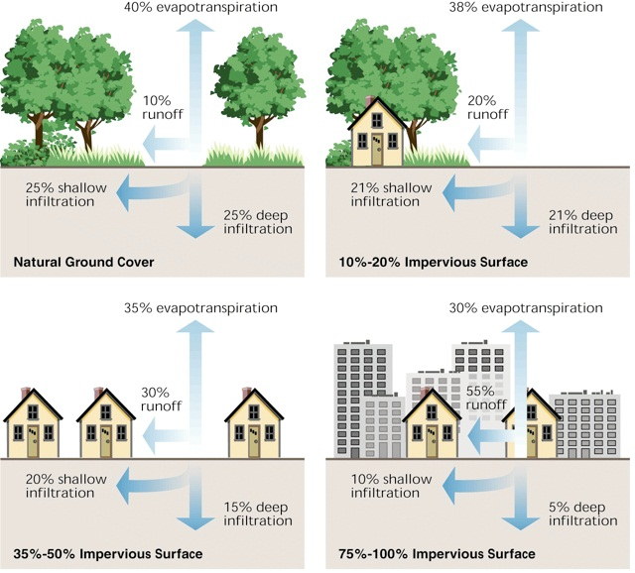
Figure 1: Degrees of Imperviousness and its Effects on Stormwater Runoff These four images show increasing amount of stormwater runoff as the area becomes developed with more impervious surfaces. Source: In Stream Corridor Restoration: Principles, Processes, and Practices (10/98) By the Federal Interagency Stream Restoration Working Group (FISRWG) (15 Federal agencies of the U.S.)

Research by the Center for Watershed Protection has found that stream quality becomes impaired when 10% of the stream's watershed is impervious and that an urban stream's ecology is severely impacted when more than 25% of its watershed is impervious. When flowing downhill within a watershed, stormwater runoff can pick up pollutants from various human sources and activities. It can also collect pollutants deposited from the air such as particulates and air pollutants carried to the earth's surface by precipitation, by windblown dust, or by simply settling out of the atmosphere. Urban runoff can also dissolve or transport chemicals that may be found naturally in soil or nutrients which may have been deliberately added to lawns. Common urban pollutants can include such things as pesticides and fertilizers applied to residential lawns, parks and golf courses, enteric microbes from animal waste, industrial chemicals that may have been accidentally spilled on the ground or improperly stored, or oils and greases leaking from cars parked in lots or on driveways.

Lesson 2 - “Water is Life” Graphic Organizer for Conceptual Model

Name:
Date:

TITLE OF YOUR MODEL:

DETAIL 1 | DETAIL 2 | DETAIL 3
SCIENTIFIC VOCABULARY: | SCIENTIFIC VOCABULARY: | SCIENTIFIC VOCABULARY:
EXPLAIN HOW THE DETAIL CLARIFIES THE MODEL. | EXPLAIN HOW THE DETAIL CLARIFIES THE MODEL. | EXPLAIN HOW THE DETAIL CLARIFIES THE MODEL.
EXPLANATION OF YOUR MODEL:

CITATION FOR YOUR MODEL

Appendix C: Protocols

- Gallery Walk
- Word Wall

Gallery Walk Protocol

Purpose:
Use this Gallery Walk protocol to create a process for students to learn about and respond to several articles on a topic, or several examples of text on a certain topic. This protocol allows students to move around the room in order to view a variety of texts and to engage in small-group collaboration.

Procedure:
- Divide students into small groups of 3-4 (or pairs).

- Assign each group an article/piece of text to read.

- After each group reads its article/text, have group members discuss the article then write main ideas and questions from the article on chart paper.

- Have the groups post their chart paper on the wall with a chart paper next to it.

- Ask groups to rotate around the room reading the main ideas and key details from each text. Have students write responses on post-its as they read each chart paper and stick the post-its to the blank sheets of chart paper next to the ones on the articles.

- After everyone has responded to each of the articles, have the groups to their original chart paper and read and discuss the post-its left by other.

- Assign each group a specific segment of your topic (example: legislative branch of government, role of a worker bee, or transportation on the river).

- Provide each group with additional materials they need to further enhance the study that has already been introduced, probably in a large-group setting (example: Government, Insects, Importance of our River).

- Allow time for group to read and discuss the new information. Using prior knowledge along with the new knowledge, have them create a visual representation that each person in the group will use to teach others in the class.

- Be clear that each person has to understand the text and images on the poster in order to present the information effectively. Allow time for the groups to help one another focus on key components.

- Post the work around the room or in the hallway.

- Regroup participants so each new group has at least one member from the previously established groups.

- Give specific directions at which poster each group will start and what the rotation will look like.

- The speaker at each poster is the person(s) who participated in the creation of the poster.

- When all groups have visited each poster, debrief.

Debrief:
What was your biggest “a-ha” during the tour?
How was your learning enhanced by this method?
What role did collaboration play in your success?
Why was the individual responsibility component so important?

Word Wall Protocol

Purposes:
- To provide students with an opportunity to demonstrate their understanding of a related set of terms.
- To establish visual models that enhance understanding of a set of terms.

Steps:
- Using note cards or sheets of paper, write one term or picture per card. Limit the number of cards to around 10, fewer for younger children.
- Also make cards with one-way and two-way arrows.
- Use the floor or magnets and a magnetic board to display the cards. Make sure the terms on the cards are known.
- Ask a student or a pair of students to arrange the cards in a way that connects them or makes a model of the terms. Ask the student to explain what they are doing as they go along. Observers may ask questions once the model is created
- Repeat with another student of pair
- Keep the cards available for use as long as the terms/topic are part of the instruction

Possible debrief questions:
- How did working with the cards help you understand the topic?
- Was your thinking similar/different from the student doing the arranging?
- Are there words you would add/subtract from the word wall?

Modification:
- Give each student his or her own set of word cards

The following protocols were adopted from Expeditionary Learning: elschools.org

