Title/Author: The Snowy Day by Ezra Jack Keats
Suggested Time to Spend: 5 Days (Recommendation: One sessions per day, at least 20 minutes per day)
Common Core grade-level ELA/Literacy Standards: RL.K.1, RL.K.2, RL.K.3, RL.K.4, RL.K.7; W.K.2; SL.K.1, SL.K.2
Lesson Objective:
Students will listen to this literary text read aloud and use literacy skills (reading, writing, discussion and listening) to understand the central message of the story.
Teacher Instructions
Before the Lesson
- Read the Big Ideas and Key Understandings and the Synopsis below. Please do not read this to the students. This is a description to help you prepare to teach the book and be clear about what you want your children to take away from the work.
Big Ideas/Key Understandings/Focusing Question
How does the change in temperature affect the state of water/precipitation?
Synopsis
A boy wakes up to a snow-covered city. He excitedly goes outside to play. The boy takes a snowball and brings it inside his home to save. He is saddened when later in the evening he discovers the snowball is gone. The boy awakens the next day to find that the snow is still there and there is now new snow.

- Go to the last page of the lesson and review “What Makes this Read-Aloud Complex.” This was created for you as part of the lesson and will give you guidance about what the lesson writers saw as the sources of complexity or key access points for this book. You will of course evaluate text complexity with your own students in mind, and make adjustments to the lesson pacing and even the suggested activities and questions.
- Read the entire book, adding your own insights to the understandings identified. Also note the stopping points for the text-inspired questions and activities. Hint: you may want to copy the questions vocabulary words and activities over onto sticky notes so they can be stuck to the right pages for each day’s questions and vocabulary work.
- Consider pairing this series of lessons on The Snowy Day with a text set to increase student knowledge and familiarity with the topic. A custom text set can be found here. Note: This is particularly supportive of ELL students.

Note to teachers of English Language Learners (ELLs): Read Aloud Project Lessons are designed for children who cannot read yet for themselves. They are highly interactive and have many scaffolds built into the brief daily lessons to support reading comprehension. Because of this, they are filled with scaffolds that are appropriate for English Language Learners who, by definition, are developing language and learning to read (English). This read aloud text includes complex features which offer many opportunities for learning, but at the same time includes supports and structures to make the text accessible to even the youngest students.
This lesson includes features that align to best practices for supporting English Language Learners. Some of the supports you may see built into this, and /or other Read Aloud Project lessons, assist non-native speakers in the following ways:

- These lessons include embedded vocabulary scaffolds that help students acquire new vocabulary in the context of reading. They feature multi-modal ways of learning new words, including prompts for where to use visual representations, the inclusion of student-friendly definitions, built-in opportunities to use newly acquired vocabulary through discussion or activities, and featured academic vocabulary for deeper study.
- These lessons also include embedded scaffolds to help students make meaning of the text itself. It calls out opportunities for paired or small group discussion, includes recommendations for ways in which visuals, videos, and/or graphic organizers could aid in understanding, provides a mix of questions (both factual and inferential) to guide students gradually toward deeper understanding, and offers recommendations for supplementary texts to build background knowledge supporting the content in the anchor text.
- These lessons feature embedded supports to aid students in developing their overall language and communication skills by featuring scaffolds such as sentence frames for discussion and written work (more guidance available here) as well as writing opportunities (and the inclusion of graphic organizers to scaffold the writing process). These supports help students develop and use newly acquired vocabulary and text-based content knowledge.

The Lesson – Questions, Activities, and Tasks

Questions/Activities/Vocabulary/Tasks | Expected Outcome or Response (for each)
FIRST READING:  Read aloud the entire book with minimal interruptions. Stop to provide word meanings or clarify only when you know the majority of your students will be confused. | The goal here is for students to enjoy the book, both writing and pictures, and to experience it as a whole. This will give them some context and sense of completion before they dive into examining the parts of the book more carefully.
SECOND READING:  Reread p. 1-2  QUESTIONS:  The author states “Snow had fallen during the night.” What does it mean the snow had fallen? What was the result of the snow falling?  Reread p. 3-4  QUESTIONS:  What did Peter do to prepare to go outside? Why?  For the rereading of the following pages, have the students act out what Peter’s adventures in the snow.  Reread p. 5-6 **WITHOUT SHOWING THE PICTURE**  Activity:  Act out and explain how Peter walks in the snow.  QUESTIONS:  What happened to Peter’s feet as he walked in the snow? How do you know?  Reread p. 7  QUESTIONS:  The author states that Peter dragged his feet slowly. Why do you think the author wrote the word “s-l-o-w-l-y,” like this?  Reread p. 8, 9 **WITHOUT SHOWING THE PICTURE**  Act out and explain how Peter is now walking in the snow.  What is the result of how he walked?  How did the tracks change?  Reread p. 9, 10, 11 **WITHOUT SHOWING THE PICTURE**  QUESTIONS:  Act out and explain what Peter does. What is the result? | Peter put on his snowsuit. It is cold outside from the snow.  Students should walk with their toes pointing out and then their toes pointing in. As students explain: Crunch, crunch, crunch. His feet sank into the snow.  They sank into the snow. It left footprints in the snow.  The children will recognize how the teacher exaggerated/elongated the word slowly. The students will connect the hyphenated word s-l-o-w-l-y with how it is read. The author wrote the word like that so that the reader would know how to read it differently than the other words.  Students drag their feet.  Students should respond with slowly.  He made lines with his feet. The tracks form a line.  It went from two lines of tracks in the snow and went to three drag tracks with the stick.  He made lines with his feet. The tracks form a line.  The tracks went from two lines of tracks in the snow and went to three drag tracks with the stick.  Students pantomime hitting a tree with the stick. Students recall the onomatopoeia PLOP to describe the snow falling onto Peter’s head.
Activity:  Begin creating a chart of Peter’s adventures in the snow. (Leave a column blank to add pictures of the students’ reenacting Peter’s adventures in the snow*, which will occur during the last session.) *If applicable. | As a class, brainstorm Peter’s adventures in the snow. List them in a chart. The chart should include pictures/phrases/vocabulary that match the story.  The pictures/phrases/vocabulary should highlight the key vocabulary:  - Fallen snow has covered everything as far as the eye could see  - Piled  - Crunch, crunch, crunch - Sank  - Tracks  - Plop
THIRD READING:  Reread p. 12  QUESTION:  Is Peter walking toward you, or away from you? How do you know?  Reread p. 13, 14  QUESTION:  Why did Peter decide he wasn’t old enough to join in the snowball fight?  Reread 15, 16, 17, 18  Activity:  Think about what Peter did instead of joining in the snowball fight. Students will retell the four activities Peter did after not joining the snowball fight. | Peter is walking away from you. The tracks are getting smaller; we only see the back of him.  Peter now has snow on the front of his snowsuit. He got hit with a snowball. He is on the ground. He doesn’t look happy. He is looking at the snowball that hit him. He just sits in the snow, and does not join in.  Using your whiteboard, divide it into 4 sections. Draw or write the four events in the correct sequence.  Students should show the smiling snowman, Peter making an angel, Peter pretending to be a mountain climber, and sliding down.
FOURTH READING:  Gather snow from outside and keep frozen for use during this reread section.  *If you live in a climate in which there is not snow, you may make snow using a crushed ice machine. You may also use wet sand or play-doh.*  Reread p. 19-20  QUESTIONS:  The author uses the word packed. Packed means to combine into a bundled. What does Peter pack and how does he pack it?  QUESTIONS:  Where did Peter pack his snowball? What did he do with it and why?  Activity:  Act out how you would pack a snowball.  How did the setting change? Use details from text to explain how they are different.  Reread p. 21-22  QUESTIONS:  On page 21, the author states, “He thought and thought and thought about them.” Who was he? What was he thinking about? Recall some of the adventures and discuss it.  Reread p. 23-24  QUESTIONS:  The author states that Peter was very sad. Why was he sad?  Reread p. 25  QUESTIONS:  What did he dream about? What happened?  How was his dream connected to what happened to his snowball?  Reread p. 26-28  QUESTIONS:  What happened when Peter woke up? How do you know? | He picked up a handful of snow and then another and still another. He packed it round and firm into a form of a snowball.  Peter packed his snowball outside. He put it in his pocket to save it for tomorrow.  Have one student make a snowball (or model ball) and place a snowball in a cloth/nylon bag. Take a picture of the snowball in the bag immediately after placing it into the bag.  Student can pantomime packing a snowball with their hands or take turns packing a snowball utilizing snow or an alternative material: crushed ice, wet sand, or play-doh.  He was outside and then went inside. The outside was cold and he was in the snow. He was wearing a snowsuit because it was cold and snowy outside. Inside it was warm and he was taking off his wet socks. He was not wearing a shirt or long pants.  He is Peter. He was thinking about his adventures. Adventures: Feet walking in and out, making tracks, hitting the tree with the stick, snowball fight, smiling snowman, angels, mountain-climber, sliding down the mountain, and packing his snowball.  His pocket was empty. The snowball wasn’t there.  He dreamed about the sun. The sun melted all the snow away.  In his dream the sun melted all the snow away. His snowball melted in his pocket because he brought it into his warm house. The sun is warm and can melt snow.  New snow was falling. He looked out the window (illustration). He and his friend went outside to play in the deep, deep snow.
Activity:  Adding to class chart.  Observe and discuss the change in the snowball and the socks. Add pre and post photos to the chart.  Activity:  Shared Writing: In the story, Peter goes outside to play. As a class, create a list of items Peter and other characters in the book wore to be prepared to play in the snow.  Students will share the list with their family so that they are prepared to go outside the following day (if applicable to the weather). | Students state the change in temperature had on the snowball and use the vocabulary word melted.  The list could include: snowsuit (On Peter p.3-4), hats (On Peter and boys p.13-14), mittens (On Peter and boys p. 13-14), scarf (On boy p. 14), boots (so socks do not get wet (p. 20)
Fifth Reading:  Review the chart completed by the class throughout the rereading of the story. Have student dress appropriately for the weather and act out the sequence of events in the snow. The students will act out Peter’s adventures in the snow as the pages are reread to them. Do not show the students the pages as it is reread to them. Take pictures of the students’ reenactment to add to the chart.  *If you live in a climate in which there is not snow, you may make snow using a crushed ice machine. You may also use wet sand or play-doh. Students could utilize action figures and props to act out the story* | The students will act out Peter’s adventures in the snow, when read pages from the story. The students will paraphrase their actions as they act out Peter’s adventures. Pictures of the Students’ reenactment will be added to the chart.

FINAL DAY WITH THE BOOK - Culminating Task
- Using evidence from the text, draw and write how the change in temperature affects the snow throughout Peter’s day.
  - Additional guidance: When responding to this prompt, students would draw and write about events from Peter’s day that help to show how the change in temperature causes changes in the snow (waking up to the snow covering everything as far as the eye could see, him walking in the snow, him making tracks, hitting the tree with a stick and snow plopping on his head, the snowball fight, the snowman, angels, mountain-climber and sliding down the hill, packing the snowball, putting his snowball in his pocket, going into the warm house, taking off his wet socks, finding his pocket empty, waking up to his snow filled day).

Vocabulary
These words merit less time and attention  (They are concrete and easy to explain, or describe events/  processes/ideas/concepts/experiences that are familiar to your students) | These words merit more time and attention  (They are abstract, have multiple meanings, and/or are a part  of a large family of words with related meanings. These words are likely to describe events, ideas, processes or experiences that most of your student will be unfamiliar with)
Page 2 – covering: a layer of something, to blanket  Page 5 – sank: to go down below the surface  Page 11 – plop: a short sound as an object drops (snow dropping on the boy’s head)  Page 17 – heaping: to put into a large pile | Page 2 – fallen: came down, descend  Page 7 – tracks: a mark or line of marks left behind  Page 19 – packed: means to combine into a bundled  Page 25 – melted: to make or become liquefied by heat

Extension learning activities for this book and other useful resources
- Record and track daily temperature and activities appropriate for the temperature.
- Art Center (adapted from Scholastic’s “Ezra Jack Keats Author Study,” in the section “The Snowy Day Extension Activities”): Using the EJK Foundation home page as a guide, the students paint a white, snowy hill on blue construction paper. I asked parent volunteers to make cutouts of Peter prior to the lesson, and supplied doll shoes, toothpicks, a rubber stamp and cotton swabs for Peter’s footprints, the track he makes with a stick, and snowflakes.
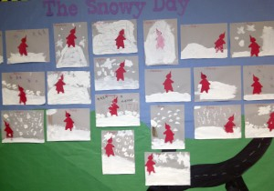
- Writing Center: The students are given a page with the phrase, “Snow is…,” and directed to complete the sentence with a word from the board, for example, “Snow is cold” or “Snow is soft.” The teacher can also write a child’s chosen word on an index card for the child to copy. The children draw a picture that illustrates their sentence with color pencils or crayons. The completed pages can be compiled into a class book titled, “Snow is….” First- and second-graders can write their own sentence and make a book themselves. Note: This is particularly supportive of English Language Learners.
- Useful websites with activities:
  - http://www.scholastic.com/teachers/lesson-plan/snowy-day-extension-activities
  - http://www.ezra-jack-keats.org/fun-games/the-snowy-day-game/

Note to Teacher
- Sample of completed classroom chart.
The Snow Day
Vocabulary Words | Student Definitions (defined by the student, using their words) | Picture definitions
Fallen Snow | The snow comes down from the sky | 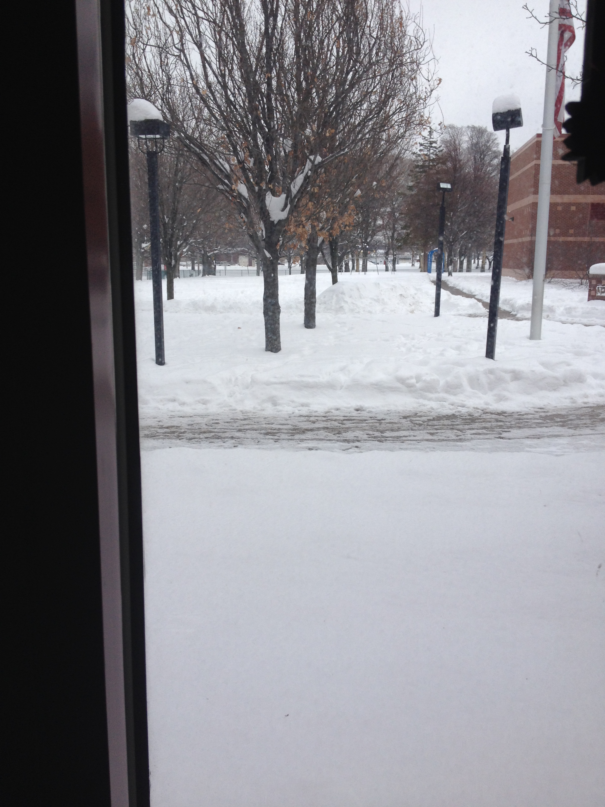
Cover | It goes over everything like a blanket
Piled | In a big ball or mountain
Crunch | The sound the snow makes under your feet. | 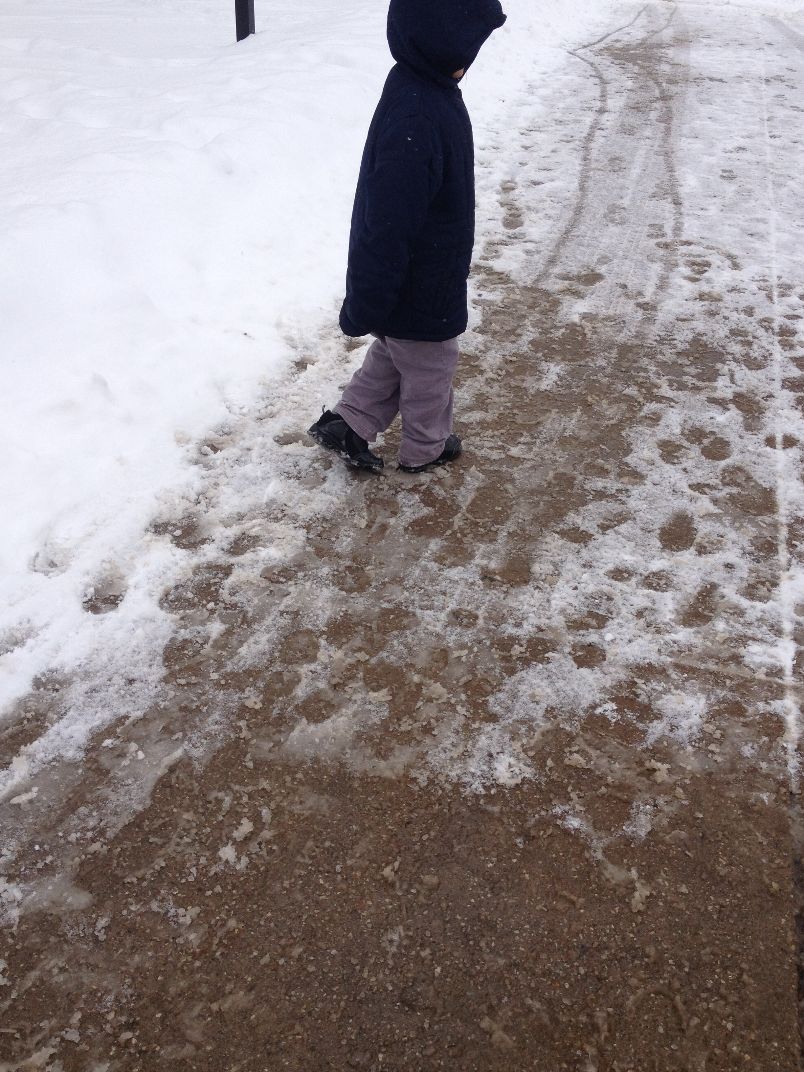
Sank | When your feet go down into the snow. | 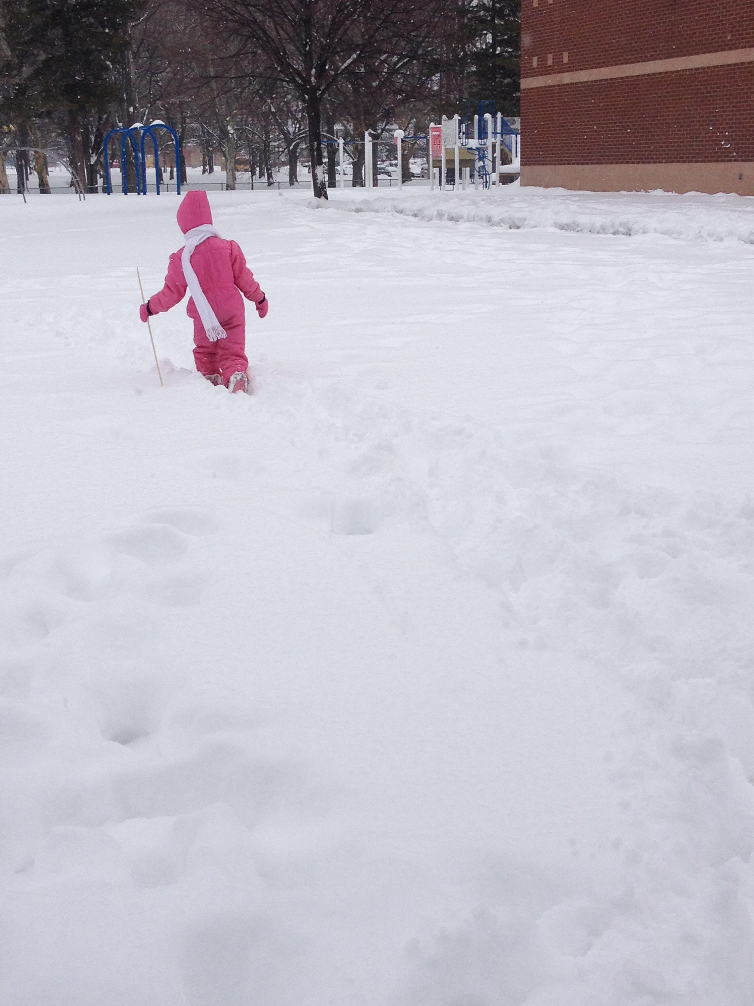
Tracks | What is left behind when you walk in the snow; a shape, mark, or footprint | 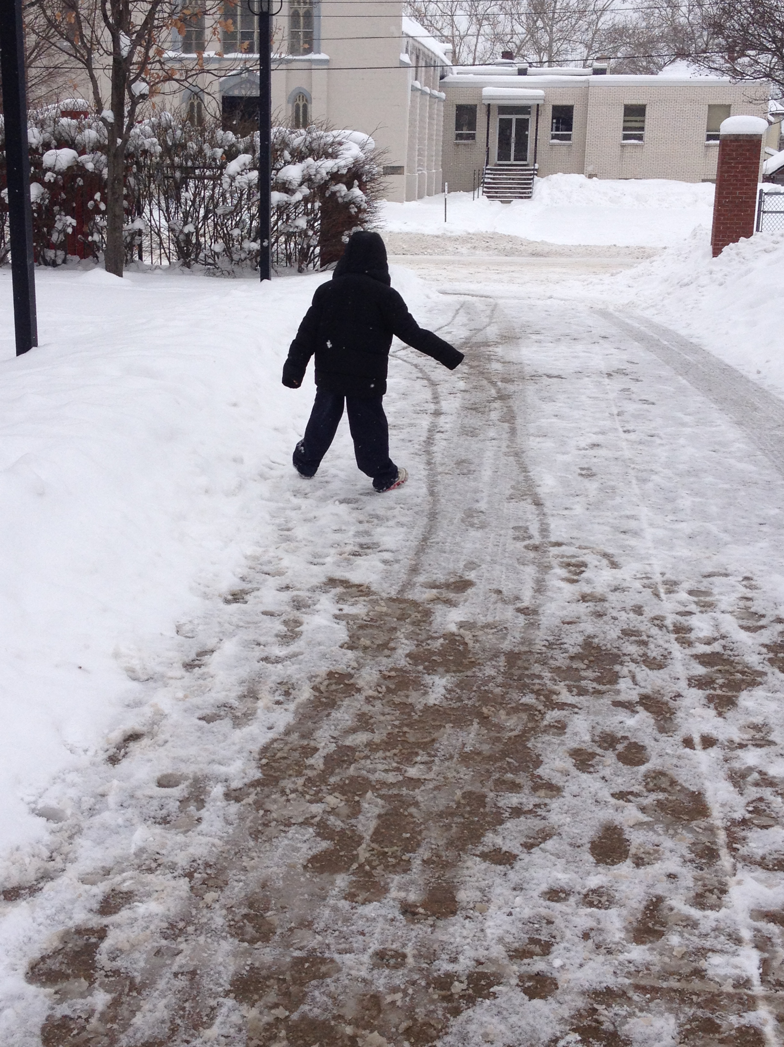
Plop | The sound the snow makes as it falls on your head. | 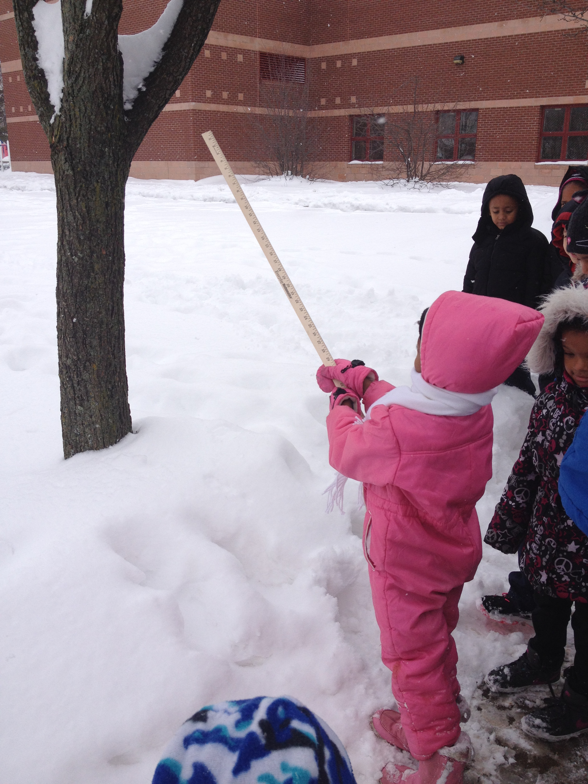
Snow inside: What will happen to the snow?  Why? | It’s going to melt.  It gets warm inside. | 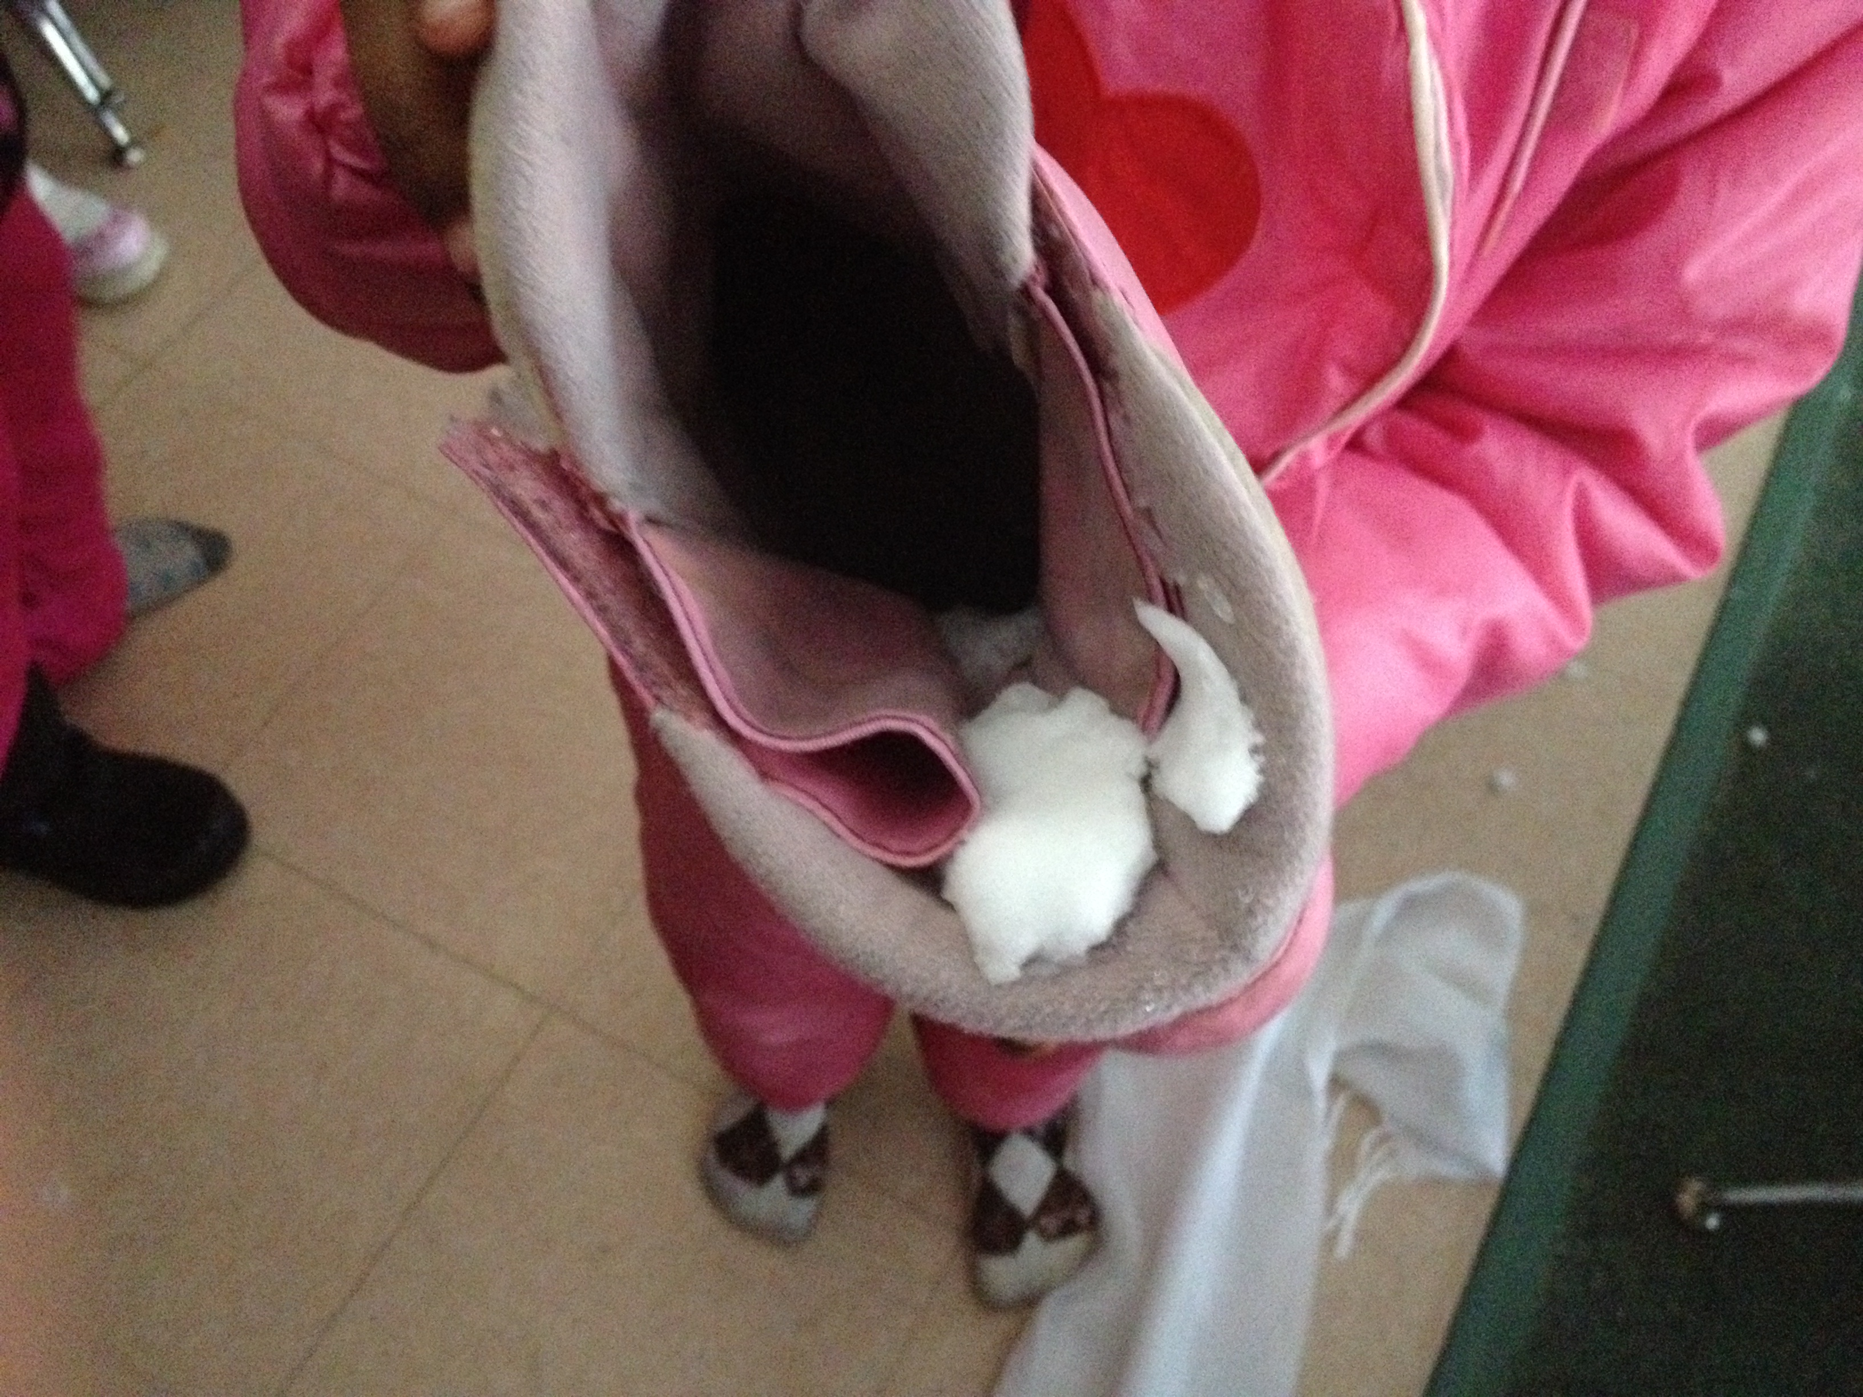
20 minutes later: What happened to the snow? | It melted. | 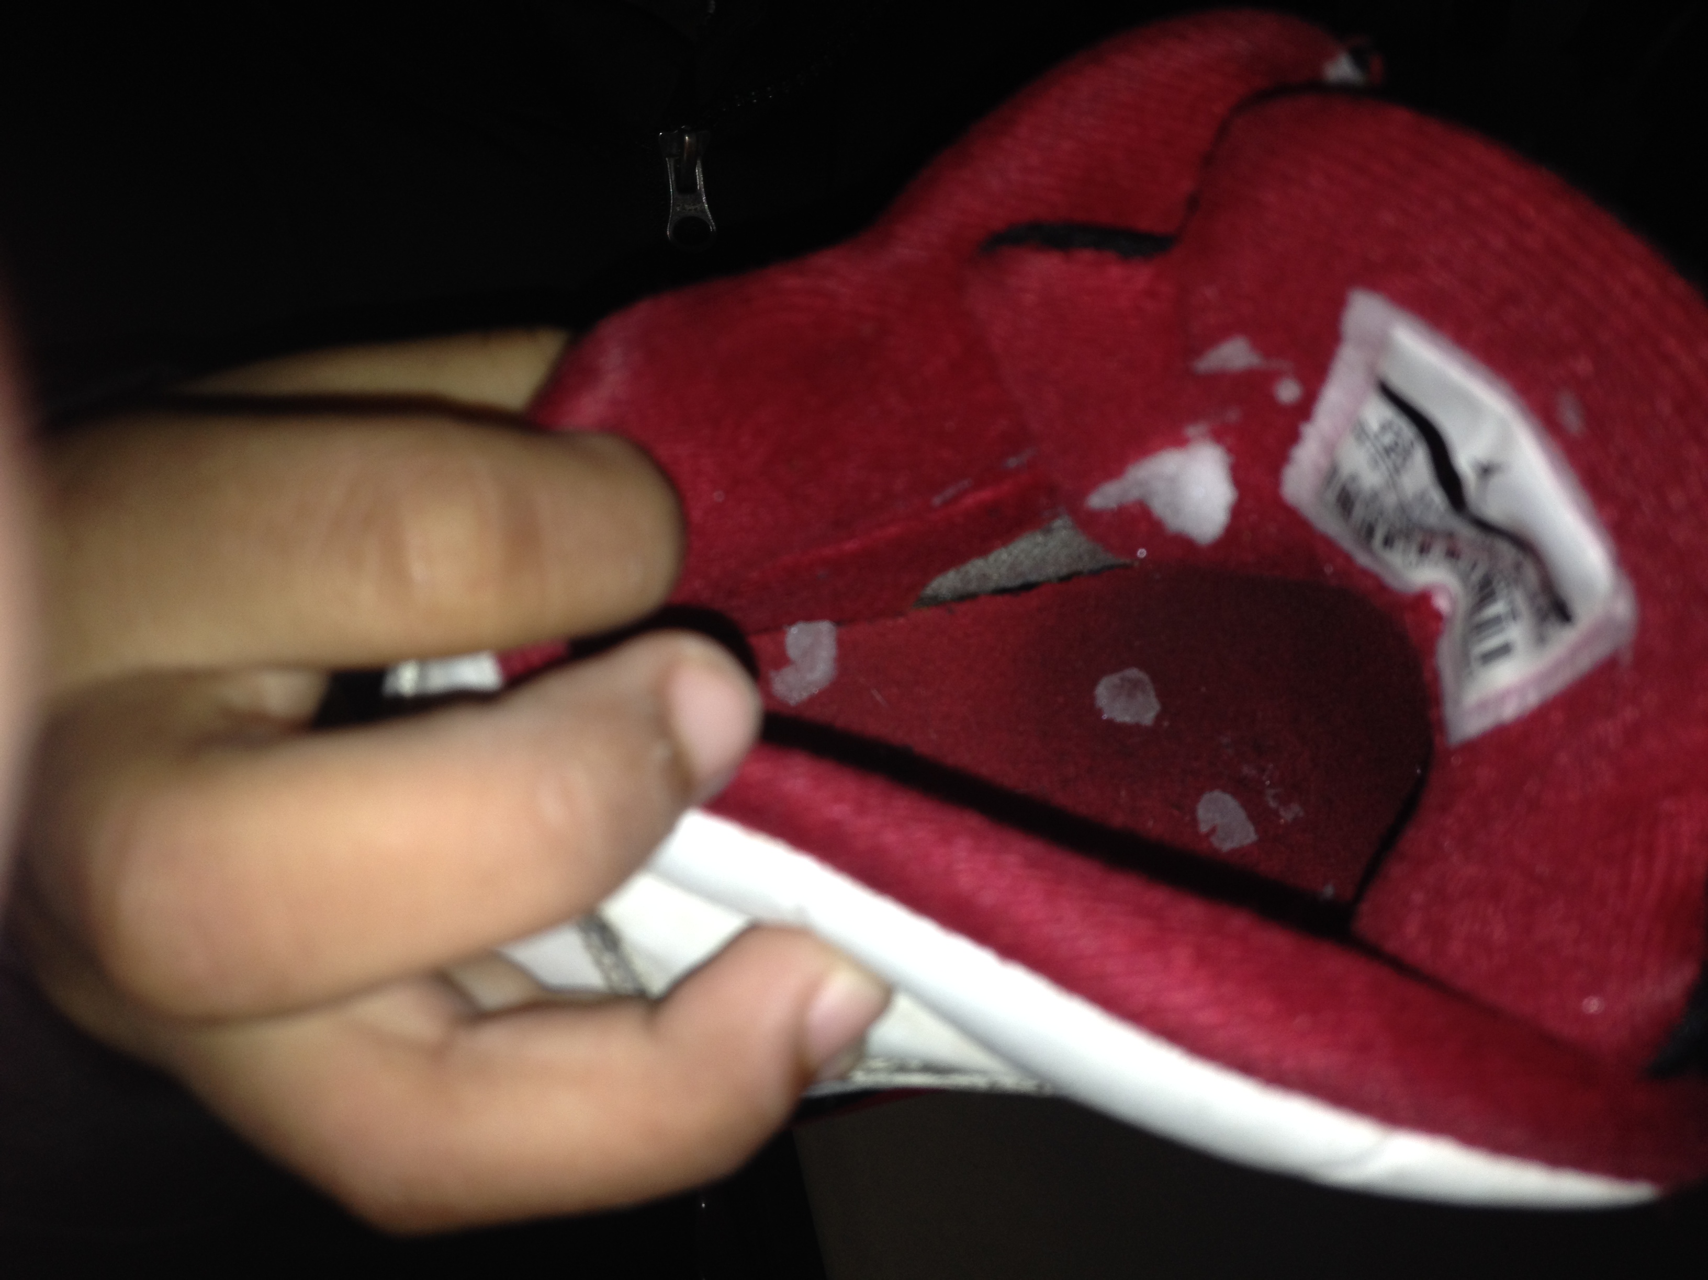

What Makes This Read-Aloud Complex?
- Quantitative Measure
Go to http://www.lexile.com/ and enter the title of your read-aloud in the Quick Book Search in the upper right of home page. Most texts will have a Lexile measure in this database.

Most of the texts that we read aloud in K-2 should be in the 2-3 or 4-5 band, more complex than the students can read themselves.
2-3 band 420-820L
4-5 band 740-1010L

___500_____

- Qualitative Features
Consider the four dimensions of text complexity below. For each dimension*, note specific examples from the text that make it more or less complex.
Weather: How does temperature change and affect the weather and climate?
This story is a fictional piece of text where students need to make a connection to the scientific concept that temperature effects weather.

Text with multiple transition words
Some complex sentences

Background knowledge about hot and cold temperatures; how the temperatures allow for different types of weather.

Meaning/Purpose
Structure

Language
Knowledge Demands

*For more information on the qualitative dimensions of text complexity, visit http://www.achievethecore.org/content/upload/Companion_to_Qualitative_Scale_Features_Explained.pdf

- Reader and Task Considerations
What will challenge my students most in this text? What supports can I provide?
Building prior background knowledge about temperature effecting weather; previously read nonfiction texts about weather, science lessons about weather/temperature.

How will this text help my students build knowledge about the world?
Children need to have an understanding about how temperature changes allow for different types of weather. This can easily be connected to weather patterns throughout the world.

- Grade level
What grade does this book best belong in? Kindergarten

All content linked to within this resource was free for use when this resource was published in March 2018. Over time, the organizations that manage that external content may move or remove it or change the permissions. If the content is no longer available, please email info@studentsachieve.net.

