Unit 3/Week 3
Title: Time for Kids: Kid Reporters at Work
Suggested Time: 5 days (45 minutes per day)
Common Core ELA Standards: RI.4.1, RI.4.4, RI.4.5, RI.4.7; RF.4.3, RF.4.4; W.4.2, W.4.4, W.4.9; SL.4.1; L.4.1, L.4.2, L.4.4

Teacher Instructions
Refer to the Introduction for further details.
Before Teaching
- Read the Big Ideas and Key Understandings and the Synopsis. Please do not read this to the students. This is a description for teachers, about the big ideas and key understanding that students should take away after completing this task.
Big Ideas and Key Understandings
Children can be a positive force for improving the lives of others. Some efforts involve many participants and some efforts are the work of just a few.
Synopsis
Terrence Cheromcka and Martin Jacobs, two Time For Kids reporters, report on two very different organizations that involve children playing an important role in making life better for other children.
- Read entire main selection text, keeping in mind the Big Ideas and Key Understandings.
- Re-read the main selection text while noting the stopping points for the Text Dependent Questions and teaching Vocabulary.
During Teaching
- Students read the entire main selection text independently.
- Teacher reads the main selection text aloud with students following along. (Depending on how complex the text is and the amount of support needed by students, the teacher may choose to reverse the order of steps 1 and 2.)
- Students and teacher re-read the text while stopping to respond to and discuss the questions and returning to the text. A variety of methods can be used to structure the reading and discussion (i.e.: whole class discussion, think-pair-share, independent written response, group work, etc.)

Text Dependent Questions
Text-dependent Questions | Evidence-based Answers
The author says kid reporters, like adults must be “qualified for the job.” Using the text, find three skills that a kid reporter must have in order to be considered for the job of TFK reporter. | - Persistence in tracking down a good story  - Good interviewing skills  - Ability to write clearly about complicated topics
As the two reporters are introduced, they are said to be very different. Before even meeting them in the story, what do we know that they have in common? | Both are determined to do a good job as reporters covering an interesting story.
In this assignment, how was Terrence going to meet people from all over the world without traveling to many different places? | She was going to New York to cover a story at the opening ceremony of the United Nations Special Sessions on Children. There would be 375 kids from all over the world there.
According to the author, what were the most important issues of the UN during this special session? | For Children all over the World  - Healthcare  - Education  - Basic rights
What evidence can you site that supports what the issues are for this UN special session? | In the picture, the audience is made up of mostly children. There are kids from different countries as evidenced by their clothing.
Who is the important person that gives the kids hope that their efforts at the conference will help improve conditions for children? | United Nations Secretary General Kofi Annan
Analyze the statement made by United Nations Secretary General Kofi Annan, “Your voices will be heard, I promise you.” What does this statement say to the participants of the conference? | The statement lets participants know that they will not be ignored.
Terrence writes “It really reminded me of why the U.N. is working so hard to improve children’s lives and why its mission is so important.” What does “It” refer to? | “It” refers to an exhibit she saw of the effects of war depicting pictures of child soldiers fighting in war-torn countries.
Martin Jacobs had an opportunity to interview Andrew Hsu. List 3 of Hsu’s accomplishments referenced in the text. | 11 year old scientist, competitive swimmer, founder of World Children Organization (WCO)
The author states “the brothers started this venture in order to help improve the lives of children.” Use the text to figure out what venture means. | The brothers founded an organization so this “venture” is a new idea or undertaking that they are putting in motion. A venture also means that you are trying something even when you don’t know the final result
Why does the mission of the WCO focus on many different countries, but not the United States? | Many countries do not make free education available to all kids like the United States does.
According to Martin, what will the production of their videos and education of children around the world help to do? | This will help end the problems of poverty, hunger, child labor, and abuses of children’s rights.
We understand how organizations like the U.N. and the WCO help make the world a better place. How do reporters like Terrance and Martin help to make the world a better place as well? | Both reporters use their talents to spread news about worthwhile organizations and amazing young people. Reporting these stories to young people can inspire other youth to take action to improve conditions around the world. The information that they share can also let other youth know how they can help these organizations.
Using a Venn diagram, compare and contrast Terrence’s and Martin’s assignments from TFK. How were they different and similar? | Terrence Martin  New York Washington  U.N. Special Session on Children State Engineering and Science Fair  Interviewed many students Interview focused on 1 student  Several different issues One major issue  Similarities: Both interviews focused on children.  Improving education of kids  Both had to travel away from their home state for the  activity.

Vocabulary
 | KEY WORDS ESSENTIAL TO UNDERSTANDING | WORDS WORTH KNOWING  General teaching suggestions are provided in the Introduction
TEACHER PROVIDES DEFINITION  not enough contextual clues provided in the text | enterprising  devastating  identified  commitment | journalists  behind-the-scenes  persistence
STUDENTS FIGURE OUT THE MEANING  sufficient context clues are provided in the text | promote  priority  exhibit  venture | mission
Culminating Task
- Re-Read, Think, Discuss, Write
- Complete the Venn diagram (given by teacher) to illustrate the differences and similarities of the United Nations Special Session on Children and the World Child Organization. When completed, have students work in small groups to create a scenario where a small organization like the WCO would be helpful or where a large organization like the U.N.’s Conference for Children would be most helpful.
Example of when a small organization would be helpful: There are several homes that have foreclosed in the neighborhood and no one has been caring for the lawn. The weeds are growing excessively and it is making the neighborhood look bad. Students from the local high school and middle school in the area come together to create a neighborhood beautification organization to help take care of not only the neighborhood, but the environment as well.

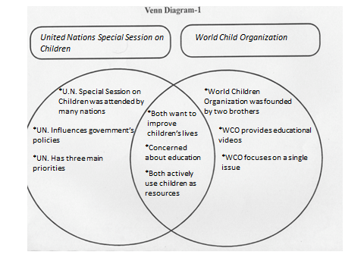
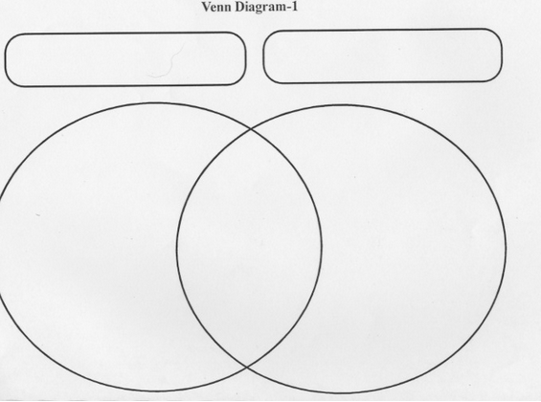

Additional Tasks
- The WCO is an organization that started out as a venture of two brothers, Andrew and Patrick Hsu. It has been successful and helped kids all over the world by educating them in science, math, and language. We know that a venture is a project that involves some risk-taking. What do you think were some of the risks of their venture? What has been some of the rewards? What is a venture you have taken? What were some of the risks involved? What were some of the rewards?

Note to Teacher
- Teacher must make sure students are clear on the comprehension skill of Compare and Contrast. It is also important for the teacher to model the strategy for students with related, informational text.

