Unit 1/Week 1
Title: Class President
Suggested Time: 5 days (45 minutes per day)
Common Core ELA Standards: RL.5.1, RL.5.2, RL.5.3, RL.5.4, RL.5.6, RL.5.7; W.5.1, W.5.4, W.5.9; SL.5.1, L.5.4, L.5.5, L.5.6

Teacher Instructions
Refer to the Introduction for further details.
Before Teaching
- Read the Big Ideas and Key Understandings and the Synopsis. Please do not read this to the students. This is a description for teachers, about the big ideas and key understanding that students should take away after completing this task.
Big Ideas and Key Understandings
a. Focusing on the benefits of an entire group rather than the gains of an individual is highly desirable in some situations.
b. Cooperation and communication are essential for leadership.
Synopsis
In this excerpt from Class President, the election for class president of the 5th grade shapes up as a two-way race between Cricket and Lucas. Lucas’s friend, Julio, is determined to help Lucas win the race because Cricket is running a strong campaign. Throughout the course of the story, the students begin to recognize Julio as a leader, showing the qualities that a class president should have. In the end, the students elect Julio as the class president because of his ability to think about others rather than just himself.

- Read entire main selection text, keeping in mind the Big Ideas and Key Understandings.
- Re-read the main selection text while noting the stopping points for the Text Dependent Questions and teaching Vocabulary.

During Teaching
- Students read the entire main selection text independently.
- Teacher reads the main selection text aloud with students following along.
(Depending on how complex the text is and the amount of support needed by students, the teacher may choose to reverse the order of steps 1 and 2.)
Students and teacher re-read the text while stopping to respond to and discuss the questions and returning to the text. A variety of methods can be used to structure the reading and discussion (i.e.: whole class discussion, think-pair-share, independent written response, group work, etc.)

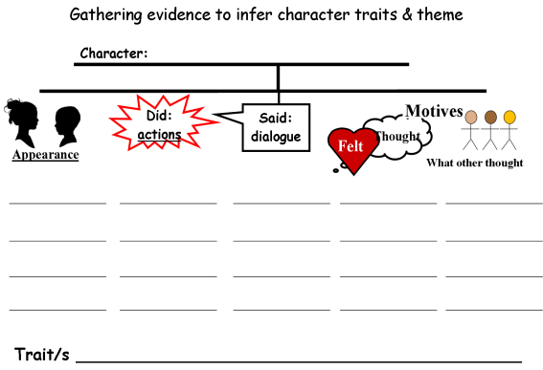
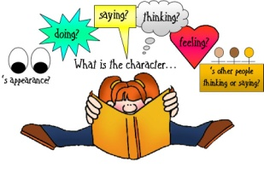
Text Dependent Questions Note: during this questioning, the teacher builds a T-chart and lists the traits of Julio on the left and the corresponding evidence on the right as students respond to the questioning about Julio. Another way to understand how to gather evidence would be a tree map (on the right):

Text Dependent Questions | Answers
Why does the anthology use italics for the first 3 paragraphs of the story? What is the purpose of this text for the reader?  Nomination – What is the root word of nomination? ____ Therefore, what does nomination mean? (if students do not know what “nominate” means, use context clues)  Use evidence from the text to describe how Julio feels about Cricket.  Reread the sentences from Julio’s poster. (DON’T BUG ME! VOTE FOR LUCAS COTT) Why did Julio use the phrase “Don’t bug me.” (what does the phrase mean and what is the significance of the word “bug”?)  After reading these first 2 pages, what traits does Julio possess? Back up your inference with evidence from the text. | • Because this is an excerpt from a chapter book, the reader needs to be caught up” as to what has already happened in previous chapters, so the reader will understand what will be presently read. Since this text summarizes the previous action, it is not true text from the story, so it is in italics.  • nominate. It means the act of someone nominating a person for an election, etc. (Context clues can also be used to help the reader determine the definition, as the word “election” is in the previous sentence.)  • Julio views Cricket as strategic, tricky, and capable of winning- Cricket has some good strategies to help her win - using bribery. In the narration it says: “Gives out miniature chocolates”; “But it didn’t mean he was going to vote for Cricket”; “What could Lucas give out that was better than chocolate”; “If you are going to run against Cricket, we’ve got to get to work.”  • Means “don’t bother me” but also the word “bug” as a reference to Cricket’s name (Don’t Bug Me… Cricket!).  • clever – don’t bug me – a pun on Cricket’s name/ understands bribery but eats the chocolate anyway.  loyal – determined to help his friend by making poster
Let’s look at the dialogue from Julio on the top of the page. (It’s not fair to make us stop playing soccer just because we might get hurt. Someone might fall down walking to school, but we still have to come to school every day.) Based on this text, what are some more traits Julio exemplifies?  Bore: find the word ‘bore’. …(he) had eyes that seemed to bore right into your head when he looked at you. Based on these clues what are some synonyms of this word?  Compare and contrast Julio’s remarks about playing soccer and seeing the principal with the remarks of Cricket and Lucas.  Why did Julio suggest that Cricket come to see the principal too? What does this imply/suggest about Julio?  You couldn’t kick a ball if it was glued to your foot. What is the meaning of this figurative language? Why did Lucas say this to Cricket?  How does the illustrator “grasp” the feelings of each character?  What can you infer from Cricket’s remark, “Me? I don’t care if we can’t play soccer!” | • logical: ‘It’s not fair to make us stop….’  wise: use of an analogy: ‘Someone might fall down walking to school, but we still have to come to school every day’  • drill or penetrate (into your head)  (Also could use homonym – boar/bore or Multiple Meaning as in dull - boring.  • Julio says, ”Couldn’t we talk to the principal?” etc, and has the courage to speak out for what he believes and is not fearful to see the principal; in contrast, Cricket says. “You could play jacks,” meaning just do something else – not wanted to face the problem. “I don’t care about soccer” – thinking only of herself; Lucas says, “Uh, sure,” showing that he is apprehensive.  • Even though Cricket was running against his best friend, Julio did things for the good of others, not only for his benefit or his friend’s.  • Cricket can’t kick a ball because she misses it – and even if it was glued to her foot, she would still miss it! This is Lucas’s way of saying she cannot play soccer and doesn’t care if it had been banned.  • He focuses on their faces and draws their expressions, visually helping the reader to better infer the feelings of each character.  • Cricket is selfish – does not have the qualities of a leader – even her teacher reminds her to speak for the whole class, not just girls.
Let’s continue to contrast Julio’s actions and words to his two classmates while in the principal’s office. Look carefully at the author’s descriptions of each character and the characters’ words to help you gather your evidence to in order to infer their differences.  Follow up: The description, “Cricket looked as pale as Lucas”… What does this mean and how does it help you understand more about how Lucas and Cricket are feeling?  What type of craft did the author use here? | • Julio continues have leadership skills and well as being cooperative. Evidence: waits to speak, uses logic and examples – jumping rope, the principal’s chair. Also the principal listens to Julio and agrees to change his decision. In contrast, Lucas and Cricket remain quiet and look pale. Cricket continues to just think about her own needs. Evidence: “Can’t we jump anymore?”  • Pale means white – like a ghost. She is fearful to speak just as Lucas is. (RL7 Teachers may point out the illustrations here – who’s in front, who’s in back - looking ashen.)  • Simile
The text says, ‘He knew he could be a good leader.’ How does Julio come to this conclusion? (On both pg. 25-26, what thoughts, actions and words of himself and others helped him to come to this conclusion?) | • Julio notices that Cricket takes the credit for the soccer decision. He realizes that neither Cricket nor Lucas were able to stand up for themselves. Julio also realizes that the students should have more power in the decision of the class and school, where Cricket just agrees with ideas where no choice was given. He already is thinking about how to help his class spend the money they earn from the book fair.
Let’s review the nomination procedure. When Julio is nominated, what were Cricket’s remarks about Julio and what do these remarks indicate? | • Cricket says that Julio cannot run for president because he is from Puerto Rico. These remarks are not only false, but are cruel. This shows Cricket’s desperation to become president, without feelings for others- not the remarks of someone who would make a good leader.  “But Julio is not one of the top students like Zoe or Lucas or me.” Again, her remarks are unfounded and cruel – sign of desperation.
What evidence demonstrates Julio’s pride?  How does the author show Julio’s feelings after being nominated and spoken about? | • He speaks out about how Puerto Ricans are Americans, even if it would result in him not being elected.  • The author uses words like: his ears were getting hot with embarrassment. The author makes sure the reader knows about Julio’s thoughts and actions as indicated: He had never heard Arthur… Julio sat in his seat without moving.. couldn’t say a word… could hardly breathe…
Describe some ways this story is about competition. Provide examples from the story.  Describe some ways this story is about cooperation.  Provide examples from the story. (The teacher may write these examples on the board as students give them. This will help them create a theme statement)  Now, what could be some “Nutshell” statements about the theme of this story, incorporating some of the examples on the board. (This can be a prediscussion to the culminating activity. | Cricket’s words ‘As you know... I will president of the U.S. one day…. need practice… do a much, much better job than Julio…, The money SHOULD go to the Humane Society… ’ indicates her competitiveness.  Julio’s words ‘I might vote for Cricket … someday… Our class should make decisions together… a way everyone likes…’  Using this evidence, the students should come up with some theme statements: Cooperation and Communication demonstrates leadership.

Vocabulary
 | KEY WORDS ESSENTIAL TO UNDERSTANDING  Words addressed with a question or task | WORDS WORTH KNOWING  General teaching suggestions are provided in the Introduction
TEACHER PROVIDES DEFINITION  not enough contextual clues provided in the text | Campaign  Represent  Candidate  Nominate/nomination | Confidence  Convince  Bore  Parliamentary procedure
STUDENTS FIGURE OUT THE MEANING  sufficient context clues are provided in the text | Elect/election | Running  Managed  Shrugged  Beamed  Gestured  Alarmed  Conducted

Culminating Task
- Re-Read, Think, Discuss, Write
Using evidence from the story – what characters say, do, and think- determine some characteristics or traits of Cricket and Julio. (A way to assist students with this task, students can use these maps to analyze Julio and of Cricket:)
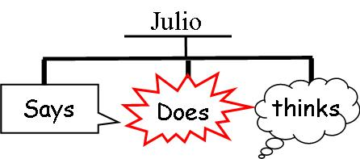
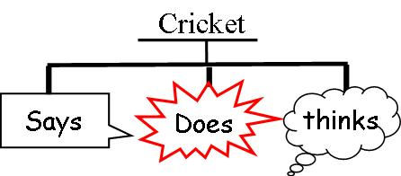

__________ ___________ ____________ __________ ___________ ____________
__________ ___________ ____________ __________ ___________ ____________
__________ ___________ ____________ __________ ___________ ____________
Therefore, Cricket is _________( Traits/characteristics) Therefore, Julio is _________( Traits/characteristics)

Now, contrast their actions and motives in order to determine who would be the best class president and why.
You can use a Venn diagram or a double bubble to contrast their characteristics/traits/evidence

Write a short paragraph on another piece of paper to tell the differences between the two students and justify why one would be a better president than the other. Give reasons and examples from the text. Use complete sentences when defending your position.

Answer: Julio should be class president because he thinks about all the students, not just himself. One example is his willingness to speak for his class by seeing the principal. Instead of going by himself, he asks Lucas and Cricket to go, even if she is not one of his favorite people. Also, he helped Arthur get new glasses and made a poster for Lucas. In contrast, Cricket just wanted to be president to prove she is the best and most popular. She tries to win people over by giving them chocolates. She also doesn’t care about her whole class when they want play soccer. She says, “I don’t care about soccer.” Finally, she tries to stop Julio from becoming president by saying he is not an American citizen.

Additional Tasks
Explain the theme of cooperation and competition as exemplified in this story. Use examples from the text to state your argument (claim):
Refer back to this evidence from the questioning section to create the argument and evidence/examples to back up the claim:

Cricket’s words ‘As you know... I will president of the U.S. one day…. need practice… do a much, much better job than Julio…, The money SHOULD go to the Humane Society… ’ indicates her competitiveness.

Julio’s words ‘I might vote for Cricket … someday… Our class should make decisions together… a way everyone likes…’

Using this evidence, the students should come up with some theme statements: Cooperation and Communication demonstrates leadership.

