Unit 2/Week 5
Title: The Great Kapok Tree
Suggested Time: 5 days (45 minutes per day)
Common Core ELA Standards: RL.4.1, RL.4.2, RL.4.3, RL.4.4; W.4.2, W.4.4, W.4.9; SL.4.1; L.4.1, L.4.2, L.4.4, L.4.5

Teacher Instructions
Refer to the Introduction for further details.
Before Teaching
- Read the Big Ideas and Key Understandings and the Synopsis. Please do not read this to the students. This is a description for teachers, about the big ideas and key understanding that students should take away after completing this task.
Big Ideas and Key Understandings
It’s important for people to be respectful of the delicate balance of nature within an ecosystem as all living things depend on one another.
Synopsis
In this fantasy by Lynn Cherry, a man is trying to cut down a kapok tree in the Amazon rainforest. After a while of cutting the hard wood, the man grew tired and falls asleep. As he slept, several animals of the rainforest and a Yanomamo child whisper in his ear to convince the man of the importance of this tree in the fragile ecosystem. One of the creatures (a bee) told the man “You see, all living things depend on one another.” When the man awakes he sees the child and all the creatures that depend on the tree. The man finds the sight of the child and the creatures wondrous. He stood up and swung back to chop again, but he looked back at the child and the creatures. At the very end of the story, the man hesitates, drops his axe and walks out of the forest.
- Read entire main selection text, keeping in mind the Big Ideas and Key Understandings.
- Re-read the main selection text while noting the stopping points for the Text Dependent Questions and teaching Vocabulary.
During Teaching
- Students read the entire main selection text independently.
- Teacher reads the main selection text aloud with students following along. (Depending on how complex the text is and the amount of support needed by students, the teacher may choose to reverse the order of steps 1 and 2.)
- Students and teacher re-read the text while stopping to respond to and discuss the questions and returning to the text. A variety of methods can be used to structure the reading and discussion (i.e.: whole class discussion, think-pair-share, independent written response, group work, etc.)

Text Dependent Questions
Text-dependent Questions | Evidence-based Answers
Who entered the forest at the beginning of the story? Why? | The two men entered the forest to chop down the tree. The bigger man showed the smaller man the Kapok tree to chop and then left the smaller man to chop it.
The author writes, “Now all was quiet as the creatures watched the two men and wondered why they had come.” What does the word creatures mean? | Creatures are the animals that are living and hiding in the forest.
What is the smaller man’s problem? Why does he fall asleep? | The wood is very hard and the man is having trouble chopping down the tree. The man falls asleep because he grew tired and the heat and hum of the forest lulled him to sleep.
What can the reader figure about the age of this Kapok tree based on what the boa constrictor hissed in the man’s ear? What else does the boa hiss in the man’s ear? | The Kapok tree is very old and has been there a very long time. The snake’s ancestors, who are his relatives of the past, have lived there for many generations. He also tells the man that it “is a tree of miracles” and it is his home.
Who told the man “all living things depend on one another?”  What does depend mean in this sentence? How do living things depend on each other according to this creature? | The bee buzzed this in the man’s ear.  In this sentence depend means that the living things rely on each other in order to survive. The trees and flowers need the bee to pollinate them so that new trees and flowers grow, while the bee needs the tree in order to have a place to live.
Why do the monkeys chatter to the sleeping man that “the forest will become a desert”? What possible events are they warning the sleeping man about? | The monkeys chatter in the man’s ear because they are concerned that their rainforest home will become a desert and they can’t survive in a desert. They are trying to prevent their habitat from being destroyed.  The monkeys are worried that the man (people) will not stop with one tree, but instead will continue to cut more leaving only stumps and roots. The roots will wither and die, which will leave nothing to hold the soil in place. The soil would then be washed out by the heavy rains of the rain forest (erosion).
Ruins are the remains of something destroyed or decayed.  The animals are all giving reasons as to why the tree should not be cut down and explaining how the forest will be left in ruins. Think about what you have read so far. What are some of the reasons that the animals have given so far as to why the tree should not be cut down? | It’s a tree of miracles and home to the snakes for many generations, the bees hive is in the tree and he is who pollinates the forest so it will continue to grow, the trees roots will wither and die and the soil will wash away causing the forest to become a desert, people will begin to settle on the land and leave no home for the animals.
What is the true underlying message that all of the animals are trying to relay to the man about why the tree should not be cut down? | The animals are trying to get the man to understand that cutting down the tree will affect all of the nature living in that habitat, not just the tree. Cutting down the tree will cause other things/animals/plants to feel the effects as well. The tree helps to keep the environment balanced and the animals depend upon it.
Which creatures whispered to the sleeping man, “If you cut down the forests you will destroy that which gives us all life.” What does destroy mean? Explain what the creatures are whispering about what would “destroy…us all”. | Destroy means to ruin completely or to damage the forest beyond repair. Four tree porcupines whispered to the man. The trees produce oxygen, which animals and humans need to live.
Why did no one notice the jaguar? What is the jaguar’s concern and why might that be particularly threatening to the man? | No one noticed him “because his spotted coat blended into the dappled light and shadows of the understory”. The jaguar is concerned that he will not be able to find food, since he eats the birds and animals that live in the tree. If it is cut down, they will have no place to live and will die or move away. Then he will have nothing to eat. This could be threatening for the man because the jaguar could eat or attack him.
The anteaters say the man has “no thought for the future” and “what happens tomorrow depends upon what you do today”. Explain what the anteaters mean by these statements.  What did you notice about the anteaters as they climbed down the tree? Why is that significant to what the anteaters are saying? | The anteaters are trying to show the man that his actions today will affect the future. It may be long after he is gone, but it will have an effect on the generations to come. Cutting one tree may not be important now, but the actions it could cause could affect what is yet to come. The anteaters are saying that he and the big man are not thinking about how the action of cutting this one tree will have an effect on their children and future generations, not only the forest.  The anteaters are all carrying their young (their children) on their backs as they climb down the tree. This supports the fact that the anteaters are also thinking about their own future generations (the future of their babies) and not just themselves.
What does the sloth mean when she asks what beauty is worth and what the man will feast his eyes on if he destroys the rain forest? | The man could make money by selling wood from the Kapok tree, but the beauty of the tree is worth more than money. If the man destroys the rain forest, he won’t have anything beautiful to admire.
Why did the Yanomamo child murmur to the sleeping man, “when you wake, please look upon us all with new eyes”? What does the child mean “with new eyes”? | The child is asking the man to see the forest differently than he did when he walked in. When he walked into the forest it was very quiet and still, but now the animals have come out and are begging for him to see this forest as their home. When the man walked in he simply saw a quiet place with a tree to chop. He didn’t see all of the wonderful creatures.
What does the man see when he wakes? What is he feeling? Cite evidence to support how you know what he is feeling. | When the man wakes he sees the child and all of the wondrous and rare creatures that depend upon the Kapok tree. He has a feeling of astonishment. He is amazed at the new things he sees now that he missed when he first entered the forest. The author describes how the man is looking around and noticing the canopy of the tree, the “bright light glowing like jewels”, the “dark green forest”, “strange and beautiful plants”, “fragrant perfume of the flowers”, and the “steamy mist”. It is all described pleasantly so you know that the character is viewing it in a pleasant new way.
What is the man looking at over his shoulder? How does this affect his decision at the end of the story? | He turned and looked back at the animals and the child. He’s thinking of the forest in a new way. The man decides not to cut down the Kapok tree after all because it’s too important.

Vocabulary
 | KEY WORDS ESSENTIAL TO UNDERSTANDING | WORDS WORTH KNOWING  General teaching suggestions are provided in the Introduction
TEACHER PROVIDES DEFINITION  not enough contextual clues provided in the text | ancestors, generations  wither, ruins  worth | hum  pollinate, scampered, canopy, underbrush, smoldering  dappled, piped, understory, padded  feast, tribe  wondrous, rare, start  amidst
STUDENTS FIGURE OUT THE MEANING  sufficient context clues are provided in the text | creatures  depend, oxygen  destroy  hesitated | trunk, blows, foot, gash, lulled  hive, troupe, settle  clinging, murmured, young, knelt  dangle, suspended, fragrant, streaming, spots, strike
Culminating Task
- Re-Read, Think, Discuss, Write
- It’s important for people to be respectful of the delicate balance of nature within an ecosystem as all living things depend on one another. Write an essay that explains how the preservation of the Kapok tree is integral to the rain forest ecosystem in this story. Use information from the story The Great Kapok Tree to support your answer.
  - Answer:
We understand how the Kapok tree plays a very important role in the rain forest ecosystem by reading this story. Not only does the tree ensure balance in the ecosystem, but it also affects humans and our future.
One reason the preservation of the Kapok tree is important to the rain forest is because it is home to many animals that are interdependent with the other animals and plants. Animals such as the bees live in the trees. The bees pollinate the trees and flowers throughout the rain forest. If their home, the Kapok tree, is destroyed, the plants and trees will not be pollinated and then no new plants will grow. The rain forest will die. Animals such as the boa constrictor, monkeys, toucans, macaw, cock-of-the-rock, tree frogs, jaguar, porcupines, anteaters, three-toed sloth, and many more also live in the rain forest. If the rain forest is destroyed, where will these animals live? They will be homeless! Where will they find food if there food source is dying or has moved? These animals depend upon the rain forest for shelter and food. They depend upon one another. Another reason is that humans and animals must have oxygen in order to breathe. The trees in the rain forest produce oxygen. If the Kapok tree is destroyed and possibly other trees in the rain forest, our supply of oxygen will be diminished. Humans will not be able to survive and new plants will not be able to grow in order to produce oxygen again. Furthermore, if all the trees in the rain forest are chopped down, the roots of these great trees will wither and die, and there will be nothing left to hold the earth in place. When the heavy rains come, the soil will be washed away and the forest will become a desert. Finally, we must think of the future. If the trees in the rain forest were chopped down, fires may be set to clear the underbrush, and soon the forest would disappear and be left a desert land. Where once there was life and beauty only black and smoldering ruins may remain. We must think of our children, who would find it difficult to live in a world without trees. Consider the consequences of chopping down the Kapok tree. Please don’t destroy the rain forest so that it will be around for the animals and for future generations. We need to help preserve the rain forest. The living things in this ecosystem depend on the rain forest!

Additional Tasks
- Have students classify the living things they see in the illustrations throughout the selection to give them a better idea of the variety of life in the rain forest.
  - Answer: Plants-trees, flowers, ferns, vines; animals- insects, large cats, birds, sloths, anteaters, monkeys, frogs, porcupines, humans
- Give students a copy of the blank world map and have them color in the rain forest around the world.
- The author, Lynn Cherry, uses vivid language (onomatopoeia, alliteration, and assonance) to bring her words to life. Reread the story to find examples of descriptive language. How does the language describe plants and animals in the text?
  - Answer: The use of onomatopoeia—“Whack! Chop!”—helps us imagine the sounds of the tree being chopped down. The use of alliteration and assonance when she describes the snake evokes a snakelike sound—“slithered…sleeping” and “snake…slid…hissed.”
- How has the author used vivid action verbs to evoke a feeling or appeal to our senses in this story? What is the author’s purpose for using such verbs in this story?
  - Answer: The bee “buzzed”; the monkeys “scampered” and “chattered”-descriptive words that let us see and hear them; and the toucan squawks. The author is trying to get us to feel as if the animals are real in the story. By using the verbs of the sounds that the animals would actually make she is trying to make the characters “come alive” as we read. She is using the animals to persuade us to agree with the need for a balance in the ecosystem of the forest.
- Explain to students that when the animals try to persuade the man not to cut down the Kapok tree, they are giving reasons why the rain forests should be preserved. Writers use different techniques to convince their readers to agree with them. One technique is to appeal to the emotions of readers. Another technique writers sometimes use is to persuade their readers to support their opinions with facts and reasons. Which of the animals’ arguments appeals to our emotions? Why? List at least one of each
  - Answer: The tree frog’s message that many animals will be left homeless appeals to our emotions because most people are sympathetic and would not want to leave animals homeless. The tree porcupine’s message that cutting down trees will reduce the amount of oxygen in the air appeals to reason because we need oxygen to breathe, and if it were reduced, we would be in trouble.

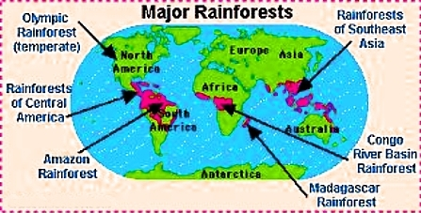

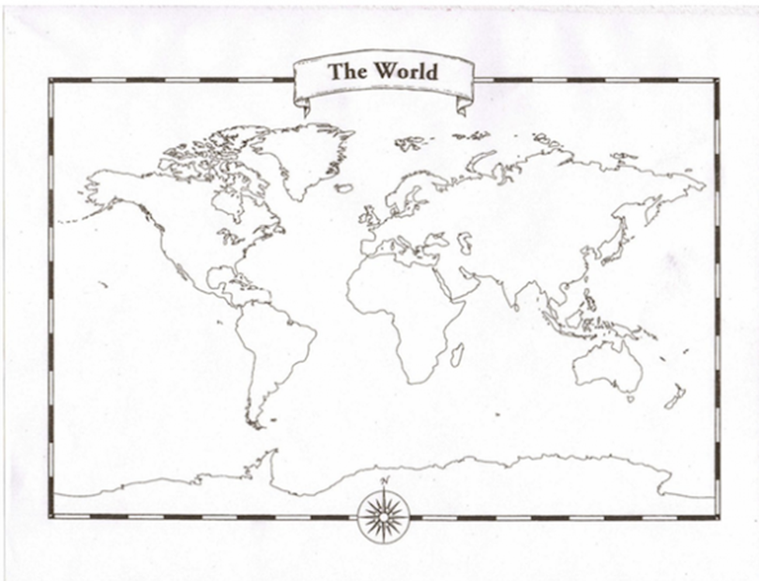

Note to Teacher
- The Great Kapok tree has a Lexile of 670L—which is below the 4th grade band of complexity (www.achievethecore.org/text-complexity), however the text is moderately complex due to the levels of meaning behind the text, the vocabulary, and the theme of the text.
- Clarify vocabulary: Senhor is the Portuguese version of the Spanish Senor. It means the same as sir or mister.
- After reading the story you may want to show students the location of the Amazon Rainforest on a map to help children understand the location.

Name _____________________________________________ Date ________________

“The Great Kapok Tree”

- Who entered the forest at the beginning of the story? Why?

- The author writes, “Now all was quiet as the creatures watched the two men and wondered why they had come.” What does the word creatures mean?

- What is the smaller man’s problem? Why does he fall asleep?

- What can the reader figure about the age of this Kapok tree based on what the boa constrictor hissed in the man’s ear? What else does the boa hiss in the man’s ear?

- Who told the man “all living things depend on one another?” What does depend mean in this sentence? How do living things depend on each other according to this creature?

- Why do the monkeys chatter to the sleeping man that “the forest will become a desert”? What possible events are they warning the sleeping man?

- Ruins are the remains of something destroyed or decayed. The animals are all giving reasons as to why the tree should not be cut down and explaining how the forest will be left in ruins. Think about what you have read so far. What are some of the reasons that the animals have given so far as to why the tree should not be cut down?

- What is the true underlying message that all of the animals are trying to relay to the man about why the tree should not be cut down?

- Which creatures whispered to the sleeping man, “If you cut down the forests you will destroy that which gives us all life.” What does destroy mean? Explain what the creatures are whispering about what would “destroy…us all.”

- Why did no one notice the jaguar? What is the jaguar’s concern and why might that be particularly threatening to the man?
- The anteaters say the man has “no thought for the future” and “what happens tomorrow depends upon what you do today”. Explain what the anteaters mean by these statements. What did you notice about the anteaters as they climbed down the tree? Why is that significant to what the anteaters are saying?

- What does the sloth mean when she asks what beauty is worth and what the man will feast his eyes on if he destroys the rain forest?

- Why did the Yanomamo child murmur to the sleeping man, “when you wake, please look upon us all with new eyes”? What does the child mean “with new eyes”?

- What does the man see when he wakes? What is he feeling? Cite evidence to support how you know what he is feeling.

- What is the man looking at over his shoulder? How does this affect his decision at the end of the story?

