Ratios and Rates

6.RP.A Application Mini-Assessment by Student Achievement Partners

OVERVIEW

This mini-assessment is designed to illustrate some of the expectations of cluster 6.RP.A, which sets an expectation for understanding ratio concepts and using ratio reasoning to solve problems. This mini-assessment is designed for teachers to use either in the classroom, for self-learning, or in professional development settings to:

* **Evaluate** students’ understanding of 6.RP.A in order to prepare to teach this material or to check for student ability to demonstrate understanding and application of these concepts;
* **Gain knowledge about** assessing ratio and rate application problems;
* **Illustrate CCR-aligned** assessment problems;
* **Illustrate best practices** for writing tasks that allow access for all learners; and
* **Support mathematical language acquisition** by offering specific guidance.

MAKING THE SHIFTS

This mini-assessment attends to **focus** as it addresses understanding of ratio concepts and using ratio reasoning to solve problems, which is at the heart of the grade 6 standards and a key component of the Major Work of the Grade.[1] It addresses **coherence** by building on elementary understandings of multiplication and division. Work with ratios in grade 6 focuses on ratio and rate language; recognizing, generating, and graphing pairs of equivalent ratios; reasoning about ratio tables and comparing ratios; and solving problems using a variety of methods (see answer key for sample solution methods). In grade 7, students will extend work with ratios to rational numbers (e.g., 1/2 cup sugar for every 1/3 cup oil), proportional relationships, and solving multi-step ratio and percent problems. This mini-assessment targets the *application* aspects of cluster 6.RP.A,and addresses onlyone of the three elements of **rigor**.

A CLOSER LOOK

At the heart of this mini-assessment is the concept of a ratio: ratios express the relative size of two (or more) quantities and can be expressed in a variety of ways, such as “4 to 3,” “4 for every 3,” 4:3, or $\frac{4}{3}$ (6.RP.A.1). When two ratios express the same relative size, they are called “equivalent.” In grade 6, students use their familiarity with the multiplication table to explore equivalent ratios by making ratio tables (6.RP.A.3a). Students are also first exposed in grade 6 to rates and unit rates, like paying $5 per hamburger or walking 4 miles per hour (6.RP.A.2).

**6.RP.A.3.** Use ratio and rate reasoning to solve real-world and mathematical problems, e.g., by reasoning about tables of equivalent ratios, tape diagrams, double number line diagrams, or equations.

**6.RP.A.** Understand ratio concepts and use ratio reasoning to solve problems.

The majority of questions align to 6.RP.A.3 making this a mini-assessment that focuses primarily on application; however, some questions also target students’ conceptual understanding of ratios and rates. Some questions include decimals to give students practice with a variety of numbers, while responding to authentic real-world application questions.

This mini-assessment is not representative of the entire 6.RP.A cluster and is intended to be used early in the grade-level work of ratio and rate reasoning.

SUPPORT FOR ENGLISH LANGUAGE LEARNERS

This lesson was designed to include specific features that support access for all students and align to best practice for English Language Learner (ELL) instruction and assessment. Go [here](https://achievethecore.org/page/3165/support-for-the-english-language-learner-adaptation-project-annotated-bibliography) to learn more about the research behind these supports. Features that support access in this mini-assessment include:

* Tasks that allow for multi-modal representations, which can deepen understanding of the mathematics and make it easier for students, especially ELLs, to give mathematical explanations.
* Tasks that avoid unnecessarily complex language to allow students, especially ELLs, to access and demonstrate what they know about the mathematics of the assessment.

Prior to this mini-assessment, ensure students have had ample opportunities in instruction to read, write, speak, listen for, and understand the mathematical concepts that are represented by the following terms and concepts:

* ratio
* coordinate plane
* point
* equivalent ratio
* coordinates
* for every
* how many

Students should engage with these terms and concepts in the context of mathematical learning, not as a separate vocabulary study. Students should have access to multi-modal representations of these terms and concepts, including: pictures, diagrams, written explanations, gestures, and sharing of non-examples. These representations will encourage precise language, while prioritizing students’ articulation of concepts. These terms and concepts should be reinforced in teacher instruction, classroom discussion, and student work (for example, through engagement in [mathematical routines](https://achievethecore.org/page/3164/mathematical-language-routines)).

ELLs may need support with the following words found in this mini-assessment:

* decide whether
* check
* explain
* additional
* destination
* circle
* plot
* social media
* sources
* same
* enhancer

In preparation for giving this mini-assessment, teachers should strive to use these words in context so they become familiar to students. It will be important to offer synonyms, rephrasing, visual cues, and modeling of what these words mean in the specific contexts represented in the items in this mini-assessment. Additionally, teachers may offer students the use of a student-friendly dictionary, or visual glossary to ensure they understand what is being asked of them in each item.

|  |  |
| --- | --- |
| Sketch |  |
| Point | • |
| Locate | • |

*An example of a visual glossary for student use.*

Name: Date:

1. There are 24 adults and 30 children at a science museum. What is the ratio of children to total people at the science museum?
2. A study showed that the ratio of the number of people who get their news from social media to the number of people who get their news from other sources is 3:7.

Based on the ratio, how many people in a town of 900 people get their news from social media?

1. Tickets for a baseball game cost $60 for a family of 5. Adult and youth tickets cost the same amount. Based on this information, decide whether each statement is TRUE or FALSE. Check TRUE or FALSE for each row.

|  |  |  |
| --- | --- | --- |
|  | **TRUE** | **FALSE** |
| 2 tickets cost $24. |  |  |
| For $40, you can buy 4 tickets. |  |  |
| The cost is $12 per ticket. |  |  |
| The cost for 10 tickets is $65. |  |  |

1. It takes Mildred about 3 minutes to walk 2 blocks. A point has been plotted in the coordinate plane to represent this situation*.* 
   1. Plot a second point that represents an equivalent ratio.

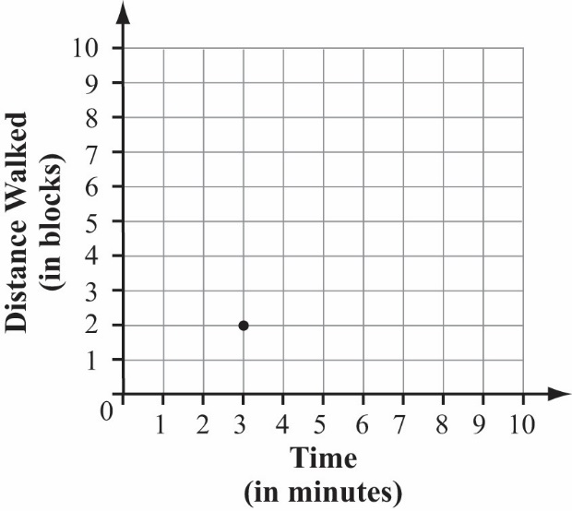

* 1. Explain what the coordinates of the point you plotted represent.

1.  Two jars of sauce are needed to make 1 tray of lasagna. One box of noodles is needed to make 2 trays of lasagna. What is the ratio of jars of sauce to boxes of noodles for this lasagna?
2. A store has two different sizes of ice cream. The smaller container costs $3.87 for 48 ounces. The larger container costs $6.42 for 128 ounces. Which ice cream costs less per ounce? Explain your answer using numbers, words, and/or pictures.
3. 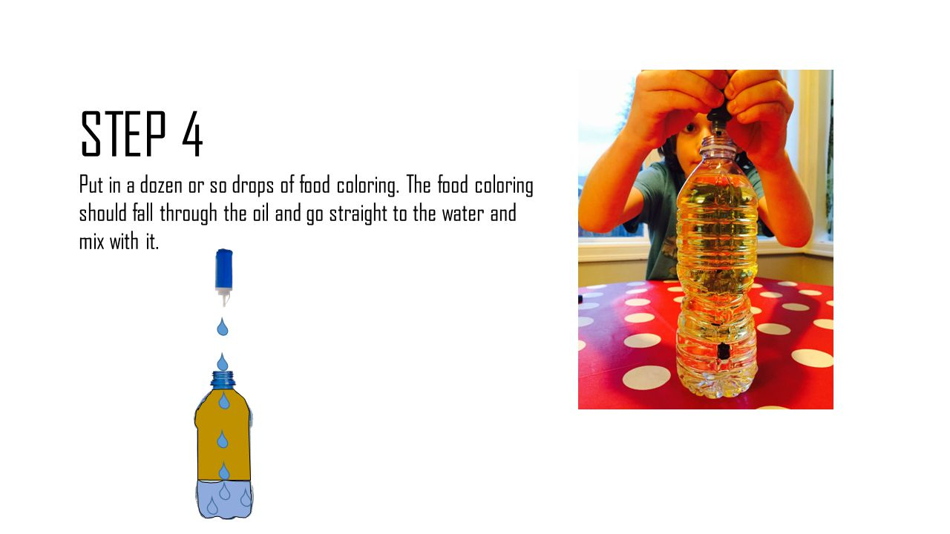Penelope likes to drink flavored water by adding flavor enhancer. She likes to mix 0.5 teaspoon of flavor enhancer for every 8 fluid ounces of water. Below are several flavored water mixtures made by Penelope’s friends.
   1. Circle all of Penelope’s friends who like the same ratio of water to flavor enhancer as Penelope.

|  |  |  |  |  |  |  |
| --- | --- | --- | --- | --- | --- | --- |
|  | Harry | Isabella | Jefferson | Klara | Leo | Marty |
| Flavor (tsp.) | 8 | 6 | 5 | 1 | 4 | 2 |
| Water  (fl. oz.) | 128 | 72 | 80 | 16 | 64 | 24 |

* 1. Choose one of the answers you circled. Explain how you know the water has the same flavor intensity.

1. Alan is making banana bread. The ratio of cups of mashed bananas to cups of flour for his recipe is 6:3.
   1. Alan uses 3 cups of mashed bananas to make 1 loaf. How many cups of flour will he use? Explain your answer using numbers, words, and/or pictures.

* 1. Erik uses Alan’s recipe to make banana bread. Erik uses 9 cups of flour in total. How many loaves does Erik make? Explain your answer using numbers, words, and/or pictures.

1. Jenna’s family is going on a trip to visit relatives.

* After driving 72 miles, they used 3.2 gallons of gas.
* Her family has 850 miles remaining on their road trip.
* The gas tank in their car can hold 15 gallons.

They filled the gas tank at the start of the road trip. They plan to only stop to fill up when their gas tank nears empty. There are plenty of gas stations along their route.

How many additional stops for gas will Jenna’s family need to make to get to their destination? Explain your answer using numbers, words, and/or pictures.

Name: Date:

1. There are 24 adults and 30 children at a science museum. What is the ratio of children to total people at the science museum? **30:54 OR equivalent ratio**

*Note: no work is required for full credit on this problem.*

*Sample solution method using* ***tape diagram****:*

 30 children: 54 total people

Alignment: 6.RP.A.1

1. A study showed that the ratio of the number of people who get their news from social media to the number of people who get their news from other sources is 3:7.

10 parts 🡪 900 people

1 part 🡪 900 ÷ 10 = 90 people

3 parts 🡪 90 × 3 = 270 people

Alignment: 6.RP.A.3

1. Based on the ratio, how many people in a town of 900 people get their news from social media? **270**

*Note: no work is required for full credit on this problem.*

*Sample solution method using* ***tables of equivalent ratios***:

|  |  |  |  |  |
| --- | --- | --- | --- | --- |
| News from Facebook | 3 | 6 | 30 | 270 |
| News from elsewhere | 7 | 14 | 70 | 630 |
| Total | 10 | 20 | 100 | 900 |

*Sample solution method using* ***tape diagrams***:

**

1. Tickets for a baseball game cost $60 for a family of 5. Adult and youth tickets cost the same amount. Based on this information, decide whether each statement is TRUE or FALSE. Check TRUE of FALSE for each row.

Alignment: 6.RP.A.2, 6.RP.A.3

|  |  |  |
| --- | --- | --- |
|  | **TRUE** | **FALSE** |
| 2 tickets cost $24. | **✓** |  |
| For $40, you can buy 4 tickets. |  | **✓** |
| The cost is $12 per ticket. | **✓** |  |
| The cost for 10 tickets is $65. |  | **✓** |

1. It takes Mildred about 3 minutes to walk 2 blocks. A point has been plotted in the coordinate plane to represent this situation.

Alignment: 6.RP.A.3

**a.** Plot a second point that represents an equivalent ratio.

**b.** Explain what the coordinates of the point you plotted represent.

*Sample solution method using the additive* ***structure in the graph***:   
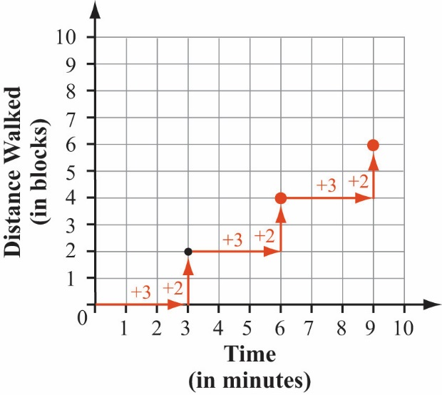

Possible answers include:

**(6, 4)** – 4 blocks walked in 6 min

**(9, 6)** – 6 blocks walked in 9 min

**(4.5, 3)** – 3 blocks walked in 4.5 min

1. Two jars of sauce are needed to make 1 tray of lasagna. One box of noodles is needed to make 2 trays of lasagna. What is the ratio of jars of sauce to boxes of noodles for this lasagna?  
   **4:1 OR equivalent ratio**

Alignment: 6.RP.A.1

1. A store has two different sizes of ice cream. The smaller container costs $3.87 for 48 ounces. The larger container costs $6.42 for 128 ounces. Which ice cream costs less per ounce? Explain your answer using numbers, words, and/or pictures. *Sample solution method using* ***tables to compare ratios****:*

I can see that the larger container will cost less per ounce. If I buy 2 of the smaller containers, it will still be less ice cream (96 oz.), but it will cost more than 1 of the large containers.

Alignment: 6.RP.A.3

|  |  |  |  |
| --- | --- | --- | --- |
| Ounces | 48 | 96 | 128 |
| Small | $3.87 | $7.74 |  |
| Large |  |  | $6.42 |

*Sample solution using* ***unit rate****:*   
small ≈ $0.08 per ounce; large ≈ $0.05 per ounce; large is ≈ $0.03 less per ounce

1. Penelope likes to drink flavored water by adding flavor enhancer. She likes to mix 0.5 teaspoon of flavor enhancer for every 8 fluid ounces of water. Below are several flavored water mixtures made by Penelope’s friends.

Alignment:

6.RP.A.2, 6.RP.A.3

* 1. Circle the flavored water mixtures that Penelope would like best.

|  |  |  |  |  |  |  |  |
| --- | --- | --- | --- | --- | --- | --- | --- |
|  | Harry | Isabella | Jefferson | Klara | Leo | Marty | Penelope |
| Flavor (tsp.) | 8 | 6 | 5 | 1 | 4 | 2 | 0.5 |
| Water  (fl. oz.) | 128 | 72 | 80 | 16 | 64 | 24 | 8 |

*Note: students will likely use the given table to look for equivalent ratios, starting from Penelope’s ratio of 0.5:8 and creating a unit rate of 1 teaspoon per 16 fluid ounces (see rightmost column).*

* 1. Choose one of the answers you circled. Explain how you know the water has the same flavor intensity.   
     *Sample explanation*:I know that Leo’s flavored water has the same intensity as Penelope’s because I can multiply the amount of flavor used (0.5 × 8 = 4) and the amount of water used (8 × 8 = 64) by the same factor (8).

1. Alan is making banana bread. The ratio of cups of mashed bananas to cups of flour for his recipe is 6:3.

Alignment: 6.RP.A.3

* 1. Alan uses 3 cups of mashed bananas to make 1 loaf. How many cups of flour will he use? Explain your answer using numbers, words, and/or pictures.

**1.5 cups of flour for 1 loaf**  
  
*Sample solution using a* ***double number line diagram***:

6

0

1

**1.5**

2

3

cups bananas

cups flour

4

**3**

2

0

* 1. Erik uses Alan’s recipe to make banana bread. Erik uses 9 cups of flour in total. How many loaves does Erik make? Explain your answer using numbers, words, and/or pictures.   
     I know Alan’s recipe uses 1.5 cups of flour for one loaf of banana bread. So, if Erik uses Alan’s recipe to make loaves with 9 cups of flour total, he will make 6 loaves.

1. Jenna’s family is going on a trip to visit relatives.

Alignment: 6.RP.A.3

* After driving 72 miles, they used 3.2 gallons of gas.
* Her family has 850 miles remaining on their road trip.
* The gas tank in their car can hold 15 gallons.

They filled the gas tank at the start of the road trip. They plan to only stop to fill up when their gas tank nears empty. There are plenty of gas stations along their route.

How many additional stops for gas will Jenna’s family need to make to get to their destination? Explain your answer using numbers, words, and/or pictures.

*Sample solution using* ***estimation*:**

* Since the family used about 3 gallons of gas to drive about 75 miles, they can drive about 100 miles on 4 gallons of gas.
* So, to drive another 850 miles, they need another 34 gallons of gas.
* In total, this would mean 37-38 gallons of gas would be used, requiring 2 additional stops for gas.

*Sample solution using* ***precise calculation*:**

* For the first 72 miles, their fuel economy was 72 ÷ 3.2, or 22.5, miles per gallon.
* With 850 miles remaining, they will use an additional 850 ÷ 22.5, or $37.\overline{7}$, gallons of gas.
* In total, they will have used $37.\overline{7}+3.2$, or $40.9\overline{2}$ gallons of gas.
* Since they started with 15 gallons, they need an additional $25.9\overline{2}$ gallons, so they will need to make 2 additional stops for gas.

1. For more on the Major Work of the Grade, see achievethecore.org/emphases.