Name: Date:
Kindergarten

Based on the Writing for Understanding Approach, Vermont Writing Collaborative ©2011

My Class Research Project on
Keeping our Earth Healthy

Small Group Research Question
How can I take care of the earth’s air?
Becoming an Expert
Group Research Packet
An expert is someone who knows a lot about a particular topic. Follow these steps to become an expert.

Becoming an Expert
An expert is someone who knows a lot about a particular topic.
✓  Done | Steps
 | Where am I going?
 | Reread
 | Thrilling Three
 | 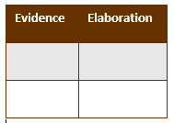 Reading for Evidence
 | Recording Evidence
 | The Focus Statement
 | Working with Evidence

Where Am I Going?
I can use sources to participate in a research project. (W.K.8)

Research Question: How can I take care of the earth’s air?

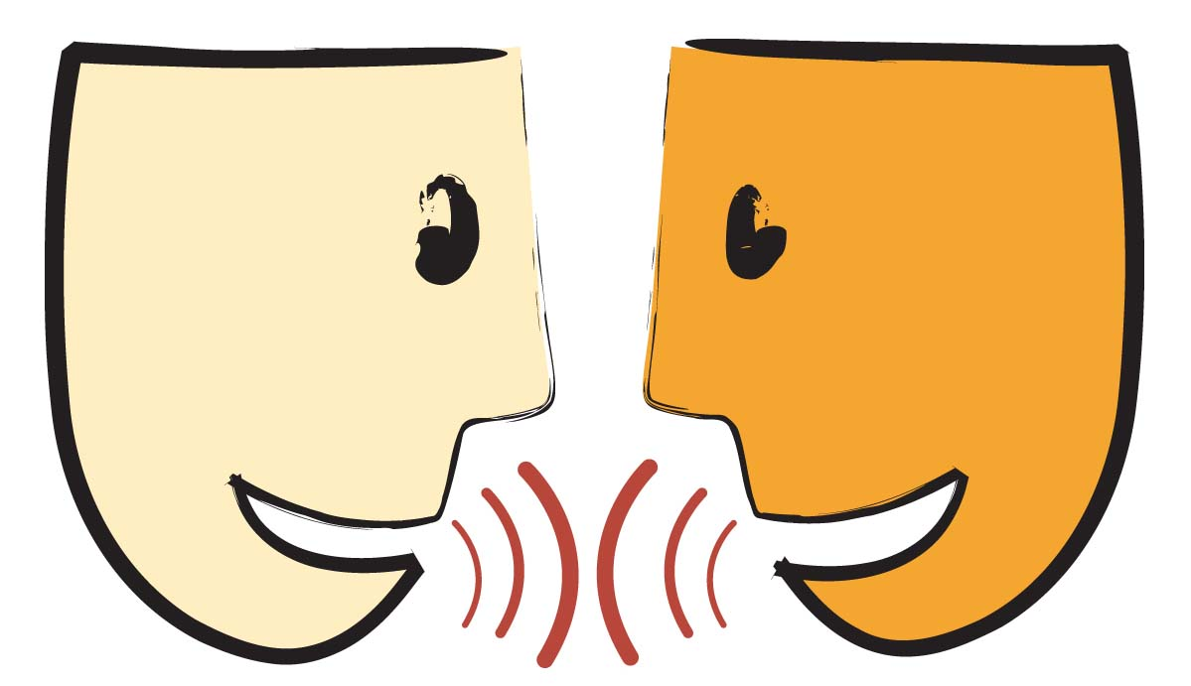
Turn and Talk: What part of this source can help you answer your group research question?

Title: _______________________________________________________________________

_______________________________________________________________________

Page Number:
_______________________________________________

Reread
I can listen to a text read aloud. (RF.K.4)
Listen closely as your teacher reads the text aloud.

Thrilling Three
I can use words I learned in a sentence. (L.K.6)

What are some important words in this text?
Important Words | Picture
1.
2.
3.

Reading for Evidence
I can gather information to answer a research question. (W.K.8)

Research Question: How can I take care of the earth’s air?

Sticky note on evidence

Look

Think and Discuss

Recording Evidence
I can record information to answer a research question. W.K.8

With your group, complete the evidence chart below.

Idea | Examples/Elaboration
Reducing carbon dioxide

The Focus Statement
I can answer a research question using information that I gathered. (W.K.8)

Research Question: How can I take care of the earth’s air?

Turn and talk with your group about what you think is the ‘big idea”.

A focus statement tells what you have learned from your research in a single sentence.

Focus Statement:

_____________________________________________________________

_____________________________________________________________
Working with Evidence
I can speak in a complete sentence using ideas from my notes. (SL.K.6)
I can use words I learned through reading and discussions. (L.K.6)

Your teacher has pictures for you to work with. As you practice working with the evidence you will talk in complete sentences. You can use the sentence frame to help you.

Focus Statement: I can take care of the earth’s air by reducing carbon dioxide.

I can _______________________.

Now you are ready to write!
Use your Writing Resource Packet to write about your research. Check off each step when you complete it.

