Name:

Grade 2 Date:

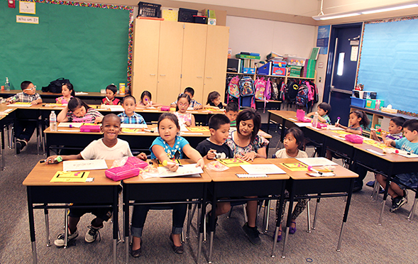

Based on the Writing for Understanding Approach, Vermont Writing Collaborative

My Class Research Project on
Biodiversity in the River Habitat

Research Question:
What kinds of living things can be found in the river habitat?

Becoming an Expert
Class Research Packet
An expert is someone who knows a lot about a particular thing. Follow these steps to become an expert.

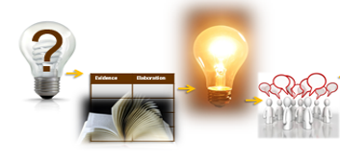

Becoming an Expert
Check each step as you finish. | Steps
 | Where Am I Going? |  | Text Structure
 | First Read |  | Close Read
 | Thrilling Three |  | Rolling Knowledge Journal
 | Reading for Evidence
 | Recording Evidence | Focus Statement
 | Working with Evidence

Where Am I Going?
Work with your class to discuss the questions below.

?
When you do research, you study a topic to find out more information. Read the research question below to find out what you will be studying.

What kinds of living things can be found in the river habitat?

Where might you find information to answer this question? Turn and share your ideas with a partner.

A source is something we use to get information to answer the research question. A source might be a book, an article, a video or a website. With your partner, look through the source your teacher has given you. Then, discuss this question:
How will this source help you answer your research question?

It is important to list the sources you use, so you can remember where you got your information. Write the title and author of your source below.

Title:______________________________________________

____________________________________________________

Author:____________________________________________

Text Structure
With your teacher, look closely at the source to better understand how to find the information you need.

Look at the Table of Contents. Which chapters will help you answer the focus question?

Choose one of the chapters. Find the page. What do you notice about the heading at the top of the page?

In the chapter, Living on the River Bank, look at the words in bold on the pages. These are important words. Where can you find the definitions of the words in this book?

Look closely at the photographs on the pages of the book. What can you learn from the photos about the diversity of living things in the river?

First Read
With your class, read the source aloud.

Ideas for a First Read:
- Listen carefully as your teacher reads aloud.
- Take turns reading, have each person read a sentence or paragraph.
- Choose one or two people to read aloud. The rest of the group reads along silently while listening.
- Listen to a recording of your book, reading along silently while you listen.

Close Read
With your class, carefully reread parts of the text.

Work together to follow the directions and discuss the questions in each box.
Reread pages 4-7 | What are rivers? Where are they found?
Reread pages 8 – 13 | What living things can be found in the river habitat? How do they live there?
Reread pages 14 – 19 | What living things can be found in the river habitat? How do they live there?
Reread pages 20 – 27 | What other living things can be found in the river habitat?
The “Thrilling Three” (optional)
With a partner, identify 3 important words from the text.

From your source, chose 3 words that are important to understanding the text.
Below, or on a separate sheet of paper, use your 3 words to write about the most important idea of the text. Write one sentence for each word.
Important Words
1.

2.

3.

Rolling Knowledge Journal (optional)
Keep track of all you’re learning!

What did you learn that was new and important about the topic from this resource? Write, draw, or list what you learned from the text about your topic. Add to this chart each time you use a new source. Add as many pages as you like.
Title:

New and important learning about the topic:
Title:

New and important learning about the topic:

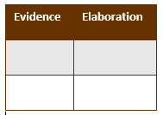
Reading for Evidence
Work as a class to gather and share information that will help you answer your research question.
- Together, look at the public note chart that your teacher has made. Discuss these questions as a class:
What is your Research Question? What kinds of information will go in each column?

The river has a diversity of living things.

Evidence of diversity: animals or plants  Who lives here? | Elaboration: How do they live here?
Beavers | They build lodges in the river out of trees they cut down from the banks.

- Fill in the first row of the public note chart together.

- Your teacher will tell you who your partner is and which part of the text you will work on. You will also get some sticky notes! With your partner, reread your part of the text. When you find some information that will help you answer your research question, mark it with a sticky note.

- Keep working until all the important information has been marked.
Recording Evidence
With your class, complete the public note chart.

- Meet with the whole group again. Take turns sharing one piece of information that you found. Talk about what words or pictures to put on the public notes. Your teacher will fill in the appropriate row on the class chart.

- Keep sharing until all the information has been recorded.

THE FOCUS STATEMENT!
What is the “big idea”?
Look carefully at all of the evidence you have gathered. What is the “big idea” that came out of your research? Turn and talk to a partner.

A focus statement tells what you have learned from your research in a single sentence. Your teacher and classmates will help you to write a focus statement below.

Focus Statement:______________________________________

____________________________________________________

More Evidence (optional)
On your own or with a partner, find more information for the public notes.

Work with a new source. Find information and mark it with sticky notes. Your teacher will help you explain what you have found and add it to the public note chart.

Working with Evidence
Work with your classmates to better understand the information you found.

Draw and Explain

Draw:
1. Fold your paper into quarters. Label the boxes 1, 2, 3 and 4 like this:
1. | 2.
3. | 4.
2. Draw and label a sketch of one piece of evidence you learned from your source in box #1.
3. Continue to draw and label pieces of evidence in boxes 2, 3 and 4.
4. Be ready to share and explain the evidence to a partner.
5. Follow your teacher’s directions to explain your evidence.
Now you are ready to write!
Use your Writing Resource Packet to write about your research. Check off each step when you complete it.
Sharing Your Expertise Record Sheet

Use this record sheet with your Writing Resource Packet.
Finished | Steps
 | Learn from a Model | Write an Introduction
 | Write a Focus Statement | Write the First Piece of Evidence
 | Add More Evidence
 | Write a Conclusion | Revise/Edit
 | Share and Celebrate!

