Multi-Digit Addition and Subtraction Using the Standard Algorithm
4.NBT.B.4 Fluency Mini-Assessment by Student Achievement Partners

OVERVIEW
This mini-assessment is designed to illustrate the standard 4.NBT.B.4, which sets an expectation for fluently adding and subtracting multi-digit whole numbers using the standard algorithm. This mini-assessment is designed for teachers to use either in the classroom, for self-learning, or in professional development settings to:
- Evaluate students’ progress toward the skills described by 4.NBT.B.4 in order to prepare to teach this material or to check for fluency near the end of the grade;
- Gain a better understanding of assessing fluency with adding and subtracting multi-digit whole numbers;
- Illustrate CCR-aligned assessment problems;
- Illustrate best practices for writing tasks that allow access for all learners; and
- Support mathematical language acquisition by offering specific guidance.

MAKING THE SHIFTS
This mini-assessment attends to focus as it addresses multi-digit addition and subtraction, which is Major Work of fourth grade. It addresses coherence across grades because adding and subtracting multi-digit whole numbers sets the stage for multi-digit decimal operations. Standard 4.NBT.B.4 and this mini-assessment target procedural skill and fluency, one of the three elements of rigor.
A CLOSER LOOK
Standard 4.NBT.B.4 is a prime example of how “[t]he Standards are not written at uniform grain size” (K–8 Publishers’ Criteria, Spring 2013, p. 18). One cannot address this standard in a single day, lesson, or unit. It will take significant classroom time throughout grade 4 to ensure all students master this standard.
4.NBT.B.4. Fluently add and subtract multi-digit whole numbers using the standard algorithm.

The standard calls for fluency using the standard algorithm. Standard algorithms for addition and subtraction are based on decomposing numbers written in base-ten notation. This reduces addition or subtraction of two multi-digit whole numbers to a collection of single-digit computations of place-value units. In order to add 275 + 469 in the example below, 275 can be decomposed into 2 hundreds, 7 tens, and 5 ones. Similarly, 469 can be decomposed into 4 hundreds, 6 tens, and 9 ones. Then ones can be added with ones, tens with tens, and hundreds with hundreds. Although some students might use drawings for larger addends, visual models are not representative of fluency.
Showing regrouping in the standard algorithm for addition:
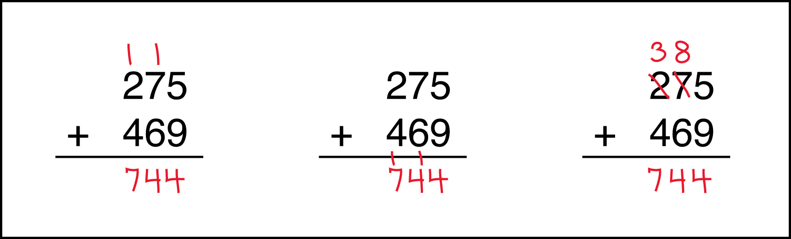

For subtraction, students need to evaluate whether ungrouping and regrouping is necessary. Students may either treat each place value column separately and ungroup and subtract before moving on or they may check all potential ungroupings first and then perform all the subtractions.

Students have been building understanding of addition and subtraction since kindergarten and first grade. In fourth grade, they work towards employing the standard algorithm to perform fast and accurate multi-digit addition and subtraction. Students who leave grade 4 without meeting standard 4.NBT.B.4 (performing these calculations fluently) are likely to have trouble with addition and subtraction of multi-digit decimals (6.NS.B.3).
Showing ungrouping and regrouping in the standard algorithm for subtraction:
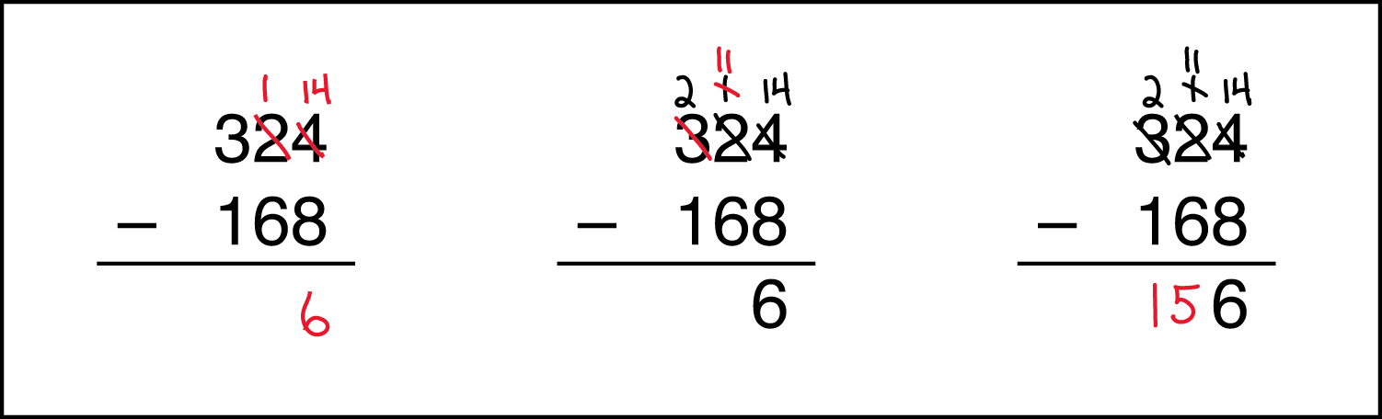

This mini-assessment includes a variety of addition and subtraction problems ranging from 3-digit to 6-digit numbers. There are some problems that require regrouping or ungrouping, and others assess if students can correctly regroup and notate.
Elementary-grade students build up a repertoire of computation algorithms as well as computation strategies (see text box). For some computations, the standard algorithm is efficient; for other computations, opportunistic strategies are best. For example, the difference 612 – 13 is easy to find by using a mental strategy (such as subtracting 12 then subtracting 1 more, or simply reasoning that the answer will be one less than 600). On the other hand, the difference 661 – 237 may be easier to find using the standard algorithm. Problem 4 (5,096 – 2,999) is an example of one that may be best performed mentally or on paper using an opportunistic strategy. For this mini-assessment, examples of opportunistic strategies appear on page 4.
Computation Algorithm: A set of predefined steps applicable to a class of problems that gives the correct result in every case when the steps are carried out correctly.
Computation Strategy: Purposeful manipulations that may be chosen for specific problems, may not have a fixed order, and may be aimed at converting one problem into another.
378 × 6
SUPPORT FOR ENGLISH LANGUAGE LEARNERS

This lesson was designed to include specific features that support access for all students and align to best practice for English Language Learner (ELL) instruction and assessment. Go here to learn more about the research behind these supports. Features that support access in this mini-assessment include:
- Tasks that allow for multi-modal representations, which can deepen understanding of the mathematics and make it easier for students, especially ELLs, to give mathematical explanations.
- Tasks that avoid unnecessarily complex language to allow students, especially ELLs, to access and demonstrate what they know about the mathematics of the assessment.
Prior to this mini-assessment, ensure students have had ample opportunities in instruction to read, write, speak, listen for, and understand the mathematical concepts that are represented by the following terms and concepts:
- sum
- subtract
- compute
Students should engage with these terms and concepts in the context of mathematical learning, not as a separate vocabulary study. Students should have access to multi-modal representations of these terms and concepts, including: pictures, diagrams, written explanations, gestures, and sharing of non-examples. These representations will encourage precise language, while prioritizing students’ articulation of concepts. These terms and concepts should be reinforced in teacher instruction, classroom discussion, and student work (for example, through engagement in mathematical routines).

Name: Date:
1. | $$\text{7,816}$$  $$+ \text{5,436}$$ | 2. | $$\text{987,654}$$  $$- \text{765,213}$$
3. | What is the sum of 531,421  and 468,579? | 4. | Subtract 2,999 from 5,096.
5. | $$\text{3,020}$$  $$- \text{687}$$ | 6. | Compute: 43,274 + 51,568 – 3,260.

Note for strategies: The standards expect students to do all of these problems with the standard algorithm; however, in specific cases (#4) a student may use a computation strategy to mentally subtract 3,000 and then add 1 to the answer.

1.  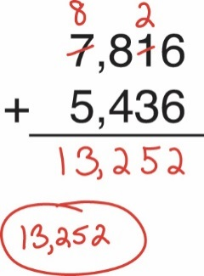 | 2.  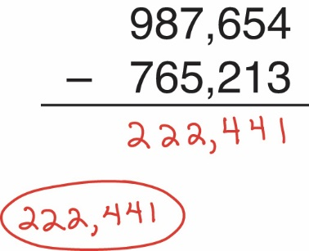
3.  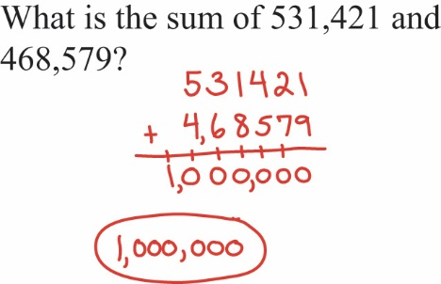 | 4.  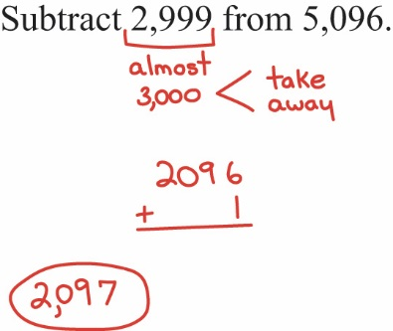
5.  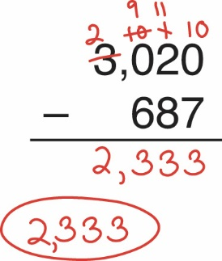 | 6.  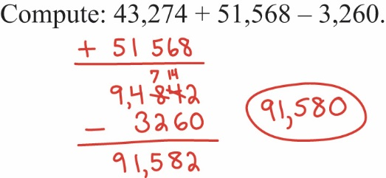

For more on the Major Work of the Grade, see achievethecore.org/focus.
For more on the standard algorithm, read page 3 of the progression document, K–5, Number and Operations in Base Ten.
CCSSM, 1.NBT.C.4, p. 16.
Definitions originally appear in the Glossary of the Common Core State Standards for Mathematics, http://www.corestandards.org/wp-content/uploads/Math_Standards.pdf#page=85.

