Research Pack Basics: An Introduction to the Research Packs

Welcome to the Research Packs! You and your students are about to set off on an adventure where you will explore new and important information about the world of science.
In the process, your students will be:
- Reading carefully and thoughtfully. They will work with texts – successfully – that expand their world of knowledge and understanding.
- Thinking, not only like a scientist, but also as a critical thinker and a problem-solver.
- Writing, where they will pull together what they have learned in fully-developed, grade appropriate informative writing pieces that communicate what they know and understand.

Perhaps best of all, all of this will be manageable for you as the teacher!

First, the “why”
Increasingly, research is confirming what teachers’ long experience with working with children has been telling us – content matters. Knowing important stuff matters. Vocabulary matters. Children who know about the world, know the words and ideas that are part of that understanding, and can work with those ideas orally – these children are well-positioned to succeed in school from the earliest grades on.

One crucial way to gain content knowledge and understanding is by successfully reading rich (and accurate!) texts. The more students are able to gain meaning from reading, and the more they learn to gain that meaning on their own, the better they are able to learn – not just about the topic at hand, but about any content down the line. (In a very real sense, the more one knows, the more one is able to know!). This requires attention to a volume of connected reading to gain deep understanding of that body of knowledge.

Reading successfully is about gaining information, gaining many small bits of knowledge, but it is much more than that. As students are guided to read successfully, they develop habits of mind that go beyond what they are reading in any one task. They begin to recognize that reading a text is not a single, isolated experience – rather, it is a series of “building experiences” where reading and re-reading and re-reading again yields deeper and richer understanding of the content. Students see themselves – correctly! – as capable readers and meaning-makers. They come to expect to make meaning from text.

Finally, when students synthesize understanding in writing, they create a coherent chunk of meaning about that content. Putting ideas together, grounded in evidence from the texts they have read and discussed, helps students in two crucial ways. First, it helps them pull together what they know into a “sense-making” experience. The content they have written about is now synthesized into connected, clear understanding. Second, writing a successful piece helps create a “mental map” for students of what clear, logical, connected thought can look like – in other words, it creates a model for students of effective, text-based writing and thinking that they can carry forward to new tasks.

Now, the “what”

Science content.
Each Research Pack is based on a particular science standard from the Next Generation Science Standards and is designed to help students build strong understanding of that science standard/concept. In each Research Pack, a particular science standard creates the core of the content understanding that students are learning.

Central research question
Each Research Pack is built around a central “research question” to focus the work students will do. This question guides the final informative piece that students write, and therefore also the reading and thinking that students will do as they hone in on the knowledge and understanding the research is building. Students research, not to gather a collection of loosely related facts, but to build deep understanding of science concepts and content.

Carefully selected texts
Each Research Pack uses several texts directly related to the science content understanding that students are building as well as some vetted internet resources. These could be supplemented, especially at the independent level, if the teacher wishes to do so, but are also sufficient as they are. They have been chosen both for their content and text complexity level. The class shares text sets for research, keeping initial costs of setting up the project low. The Research Packs themselves are available for free, online, under a Creative Commons license.

“Rule of Three”
Each Research Pack has been designed with the “rule of three” in mind. This means that,
for all grade levels:
• The first “research experience” in the pack is completed as a full class and is very highly guided and scaffolded. The idea here is that this kind of research/thinking/writing work is new for students, and strong and specific, guided instruction is needed. In this first research experience, teachers are not “seeing if” students can research, understand, and then write – they are “making sure” that students can research, understand, and then write.

• The second “research experience” focuses the same science understanding, but this time students are working with new content in small groups. The teacher is still very available for assistance, but students are using the same approach as they did the first time with somewhat more independence. In this less guided research experience, students will center their research on the same science standard and the same research question, but new text. Groups will work together to read, to take notes, to gather evidence. Then each student, writing in chunks, will write an individual informative piece that synthesizes his or her understanding.

For grades 3-5 only:
• Older elementary students now complete a third, independent part of the research project. The third “research experience” again uses the same science understanding, but this time students are using a now-very-familiar approach to read, think, and write more independently. By this time students will have built some successful approaches and habits of mind (and content understanding) from the two earlier experiences. They are well-positioned to read, think, take notes, and write successfully on their own.

NOTE: it’s important to remember that these Research Pack materials can be used flexibly. Classrooms are different, and available time is different. For example, a teacher may choose to use only the highly guided experience in this set. He may choose to use the highly guided and small group experiences, and omit the independent. He may choose to add an independent component for younger students as enrichment. There are undoubtedly other approaches as well.

What we would NOT recommend is leaving out the full group, highly-guided “research experience.” It is critically important that research – reading, re-reading, talking, note-taking, writing – is successful for students. That can happen only in the presence of strong, effective instruction.

Finally, the “how”
How has the Research Pack been designed? What does the project look like?

The full Research Pack sequence will take about six weeks of daily work (30-45 minutes per day) at grades 3-5 and 4 weeks at grades K-2. When the project is complete, students will have researched several different aspects of a topic (for example tornados, earthquakes and hurricanes in a Pack on natural disasters) and written 2-3 research “reports” that meet the expectations of CCSS aligned informative writing.

Each research experience is divided into two parts:
In Part 1, students “become an expert”. In these sessions, students work closely with text to develop a rich and full understanding of the science content and gather and organize the information they will need to write about their research question. The strategies they learn for finding, recording and organizing information are applicable to other research tasks, and can be easily adapted to other content areas where students need to draw evidence from text, including social studies and literature.

In Part 2, students “share the knowledge” they have gained by writing about it. In these sessions, students work with the science knowledge they have developed, as well as writing craft and structure, to create an informative piece that constructs and clearly communicates the understanding they have gained. Here again, students will learn and practice the basics of writing an informative/explanatory piece, a foundational skill applicable in many different contexts.

Throughout the Research Pack, students will see icons that correspond to the stages that the lessons will take them through as they read, learn, think, and write. Each represents a step in the research process.

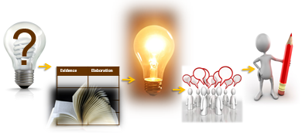

Becoming an Expert: Working with Complex Text to Answer a Research Question

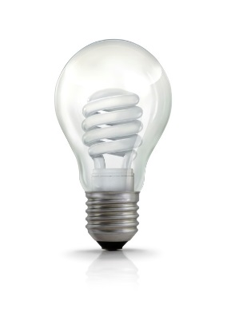 Session One Where Am I Going?
?
In this session students get a sense of the central text. Since this is all informational text, it is important for students to get a sense of the sources they will be working with, who wrote the text, how the text is laid out, and what they are likely to learn from it. They are given the central research question for the whole research experience. Then, they preview the central source to better understand aspects of text structure that will help them to efficiently locate the information they need.

Session Two -Three Reading the Text
Reading the central text generally takes two sessions. Students do a first reading for a “gist understanding.” Then they return to parts of the text for a close read where they are guided to look closely at important sections, using carefully chosen text-dependent questions that will help build meaning of the science content (and which are key to effective writing at the end).

Session Four Reading for Evidence
At this point, students move from a strong overall “background understanding” of the science content to a more focused understanding. They re-visit the research question to read the text again. They mark the text for evidence (information that will help them answer the research question), using sticky notes. Younger students find and record evidence as a group. Older students work toward finding information independently.

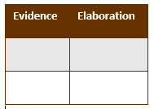Session Five Recording Evidence
Now students are ready to record the evidence they identified. Using a chart / note-catcher, they record the evidence. They do this using a combination of domain specific vocabulary and their own words. These notes will form an invaluable “bridge to writing” for the work to follow.

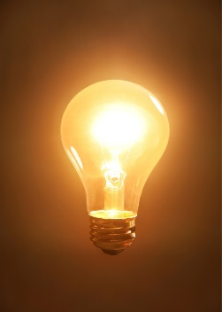 Session Six Additional Evidence / Focus Statement
Then, students take an important step. Looking at the information they have gathered to “answer the question”, they craft a Focus Statement that clearly and accurately addresses the research question. This Focus Statement will be the main idea (focus) of the written piece.

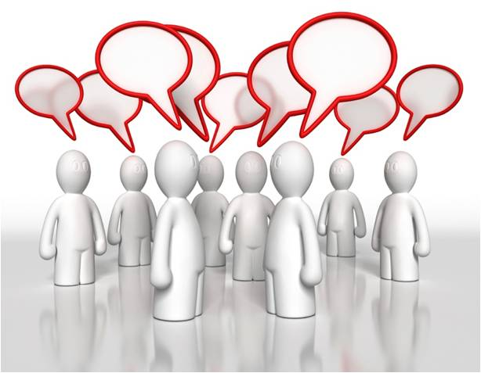 Session Seven Working with Evidence
Here students make the evidence their own. Depending on the particular grade level, they will use oral processing to talk through the evidence, draw the evidence, perhaps pantomime or even act out the evidence. Using activities, they will make this knowledge their own. This is key step before writing – students cannot write what they could not have spoken.

Once students have gathered information, they will synthesize and deepen their understanding of the science concept they have researched by writing an informative/explanatory piece. Each step of the writing is carefully explained and supported, using a model.

Sharing the Knowledge: Writing an Informative/Explanatory piece
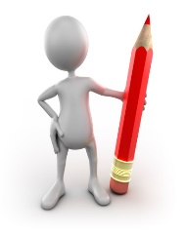Session One Analyzing a Model
Students will be writing an informative/explanatory piece in order to convey a fairly complex science concept. Often, students have not seen this type of writing before, or done it themselves. In this session, students work closely with a model piece of writing. It will be similar in structure to the piece they themselves will write, and similar in type of thinking, but will be about different content.

Session Two Writing an Introduction
Students will write an introductory sentence (primary grades) or paragraph (grade 3-5), drawing on both the model and class instruction. This will include the Focus Statement that answers the research focusing question. They will revise and edit before moving on to write the body of the piece which will develop their thinking.

Session Three Writing the Body of the Piece
Here, students will use the evidence they have already gathered to construct their first detail sentence (primary grades) or body paragraph (grades 3-5). They will revise and edit before moving on to the next part of the piece.

Session Four Writing the Body of the Piece
Now students use the evidence they have already gathered to add more detail or write a second body paragraph. Again, they will revise and edit before moving on to the conclusion.

Session Five Writing a Conclusion
Students write a concluding paragraph or statement for the piece. What the conclusion may look like will depend on the age and/or level of the students.

Session Six Final Revision and Editing, Adding a Visual
With the first draft of the report now complete, students use a grade specific standards-based checklist to go back over their own writing and make final revisions and/or corrections. They then create a visual (drawing, photograph, etc) to enhance the meaning of the piece.

Session Seven Share and Celebrate
In a variety of ways, students share and celebrate their writing with each other. This section also offers resources for further learning about the topic.

And now, back to the “why”

Students then repeat this cycle of research and writing to explore other aspects of the topic with increasing independence. They gradually build a rich knowledge base and internalize skills and habitats of mind essential for lifelong learning.

Working on each research project takes time, but in the process, students learn much, not only about the topic they have been researching, but about how to read complex text, find and make sense of information, and write a clear, focused piece to share their thinking.

And, of course, it’s always fun to become an expert!

