Research Pack ‘Quick Start’ Guide
Welcome to the Research Packs! You and your students are about to set off on an adventure where they will explore new and important information about the world of science.
In the process, your students will be:
- reading carefully and thoughtfully
- thinking critically
- writing fully-developed, grade appropriate informative writing pieces

Perhaps best of all, all of this will be manageable for you as the teacher! Once you are familiar with the approach, Research Packs are designed to be used with minimal preparation.

How does it work?
Each Research Pack has been designed with the “rule of three” in mind. This means that:
• The first “research experience” in the pack is completed as a full class and is very highly guided and scaffolded by the teacher. In this first research experience, teachers are not “seeing if” students can research, understand, and then write – they are “making sure” that students can research, understand, and then write.
• The second “research experience” focuses the same science concept / understanding, but this time students are working with new content in small groups. The teacher is still very available for assistance, but students are using the same approach as they did the first time with somewhat more independence.
For grades 3-5:
• Older elementary students now complete a third, independent part of the research project. The third “research experience” again uses the same science concept / understanding, but this time students are using a now-very-familiar approach to read, think, and write more independently.
NOTE: Research Pack materials can be used flexibly. Classrooms are different, and available time is different. For example, a teacher may choose to use only the first highly guided experience in this set. He may choose to use the highly guided and small group experiences, and omit the independent. What we would NOT recommend is leaving out the full group, highly-guided “research experience.” It is critically important that research – reading, re-reading, talking, note-taking, writing – is successful for students. That can happen only in the presence of strong, effective instruction.

The three pages that follow (one for each “research experience”) provide an overview of what you and your students will be doing as you work through each stage of the project. Once you have read through this guide, simply download the student and teacher packs, gather or purchase the texts listed in the Teacher Resource Guide and dive right in!
The First Research Experience (approximately 2 weeks, 30-45 minutes each day)
Class Research Pack
Description:
In this first research experience, the teacher guides the full class, step by step, in gathering the information needed to answer a focused research question, using provided sources. Students are actively involved as each step in the research process is explained, modelled, and practiced with support. Using a highly guided approach, students then write an informative explanatory piece to report their findings.
Materials:
• Introductory Text, Central Text (see Teacher Resource Pack for titles)
• Internet Access (optional)

• Class Research Pack *Writing Resource Pack * Teacher Resource Pack
(one per student) (one per student) (one copy)

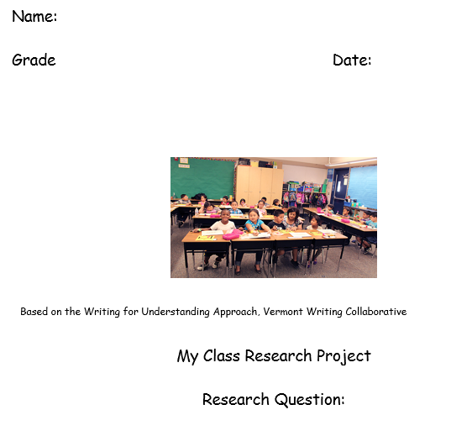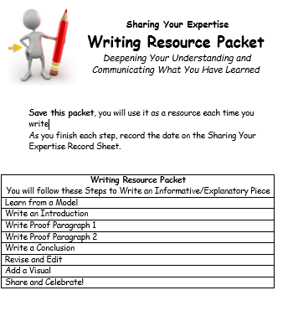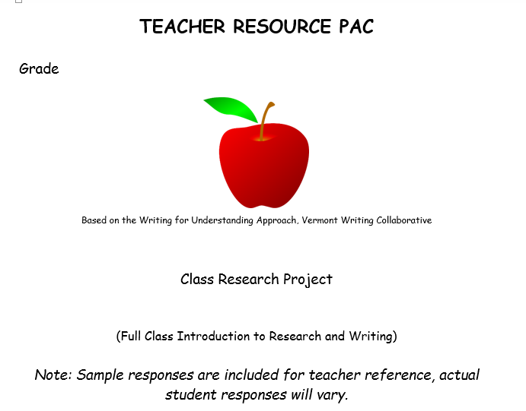
*NOTE: these two packs, the Writing Resource Pack (for the student) and the Teacher Resource Pack (for the teacher) will be re-used for all three research experiences.

How to use the Packs:
- Read the recommended Introductory Text aloud to your class in order to pique some interest, and to provide some context on the topic students will be researching. To ensure basic understanding of the ideas in the text, stop to clarify and discuss as needed. There are no specific guidelines on how to use this introductory text, so plan the session to meet the needs of your own students.
- Guide your students, step by step, through the Class Research Pack. The checklist at the front of each Pack provides a rough pacing guide. Each row of the checklist represents one 45 minute work session. Activities will work best if you present them consecutively.
You can find sample student responses and teaching tips in the Teacher Resource Pack. All of the information you need to guide the activity each day is available on an annotated teacher page that looks very similar to the one students are using.
- When it’s time to write, guide your students in writing a highly supported informative/explanatory piece using the Writing Resource Pack. To give you a sense of what this piece might look like, you can find sample student responses and teaching tips in the Teacher Resource Pack.
The Second Research Experience (approximately 2 weeks, 30-45 minutes each day)
Group Research Pack
Description:
In this second research experience, the teacher steps back a bit. Students work in small groups to explore a new aspect of the topic. Together, the group uses new sources to gather additional information and deepen their understanding of the science concept that focuses the research. Each student, individually, writes a short, informative report to communicate the group’s findings.

Materials:
• Small Group Texts (see Teacher Resource Pack for titles)
• Internet Access (optional)
• Group Research Pack * Writing Resource Pack & Teacher Resource Pack
(one per student) (saved from first research experience)

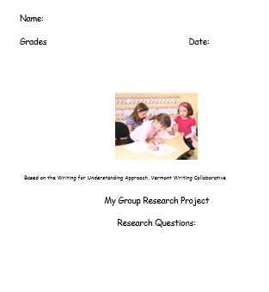
* Note: these two Packs, the Writing Resource Pack and the Teacher Resource Pack, used in the first research experience, are being used again here.

How to use the Packs:
- This time, divide your class into small groups. Each will explore a question closely related to the class research question. Your role will be to support each group, as needed, in using the Group Research Pack to complete their own research. The procedure used will be essentially the same as the one used in the Class Research Pack. You can find recommended texts and sample graphic organizers for each small group topic in the Teacher Resource Pack.
- When it’s time to write, guide your students in writing a supported informative/explanatory piece using the same Writing Resource Pack they used when they worked as a full class. Students use the same pack and procedure to guide them in writing a piece that communicates their new research. The familiar process and topic supports increased independence in this second writing piece.

Grades 3-5 Only:
The Third Research Experience
Individual Research Pack (1- 2 weeks, 30-45 minutes each day)
Description:
In this third research experience, individual students choose a new aspect of the topic to explore. Using the resources available for small groups, each student chooses new sources, and works independently to gather information on a question closely related to the class research question. When the research is complete, each student writes a short, informative report to communicate his/her findings.
Materials:
• Small Group Texts (see Teacher Resource Pack for titles)
• Internet Access (optional)
• Individual Research Pack: Writing Resource Pack & Teacher Resource Pack
(one per student) (saved from first research experience)

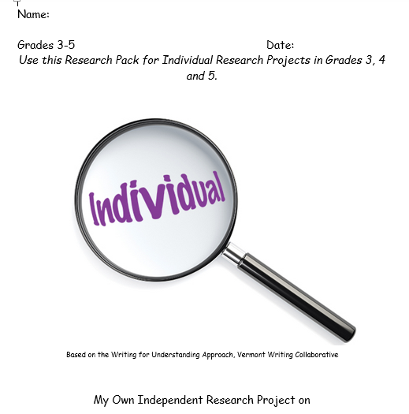

* Note: these two Packs, the Writing Resource Pack and the Teacher Resource Pack, used in the first two research experiences, are being used again here.
How to use the Packs:
- Support each student in using the Individual Research Pack to complete his/her own research. The Individual Research Pack is designed to be used with any topic or research question, but leads students through the same basic steps as the packs they have used previously. Students are expected to apply what they have learned about how to research to effectively complete the project using the more general directions in the Individual Research Pack.
- Students write an informative/explanatory piece independently using the Writing Resource Pack.
When the project is complete, your students will have built a strong knowledge base, developed strategies for reading complex nonfiction text, practiced taking notes and organizing information, and internalized an approach to research and writing that can be applied across grade levels and subject areas. Most importantly, the carefully measured support you have provided throughout this process will leave students feeling comfortable and confident as researchers and writers!

