Title/Author: Wemberly Worried by Kevin Henkes
Suggested Time to Spend: 4 Days (Recommendation: two sessions per day, at least 20 minutes per day)
Common Core grade-level ELA/Literacy Standards: RL.K.1, RL.K.2, RL.K.3, RL.K.4, RL.K.7, RL.K.10; W.K.2, W.K.8; SL.K.1, SL.K.2, SL.K.6; L.K.1, L.K.4
Lesson Objective:
Students will actively listen to the picture book Wemberly Worried and use literacy skills-reading, writing, discussion, and listening-to demonstrate their understanding of the Big Idea.
Teacher Instructions
Before the Lesson
- Read the Big Ideas and Key Understandings and the Synopsis below. Please do not read this to the students. This is a description to help you prepare to teach the book and be clear about what you want your children to take away from the work.
Big Ideas/Key Understandings/Focusing Question
The world is full of things to worry about but with the help of friends and family, we can confront and overcome our fears.
Synopsis
In this picture book, the main character, a mouse named Wemberly, constantly worries about big and small things. Her largest worry is about starting school. Her teacher pairs her with another student who appears to be as worried as she. By spending time together and having fun, the friends forget to be worried.
- Go to the last page of the lesson and review “What Makes This Read-Aloud Complex.” This was created for you as part of the lesson and will give you guidance about what the lesson writers saw as the sources of complexity or key access points for this book. You will of course evaluate text complexity with your own students in mind, and make adjustments to the lesson pacing and even the suggested activities and questions.
- Read the entire book, adding your own insights to the understandings identified. Also note the stopping points for the text-inspired questions and activities. Hint: you may want to copy the questions vocabulary words and activities over onto sticky notes so they can be stuck to the right pages for each day’s questions and vocabulary work.

Note to teachers of English Language Learners (ELLs): Read Aloud Project Lessons are designed for children who cannot read yet for themselves. They are highly interactive and have many scaffolds built into the brief daily lessons to support reading comprehension. Because of this, they are filled with scaffolds that are appropriate for English Language Learners who, by definition, are developing language and learning to read (English). This read aloud text includes complex features which offer many opportunities for learning, but at the same time includes supports and structures to make the text accessible to even the youngest students.
This lesson includes features that align to best practices for supporting English Language Learners. Some of the supports you may see built into this, and /or other Read Aloud Project lessons, assist non-native speakers in the following ways:

- These lessons include embedded vocabulary scaffolds that help students acquire new vocabulary in the context of reading. They feature multi-modal ways of learning new words, including prompts for where to use visual representations, the inclusion of student-friendly definitions, built-in opportunities to use newly acquired vocabulary through discussion or activities, and featured academic vocabulary for deeper study.
- These lessons also include embedded scaffolds to help students make meaning of the text itself. It calls out opportunities for paired or small group discussion, includes recommendations for ways in which visuals, videos, and/or graphic organizers could aid in understanding, provides a mix of questions (both factual and inferential) to guide students gradually toward deeper understanding, and offers recommendations for supplementary texts to build background knowledge supporting the content in the anchor text.
- These lessons feature embedded supports to aid students in developing their overall language and communication skills by featuring scaffolds such as sentence frames for discussion and written work (more guidance available here) as well as writing opportunities (and the inclusion of graphic organizers to scaffold the writing process). These supports help students develop and use newly acquired vocabulary and text-based content knowledge.

The Lesson – Questions, Activities, and Tasks

Questions/Activities/Vocabulary/Tasks | Expected Outcome or Response (for each)
FIRST READING:  Read aloud the entire book with minimal interruptions. Stop to provide word meanings or clarify only when you know the majority of your students will be confused. | The goal here is for students to enjoy the book, both writing and pictures, and to experience it as a whole. This will give them some context and sense of completion before they dive into examining the parts of the book more carefully.
SECOND READING:  Use the illustrations on pages 1-8 projected on a document camera.  What is Wemberly worried about?  Read pages 10- 11  Why does Wemberly rub Petal's ears?  Read pages 12-13  What happens when Wemberly worries?  Read pages 17-19  Wemberly is worried about school. What are some of her worries?  Read pages 22-23  How are Wemberly and Jewel alike?  Read pages 26-27  How did Wemberly and Jewel overcome their worries?  Read pages 28-29  Using what you know from the story, infer how Wemberly will feel about school tomorrow and why. | Accept any reasonable answer children provide, however the following are some examples:  - Page 1- It might rain, she may be stung by a bee  - Page 2-Where are my parents?  - Page 3- I spilled my juice, will my rabbit fall in the tub? Will I shrink?  - Page 6-Will the tree fall?  - Page 8- Is the playground safe? Will I fall?  To try and stop worrying.  Her worries don’t come true.  Her parents try to show her that she has nothing to worry about.  What if no one else has spots?  What if the teacher is mean?  What if the room smells bad?  What if she can’t find the bathroom?  What if she cries?  Jewel was standing alone, wearing stripes and holding her doll.  The sat side by side, they played together and weren’t worried.  Wemberly will not be worried about coming to school because she has made a new friend, Jewel.
THIRD READING:  Reread entire book-presenting vocabulary words and meaning as needed but paying close attention to Wemberly’s thoughts.  As you reread page 1, ask  “Wemberly worried about everything.” What does it mean to be worried?  As you reread page 3, ask  “Mama, what if I shrink?” Wemberly is in the bathtub. Have any of your clothes gotten smaller after they were washed? What is worried about?  As you reread page 4, ask  “And she worried throughout the day.” What do you think the author means by throughout the day?  As you reread page 5 ask  Why do her parents worry when she worries?  As you reread page 6-7, ask  What are her worries and why do these things make her worry?  “and the noise the radiators made.” A radiator is a heater that was used long ago. It was filled with hot water and the steam that sometimes came out sounded like a snake.It sounds like the air blowing out of the vents of your house when the furnace or air conditioning comes on.  Why does this make Wemberly worry?  As you reread page 8, ask  “and the bolts on the slide, and the bars on the jungle gym.” Bolts are metal pins used to hold the slide together.  Why might Wemberly be worried about them?  A jungle gym is a climbing structure for children to play on. Why does the height of it worry her?  “Too rusty.” Rust is orange, brown flaky metal that is old and falling apart.  What do you think was rusty on the playground and why was she worried?  Brainstorm with your students the difference between small worries and big worries. Create a Tree Map to list the small and big worries from the test. The teacher will need to draw pictures beside the “worries” to help the students read the map. | Worried means to be nervous about something.  To shrink means to get smaller.  She is worried about getting smaller.  Wemberly worried all day and all night.  Parents worry when their kids are upset.  Tree- it might fall on her  crack in wall- something scary could come out of it  She thinks a snake will come out of the radiator.  She is worried about the bolts being too loose and the slide falling apart.  Answers may vary but Wemberly is afraid of falling off.  Wemberly was worried about the chains on the swings being rusty. She was worried that the swings would break while she was swinging on them.  Example of a tree map:  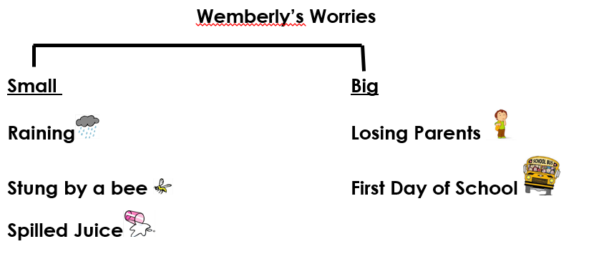

FINAL DAY WITH THE BOOK - Culminating Task
Students will generate resolutions to “How does Wemberly overcome her biggest worry?”
Procedure:
- On the board, model how to draw a Circle Map with Wemberly’s name in the middle.
- Divide the class into groups of 2-3 children. Give each group a large piece of paper, crayons, markers, pencils, etc. Let the students copy the teacher drawn Circle Map onto their paper.
- Each group will discuss the things Wemberly worried about and who helped her overcome her worries…i.e. Wemberly rubbed Petal’s ears, her family loved her, building with blocks with Jewel and playing dolls with Jewel.
- The students will illustrate and write a word or two inside the large circle as evidence of how she overcame her biggest worry.
- Gather the class together. Use chart paper to complete the statement, “Wemberly’s biggest worry was going to school.” Next, let your students discuss and share their circle maps. Display their maps around the room so they can use them as a reference to answer the “big idea” question, “How does Wemberly overcome her biggest worry?”
- Scribe their responses using pictures to enhance understanding. For example, students may say, “She rubbed Petal’s ears, her family showed her love and she played with blocks and dolls with her friend Jewel” etc. Add pictures beside each statement.

**It may be helpful to draw the large circle after the illustrations are drawn. That way the students will not draw the outer circle too small.
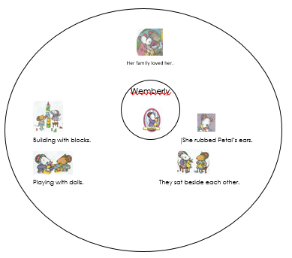

These words merit less time and attention  (They are concrete and easy to explain, or describe events/  processes/ideas/concepts/experiences that are familiar to your students ) | These words merit more time and attention  (They are abstract, have multiple meanings, and/or are a part  of a large family of words with related meanings. These words are likely to describe events, ideas, processes or experiences that most of your student will be unfamiliar with)
Page 3 - shrink – to make smaller  Page 7 - radiator – heaters of long ago  Page 8 - bolts – a metal pin used to hold two things together  Page 8 - jungle gym – a climbing structure for children to play on  Page 8 - rusty – orange, brown flaky metal that is old and falling apart | Page 1 - worried – nervous about something  Page 4 – throughout – everywhere

Extension learning activities for this book and other useful resources
- If students are currently working on letter sounds, generate a Circle Map of things that start with the letter W. Then guide students to choose a word from the map and complete a slotted sentence, “Wemberly worried about _____________.” and draw a picture of Wemberly to illustrate it. For example, Wemberly worried about walruses or Wemberly worried about winter.

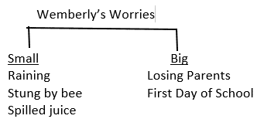

What Makes This Read-Aloud Complex?
- Quantitative Measure
Go to http://www.lexile.com/ and enter the title of your read-aloud in the Quick Book Search in the upper right of home page. Most texts will have a Lexile measure in this database.

Most of the texts that we read aloud in K-2 should be in the 2-3 or 4-5 band, more complex than the students can read themselves.
2-3 band 420-820L
4-5 band 740-1010L

AD 170L

- Qualitative Features
Consider the four dimensions of text complexity below. For each dimension*, note specific examples from the text that make it more or less complex.
- Confronting and resolving fears
- Everyone is anxious and expresses it in different ways

Through the use of illustrations and thought bubbles, the reader understands the fears that Wemberly expresses. The parents’ dialogue is written in traditional story format.

The parents’ dialogue is traditionally written, however Wemberly’s dialogue is written in thought bubbles. Challenging vocabulary words include: radiator, jungle gym, and rusty bolts.

- Students need to know what thought bubbles are and how they are used in the text.
- Students need to understand that starting new or unknown things can make you feel anxious.

Meaning/Purpose
Structure

Language
Knowledge Demands

*For more information on the qualitative dimensions of text complexity, visit http://www.achievethecore.org/content/upload/Companion_to_Qualitative_Scale_Features_Explained.pdf

- Reader and Task Considerations
What will challenge my students most in this text? What supports can I provide?
  - Participating in a discussion about fears can often be intimidating in Kindergarten. I can support my students by sharing that adults experience fears as well and validating their fears and worries about the world.
How will this text help my students build knowledge about the world?
  - Students will learn that everybody is afraid sometimes and it’s okay when we have friends and family to support us.
- Grade level
What grade does this book best belong in? K as a read-aloud

All content linked to within this resource was free for use when this resource was published in March 2018. Over time, the organizations that manage that external content may move or remove it or change the permissions. If the content is no longer available, please email info@studentsachieve.net.

