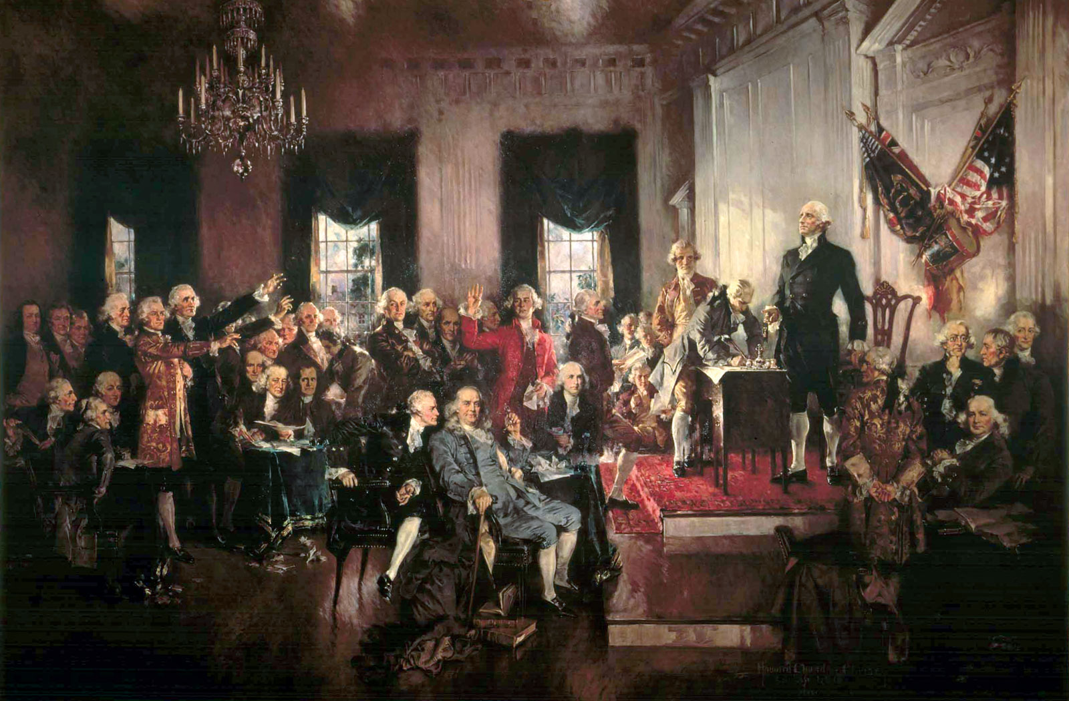

What do you see? | What do you think it means? | What specific textual evidence helps to support or refute your interpretation?

Goal:
You have been selected to be part of a group to determine whether the artist’s political message displayed in the image is one that justifies its display in its Washington D.C. location. To determine this, you must critically analyze the image, determine the artists intended message, determine the author’s use of his craft to portray that message, and lastly, determine if the painting portrays the spirit of the Constitution and the Continental Congress of 1787.

