**Trigonometric Functions and Their Graphs**

**Background:** This lesson is intended to further develop students’ understanding of trigonometric functions and graphs. Students will investigate how the constants *a*, *b* and *c* of the general forms and ****affect the graph of the function.

**Lesson Structure:**

**1. Pre-Assessment**

Prior to the lesson, students will complete the pre-assessment individually. Half the class will be given *Form A* where *Question 2* asks for a graph from a function, while the other half will be given *Form B* where *Question 2* asks for a function from a graph. The pre-assessment serves two purposes: (1) The teacher can determine whether graphing trigonometric functions or writing trigonometric functions was more difficult for the students, and (2) The teacher can create pairs of students for the activity that reflect the students’ needs.

**2. Lesson:**

The cards should be photocopied on colored paper as follows: Pages 2,3,4 (Color A), Pages 5,6 (Color B), Pages 7,8 (Color C). Each pair of students should receive all three groups of cards.

**a.** Have the students work in pairs for 8 minutes, working only with the cards in Color Group A. The objective is to match functions and graphs. After the students have completed, debrief as a class, covering questions such as, “Which cards, were easy/difficult to match?” “Which graphs had similarities?”

*Note: My students’ work on the pre-assessment showed that they struggled more with graphing trigonometric functions than writing functions from a graph. If the reverse is true in your class, the order of the following parts of the lesson could be interchanged.*

**b.** For the next 8 minutes, have the students work only with the cards in Color Group B. The objective is to write a function on the blank cards from the given graph. Debrief by going over correct answers and having students clearly explain how they wrote their functions.

**c.** For the final 8 minutes, have the students work only with the cards in Color Group C. The objective is to provide a graph from a given function. As a debrief, have students draw their graphs on the board and explain how they made their decisions in graphing.

**3. Post-Assessment:** *Questions 1 and 2* are straightforward from the lesson. *Question 3* was never explicitly covered during the lesson, but requires students to understand that a vertical shift is caused not only by a change in amplitude, but also a change in midline.

|  |
| --- |
|  |

|  |
| --- |
|  |

|  |
| --- |
|  |

|  |
| --- |
|  |

|  |
| --- |
|  |

|  |
| --- |
|  |

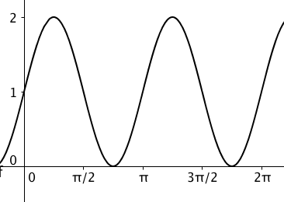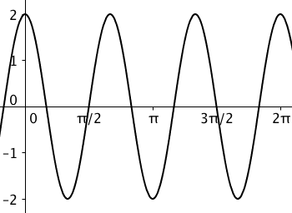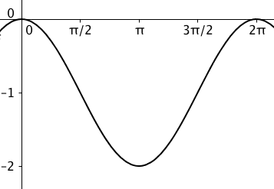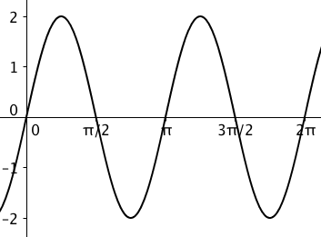

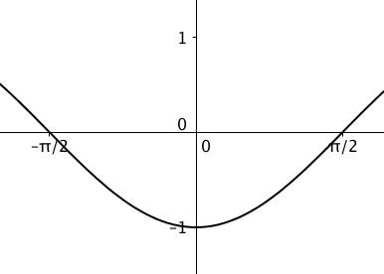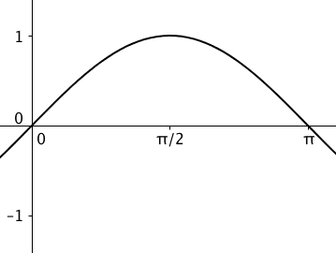

|  |
| --- |
|  |

|  |
| --- |
|  |

|  |
| --- |
|  |

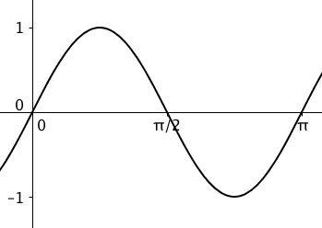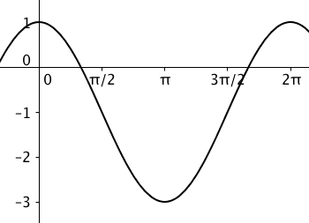

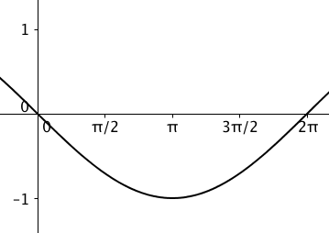

|  |
| --- |
|  |

w

|  |
| --- |
|  |

|  |
| --- |
|  |

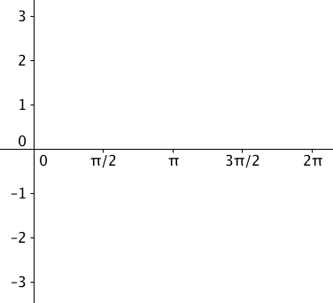



**NAME__________________________ NO CALCULATOR FORM A**

PRE-ASSESSMENT

**1.** Explain how each number affects the graph’s appearance.

y = 3 cos (4x) – 2

**NAME__________________________ NO CALCULATOR FORM B**

**1.** Explain how each number affects the graph’s appearance.

y = 3 cos (4x) – 2

**2.** Write an equation that could represent the graph of this trigonometric function:

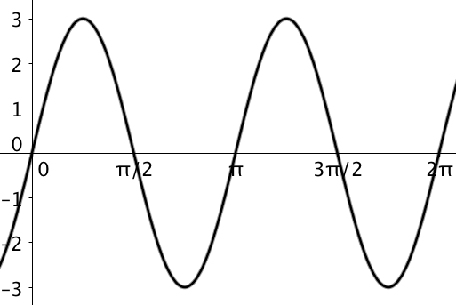

**2.** Sketch a graph of the function: **y = 3sin(2x).**

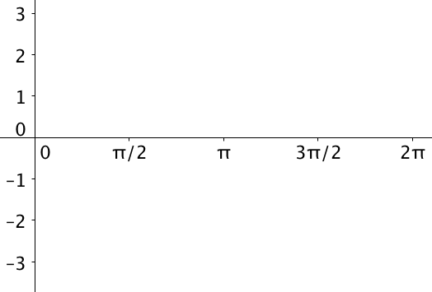

POST-ASSESSMENT

Algebra 2/Trigonometry Date ______________________________

Trigonometric Graphs Name ______________________________

**1.** Write the equation of the function represented by the graph below:

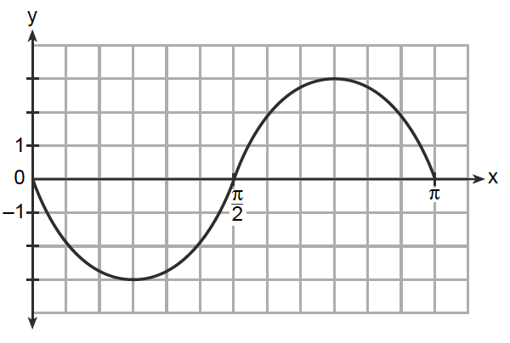

**2.** Sketch the graph of y = 3sin(2x).

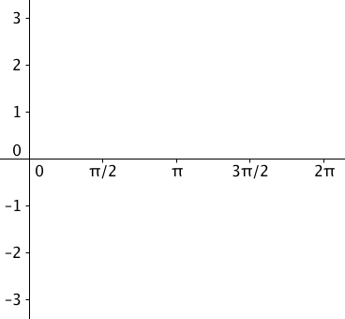

**3.** What are the *maximum* and *minimum* values of the function y = 2cos(0.5x) + 4. Explain how you found your answer.

__________________________________________________________________________________________________________________________________________________________________________________________________________________________________________