AGE GAUGE

Part 1: Data Collection

Famous Personality | Estimated Age | Actual Age
1.
2.
3.
4.
5.
6.
7.
8.
9.
10.
11.
12.
13.
14.
15.
16.
17.
18.
19.
20.

Part 2: Analysis of the Data
Using the grid below, graph your data. Be sure to label your axes and scale, and place a title on the graph.
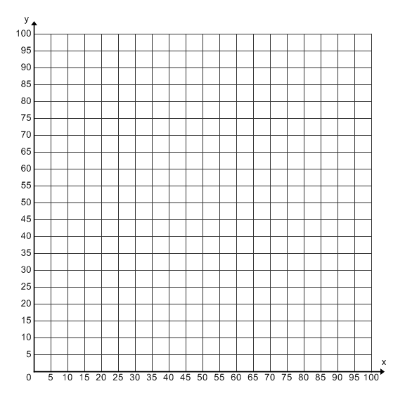

3. Is your graph linear? Why or why not?

4. Is there a correlation or association between the actual ages and your guesses? Can you draw a line that “fits” the cloud of points and that will best describe the data?

5. Choose two points to prepare a line of best fit.
First point (____ , ____) Second point (____ , ____)

6. Find the slope:___________________. Find the y-intercept: __________________

7. What is the equation for your line of best fit? ________________
Part 3: Interpret the slope/y-intercept, application
8. What does the slope of the line of fit tell you about the rate of change when comparing your guessed age to actual age?

What does the y-intercept tell you about your guesses?

9. Based upon your scatter plot, were you a bad a good guesser?__________________ Explain how you came to that decision?

What would the scatter plot look like What would the scatter plot look like for a perfect guesser? for an over guesser?

What would the scatter plot look like for
an under guesser?

*Draw a line of fit on each scatter plot.

10. What does the slope of the line of fit tell you about the rate of change when comparing guessed age to actual age of a perfect guesser?

What does the y-intercept tell you about a perfect guesser?

What could be a possible equation for a(n)……
Perfect Guesser
Under Guesser
Over Guesser
Good Guesser
Bad Guesser

What would the scatter plot look like What would the scatter plot look like for a good guesser? for a bad guesser?

