Abraham Lincoln High School Preferred Lesson Plan Format
Focus: Danielson Competency 1E: Designing Coherent Instruction - Elements are underlined and in italics

Unit EQ  How can we critically evaluate the level of our thinking on what we already know about graphing linear equations to our current work with graphing circles? How will we connect our prior work with angle and segment relationships to those that appear with circles? |  | Enduring Understanding  Geometry can be applied to many aspects of problem solving strategies. | CC & NYS Standard  G.G.49, G.G.50  G.G.51,G.G.52, G.G.53  MP1  MP2  MP3  MP7
Reflection
Pre Lesson – How did my previous formative assessment and/or skills tracking affect today’s planning?
Based on item analysis (assessment based on circle test results), students will revisit central and inscribed angles (problem similar to question that resulted in varying errors on exam) and revisit this important concept via an error analysis activity.
(Learning Activities/Assessment Plans)
At the end of the lesson the students will understand that…

Content: Students will connect their current thinking to their previous studies involving circle properties, and begin to develop reasoning for circle proofs. Today students will display their mastery for inscribed angles by working cooperatively within their groups on an error analysis activity – an activity that revisits a concept that revealed several misunderstandings on their circle exam. With confidence, students will critically analyze what it means to have an angle be inscribed vs. central, specifically how we can use these to find degree measure of intercepted arcs – even working backwards. Students will develop several strategies to evaluate the mistakes that fellow classmates made on exam questions pertaining to this, and use literacy strategies to discuss solution pathways.

Skills: Basic algebra skills, basic angle relationship concepts, foundation with central/inscribed angles.
Time:  7 min.  7 min. total  (2 min.)  2 min.  25 min.  5 min. | (Lesson and Unit Structure)  Do Now: Basic Error Analysis Question with guided annotation prompts, to prepare students for their group activity today.  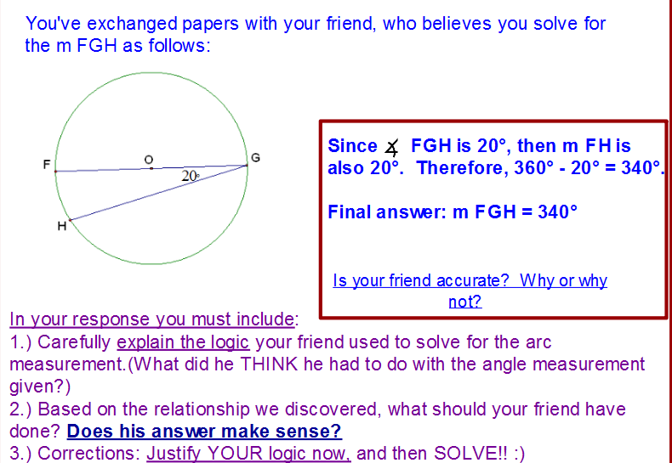  Student Assessment/Critiquing of One-Another’s work: (Turn and Talk) – Students will use their work from the do now to further assess their mastery of central vs. inscribed angles.  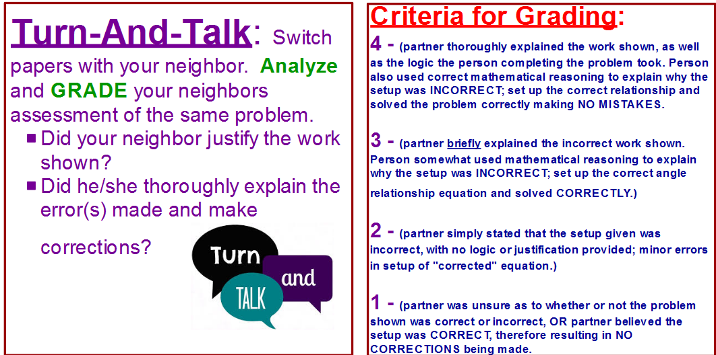  Whole class discussion around the mathematical procedures embodied in the task and/or common misunderstanding discovered in our error analysis  Organization of Student Work Groups: Students will be arranged in pre-determined, color-coded groups, based on varying levels of ability. There will be two each of low, medium, and high groups of students. Based on which color students see their name appear on the board, they will quickly move to the designated table where they will receive instructions for their task.  Lesson Content and Development: Student Centered Group Activity – Error Analysis  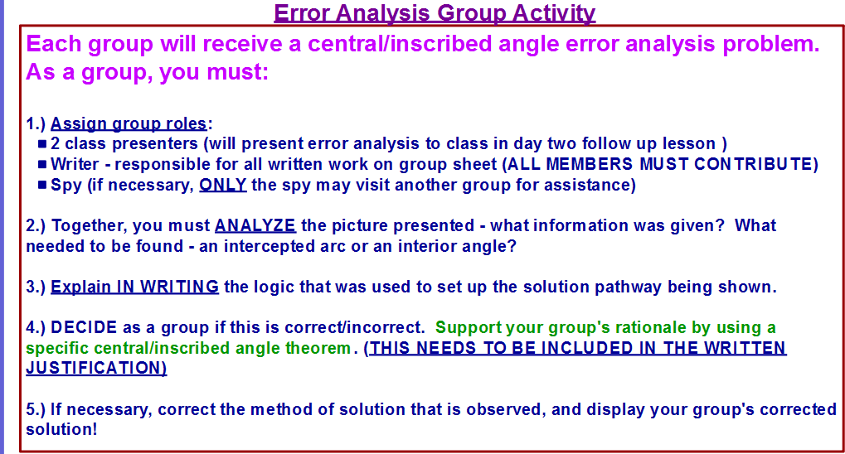  I will distribute a series of multi-layered central/inscribed angle problems, in which errors have been made in the solution pathway shown. I assign the students, working in their groups, several tasks – just like they did in the do now. They must determine the logic that was used in setting up the solution steps shown, explain the theorem/property that is used to work through the problem effectively, and then find and correct any errors they encounter by setting up the correct mathematical work. (ALL OF THEIR ANNOTATIONS MUST BE ILLUSTRATED ON THE WORKSPACE SURROUNDING THE QUESTION – via chart paper) I will be circulating throughout the room, listening to the discussion, and aiding with leading questions when necessary.  Teacher questions to check for understanding, for use with tracker: each group visited will be asked the following:  - “What is it that we are solving for in this picture – are we looking for an intercepted arc measurement, or an interior angle?”  - “What logic was used to set up the solution pathway being displayed?”  - “Is this logic correct, why or why not?”  - “How can we use what we know about central/inscribed angles to correctly solve for the unknown in the problem shown?”  (Error analysis questions are differentiated for each group, based on student ability and student’s response to multi-layered central/inscribed angle question on previous exam.)  Formative Assessment: Exit Slip/Reflection Note  Based on student tracking throughout the lesson, myself and Mr. Nicolas will assess whether a group of students can be challenged further and receive their exit slip, or if we need to assess specific challenges the student encountered that may have been difficult during the analysis activity (through use of the reflection slip).  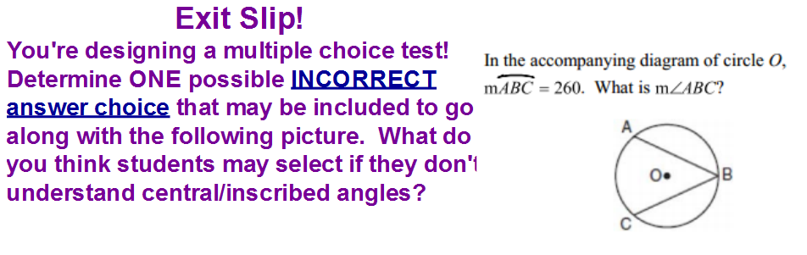  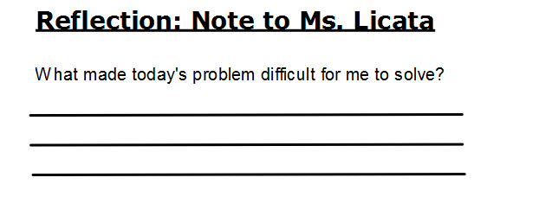  Aim: How can we critically and creatively evaluate the level of thinking involved common in setting up and solving for central/inscribed angles and their intercepted arcs?

(Instructional Materials and Resources)
Promethean board, pen for students to come up and participate using the board, error analysis questions for each group, markers for students to make corrections/annotate
(Assessment Plans)  Formative Assessment (Two types, what and when)  Skill Tracker to monitor student progress  Student Centered Activity: Error Analysis annotations  Exit Slip/Reflection Slip  Turn-And-Talk  Homework: worksheet | Examples of Formative Assessments  Think Pair Share  Skill Tracker (part of required elements)  Exit Ticket or Summary  Poll by Show of Hands  Quickwrite  Graphic Organizer
(Instructional Groups)
Purposeful Practice
Initially desks are arranged in homogenous pair groupings, to facilitate students working together during “do now” and Turn-and-talk portion of the lesson. Students will then branch into their pre-arranged groups to complete the activity portion of the lesson. Each group will receive a differentiated question based on the ability level of each group.
Reflection
Post Lesson –
What went well?
What did not go well?
Next steps?

