Title/Author: The Legend of the Indian Paintbrush by Tomie dePaola
Suggested Time to Spend: 4 Days (Recommendation: one session per day, at least 20 minutes per day)
Common Core grade-level ELA/Literacy Standards: RL.1.1, RL.1.2, RL.1.3, RL.1.4, RL.1.7, RL.1.10; W.1.2, W.1.8; SL.1.1, SL.1.2, SL.1.3; L.1.1, L.1.2, L.1.4

Teacher Instructions
Before the Lesson
- Read the Big Ideas and Key Understandings and the Synopsis below. Please do not read this to the students. This is a description to help you prepare to teach the book and be clear about what you want your children to take away from the work.
Big Ideas/Key Understandings/Focusing Question
- Little Gopher is a chosen one among his people. He perseveres to reach his dreams and becomes and unlikely hero among his people. How does one become a hero?
- How does Little Gopher become a legend among his People? One key takeaway is that Little Gopher becomes a legend among his People by leaving them the gift of the plants in the hills and meadows.
- How does Little Gopher use natural resources to help his community/his tribe/his people? One key takeaway is that Little Gopher used the reddest berries, the deepest purples from the rocks, and a white buckskin.
- How does Little Gopher persevere to complete his Dream-Vision? One key takeaway is that Little Gopher went to the hill each evening and looked at the colors that filled the sky. He awoke each morning and created the stories of his People with the tools he had. One night he heard a voice telling him that he will find the colors that he needs to paint the sunset.
Synopsis
Many years ago, when people traveled the Plains, a young Indian boy had a Dream-Vision in which it was revealed that one day he would create a painting that was as pure as the colors of the evening sky at sunset. The boy grew up to become the painter of the tribe, but although he found a pure white buckskin for a canvas and made paints from the brightest flowers and reddest berries, he could not capture the sunset. This Native folktale tells the story of how the young Indian artist finally fulfills his Dream-Vision.
- Go to the last page of the lesson and review “What Makes This Read-Aloud Complex.” This was created for you as part of the lesson and will give you guidance about what the lesson writers saw as the sources of complexity or key access points for this book. You will of course evaluate text complexity with your own students in mind, and make adjustments to the lesson pacing and even the suggested activities and questions.
- Read the entire book, adding your own insights to the understandings identified. Also note the stopping points for the text-inspired questions and activities. Hint: you may want to copy the questions vocabulary words and activities over onto sticky notes so they can be stuck to the right pages for each day’s questions and vocabulary work.

Note to teachers of English Language Learners (ELLs): Read Aloud Project Lessons are designed for children who cannot read yet for themselves. They are highly interactive and have many scaffolds built into the brief daily lessons to support reading comprehension. Because of this, they are filled with scaffolds that are appropriate for English Language Learners who, by definition, are developing language and learning to read (English). This read aloud text includes complex features which offer many opportunities for learning, but at the same time includes supports and structures to make the text accessible to even the youngest students.
This lesson includes features that align to best practices for supporting English Language Learners. Some of the supports you may see built into this, and /or other Read Aloud Project lessons, assist non-native speakers in the following ways:

- These lessons include embedded vocabulary scaffolds that help students acquire new vocabulary in the context of reading. They feature multi-modal ways of learning new words, including prompts for where to use visual representations, the inclusion of student-friendly definitions, built-in opportunities to use newly acquired vocabulary through discussion or activities, and featured academic vocabulary for deeper study.
- These lessons also include embedded scaffolds to help students make meaning of the text itself. It calls out opportunities for paired or small group discussion, includes recommendations for ways in which visuals, videos, and/or graphic organizers could aid in understanding, provides a mix of questions (both factual and inferential) to guide students gradually toward deeper understanding, and offers recommendations for supplementary texts to build background knowledge supporting the content in the anchor text.
- These lessons feature embedded supports to aid students in developing their overall language and communication skills by featuring scaffolds such as sentence frames for discussion and written work (more guidance available here) as well as writing opportunities (and the inclusion of graphic organizers to scaffold the writing process). These supports help students develop and use newly acquired vocabulary and text-based content knowledge.

The Lesson – Questions, Activities, and Tasks

Questions/Activities/Vocabulary/Tasks | Expected Outcome or Response (for each)
FIRST READING: Cold Read  Teacher will share with students that they are about to hear a folktale. Folktales are part of the various cultures. They are typically stories that have been passed down orally from generation to generation. | Students become familiar with folklore from the Native American tradition.
SECOND READING: Preteach the vocabulary with multiple meanings: gift and path. Teacher indicates that path is a word with multiple meanings. One refers to a trail on the ground that is used for walking. In this text, path refers to a course of action or direction that one goes in life. For example, we are not talking about the walking path in my neighborhood, I am referring to the path to college and the steps necessary to reach that goal. Gift is also a word with multiple meanings. We often think of gifts as presents, but in our text, gift means a natural talent.  (See page with shaman.)  Teacher will define pure (clean) and deed (actions/jobs) in context while reading.  (See page with grandfather and maiden).  Literal comprehension questions:  - What type of story is this?  - Where does the story take place?  - Who is the main character and how is he different from other boys in his tribe? (Teacher shows p. 1 to class)  Big Idea: What events in Little Gopher’s life lead to him becoming a legend among his people?  - Pg. 3 How does the Shaman describe the two different paths for boys?  - Pg. 3 What does Little Gopher like to do as a child?  - Pg. 3 Does the shaman think that Little Gopher has a special gift? And how do you know?  - Pg. 4 What does every boy in the tribe do before becoming a man?  - Pg. 4-5 Who speaks to Little Gopher in his Dream-Vision and what do they say? What is Little Gopher’s Dream-Vision?  - Is Little Gopher’s gift as important as other boys in the tribe? Explain why or why not.  - Where do the flowers come from? What do they look like?  In advance of the lesson, the teachers should draw a landscape of the hills and sunset (using brilliant reds, yellows, and oranges.)  After reading and asking the above questions, teacher will create narrative input chart that retells the important parts of the story that demonstrate the events that lead to Little Gopher becoming a legend.  Prepare in advance graphics of the following events:  - Little Gopher meets the Shaman  - Getting the Dream-Vision from the grandfather and maiden  - Images of buckskin warrior paintings  - Little Gopher painting on hillside with the “magic” paintbrushes  - Brushes take root  - The people admiring the flowers and sunset  Students will be cold called to sequence the events in order. | Literal comprehension questions:  - This is a Native American folktale.  - The story takes places in the Plains/out west.  - The main character is Little Gopher. He is different from other boys in his tribe because his is smaller than the rest of them and he couldn’t keep up with them. The other boys used to run, ride, wrestle, and shoot bows and arrows and Little Gopher didn’t.  - There are two paths—some will grow to be warriors and Little Gopher will be remembered for something else. Little Gopher’s gift is special.  - Little Gopher liked to make toy warriors from scraps of leather and pieces of wood and he decorated stones will juices and berries.  - Yes, the Shaman thinks that Little Gopher has a gift that was special. He tells him not to struggle and says that people will remember him for a different reason.  - The custom of the tribe is to go to the hills and wait for a Dream-Vision.  - Little Gopher sees “an old grandfather” which means that the grandfather is not necessary his own but how the grandfather of the entire tribe. This distinction communicates the importance of the closeness of the community. The grandfather tells him that he will paint pictures of the deeds of the warriors and the visions of the shaman and the People shall see them and remember them forever. The maiden shows him a pure white buckskin and he will paint as pure as the colors in the evening sky.  - Yes, because he became a legend. The shaman tells him he will be remembered by his people and his gift is special. His gift is special because the people will always remember the customs/traditions of the tribe because of his paintings.  - The flowers are tall. The brushes had taken root in the earth and multiplied into plants of brilliant reds, oranges, and yellows and look like the sunset.
THIRD READING:  Big Idea: How does Little Gopher use natural resources to help his tribe/fulfill his Dream Vision?  Teacher will review how various Native American tribes used natural resources daily. For example, the Iroquois used the wood from the Eastern US to create their longhouses to live in. The Plains Native Americans used every piece of the buffalo to survive—food, clothing, weapons, shelter.  (on page with shaman).  - Reread page 3, how does Little Gopher use natural resources as a child?  Teacher should pull out the following images from the text (buckskin paintings) and have students label the paintings with the terms: great hunt, great deeds, great Dream-Visions.  - How do Little Gopher’s buckskin paintings tell us about the customs/traditions of Native Americans/his people?  - What does Little Gopher use to make his paintings?  Students can add on to a chart that outlines how various Native American groups use the environment survive. (See sample below). | - Little Gopher made toys from scraps of leather and pieces of wood and he decorated smooth stones with the red juices from berries found in the hills.  - He painted great hunts, great deeds and great Dream-Visions.  - He uses skins of animals (brought home by warriors), he gathered berries and flowers and rocks of different colors to make his paints. He made soft brushes from the hairs of different animals and stiff brushes from the hair of horses’ tails.
FOURTH AND BEYOND:  Big Idea: How does Little Gopher persevere to complete his Dream-Vision?  1. What is Little Gopher’s Dream-Vision?  2. On p. 19, the text says, “Little Gopher sometimes longed to put aside his brushes and ride out with the warriors. But always he remembered his Dream-Vision and he did not go with them.” What does “longed for” mean?  3. How was Little Gopher different as a boy and as a man? How was his gift different?  After this read, the teacher with students creates a t-chart to show the difference between Little Gopher as a boy and as a man titled, “Boy and Man.”  Boy side: parents worried, not like other boys, smaller, artist of toys, no Dream-Vision, Little Gopher is his name  Man side: His name is He-Who-Brought-the-Sunset-to-the-Earth, praised by the People, completed his Dream-Vision, had a special gift of recording the stories of his people. | - Little Gopher is supposed to paint the deeds, hunts, and visions of his people and to have a white buckskin and paint a picture as pure as the evening sky.  - Longed for means that he never gave up trying and every morning he awoke and he painted the stories of his People using the tools he had.  - As a boy Little Gopher couldn’t keep up with the boys (running/playing). His mother and father were worried and he didn’t know his Dream-Vision. He never gave up. As a man, Little Gopher was praised and remembered by the People and his name was changed to He-Who-Brought-the-Sunset-to-the-Earth because he was a painter. He became a legend because he brought the hills and meadows into bloom.

FINAL DAY WITH THE BOOK – Culminating Task
- Using the template below, in the top left box write and draw the resources and objects that Little Gopher used to fulfill his Dream-Vision. In the bottom left box, draw Little Gopher’s shelter. In the right box, draw why Little Gopher is remembered as a legend by his people. Write at least one sentence to accompany each of your drawings.

Vocabulary
*Please note the book does not have page numbers.
These words merit less time and attention  (They are concrete and easy to explain, or describe events/  processes/ideas/concepts/experiences that are familiar to your students ) | These words merit more time and attention  (They are abstract, have multiple meanings, and/or are a part  of a large family of words with related meanings. These words are likely to describe events, ideas, processes or experiences that most of your student will be unfamiliar with)
p. 1 The Plains- an area of the United States which extends from the Mississippi River to the Rocky Mountains in the West, and from Canada in the North to Texas in the South. [Teacher should outline this area on a map]  p. 1 teepees- a type of house for Native Americans of the Plains region, usually made of animal skin and formed in a cone shape  p. 3 Path- a route or direction  p. 6 Warriors-soldiers  p. 6/16 Deeds- something that is done  p. 7 Maiden- a young girl  p. 26 Faithful- one who believes  p. 26 True-real  p. 32 Awoke- to wake up | p. 3 Shaman- a spiritual leader  p. 3 Gift- one’s special ability  p. 4 Dream-Vision- a dream which is one’s destiny  p. 7 Pure- clean  p. 7 Buckskin- the skin of an animal, usually that of a buffalo  p. 19 Longed- to really want to  p. 32 Brilliant- bright  p. 32 Ablaze- on fire  p. 32 Multiplied- when many more are made or created

Sample narrative input chart
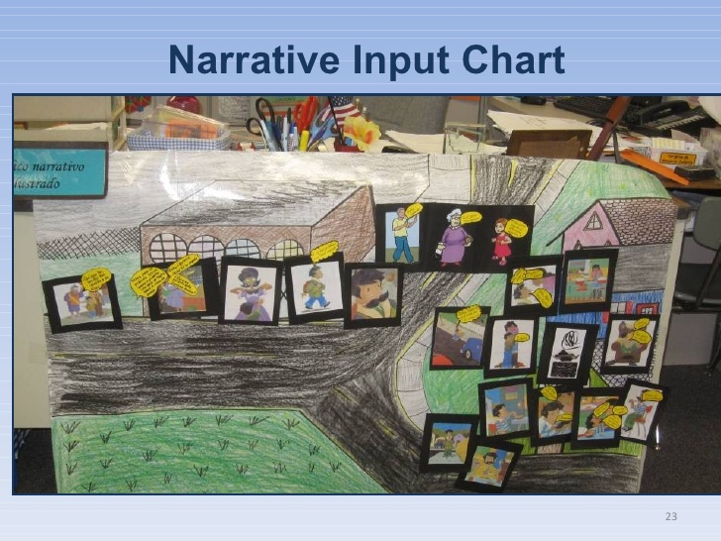
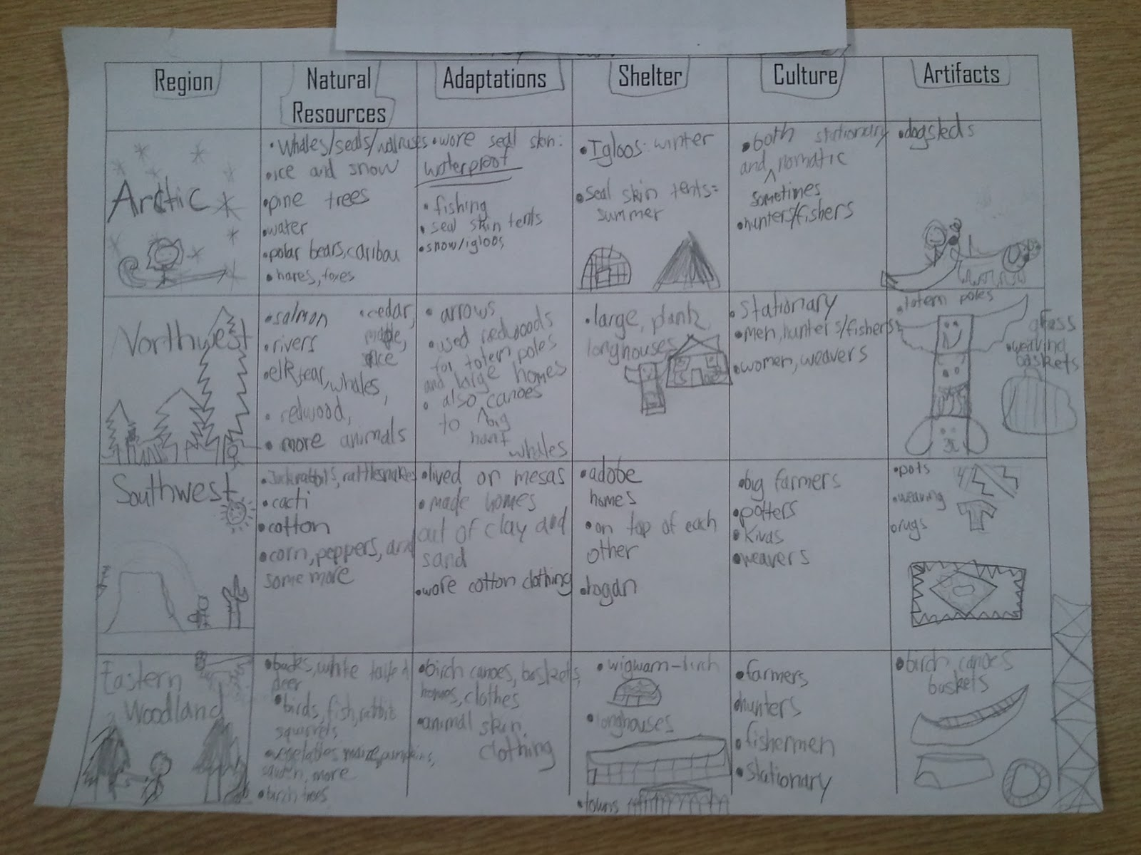
Extension learning activities for this book and other useful resources
- To help students develop their content knowledge of Native Americans, show them images from this website. Note: This is particularly supportive of English Language Learners.
  - https://www.gettyimages.com/photos/great-plains-indians?sort=mostpopular&mediatype=photography&phrase=great%20plains%20indians
- Here are other texts about this topic:
  - Levine, Ellen. If You Lived with the Iroquois. New York: Scholastic, 1998.
  - Bruchac, Joseph and James. How Chipmunk Got His Stripes. New York: Picture Puffin Books, 2003.
  - Goble, Paul. The Girl Who Loved Wild Horses. New York: Aladdin Books, 1986.
  - Littlechild, George. This Land is My Land. Emeryville, Calif: Children’s Book Press, 1993.
  - Bol, Marsha. “The Hopi of the Southwest” from North, South, East, West: American Indians and the Natural World. Pittsburgh: Carnegie Museum of Natural History and Roberts Rinehart Publishers, 1998.

What Makes This Read-Aloud Complex?
- Quantitative Measure
Go to http://www.lexile.com/ and enter the title of your read-aloud in the Quick Book Search in the upper right of home page. Most texts will have a Lexile measure in this database.

Most of the texts that we read aloud in K-2 should be in the 2-3 or 4-5 band, more complex than the students can read themselves.
2-3 band 420-820L
4-5 band 740-1010L

840
________

- Qualitative Features
Consider the four dimensions of text complexity below. For each dimension*, note specific examples from the text that make it more or less complex.
This book tells the story of a young boy who receives a Dream-Vision from the elders. The books doesn’t explicitly indicate the boy’s steps to complete his Dream-Vision, rather provides examples of the obstacles he faces to complete this Dream-Vision. Many of these examples are not literal.

The story is a creation story in the form of a narrative text.

Meaning/Purpose
Structure
Knowledge Demands
Language

There are lots of words used which have multiple meanings for which kindergarten or first grade students may not readily know the various definitions. There is also vocabulary central to Native American culture which may be unfamiliar to students.
Students should have some background of Native American culture groups, including values and how they depended on the environment to survive

*For more information on the qualitative dimensions of text complexity, visit http://www.achievethecore.org/content/upload/Companion_to_Qualitative_Scale_Features_Explained.pdf

- Reader and Task Considerations
What will challenge my students most in this text? What supports can I provide?
- Students may struggle with not understanding time and space within the story. For example, as the boy tries to complete his Dream-Vision his thoughts go between the past and the present. Teachers can map out the story by using a narrative chart to outline the activities in the story to help students keep track of events in time and space.

How will this text help my students build knowledge about the world?
- This text can be used to further extend students’ background knowledge of Native American culture groups including their values and how they depended on the earth. This story could also accompany other creation stories from Native American groups so that students learn more about how Native Americans believed the earth came to be.

- Grade level
What grade does this book best belong in? 1st as read-aloud

All content linked to within this resource was free for use when this resource was published in March 2018. Over time, the organizations that manage that external content may move or remove it or change the permissions. If the content is no longer available, please email info@studentsachieve.net.

Culminating Task Student Copy
In top left box, draw resources and objects that Little Gopher used to fulfill his Dream-Vision. In the bottom left box, draw Little Gopher’s shelter. In the right box, draw why Little Gopher is remembered as a legend by his people. Write at least one sentence to accompany each of your drawings.

