Title/Author: If You Could Go to Antarctica by Fay Robinson
Suggested Time to Spend: 5 Days (Recommendation: two sessions per day, at least 20 minutes per day)
Common Core grade-level ELA/Literacy Standards
RI.K.1, RI.K.2, RI.K.4, RI.K.6, RI.K.7, RI.K.10; W.K.2, W.K.8; L.K.4, L.K.6; SL.K.1, SL.K.2, SL.K.5, SL.K.6
Lesson Objective:
Students will listen to an illustrated informational text read aloud and used literary skills (reading, writing, discussion and listening) to understand the main idea of the text.
Teacher Instructions
Before the Lesson
- Read the Big Ideas and Key Understandings and the Synopsis below. Please do not read this to the students. This is a description to help you prepare to teach the book and be clear about what you want your children to take away from the work.
Big Ideas/Key Understandings/Focusing Question
Why are the animals that live in the Antarctic amazing? One key takeaway is that the continent of Antarctica has distinct plant, animal and climate features.

Synopsis
This text takes students on an imaginary journey to Antarctica, introducing them to some of the animals and plants they might encounter if they were to go to that continent. They are presented with information about icebergs, penguins, seals and whales, and the scientists who study this biome.
- Go to the last page of the lesson and review “What Makes This Read-Aloud Complex.” This was created for you as part of the lesson and will give you guidance about what the lesson writers saw as the sources of complexity or key access points for this book. You will of course evaluate text complexity with your own students in mind, and make adjustments to the lesson pacing and even the suggested activities and questions.
- Read the entire book, adding your own insights to the understandings identified. Also note the stopping points for the text-inspired questions and activities. Hint: you may want to copy the questions vocabulary words and activities over onto sticky notes so they can be stuck to the right pages for each day’s questions and vocabulary work.

Note to teachers of English Language Learners (ELLs): Read Aloud Project Lessons are designed for children who cannot read yet for themselves. They are highly interactive and have many scaffolds built into the brief daily lessons to support reading comprehension. Because of this, they are filled with scaffolds that are appropriate for English Language Learners who, by definition, are developing language and learning to read (English). This read aloud text includes complex features which offer many opportunities for learning, but at the same time includes supports and structures to make the text accessible to even the youngest students.
This lesson includes features that align to best practices for supporting English Language Learners. Some of the supports you may see built into this, and /or other Read Aloud Project lessons, assist non-native speakers in the following ways:

- These lessons include embedded vocabulary scaffolds that help students acquire new vocabulary in the context of reading. They feature multi-modal ways of learning new words, including prompts for where to use visual representations, the inclusion of student-friendly definitions, built-in opportunities to use newly acquired vocabulary through discussion or activities, and featured academic vocabulary for deeper study.
- These lessons also include embedded scaffolds to help students make meaning of the text itself. It calls out opportunities for paired or small group discussion, includes recommendations for ways in which visuals, videos, and/or graphic organizers could aid in understanding, provides a mix of questions (both factual and inferential) to guide students gradually toward deeper understanding, and offers recommendations for supplementary texts to build background knowledge supporting the content in the anchor text.
- These lessons feature embedded supports to aid students in developing their overall language and communication skills by featuring scaffolds such as sentence frames for discussion and written work (more guidance available here) as well as writing opportunities (and the inclusion of graphic organizers to scaffold the writing process). These supports help students develop and use newly acquired vocabulary and text-based content knowledge.

The Lesson – Questions, Activities, and Tasks

Questions/Activities/Vocabulary/Tasks | Expected Outcome or Response (for each)
FIRST READING:  - Students partner talk the title, author and illustrator of the story.  - Read aloud the entire book (or chapter) with minimal interruptions. Stop to provide word meanings or clarify only when you know the majority of your students will be confused. | The goal here is for students to enjoy the book, both writing and pictures, and to experience it as a whole. This will give them some context and sense of completion before they dive into examining the parts of the book more carefully.
SECOND READ:  Pages 4-5:  - How does the author help you understand that Antarctica is a cold place?  Pages 8-9:  - What are icebergs?  - What does the picture show us?  Pages 10-11:  - What is unusual about penguins?  - What are layers of oily feathers?  Pages 14-15:  - What does the author say blubber is?  - Why do the seals have blubber?  Page 16:  - What does lunging mean?  - What does the picture show us?  - Why does the author say that these whales are acrobatic?  Page 21:  Who works in Antarctica?  Why don’t people live there all the time? | Pages 4-5:  - Act out cold, putting on your hats, boots, coat and mittens.  - The author says that even though you would need your thickest coat, you would probably still shiver. The temperature almost never gets above 32 degrees F.  - The author says it’s the coldest place on Earth.  - The author says that we would still shiver. Antarctica is the coldest place on earth. (Have students act out shivering)  Pages 8-9:  - The picture shows us that Icebergs are chunks of snowy ice that fall into the sea. Students turn and tell their partners what icebergs are.  Pages 10-11:  - They don’t fly, they swim. They have oily feathers; they slide across the ice on their bellies. Most birds don’t do these things.  - Act out putting on layers of feathers. Act out what oily feels like. Teacher could have a few feathers available and dip them into cooking oil so that students can see and feel them. Have students turn and talk to their partners about what oily feathers are.  Pages 14-15:  - The author says that blubber is a thick layer of fat to keep the seals warm in the cold water.  Page 16:  - The picture shows us the whale jumping up.  - Have students act out lunging using their hands as a whale. Students turn and tell their partners what lunging means.  - To do acrobatics means to do any tricks requiring great skill. It takes great skill for the whales to be able to jump their large bodies out of the water.  - Scientist work in Antarctica. They study the plants and animals.  - It is too cold for people to live there all of the time.
THIRD READING:  - Why are the animals that live in the Antarctic amazing?  Have students turn and talk, taking turns asking and answering questions with a partner using the sentence frames and filling in the information on the graphic organizer.  Another idea is to have the students take notes by drawing pictures on index cards and taping them onto the chart. That way they can “read” their notes easily when it comes time to write. When you get to the page about penguins, you put on a picture of a penguin under the word. Then you ask what evidence do you see that helps us answer the focus statement; Penguins are amazing Antarctic animals. As students respond ask someone to “take notes” by drawing a quick sketch for our chart. Put it on the chart next to the words. Each “note” drawing could be done by a different student or pairs of students.  (Teacher and students demonstrate 50 feet long by counting out steps across the room or outside in the hallway.) | Chart student responses:  What is an amazing Antarctic animal?  ____________ are amazing Antarctic animals.  Why are _________ amazing?  They _______________________.  Animal They…  penguins gather in huge groups. lay their eggs. raise their chicks. don’t fly. zoom through the water. have oily feathers. slide on their bellies.  seals live in ice-cold waters. have blubber. teach their pups to swim. have large eyes.  whales lunge up from the water. visit Antarctica in the summer. can be 50 feet long.
FOURTH READING AND BEYOND:  Compliment students on how carefully they have been reading the book and explain that today you will continue to explore If You Could Go to Antarctica.  Reread from page 10 to 17 without stopping, inviting students to participate by acting out actions for the animal when it is described in the text. Call on a few students to retell something about each animal. Then have students turn and retell the fact to their partners.  Review the chart from the Third Read. Have students give their responses using sentence frames with information. | During this reading, use strategically placed pauses to encourage students to use the rhyme pattern to help you finish some of lines in the poem.  If helpful, use the class notes to help students concisely summarize.
Culminating Task
- Students use the graphic organizers they have created throughout the close reading of this book (days 2 – 4) to help them write two sentences with illustrations about the special features of an animal living in Antarctica. Students should write about one animal and at least one fact about that animal using vocabulary words from the text.
- Talking It to Writing: Students will practice asking and answering questions about their chosen animal using the following sentence frames.
  - Question/Answer Sentence Frames:
A: Why are animals that live in Antarctica amazing?
B: __________ are amazing because they _____________.
A: What do ________________ do?
(noun – animals)
B: They _______________.
(animal fact)

Name: ____________________________________________________
Culminating Activity
Animals that live in Antarctica are amazing.
___________________________________________________________ are amazing.
They__________________________________________________________________
______________________________________________________________________.

Culminating Activity
Animals that live in Antarctica are amazing.
_________________Penguins_____________________________ are amazing.
They ____(lay eggs and raise their chicks/don’t fly/slide across the ice on their bellies/have a thick layer of fat called blubber)________________.
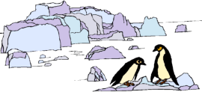

Culminating Activity (Optional Extension)
If you could go to Antarctica, what might you see?
I might see _____________________________________________________________.
________________________________ are unusual because they _________________
_______________________________________________________________________.

Culminating Activity (Optional Extension)
If you could go to Antarctica, what might you see?
I might see ___________penguins____________.
___Penguins_________ are unusual because they ________ (lay eggs and raise their chicks/don’t fly/slide across the ice on their bellies/have a thick layer of fat called blubber)________________,

Vocabulary
These words merit less time and attention  (They are concrete and easy to explain, or describe events/  processes/ideas/concepts/experiences that are familiar to your students.) | These words merit more time and attention  (They are abstract, have multiple meanings, and/or are a part  of a large family of words with related meanings. These words are likely to describe events, ideas, processes or experiences that most of your student will be unfamiliar with)
Page 3: continent- any of the main large land areas of the earth. South Pole (point to illustrations)- the southern end of the earth’s axis.  Page 5: shiver (act out)- to shake or tremble from fear or cold  Page 9: iceberg- a great mass of ice broken from a glacier and floating in the sea.  Floating (point to illustrations and act out)- staying on the surface of a liquid  Page 10: penguins- a flightless bird with webbed feet and flippers for swimming  Zoom- to move quickly upward or forward  Oily- greasy  Gather- to bring together in one place or group  Raise (point to illustrations and act out)- lift up  Page 14: blubber –whale fat  Pups- young babies  Solid – firm or hard substance  Page 16: lunging- a sudden plunge forward  Acrobatic (act out)- any tricks requiring great skill  Page 19: moss- tiny green plants growing in clusters on rocks  Melts- to change from a solid to a liquid | Page 2: could- is able to  Page 6: would – future event  Page 12: layer – a single thickness  Page 14: might – may do  Page 21: unusual – not common, rare

Extension learning activities for this book and other useful resources
- Students use the graphic organizers they have created throughout the close reading of this book (days 2 – 4) to help them create an explanatory/informative book with illustrations about the special features of creatures living in Antarctica. Students should include 3-5 animals with details about each of them using vocabulary words from the text. Note: This is particularly supportive of English Language Learners.
Topic Sentence: There are many unusual creatures living in Antarctica.
Sentence Frame: A _____ is unusual because ______.

Note to Teacher
- Teachers can point out the text features such as the title, map, sidebars/text boxes and pictures.
- Resources for building background knowledge and vocabulary:
  - Penguins Falling & Whales Jumping: https://www.youtube.com/watch?v=DGhy_Wysccs
  - Animals in the Antarctic Ice (1st minute only): https://www.youtube.com/watch?v=UoVe1Zuj3X8
  - Penguins in Antarctica: https://www.youtube.com/watch?v=mj0_p7UldVs
- Remind students of parameters of partner talk, as necessary.
- If students are not accustomed to Sentence Frames, show them how to use the frames, and remind them of the importance of listening to what their partner says. These frames are useful for EL or struggling students. Using a sentence frame is not just giving students “chances to talk,” but boosting up academic language. A sentence frame is more than “modeling” a correct response. It “unpacks” it for students and demonstrates a pattern that struggling students don’t tend to see themselves. A scaffolded sentence frame begins as a sentence starter, but adds support, enabling students to produce a competent verbal or written response in an appropriate academic register. By assigning partners and having precise tasks in which each partner will be engaged, all students are explicitly practicing academic language. Each student should always have a job. While Partner A is completing the sentence frame, Partner B should be actively listening. (Use the 4 L’s: Look, Lean, Lower Voice, Listen) Students should complete the frames with two or three words introduced during the lesson.

http://www.firstpalette.com/tool_box/printables/antarcticanimals.pdf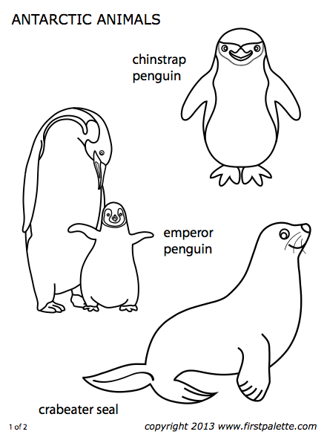
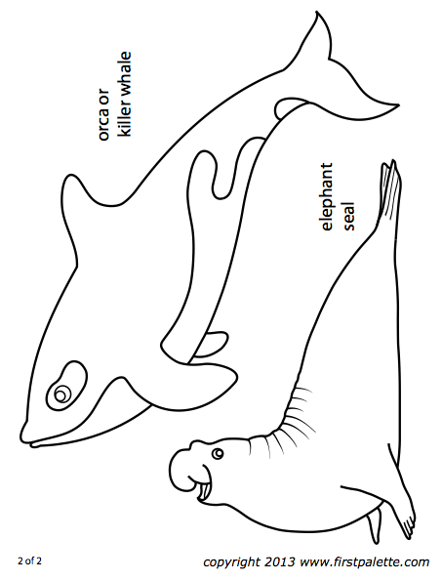
What Makes This Read-Aloud Complex?
- Quantitative Measure
Go to http://www.lexile.com/ and enter the title of your read-aloud in the Quick Book Search in the upper right of home page. Most texts will have a Lexile measure in this database.

Most of the texts that we read aloud in K-2 should be in the 2-3 or 4-5 band, more complex than the students can read themselves.
2-3 band 420-820L
4-5 band 740-1010L

_____N/A___

- Qualitative Features
Consider the four dimensions of text complexity below. For each dimension*, note specific examples from the text that make it more or less complex.

Unusual plants and animals facts about Antarctica
Imaginary journey
Would/could you go?
Fold down information in corner
If you could – often on left page
Fact on right page
Could/would/might
Figurative language: as __ as, __ like __, almost…
Split layers land huge

Some students may need background on location on a map, boat travel, cold weather, climate, ecosystem, biome

Meaning/Purpose
Structure

Knowledge Demands
Language

*For more information on the qualitative dimensions of text complexity, visit http://www.achievethecore.org/content/upload/Companion_to_Qualitative_Scale_Features_Explained.pdf

- Reader and Task Considerations
What will challenge my students most in this text? What supports can I provide?
The structure with could, would, might will be a challenge. Possible sentence frames to practice.
What could you do? I could ___. What would you do? I would ___. What might you do? I might ____.

How will this text help my students build knowledge about the world?
Facts about Antarctica/different climate/ecosystem/biome

- Grade level
What grade does this book best belong in? K-1

All content linked to within this resource was free for use when this resource was published in March 2018. Over time, the organizations that manage that external content may move or remove it or change the permissions. If the content is no longer available, please email info@studentsachieve.net.

