Grade 1, Topic 1: Solve Addition and Subtraction Problems to 10

Standards addressed | Primary in this topic:  1.OA.A.1: Use addition and subtraction within 20 to solve word problems involving situations of adding to, taking from, putting together, taking apart, and comparing, with unknowns in all positions, e.g., by using objects, drawings, and equations with a symbol for the unknown number to represent the problem.  Secondary in this topic:  1.OA.D.8: Determine the unknown whole number in an addition or subtraction equation relating three whole numbers. For example, determine the unknown number that makes the equation true in each of the equations 8 + ? = 11, 5 = ? – 3, 6 + 6 = ?.
Aspects of Rigor targeted by the standards | Primary in this topic:  Application, Conceptual Understanding
Applicable information from the progression documents | 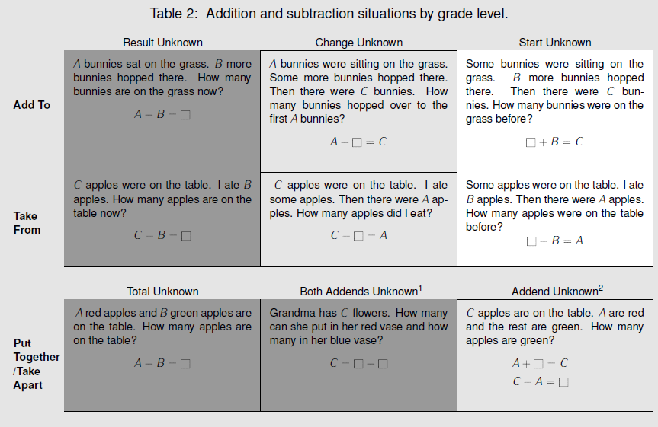  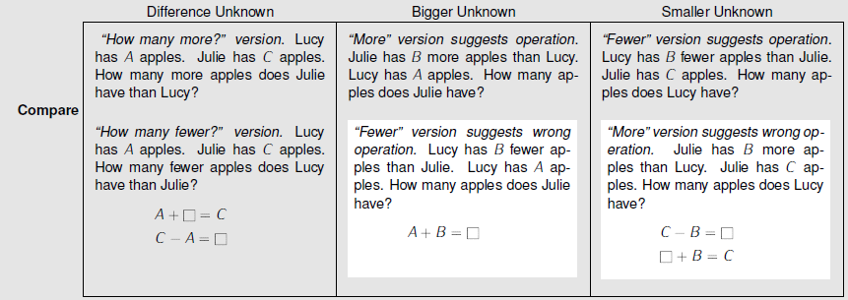  Darker shading indicates the four kindergarten problem subtypes. Grade 1 and 2 students work with all subtypes and variants. Unshaded (white) problems are the four difficult subtypes or variants that students should work with in grade 1 but need not master until grade 2. Adapted from CCSS, p. 88, which is based on Mathematics Learning in Early Childhood: Paths Toward Excellence and Equity, National Research Council, 2009, pp. 32–33.
Essential Question(s) | How can I represent and solve problems involving addition and subtraction within 20?

Anchor Tasks
Task | Explanation
1-2 Solve and Share | Reviews kindergarten problem type but with magnitude up to 20 (Starting with 1-2 because 1-1 is aligned to kindergarten expectations).
1-3 Solve and Share | Reviews kindergarten problem type but with magnitude up to 20.
1-4 Solve and Share | Reviews kindergarten problem type but with magnitude up to 20.
1-8 Solve and Share | Introduces the “Put Together/Take Apart” problem type after the review of kindergarten problem types is 1-1 to 1-4; allows students to make the connection between related types of problems.
1-5 Solve and Share | Provides opportunity to engage with new problem type.
1-6 Solve and Share | Provides opportunity to engage with new problem type.
1-7 Solve and Share | Provides opportunity to engage with new problem type.
Mixed Practice on 1.0A.A.1 | Provides opportunity for students to engage in MP.1 and make sense of a variety of problem types.

Topic Rules of Thumb
Rule | Why?
Increase the magnitude of the numbers in the problems from Lessons 1-1 to 1-4 to align to the grade 1 expectation for sums within 20. | Lessons 1–4 focus on problem types that students solved in kindergarten within 10 (K.OA.A.2). 1.OA.A.1 requires students to solve these problems within 20.  This will also serve as a formative assessment for students’ strategies for addition and subtraction which are the focus of Topics 2–4.
Be sure students complete problems in the “Math Practices and Problem Solving” section to provide opportunities for students to make sense of a mix of problem types. | MP1- Mathematically proficient students start by explaining to themselves the meaning of a problem and looking for entry points to its solution. They analyze givens, constraints, relationships, and goals. They make conjectures about the form and meaning of the solution and plan a solution pathway rather than simply jumping into a solution attempt.  (See p. 17 in the OA Progressions.)
Do not require students to write an equation to represent every story problem. Remove fill-in-the-blank equations, especially those with the addition or subtraction sign given, to focus more on students making sense of and solving the given problem. | Enhance opportunities for MP1 - “Mathematically proficient students start by explaining to themselves the meaning of a problem and looking for entry points to its solution … Younger students might rely on using concrete objects or pictures to help conceptualize and solve a problem.”
When writing equations to record student thinking, vary how equations are constructed to build understanding of the meaning of the equal sign (e.g., recording 5 = 4 +1 and 4 +1 = 5). | “Equations with one number on the left and an operation on the right (e.g., 5 = 2 + 3 to record a group of 5 things decomposed as a group of 2 things and a group of 3 things) allow students to understand equations as showing in various ways that the quantities on both sides have the same value. MP6”  (See p. 10 in the OA Progressions.)

Assessment Guidance, Topic 1
- Topic Assessment
Performance Assessment
Item #/Action | Why?
- As Is
- Modify: Delete text: “Write an equation that tells about the story” and the blanks for the equation. | Does not align to the central concern of 1.OA.A.1.
- Delete | Item is not aligned to 1.OA.A.1.
- As Is
- As Is
- As Is
- Modify: Delete text: “Which equations show the story? Choose all that apply.” and answer choices. | Does not align to the central concern of 1.OA.A.1.
- Delete | Item is not aligned to 1.OA.A.1.
9. Modify: Only use word problem, “Jennifer has 6 hair...How many bands does Jennifer have?” | Does not align to the central concern of 1.OA.A.1.
10. Modify: Delete picture and answer choices. | Does not align to the central concern of 1.OA.A.1.
11. As Is
12. Modify: Delete picture and answer choices. | Does not align to the central concern of 1.OA.A.1.

Grade 1, Topic 2: Fluently Add and Subtract Within 10

Standards addressed | Primary in this topic:  1.OA.B.3: Apply properties of operations as strategies to add and subtract.2 Examples: If 8 + 3 = 11 is known, then 3 + 8 = 11 is also known. (Commutative property of addition.) To add 2 + 6 + 4, the second two numbers can be added to make a ten, so 2 + 6 + 4 = 2 + 10 = 12. (Associative property of addition.)  1.OA.C.5: Relate counting to addition and subtraction (e.g., by counting on 2 to add 2).  1.OA.C.6: Add and subtract within 20, demonstrating fluency for addition and subtraction within 10. Use strategies such as counting on; making ten (e.g., 8 + 6 = 8 + 2 + 4 = 10 + 4 = 14); decomposing a number leading to a ten (e.g., 13 - 4 = 13 - 3 - 1 = 10 - 1 = 9); using the relationship between addition and subtraction (e.g., knowing that 8 + 4 = 12, one knows 12 - 8 = 4); and creating equivalent but easier or known sums (e.g., adding 6 + 7 by creating the known equivalent 6 + 6 + 1 = 12 + 1 = 13).  Secondary in this topic:  1.OA.B.4: Understand subtraction as an unknown-addend problem. For example, subtract 10 - 8 by finding the number that makes 10 when added to 8.  1.OA.D.8: Determine the unknown whole number in an addition or subtraction equation relating three whole numbers. For example, determine the unknown number that makes the equation true in each of the equations 8 + ? = 11, 5 = _ - 3, 6 + 6 = _.
Aspects of Rigor targeted by the standards | Primary in this topic:  Conceptual Understanding, Procedural Skill and Fluency
Applicable information from the progression documents | Unlike counting down, counting on reinforces that subtraction is an unknown-addend problem. Learning to think of and solve subtractions as unknown addend problems makes subtraction as easy as addition (or even easier), and it emphasizes the relationship between addition and subtraction. (See p.15 in the OA Progressions.)  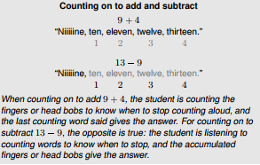  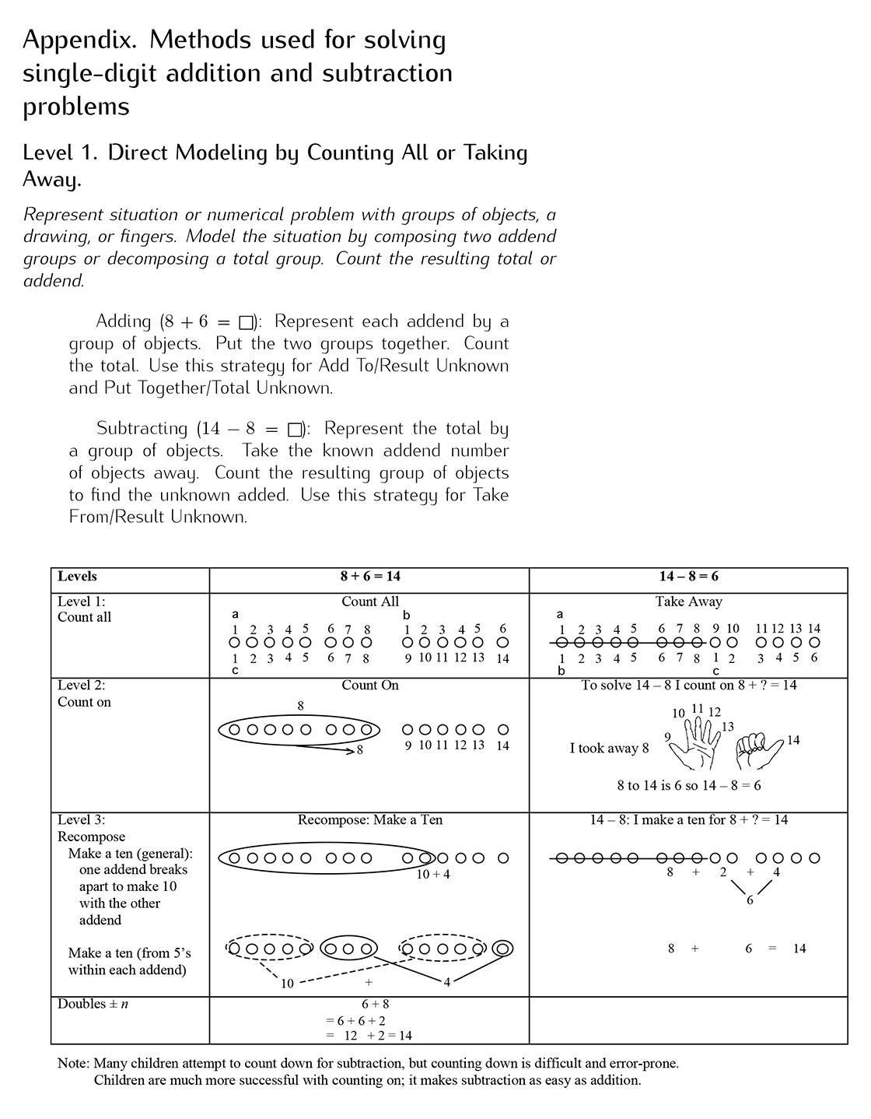  (See p. 6 in the OA Progressions.)
Essential Question(s) | What strategies can you use while adding and subtracting?  How do you decide which strategy can help you add or subtract?
Anchor Tasks
Task | Explanation
2-1 Visual Learning Bridge (problem with visual only) | Encourages counting on through set-up of problem.
Illustrative Mathematics Unit 3 Lesson 4 Sums of 10 | Offers more practice with 1.OA.C.5 and 1.OA.C.6
2-2 Solve and Share | Provides opportunity to see which facts students know from memory.
Domino Addition | Introduces commutative property while strengthening addition strategies.
2-4 Solve & Share | Introduces visual model related to place value.
Grade 1, Module 1, Lesson 26 | Provides opportunity to introduce the counting on strategy referenced in the progression.
Grade 1, Module 1, Lesson 27 | Provides opportunity to develop the counting on strategy referenced in the progression.
Module 1, Lesson 26 (lesson about “counting on” as a strategy to subtract) | Provides opportunity to introduce the counting on strategy referenced in the progression.
2-7 Solve & Share (Just present first paragraph of the problem.) | Provides opportunity for students to connect addition and subtraction.
2-9 Solve & Share (Do not require students to write an addition equation.) | Provides opportunity to connect addition/subtraction to missing addend problems in Topic 1.

Topic Rules of Thumb
Rule | Why?
Don’t require students to use a specific strategy in each lesson for Lessons 2-2 to 2-4, but rather use these three lessons as an opportunity for students to make sense of the strategies and apply them to appropriate addition problems. Emphasize the ten frame. | 1.OA.A.6 lists possible strategies students may use to add, but does not require a specific strategy.  Doubles and near doubles strategies do not connect to place value the way that make-10 methods do. (See pp. 15–16 in the CC/OA Progressions.)  (Contrasts Level 3 strategies -- near doubles vs. make a ten.)  Ten frames tie directly to 1.NBT.B.2.A.
Don’t require students to use a specific model or strategy in each lesson for Lessons 2-6 to 2-9, but rather emphasize counting on and the relationship between addition and subtraction. Use these four lessons as an opportunity for students to make sense of the strategies and apply them to appropriate subtraction problems. | 1.OA.A.6 lists possible strategies students may use to subtract, but does not require a specific strategy.  Ease and utility of the counting on strategy is a way of solving subtraction problems.  (See p. 15 in the CC/OA Progressions.)

Assessment Guidance, Topic 2
- Topic Assessment
Performance Assessment
Item #/Action | Why?
- Modify: Write in number sentence “4 + 3 = ___” | Item requires Application.
- Modify: Replace 10 frame with number sentence “2 + 6 = ___” | Item requires Application. Item requires a specific model.
- Modify: Delete text “How can you count on to find the answer?”  Write in number sentence “3 + 3 = ____.” | Item requires Application. Item requires a specific model.
- Modify: Delete everything but the number sentence. | Item requires a specific model, specifically the number line.
- Delete | Item requires a specific model.
- As Is | Note: Review of 1.OA.A.1 from Topic 1
- As Is
- As Is
9. Delete | Item requires a specific model.
10. Modify: Delete everything but the number sentence. | Item requires a specific model.
11. Modify: Replace 10 frame with number sentence “2 + 5 = ___” | Item requires Application. Item requires a specific model.
12. As Is | Note: Review of 1.OA.A.1 from Topic 1
13. Delete | Repeats addition problem from question #3.
14. Modify: Delete everything but the number sentence. | Item requires Application.
15. As Is
16. Delete | Item requires students to find all combinations of a number.

Grade 1, Topic 3: Addition Facts to 20: Use Strategies

Standards addressed | Primary in this topic:  1.OA.C.5: Relate counting to addition and subtraction (e.g., by counting on 2 to add 2).  1.OA.C.6: Add and subtract within 20, demonstrating fluency for addition and subtraction within 10. Use strategies such as counting on; making ten (e.g., 8 + 6 = 8 + 2 + 4 = 10 + 4 = 14); decomposing a number leading to a ten (e.g., 13 – 4 = 13 – 3 – 1 = 10 – 1 = 9); using the relationship between addition and subtraction (e.g., knowing that 8 + 4 = 12, one knows 12 – 8 = 4); and creating equivalent but easier or known sums (e.g., adding 6 + 7 by creating the known equivalent 6 + 6 + 1 = 12 + 1 = 13).  Secondary in this topic:  1.OA.A.1: Use addition and subtraction within 20 to solve word problems involving situations of adding to, taking from, putting together, taking apart, and comparing, with unknowns in all positions, e.g., by using objects, drawings, and equations with a symbol for the unknown number to represent the problem.
Aspects of Rigor targeted by the standards | Primary in this topic:  Procedural Skill and Fluency, Conceptual Understanding  Secondary in this topic:  Application
Applicable information from the progression documents | Students might use the commutative property of addition to change ? + 6 = 15 to 6 + ? = 15, then count on or use methods to compose 4 (to make ten) plus 5 (ones in the 15) to find 9. Students might reverse the action in the situation represented by ? - 6 = 9 so that is becomes 9 + 6 = ?. Or they might use their knowledge that the total is the first number in a subtraction equation and the last number in an addition equation to rewrite the situation equation as a solution equation: ? - 6 = 9 becomes 9 + 6 = ? or 6 + 9 = ?.  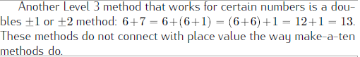  (See p. 36 in the OA Progressions.)
Essential Question(s) | How do you decide which strategy can help you add?  What strategies can you use while adding?

Anchor Tasks
Task | Explanation
3-10 Solve and Share  (use as formative assessment) | Provides opportunity to formatively assess students’ strategies for adding within 20.
3-1 Solve and Share | Provides opportunity for a variety of strategies to add within 20.
3-4 or 3-5 Solve and Share (Take out the step where students have to name the doubles fact.) | Doubles plus 1 and 2 are related to developing fluency within 20 and will be addressed in grade 2.
3-6 Solve and Share  (Utilize a double ten frame.) | Provides opportunity to highlight make 10 strategy for addition; connects to subtraction work in Topic 2.
3-7 Solve and Share | Aligns to make 10; allows for different ways to show how that strategy could be modeled.
3-8 Solve and Share  (Just give students 9+6 and ask students to explain.) | Problem allows for multiple models/strategies to solve problem. Take out visual models of strategies to be less prescriptive and allow more discretion to emphasize preferred strategy
3-9 Solve and Share | Reviews Topic 1 work of 1.OA.A.1 with numbers within 20.

Topic Rules of Thumb
Rule | Why?
Don’t require students to use a specific strategy in each lesson across Lessons 3-1 to 3-7. Use these lessons as an opportunity to highlight strategies that are generalizable (e.g., make ten) while continuing to allow them to select strategies that make sense to them as they work to solve appropriate addition problems. Doubles strategies should be de-emphasized, and lessons focusing on them can be condensed. | 1.OA.A.6 lists possible strategies students may use to add, but does not require a specific strategy.  Doubles and near doubles strategies do not connect to place value the way that make-10 methods do. (See pp. 15–16 in the OA Progressions.)  (Contrasts Level 3 strategies -- near doubles vs. make a ten.)  Ten frames tie directly to 1.NBT.B.2.A.  Strategies related to tens (e.g., ten frames, make ten, etc.) tie directly to 1.NBT.B.2.A.
Emphasize the strategy of counting on in Lessons 3-1 and 3-2 but not using the number line as a model. | The number line is not introduced in the standards until 2.MD. Counting on is explicitly called for in 1.OA.5.  Counting on is a versatile and important strategy for addition and subtraction.  (See pp.14–15 in the OA Progressions.)
Lesson 3-6 introduces Making a Ten to add, which is a strategy that should be highlighted throughout the unit and connected to the work students did in 2-10. | There is a connection between make a ten strategies for addition and subtraction and place value.  (See p. 16 in the OA Progressions)

Assessment Guidance, Topic 3
- Topic Assessment
Performance Assessment
Item #/Action | Why?
1. As Is
2. As Is
3. Modify: Only give number sentence “8+ 6 = ___” | Item requires use of the number line.
4. Delete | Item requires students to name strategies.
5. As Is
6. Delete | Item requires students to name strategies.
7. Modify: Only give number sentence “8 + 9 =___” | Does not align to the central concern of 1.OA.C.6.
8. As Is
9. Modify: Only give number sentence “7 + 4 = ___” | Does not align to the central concern of 1.OA.C.6.
10. As Is
11. As Is

Grade 1, Topic 4: Subtraction Facts to 20: Use Strategies

Standards addressed | Primary in this topic:  1.OA.B.4: Understand subtraction as an unknown-addend problem. For example, subtract 10 - 8 by finding the number that makes 10 when added to 8.  1.OA.C.6: Add and subtract within 20, demonstrating fluency for addition and subtraction within 10. Use strategies such as counting on; making ten (e.g., 8 + 6 = 8 + 2 + 4 = 10 + 4 = 14); decomposing a number leading to a ten (e.g., 13 – 4 = 13 – 3 – 1 = 10 – 1 = 9); using the relationship between addition and subtraction (e.g., knowing that 8 + 4 = 12, one knows 12 – 8 = 4); and creating equivalent but easier or known sums (e.g., adding 6 + 7 by creating the known equivalent 6 + 6 + 1 = 12 + 1 = 13).  Secondary in this topic:  1.OA.A.1: Use addition and subtraction within 20 to solve word problems involving situations of adding to, taking from, putting together, taking apart, and comparing, with unknowns in all positions, e.g., by using objects, drawings, and equations with a symbol for the unknown number to represent the problem.  1.OA.C.5: Relate counting to addition and subtraction (e.g., by counting on 2 to add 2).
Aspects of Rigor targeted by the standards | Primary in this topic:  Conceptual Understanding  Secondary in this topic:  Procedural Skill and Fluency
Applicable information from the progression documents | Counting on should be seen as a thinking strategy, not a rote method. It involves seeing the first addend as embedded in the total, and it involves a conceptual interplay between counting and the cardinality in the first addend (shifting from the cardinal meaning of the first addend to the counting meaning). Finally, there is a level of abstraction involved in counting on, because students are counting the words rather than objects. Number words have become objects to students.  This [Level 3] method can also be used to subtract by finding an unknown addend: 14 - 8 = ?, so 8 + ? = 14, so 14 =8 + 2 + 4 = 8 + 6, that is 14 – 8 = 6. Students can think as for adding above (stopping when they reach 14), or they can think of taking 8 from 10, leaving 2 with the 4, which makes 6. One can also decompose with respect to ten: 13 - 4 = 13 - 3 - 1 = 10 - 1 = 9, but this can be more difficult than the forward methods.  Put Together/Take Apart problems with Addend Unknown afford students the opportunity to see subtraction as the opposite of addition in a different way than as reversing the action, namely as finding an unknown addend. The meaning of subtraction as an unknown-addend addition problem is one of the essential understandings students will need in middle school in order to extend arithmetic to negative rational numbers.  Counting on for subtraction is easier than counting down. Also, unlike counting down, counting on reinforces that subtraction is an unknown-addend problem. Learning to think of and solve subtractions as unknown addend problems makes subtraction as easy as addition (or even easier), and it emphasizes the relationship between addition and subtraction. The taking away meaning of subtraction can be emphasized within counting on by showing the total and then taking away the objects that are at the beginning. In a drawing this taking away can be shown with a horizontal line segment suggesting a minus sign. So one can think “Taking away” indicated with horizontal line segment and solving by counting on to 13 of the 9 l 13 situation as “I took away 9. I now have 10, 11, 12, 13 [stop when I hear 13], so 4 are left because I counted on 4 from 9 to get to 13.” Taking away objects at the end suggests counting down, which is more difficult than counting on.  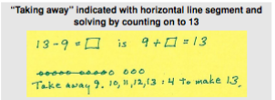  (See pp. 14–16, and 39 in the CC/OA Progressions document for additional detail on the Levels of Thinking and student movement through the levels toward fluency for subtraction.)
Essential Question(s) | How do you decide which strategy can help you subtract?  What strategies can you use while subtracting?

Anchor Tasks

Task | Explanation
4-1 Solve and Share (Remove number line.) | Provides opportunity to connect to work with subtraction within 10 in Topic 2.
4-3 Solve and Share | Provides opportunity for students to use counting up and the ten frame to develop the Make a Ten strategy.
4-4 Solve and Share | Emphasizes relationship between addition and subtraction.
4-5 Solve and Share  (Only present subtraction equation: 12 - 9 = ?) | Emphasizes relationship between addition and subtraction.
4-7 Solve and Share | Provides Opportunity for student to choose a strategy to subtract.
4-8 Solve and Share | Provides opportunity to connect 1.OA.B.4, 1.OA.C.6 and 1.OA.A.1.

Topic Rules of Thumb
Rule | Why?
4-1 to 4-7 introduce different strategies and models for subtraction within 20. Students shouldn’t be required to use a specific model or strategy in each lesson. Directions should match those in “Independent Practice” on p. 269 (“Choose a strategy to find each difference”). | 1.OA.A.6 lists possible strategies students may use to subtract, but does not require a specific strategy.  There are multiple level 2 and level strategies for solving addition and subtraction problems, but does not require the use of a specific strategy.  (See p. 14 in the OA Progressions.)
4-2 and 4-3 are an opportunity to use the structure of 10 and visual models to connect to the make ten strategy. Provide students with a double ten frame (Teaching Tool 16) throughout the Topic.  (See Intervention Activity in 4-3 for an example of connecting visual model to equations.) | Make-a-ten methods connect with place value which sets the stage for work in 1.NBT.B.2.  (See p. 16 in the OA progressions.)

Assessment Guidance, Topic 4
- Topic Assessment
Performance Assessment
Item #/Action | Why?
- As Is
- As Is
- As Is
- As Is
- Modify: Only present number sentence “12 - 8 = ___” | Does not align to the central concern of 1.OA.C.6.
- Delete | Does not align to 1.OA.C.6.
- Delete | Item does not require students to solve word problems.
- As Is
- Modify: Only present number sentence “15 - 6 = ___” | Does not align to the central concern of 1.OA.C.6.
10. Modify: Only present number sentence “15 - 8 = ___” | Does not align to the central concern of 1.OA.C.6.
11. As Is
12. As Is

Grade 1, Topic 5: Work with Addition and Subtraction Equations

Standards addressed | Primary in this topic:  1.OA.A.2: Solve word problems that call for addition of three whole numbers whose sum is less than or equal to 20, e.g., by using objects, drawings, and equations with a symbol for the unknown number to represent the problem.  1.OA.D.7: Understand the meaning of the equal sign, and determine if equations involving addition and subtraction are true or false. For example, which of the following equations are true and which are false? 6 = 6, 7 = 8 - 1, 5 + 2 = 2 + 5, 4 + 1 = 5 + 2.  Secondary in this topic:  1.OA.A.1: Use addition and subtraction within 20 to solve word problems involving situations of adding to, taking from, putting together, taking apart, and comparing, with unknowns in all positions, e.g., by using objects, drawings, and equations with a symbol for the unknown number to represent the problem.  1.OA.B.3: Apply properties of operations as strategies to add and subtract. Examples: If 8 + 3 = 11 is known, then 3 + 8 = 11 is also known. (Commutative property of addition.) To add 2 + 6 + 4, the second two numbers can be added to make a ten, so 2 + 6 + 4 = 2 + 10 = 12. (Associative property of addition.)  1.OA.D.8: Determine the unknown whole number in an addition or subtraction equation relating three whole numbers. For example, determine the unknown number that makes the equation true in each of the equations 8 + ? = 11, 5 = _ - 3, 6 + 6 = _.
Aspects of Rigor targeted by the standards | Primary in this topic:  Conceptual Understanding, Procedural Skill and Fluency, Application
Applicable information from the progression documents | Linking equations to concrete materials, drawings, and other representations of problem situations affords deep and flexible understandings of these building blocks of algebra.  (See p. 13 in the OA Progressions.)  The advance from Level 1 methods to Level 2 methods can be clearly seen in the context of situations with unknown addends. These are the situations that can be represented by an addition equation with one unknown addend, e.g., 9 + ? = 13. Students can solve some unknown addend problems by trial and error or by knowing the relevant decomposition of the total. But a Level 2 counting on solution involves seeing the 9 as part of 13, and understanding that counting the 9 things can be “taken as done” if we begin the count from 9.  (See p. 14 in the OA Progressions.)
Essential Question(s) | How can you decide if an equation is true or false?  What are some strategies you can use to help you add three numbers?

Anchor Tasks
Task | Explanation
5-1 Solve and Share | Provides opportunity to connect to work with the relationship between addition and subtraction in Topics 2 and 4.
Equality Number Sentences (record multiple correct equations for each pair of cards) | Provides opportunity to consider the meaning of the equal sign and relate that to decomposing numbers.
5-3 Solve and Share | Provides opportunity to consider the meaning of the equal sign.
Valid Equalities? | Allows more opportunity for practice with the meaning of the equal sign.
5-4 or 5-5 Solve and Share | Provides opportunity for student to consider ways to add 3 numbers.
5-6 Solve and Share | Offers more practice with situation types of 1.OA.A.1.

Topic Rules of Thumb
Rule | Why?
Allow students to select their own tool(s) (e.g., manipulatives, visual models) to find unknown addends and add three numbers. Similarly, students can choose from multiple counting strategies when solving these problems. Teaching should highlight strategies that are generalizable and efficient, but students should not be required to use a given tool or strategy for a specific lesson. | MP5 requires students to choose and use appropriate tools.  1.OA.A.2 and 1.OA.B.3 list possible models and strategies students may use to add three numbers, but does not require a specific model or strategy.  There are multiple strategies to solve missing addend and three addend equations.  (See p. 15 in the OA Progressions.)
In 5-4 and 5-5, encourage students to consider the most efficient way to add the specific numbers in each problem (e.g., introduce the concept of commutative and associative property but not the vocabulary of the operations). | This will allow connections between the Procedural Skill and Fluency work required by 1.OA.C.6 to the Application work required by 1.OA.A.2.
In 5-7, do not require students to write to explain their thinking. Allow drawings, equations, and oral explanations. | 1.OA.D.7 and 1.OA.D.8 require students to determine if equations are true and find determine the unknown number in an equation; they do not call for explanations.

Assessment Guidance, Topic 5
- Topic Assessment
Performance Assessment
Item #/Action | Why?
- Modify: Delete model | Item requires a specific model.
- As Is
- As Is
- Modify: Delete number sentence. | 1.OA.A.2 targets Application, which is not addressed if the equation is given to students.
- Modify: Delete first two sentences. | Item requires Application.
- As Is
- Modify: Delete text “complete bar diagram.” | Item requires a specific model.
- Delete | Does not align to the central concern of 1.OA.D.7 or 1.OA.D.8.

Grade 1, Topic 6: Represent and Interpret Data

Standards addressed: | Primary in this topic:  1.MD.C.4: Organize, represent, and interpret data with up to three categories; ask and answer questions about the total number of data points, how many in each category, and how many more or less are in one category than in another.  Secondary in this topic:  1.OA.A.1: Use addition and subtraction within 20 to solve word problems involving situations of adding to, taking from, putting together, taking apart, and comparing, with unknowns in all positions, e.g., by using objects, drawings, and equations with a symbol for the unknown number to represent the problem.  1.OA.A.2: Solve word problems that call for addition of three whole numbers whose sum is less than or equal to 20, e.g., by using objects, drawings, and equations with a symbol for the unknown number to represent the problem.
Aspects of Rigor targeted by the standards: | Primary in this topic:  Application  Secondary in this topic:  Conceptual Understanding
Applicable information from the progression documents: | 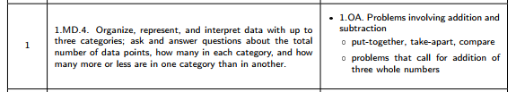  There is no single correct way to represent categorical data – and the Standards do not require Grade 1 students to use any specific format. However, students should be familiar with mark schemes like the one shown in the figure [below]. Another format that might be useful in Grade 1 is a picture graph in which one picture represents one object. (Note that picture graphs are not an expectation in the Standards until Grade 2.) If different students devise different ways to represent the same data set, then the class might discuss relative strengths and weaknesses of each scheme (MP5).  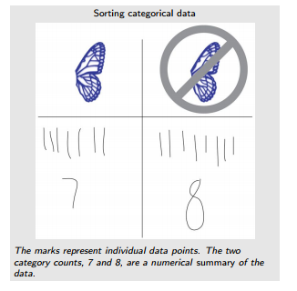  (See p. 5 in the MD Progressions.)
Essential Question(s) | How can I use addition and subtraction to understand data?

Assessment Guidance, Topic 6
- Topic Assessment
Performance Assessment
Item #/Action | Why?
- Delete | Item requires specific model (tally marks).
- As Is | Note: Use the graph from question 1.
- As Is
- As Is
- As Is
- As Is
- As Is

Grade 1, Topic 7: Extend The Counting Sequence and
Topic 8: Understanding Place Value

Order of Lessons for Merged Topics 7 & 8:  8-1, 7-1, 8-2, 7-6, 7-7, 8-3, 8-4, 8-5  Alternative: (8-1,8-2,7-1,8-3,8-4,8-5,7-4,7-7, 8-6) | Rationale for merging and reordering:  Topic 7 includes work with counting by 10s and thinking about groups of 10 on the 100s chart, but the conceptual understanding of place value is in Topic 8. By combining the topics, students can build conceptual understanding of place value while extending the counting sequence to 120.
Standards addressed: | Primary in this topic:  1.NBT.B.2: Understand that the two digits of a two-digit number represent amounts of tens and ones. Understand the following as special cases:  1.NBT.B.2a: 10 can be thought of as a bundle of ten ones — called a “ten.”  1.NBT.B.2b: The numbers from 11 to 19 are composed of a ten and one, two, three, four, five, six, seven, eight, or nine ones.  1.NBT.B.2c: The numbers 10, 20, 30, 40, 50, 60, 70, 80, 90 refer to one, two, three, four, five, six, seven, eight, or nine tens (and 0 ones).  Secondary in this topic:  1.NBT.A.1: Count to 120, starting at any number less than 120. In this range, read and write numerals and represent a number of objects with a written numeral.
Aspects of Rigor targeted by the standards: | Primary in this topic:  Conceptual Understanding  Secondary in this topic:  Procedural Skill and Fluency
Applicable information from the progression documents: | 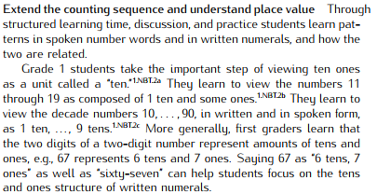  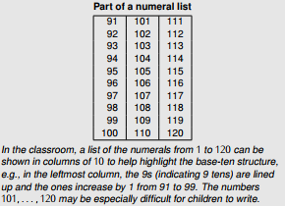  (See p. 6 in the NBT Progressions.)
Essential Question(s) | How can you use what you already know about counting to count past 100?  How and why do we count using tens and ones?

Anchor Tasks
Task | Explanation
8-1 Solve and Share | Builds on K.NBT.A.1 and extends to language of tens and ones.
7-1 Solve and Share (Modify text to say “How many counters are there?”) | Opens the topic by seeing which students are counting by 1s or 10s. Provides opportunity to begin a conversation about counting efficiently.
8-2 Solve and Share (Take out the “use cubes to show” to allow flexibility in model.) | Provides formative assessment of understanding of meaning of tens (related to work in Topic 7).
Count and write numbers to 120 | Allows students to use the structure and pattern of the number chart to expand the counting sequence.
7-6 Solve and Share | Provides a connection back to lesson 7-1 and the counting by tens that happens in that lesson.
7-7 Solve and Share (Just ask to count the apples.) | Offers good opportunity for formative assessment as students move towards Topic 8 (place value).
8-3 Solve and Share | Provides opportunity to name numbers in different ways.
8-4 Solve and Share | Provides opportunity to highlight grouping into tens, counting use tens and ones.
Represent up to 120 objects with a written numeral | Provides opportunity to connect work with 1.NBT.A and 1.NBT.B.
8-5 Solve and Share | Provides opportunity for students to represent two-digit numbers in terms of tens and ones.

Topic Rules of Thumb
Rule | Why?
7-2 to 7-5 focus on building fluency with the counting sequence by 10s and 1s to 120. These lessons can be moved to the start of the year and used to support counting routines that will be practiced repeatedly throughout the year to provide learning the counting sequence. | There are many factors (e.g., decades, number-word irregularities) involved in learning patterns that allow students to extend the counting sequence to 120.  (See p. 6 in the NBT Progressions.)
The 120 chart (and other ways to list numbers that highlight patterns) is useful to help students find and utilize the patterns present in the counting sequence. These patterns will help student master and extend the counting sequence. (See Teaching Tool 23.) | There is strategic representation of numbers via lists to help students see and generalize patterns in the counting sequence.  (See p. 6 in the NBT Progressions.)
Visual and concrete models of place value in this chapter should be intentionally connected to prior work with the Number Chart. (e.g., after lesson 8-3, ask students to explain why when counting from 29 to 30 the digit changes from 9 ones to 0 ones and 2 tens to 3 tens.) | MP7 requires students to look for and make use of structure.  Connecting patterns in the number sequence and place value understanding increases coherence by connecting 1.NBT.A and 1.NBT.B.
Throughout the topic, ensure students have many opportunities to articulate their understandings in the language of tens and ones (e.g., students should have opportunities to name 56 as “fifty-six” and “5 tens and six ones”). | “More generally, first graders learn that the two digits of a two-digit number represent amounts of tens and ones, e.g., 67 represents 6 tens and 7 ones. Saying 67 as “6 tens, 7 ones” as well as “sixty-seven” can help students focus on the tens and ones structure of written numerals.”  (See p. 6 in the NBT Progressions.)
Lessons 8-1 to 8-5 require students to use different and specific models to represent tens and ones. Allow students to use models that emphasize the composition of two-digit numbers of tens and ones (including connecting cubes, place value blocks, pictures, etc.) and make sense to students. | SMP.5 requires students to choose and use appropriate tools (including visual models) strategically.  1.NBT.B.2 does not specify a specific model that must be used to show tens and ones.

Assessment Guidance, Topic 7
- Topic Assessment
Performance Assessment
Item #/Action | Why?
- As Is
- Delete | Item requires Application.
- As Is
- As Is
- As Is
- As Is
- Delete | Item aligns to 2.OA (two-step problems).

Assessment Guidance, Topic 8
- Topic Assessment
Performance Assessment
Item #/Action | Why?
- As Is
- As Is
- As Is
- As Is
- As Is
- As Is
- Delete | Item requires students to find all the decompositions of a number.

Grade 1, Topic 9: Compare Two-Digit Numbers

Standards addressed: | Primary in this topic:  1.NBT.B.3: Compare two two-digit numbers based on meanings of the tens and ones digits, recording the results of comparisons with the symbols >, =, and <.  Secondary in this topic:  1.NBT.C.5: Given a two-digit number, mentally find 10 more or 10 less than the number, without having to count; explain the reasoning used.
Aspects of Rigor targeted by the standards: | Primary in this topic:  Procedural Skill and Fluency, Conceptual Understanding
Applicable information from the progression documents: | Grade 1 students use their base-ten work to help them recognize that the digit in the tens place is more important for determining the size of a two-digit number. They use this understanding to compare two two-digit numbers, indicating the result with the symbols <, >, and =. Correctly placing the < and > symbols is a challenge for early learners. Accuracy can improve if students think of putting the wide part of the symbol next to the larger number.  (See p.6 in the NBT Progressions.)  First graders also engage in mental calculation, such as mentally finding 10 more or 10 less than a given two-digit number without having to count by ones. They may explain their reasoning by saying that they have one more or one less ten than before. Drawings and layered cards can afford connections with place value and be used in explanations.  (See p. 7 in the NBT Progressions.)
Essential Question(s) | How can we use tens and ones to compare numbers up to 100?

Anchor Tasks
Task | Explanation
9-3 Solve and Share | Provides opportunity to connect comparing work to 1.NBT.B.2 and 1.NBT.C.3.
9-4 Solve and Share | Aligns to 1.NBT.C.3 and provides opportunity for different models to justify comparisons.
9-5 Solve and Share | Offers more opportunity to practice comparing numbers using any tool/strategy.
9-6 Solve and Share | Offers more opportunity to practice comparing numbers.

Topic Rules of Thumb
Rule | Why?
Lessons in this topic provide specific models for students to use to compare numbers. Students should be able to access and utilize a variety of models that are useful for comparing numbers and make sense to the students. | 1.NBT.C.3 calls for specific symbols for compare (e.g., <) but does not specify a model that students must use when comparing.  Students should only extend their place ten understanding to help them compare, not do so via a specific model.  (See p. 6 in the NBT Progressions.)

Assessment Guidance, Topic 9
- Topic Assessment
Performance Assessment
As an alternative, consider using Lesson 6 Problem Set as the Topic Assessment.
Item #/Action | Why?
- Delete | Item requires Application.
- As Is
- Delete | Item does not assess place value understanding and requires use of specific strategy (hundreds chart).
- Modify: Add “82 + 10 = ______” | Item requires Application.
- As Is
- Delete | Item aligns to 2.OA (two-step problems).
- As Is

Grade 1, Topic 10: Use Models and Strategies to Add Tens and Ones

Standards addressed: | Primary in this topic:  1.NBT.C.4: Add within 100, including adding a two-digit number and a one-digit number, and adding a two-digit number and a multiple of 10, using concrete models or drawings and strategies based on place value, properties of operations, and/or the relationship between addition and subtraction; relate the strategy to a written method and explain the reasoning used. Understand that in adding two-digit numbers, one adds tens and tens, ones and ones; and sometimes it is necessary to compose a ten.  Secondary in this topic:  1.NBT.C.5 Given a two-digit number, mentally find 10 more or 10 less than the number, without having to count; explain the reasoning used.
Aspects of Rigor targeted by the standards: | Primary in this topic:  Conceptual Understanding  Secondary in this topic:  Procedural Skill and Fluency
Applicable information from the progression documents: | 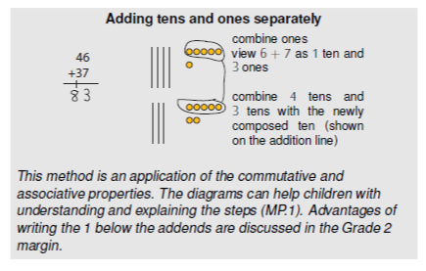  Use place value understanding and properties of operations to add and subtract  First graders use their base-ten work to compute sums within 100 with understanding (1.NBT.4). Concrete objects, cards, or drawings afford connections with written numerical work and discussions and explanations in terms of tens and ones. In particular, showing composition of a ten with objects or drawings affords connection of the visual ten with the written numeral 1 that indicates 1Ten.  Combining tens and ones separately as illustrated in the margin can be extended to the general method of combining like base-ten units. The margin illustrates combining ones, then tens. Like base ten units can be combined in any order, but going from smaller to larger eliminates the need to go back to a given place to add in a new unit. For example, in computing 46 + 37 by combining tens, then ones (going left to right), one needs to go back to add in the new 1 ten: “4 tens and 3 tens is 7 tens, 6 ones and 7 ones is 13 ones which is 1 ten and 3 ones, 7 tens and 1 ten is 8 tens. The total is 8 tens and 3 ones: 83.”  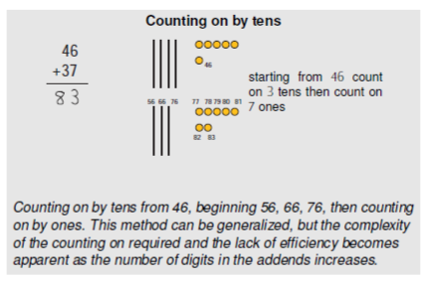  Students may also develop sequence methods that extend their Level 2 single-digit counting on strategies (see the OA Progression) to counting on by tens and ones, or mixtures of such strategies in which they add instead of count the tens or ones. Using objects or drawings of 5-groups can support students’ extension of the Level 3 make-a-ten methods discussed in the OA Progression for single digit numbers.  (See pp. 6–7 in the NBT Progressions.)
Essential Question(s) | What are ways to use tens and ones to add?

Anchor Tasks
Task | Explanation
10-1 Solve and Share | Provides opportunity to develop unit thinking about tens (see Guiding Questions in the “During” section of the PBL).
10-5 Solve and Share | Provides opportunity for students to connect addition to the work of place value in Topic 9.
10-2 Solve and Share (Do not require blocks.) | Provides opportunity to connect work of Topic 9 to adding tens and ones.
10-3 Solve and Share | Provides opportunity for students to practice adding tens and ones.
10-6 Solve and Share (Just give students 25+8.) | Provides opportunity for students to connect previous work to two-digit addition problems that involve composing a ten.
10-7 Solve and Share (Delete last three sentences.) | Provides opportunity for students to apply a model or strategy that makes sense to add within 100.
10-8 Solve and Share | Offers more practice with adding two-digit numbers.
10-9 Solve and Share | Offers more practice with adding two-digit numbers.

Topic Rules of Thumb
Rule | Why?
Lessons 9-1 and 9-2 introduced 10 more / 1 more before work had been done focused on adding tens and ones. Lessons 9-1 and 9-2 should be connected to the place value based addition work done in this unit. Lesson 10-2 will provide one opportunity for this, though the connection should not be limited to this lesson. | The standard calling for mentally finding 10 more (1.NBT.C.5) is part of the cluster titled “Use place value understanding and properties of operations to add and subtract.” The place value understanding of addition built in topic 10 can be used to build coherence and conceptual understanding with the work in 9-1 and 9-2.
Individual lessons in this topic provide specific models for students to use to add numbers. Students should be able to access and utilize a variety of models (e.g., cubes, place value blocks, ten frames, number charts, etc.) that are useful for adding numbers and make sense to the students. | 1.NBT.C.4 lists options for models but does not specify a specific model that must be used when adding or subtracting two-digit numbers.  Several examples of possible models are listed but one single model is not called for that must be used to build understanding of place value or adding and subtracting two-digit numbers.  (See pp. 6–7 in the OA Progressions.)

Assessment Guidance, Topic
- Topic Assessment
Performance Assessment
Item #/Action | Why?
- As Is
- Modify: Delete all text and graphics. Write number sentence “38 + 20 = ______” | Item requires a specific model.
- Modify: Delete all text and graphics. Write number sentence “40 + 2 = ______” | Item requires a specific model.
- As Is
- Modify: Delete all text. Write number sentence “16 + 12 = ______” | Item requires Application.
- Modify: Delete all text and graphics. Write number sentence “39 + 12 = ______” | Item requires a specific model.
- Delete | Repeats content from question #5.
- Modify: Delete 100 chart. | Item requires a specific model.
9. Modify: Delete 100 chart. | Item requires a specific model.
10. As Is
11. As Is
12. Delete | Repeats content from questions #10 and #11.
13. As Is
14. As Is
15. As Is
16. Delete | Repeats content from earlier questions.
17. Delete | Repeats content from earlier questions.
18. Delete | Does not align to the central concern of 1.NBT.C.41.
19. Delete | Does not align to the central concern of 1.NBT.C.41.
20. Delete | Does not align to the central concern of 1.NBT.C.41.

Grade 1, Topic 11: Use Models and Strategies to Subtract Tens

Standards addressed: | Primary in this topic:  1.NBT.C.6: Subtract multiples of 10 in the range 10–90 from multiples of 10 in the range 10–90 (positive or zero differences), using concrete models or drawings and strategies based on place value, properties of operations, and/or the relationship between addition and subtraction; relate the strategy to a written method and explain the reasoning used.  Secondary in this topic:  1.NBT.C.5: Given a two-digit number, mentally find 10 more or 10 less than the number, without having to count; explain the reasoning used.
Aspects of Rigor targeted by the standards: | Primary in this topic:  Conceptual Understanding  Secondary in this topic:  Procedural Skill and Fluency
Applicable information from the progression documents: | First graders also engage in mental calculation, such as mentally finding 10 more or 10 less than a given two-digit number without having to count by ones. They may explain their reasoning by saying that they have one more or one less ten than before. Drawings and layered cards can afford connections with place value and be used in explanations.  In Grade 1, children learn to compute differences of two-digit numbers for limited cases (1.NBT.6). Differences of multiples of 10, such as 70 - 40 can be viewed as 7 tens minus 4 tens and represented with concrete models such as objects bundled in tens or drawings. Children use the relationship between subtraction and addition when they view 80 - 70 as an unknown addend addition problem, 70 + ? = 80, and reason that 1 ten must be added to 70 to make 80, so 80 - 70 = 10.  First graders are not expected to compute differences of two-digit numbers other than multiples of ten. Deferring such work until Grade 2 allows two-digit subtraction with and without decomposing to occur in close succession, highlighting the similarity between these two cases. This helps students to avoid making the generalization “in each column, subtract the larger digit from the smaller digit, independent of whether the larger digit is in the subtrahend or minuend,” e.g., making the error 82 - 45 = 43.  (See p. 7 in the NBT Progressions.)
Essential Question(s) | How is subtracting groups of ten like subtracting numbers less than 10?

Anchor Tasks
Task | Explanation
11-1 Solve and Share (Highlight place value block model. Topic 10 has a lesson focused on place value block models, but there is not a separate lesson focused on place value block models for subtraction in this topic.) | Provides opportunity to connect place value understanding to subtraction.
11-2 Solve and Share | Provides opportunity to practice subtracting multiples of 10.
11-4 Solve and Share | Provides opportunity to practice subtracting multiples of 10.
11-5 Solve and Share | Provides opportunity to practice subtracting multiples of 10.
11-6 Solve and Share | Provides opportunity to practice subtracting multiples of 10.

Topic Rules of Thumb
Rule | Why?
Lessons 9-1 and 9-2 introduced 10 less / 1 less before work had been done focused on subtracting tens. Lessons 9-1 and 9-2 should be connected to the place value based subtraction work done in this unit. Lesson 11-5 will provide one opportunity for this, though the connection should not be limited to this lesson. | The standard calling for mentally finding 10 more (1.NBT.C.5) is part of the cluster titled “Use place value understanding and properties of operations to add and subtract”. The place value understanding of addition built in topic 10 can be used to build coherence and conceptual understanding with the work in 9-1 and 9-2.
Individual lessons in this topic provide specific models for students to use to subtract numbers. Students should be able to access and utilize a variety of models (e.g., cubes, place value blocks, ten frames, number charts, etc.) that are useful for subtracting two-digit numbers and make sense to the students. Throughout the topic, directions for students should follow the Guided Practice directions on p. 642 “Use the _______ or another strategy to solve a subtraction problem” | 1.NBT.C.4 lists options for models but does not specify a specific model that must be used when adding or subtracting two-digit numbers.  Several examples of possible models are listed but one single model is not called for that must be used to build understanding of place value or adding and subtracting two-digit numbers.  (See pp. 6–7 in the OA Progressions.)

Assessment Guidance, Topic 11
- Topic Assessment
Performance Assessment
Item #/Action | Why?
- Modify: Delete text and 100 chart. Just use the problem. | Item requires a specific model or strategy.
- Modify: Delete text and place value blocks. Just use the problem. | Item requires a specific model or strategy.
- Modify: Delete text and number line. Just use the problem. | Item requires a specific model or strategy.
- As Is
- As Is
- As Is
- As Is
- As Is
- As Is
- Delete | Item requires Application.

Grade 1, Topic 12: Measure Lengths

Standards addressed: | Primary in this topic:  1.MD.A.1: Order three objects by length; compare the lengths of two objects indirectly by using a third object.  1.MD.A.2: Express the length of an object as a whole number of length units, by laying multiple copies of a shorter object (the length unit) end to end; understand that the length measurement of an object is the number of same-size length units that span it with no gaps or overlaps. Limit to contexts where the object being measured is spanned by a whole number of length units with no gaps or overlaps.
Aspects of Rigor targeted by the standards: | Primary in this topic:  Application, Conceptual Understanding  Secondary in this topic:  Procedural Skill and Fluency
Applicable information from the progression documents: | Measurement is the process of assigning a number to a magnitude of some attribute shared by some class of objects, such as length, relative to a unit. Length is a continuous attribute—a length can always be subdivided in smaller lengths. In contrast, we can count 4 apples exactly—cardinality is a discrete attribute. We can add the 4 apples to 5 other apples and know that the result is exactly 9 apples.  Students then can become increasingly competent at direct comparison— comparing the amount of an attribute in two objects without measurement. For example, two students may stand back to back to directly compare their heights. In many circumstances, such direct comparison is impossible or unwieldy. Sometimes, a third object can be used as an intermediary, allowing indirect comparison. For example, if we know that Aleisha is taller than Barbara and that Barbara is taller than Callie, then we know (due to the transitivity of “taller than”) that Aleisha is taller than Callie, even if Aleisha and Callie never stand back to back.*  * “Transitivity” abbreviates the Transitivity Principle for Indirect Measurement stated in the Standards as:  If the length of object A is greater than the length of object B, and the length of object B is greater than the length of object C, then the length of object A is greater than the length of object C. This principle applies to measurement of other quantities as well. Students should apply the principle of transitivity of measurement to make indirect comparisons, but they need not use this technical term.  Length is a characteristic of an object found by quantifying how far it is between the endpoints of the object. “Distance” is often used similarly to quantify how far it is between any two points in space. Measuring length or distance consists of two aspects, choosing a unit of measure and subdividing (mentally and physically) the object by that unit, placing that unit end to end (iterating) alongside the object. The length of the object is the number of units required to iterate from one end of the object to the other, without gaps or overlaps.  (See pp. 2–3 in the G Progressions; See also pp. 8–10 G Progressions for grade 1-specific information)
Essential Question(s) | How do you measure the length of an object?

Anchor Tasks
Task | Explanation
12-1 Visual Learning Bridge | Allows for direct comparison of length in a way that the Solve and Share does not because objects are the same thickness and aligned at one end.
12-2 Solve and Share | Allows for discovery and application of transitivity.
12-3 Solve and Share | Allows for measurement with a unit, no gaps or overlaps.
12-4 Solve and Share | Provides more practice measuring.

Topic Rules of Thumb
Rule | Why?
Throughout the unit, students should have opportunities to measure using different units (e.g., cubes, paperclips). Using only connecting cubes can lead to false positives about students’ understanding of gaps or overlaps. | 1.MD.A.2 calls for understanding measurement as the number of units that span an object with no gaps or overlaps. Connecting cubes connect, and may not provide opportunities for mistakes and learning around gaps and overlaps.

Assessment Guidance, Topic 12
- Topic Assessment
Performance Assessment
Item #/Action | Why?
- As Is
- As Is
- As Is
- As Is
- As Is
- As Is
- As Is
- As Is

Grade 1, Topic 13: Time

Standards addressed: | Primary in this topic:  1.MD.B.3: Tell and write time in hours and half-hours using analog and digital clocks.
Aspects of Rigor targeted by the standards: | Primary in this topic:  Procedural Skill and Fluency
Applicable information from the progression documents: | N/A
Essential Question(s) | N/A

Assessment Guidance, Topic 13
- Topic Assessment
Performance Assessment
Item #/Action | Why?
- Delete | Item requires Application.
- As Is
- As Is
- Delete | Item requires converting between units.
- Delete | Item requires Application.
- As Is
- As Is

Grade 1, Topic 14: Reason With Shapes and Their Attributes

Standards addressed: | Primary in this topic:  1.G.A.1: Distinguish between defining attributes (e.g., triangles are closed and three-sided) versus non-defining attributes (e.g., color, orientation, overall size); build and draw shapes to possess defining attributes.  1.G.A.2: Compose two-dimensional shapes (rectangles, squares, trapezoids, triangles, half-circles, and quarter-circles) or three-dimensional shapes (cubes, right rectangular prisms, right circular cones, and right circular cylinders) to create a composite shape, and compose new shapes from the composite shape.
Aspects of Rigor targeted by the standards: | Primary in this topic:  Conceptual Understanding, Procedural Skill and Fluency
Applicable information from the progression documents: | In Grade 1, students reason about shapes. They describe and classify shapes, including drawings, manipulatives, and physical-world objects, in terms of their geometric attributes. That is, based on early work recognizing, naming, sorting, and building shapes from components, they describe in their own words why a shape belongs to a given category, such as squares, triangles, circles, rectangles, rhombuses, (regular) hexagons, and trapezoids (with bases of different lengths and nonparallel sides of the same length). In doing so, they differentiate between geometrically defining attributes (e.g., “hexagons have six straight sides”) and non-defining attributes (e.g., color, overall size, or orientation). For example, they might say, “This has to go with the squares, because all four sides are the same, and these are square corners. It doesn’t matter which way it’s turned” (MP3, MP7). They explain why the variants shown earlier (p. 6) are members of familiar shape categories and why the difficult distractors are not, and they draw examples and nonexamples of the shape categories. Students learn to sort shapes accurately and exhaustively based on these attributes, describing the similarities and differences of these familiar shapes and shape categories (MP7, MP8).  From the early beginnings of informally matching shapes and solving simple shape puzzles, students learn to intentionally compose and decompose plane and solid figures (e.g., putting two congruent isosceles triangles together with the explicit purpose of making a rhombus), building understanding of part-whole relationships as well as the properties of the original and composite shapes. In this way, they learn to perceive a combination of shapes as a single new shape (e.g., recognizing that two isosceles triangles can be combined to make a rhombus, and simultaneously seeing the rhombus and the two triangles). Thus, they develop competencies that include solving shape puzzles and constructing designs with shapes, creating and maintaining a shape as a unit, and combining shapes to create composite shapes that are conceptualized as independent entities (MP2). They then learn to substitute one composite shape for another congruent composite composed of different parts.  (See p. 8 in the G Progressions; See also Composing and Decomposing Shapes, pp. 3–4 in the G Progressions.)
Essential Question(s) | N/A
Assessment Guidance, Topic 14
- Topic Assessment
Performance Assessment
Item #/Action | Why?
- As Is
- As Is
- Delete | Repeats content from question #8.
- As Is
- Delete | Item requires explanation.
- Delete | Items requires a specific model or strategy (pattern blocks).
- As Is
- As Is
- As Is
- As Is
- Delete | Repeats content from question #8.
- As Is

Grade 1, Topic 15: Equal Shares of Circles and Rectangles

Standards addressed: | Primary in this topic:  1.G.A.3: Partition circles and rectangles into two and four equal shares, describe the shares using the words halves, fourths, and quarters, and use the phrases half of, fourth of, and quarter of. Describe the whole as two of, or four of the shares. Understand for these examples that decomposing into more equal shares creates smaller shares.
Aspects of Rigor targeted by the standards: | Primary in this topic:  Procedural Skill and Fluency, Conceptual Understanding
Applicable information from the progression documents: | In Grades 1 and 2, students use fraction language to describe partitions of shapes into equal shares. In Grade 3 they start to develop the idea of a fraction more formally, building on the idea of partitioning a whole into equal parts.  (See p. 3 in the NF Progressions.)
Essential Question(s) | N/A

Assessment Guidance, Topic 15
- Topic Assessment
Performance Assessment
Item #/Action | Why?
- As Is
- As Is
- As Is
- As Is
- As Is
- Delete | Item requires Application.

See Glossary, Table 1
Students need not use formal terms for these properties.

