Grade 4, Topic 1: Generalize Place Value Understanding

Standards addressed | Primary in this topic:  4.NBT.A.1: Recognize that in a multi-digit whole number, a digit in one place represents ten times what it represents in the place to its right. For example, recognize that 700 ÷ 70 = 10 by applying concepts of place value and division.  4.NBT.A.2: Read and write multi-digit whole numbers using base-ten numerals, number names, and expanded form. Compare two multi-digit numbers based on meanings of the digits in each place, using >, =, and < symbols to record the results of comparisons.  4.NBT.A.3: Use place value understanding to round multi-digit whole numbers to any place.
Aspects of Rigor targeted by the standards | Primary in this topic:  Conceptual Understanding  Secondary in this topic:  Procedural Skill and Fluency
Applicable information from the progression documents | 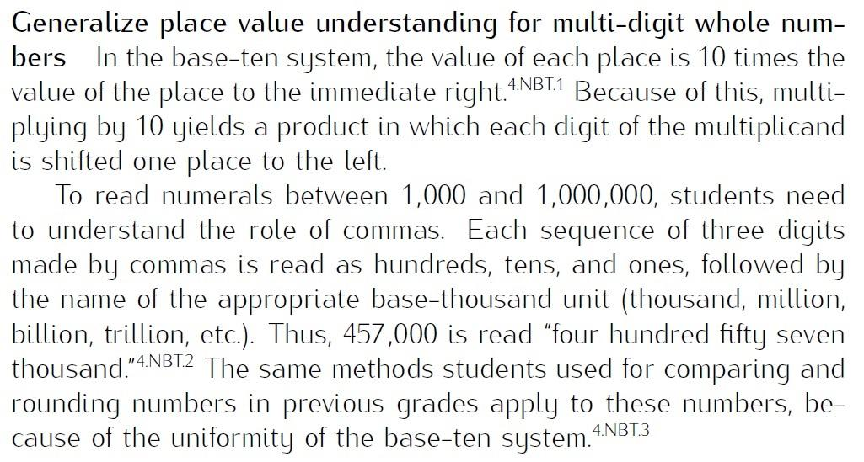  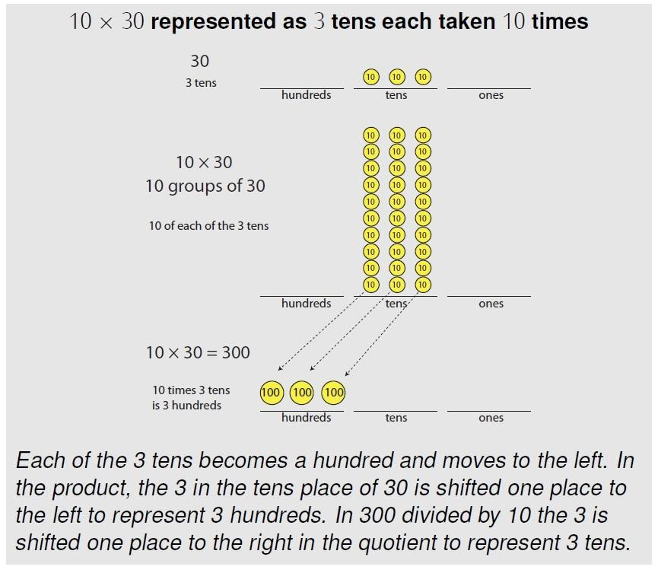  (See p. 13 in the NBT Progressions.)
Essential Question(s) | How are the digits in a multi-digit number related to each other?  How can place value understanding be used to read, write, compare, and round multi-digit numbers?

Anchor Tasks
Task | Explanation
1-2 Solve and Share | This problem asks students to look at patterns to begin thinking about the relationship between a digit in different places in a number.
Illustrative Mathematics Unit 4 Lesson 10 Ten Times as Much | This lesson helps students understand that a number multiplied by ten will result in a product that is ten times the value of the original number. The concept is developed through work with a place value chart which allows students to see the digit move from one place value to another.
Thousands and Millions of Fourth Graders | This task should be used to introduce the concept of multiplicative comparison (the idea of 10 times as much) and to connect it to the idea of the relationship between digits in a number from the previous lesson.
Threatened and Endangered | This task is another way for students to think about how a digit in one place represents ten times what it represents in the place to its right, and to continue to develop understanding of multiplicative comparison.
1-1 Visual Learning Bridge | This problem asks students to read multi-digit numbers and write the number names and expanded form.
1-3 Extension for early finishers from the Solve and Share | This asks students to compare numbers after writing them, emphasizing writing multi-digit numbers and then comparing, absent context.
1-4 Solve and Share | This task requires students to use place value understanding to think about rounding numbers.

Topic Rules of Thumb
Rule | Why?
Emphasize the use of place value understanding to compare and round numbers, rather than teaching a procedure for rounding. | 4.NBT.A targets generalizing place value understanding for grade 4 work with multi-digit numbers.

Assessment Guidance, Topic 1
- Topic Assessment
Performance Assessment
Item #/Action | Why?
- As Is
- As Is
- As Is
- As Is
- Delete | 4.NBT.A does not require Application.
- As Is
- As Is
- As Is
9. As Is
10. Delete | 4.NBT.A does not require Application.

Grade 4, Topic 2: Fluently Add and Subtract Multi-Digit Whole Numbers

Standards addressed | Primary in this topic:  4.NBT.B.4: Fluently add and subtract multi-digit whole numbers using the standard algorithm.  Secondary in this topic:  4.OA.A.3: Solve multistep word problems posed with whole numbers and having whole-number answers using the four operations, including problems in which remainders must be interpreted. Represent these problems using equations with a letter standing for the unknown quantity. Assess the reasonableness of answers using mental computation and estimation strategies including rounding.
Aspects of Rigor targeted by the standards | Primary in this topic:  Procedural Skill and Fluency  Secondary in this topic:  Application
Applicable information from the progression documents | 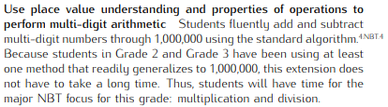
Essential Question(s) | What is the standard algorithm for adding and subtracting?  How can mental computation and estimation strategies be used to assess the reasonableness of answers?

Anchor Tasks
Task | Explanation
2-3 Solve and Share | Use this problem to ensure students are using the standard algorithm throughout the topic.
2-4 Convince Me! | This problem asks students to look at a standard algorithm subtraction problem and identify the error, then show the correct subtraction.
2-5 Solve and Share | Use Ali’s work in the Analyze Student Work section to have students decide if Ali completed the problem correctly or not, and explain why or why not. This emphasizes the standard algorithm for subtraction.
Fluency Practice/Assessment Worksheets 1 of 6 #1-8 | These problems give practice with addition and subtraction using the standard algorithm. Present some of the problems to students horizontally, such as 464,982 - 52,680.

Topic Rules of Thumb
Rule | Why?
Provide students with extensive practice solving multi-digit addition and subtraction problems not in context. | 4.NBT.B.4 calls for procedural skill and fluency with using the standard algorithm which is the capstone to the progression of understanding and skill with addition and subtraction in K-4.
Encourage students to use mental math, to assess the reasonableness of answers, and to round to estimate throughout the lessons in the topic, not just in isolated places. | MP1 states that mathematically proficient students check their answers to problems using a different method, and they continually ask themselves, “Does this make sense?”

Assessment Guidance, Topic 2
- Topic Assessment
Performance Assessment
Item #/Action | Why?
Use an external assessment for this topic, such as:  Multi-Digit Addition and Subtraction | 4.NBT.B.4 has a procedural skill and fluency requirement not met by the Topic 2 Assessment.

Grade 4, Topic 3: Use Strategies and Properties to Multiply by 1-Digit Numbers

Standards addressed | Primary in this topic:  4.OA.A.1: Interpret a multiplication equation as a comparison, e.g., interpret 35 = 5 × 7 as a statement that 35 is 5 times as many as 7 and 7 times as many as 5. Represent verbal statements of multiplicative comparisons as multiplication equations.  4.OA.A.2: Multiply or divide to solve word problems involving multiplicative comparison, e.g., by using drawings and equations with a symbol for the unknown number to represent the problem, distinguishing multiplicative comparison from additive comparison.  4.NBT.B.5: Multiply a whole number of up to four digits by a one-digit whole number, and multiply two two-digit numbers, using strategies based on place value and the properties of operations. Illustrate and explain the calculation by using equations, rectangular arrays, and/or area models.  Secondary in this topic:  4.OA.A.3: Solve multistep word problems posed with whole numbers and having whole-number answers using the four operations, including problems in which remainders must be interpreted. Represent these problems using equations with a letter standing for the unknown quantity. Assess the reasonableness of answers using mental computation and estimation strategies including rounding.
Aspects of Rigor targeted by the standards | Primary in this topic:  Conceptual Understanding  Secondary in this topic:  Application
Applicable information from the progression documents | 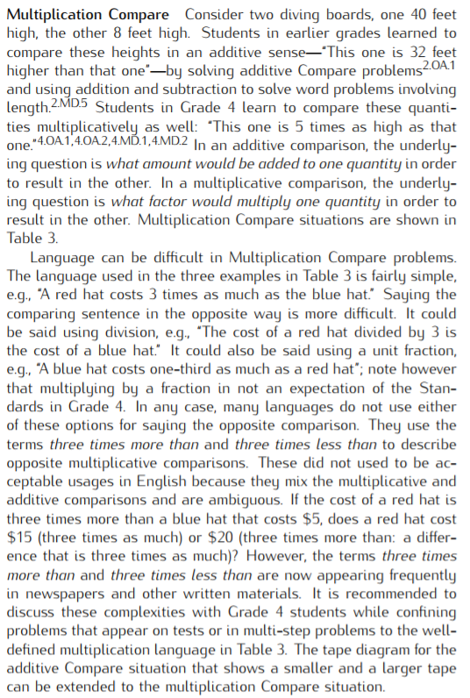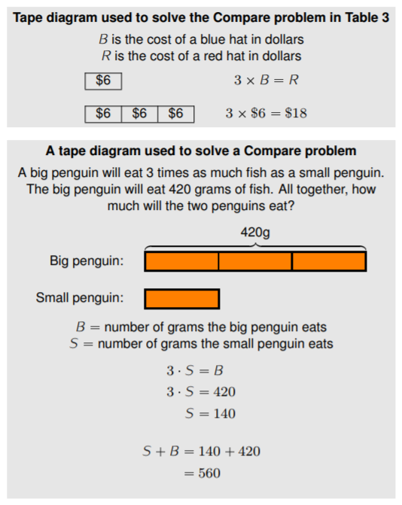  (See p. 29 in the OA Progressions.)  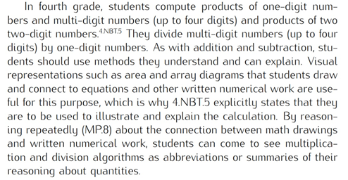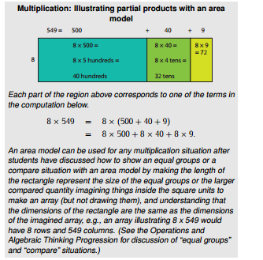  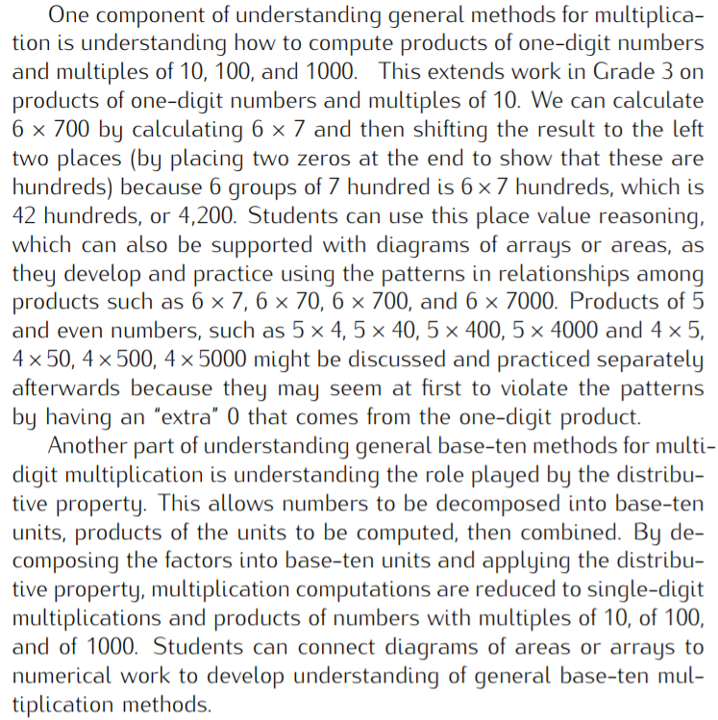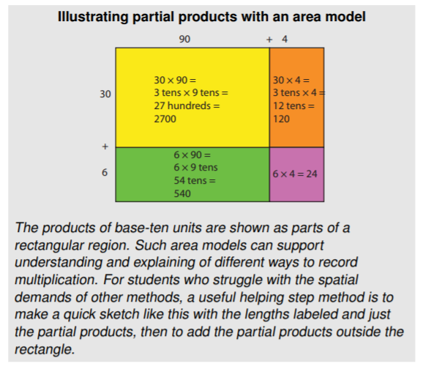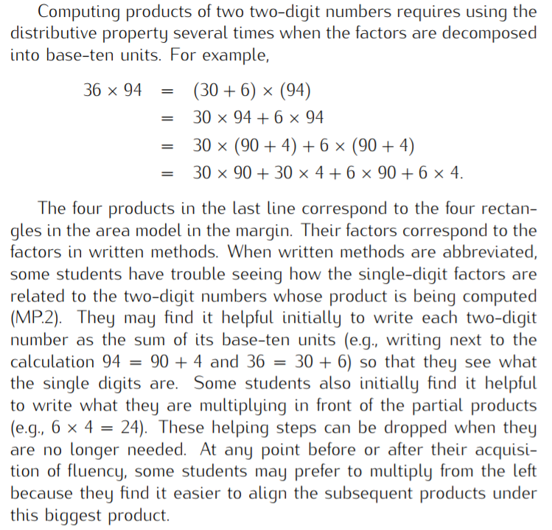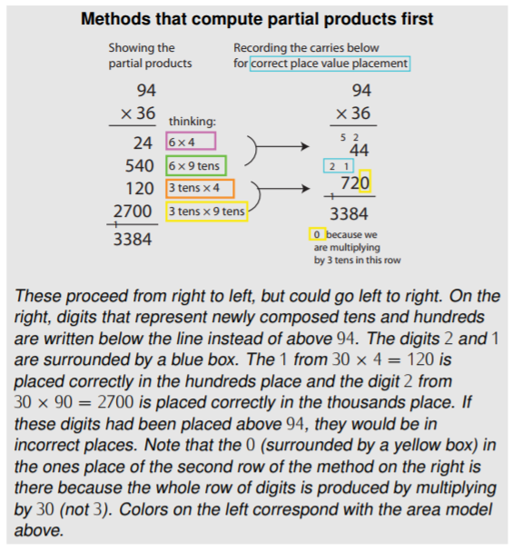  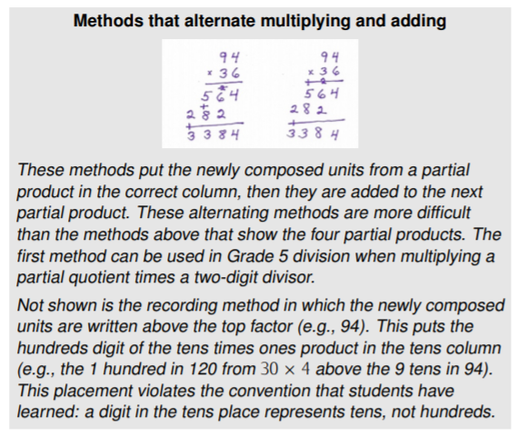  (See pp. 14–15 in the NBT Progressions.)
Essential Question(s) | How can multiplication be used to compare quantities?  How can place value understanding and properties of operations be used to multiply multi-digit numbers?  How can arrays, area models, and/or equations be used to explain multi-digit multiplication?
Anchor Tasks
Task | Explanation
6-1 Solve and Share and Visual Learning Bridge (problem only) | Introduces multiplication as comparison, since many of the problems in this topic rely on the definition of multiplication in 4.OA.A.1.  Note: This lesson includes multiplication and division beyond what students learned in grade 3. When using problems from this lesson, be sure to use only multiplication and division within 100.
6-2 Visual Learning Bridge (problem only) | Provides practice writing equations and solving problems involving multiplicative comparison  Note: This lesson includes multiplication and division beyond what students learned in grade 3. When using problems from this lesson, be sure to use only multiplication and division within 100.
3-1 Solve and Share with “Look Back!” | This task launches students into understanding general methods for multiplication by starting with understanding how to compute products of one-digit numbers and multiples of 10, 100, and 1000.
3-5 Solve and Share | This task reinforces students’ previous understanding of multiplication as the total number of objects in a number of groups of a number of objects each, using larger numbers, and gives a choice of strategy to use.
3-6 Solve and Share | This task reinforces students’ previous understanding of multiplication as the total number of objects in a number of groups of a number of objects each, using larger numbers, and gives a choice of strategy to use.
3-6 Convince Me! | This problem asks students to consider place value to decide if the multiplication is correct, and then explain why it is correct. It is a bridge to the distributive property.
3-3 Visual Learning Bridge | Because this problem is an area problem (yards wide by yards long), it encourages students to set up an area model, which can be used to illustrate the distributive property.

Topic Rules of Thumb
Rule | Why?
De-emphasize formal definitions of properties of operations (distributive, associative, commutative). | The role of the properties of operations in 4.NBT.B.5 is for students to use them to multiply.
Encourage students to use mental math, to assess the reasonableness of answers, and to round to estimate throughout the lessons in the topic, not just in isolated places. | MP1 states that mathematically proficient students check their answers to problems using a different method, and they continually ask themselves, “Does this make sense?”
Strategies and models should be presented to students as options, and they should use methods they understand and can explain. Emphasize the connection between visual representations students draw and equations. | While standard algorithm is a strategy based on place value, it is not required until 5th grade (5.NBT.B.5).  [Also see NBT progression above.]

Assessment Guidance, Topic 3
- Topic Assessment
Performance Assessment
Item #/Action | Why?
- Modify: Delete text “choose numbers from the box to complete and solve the problem.” Delete box and numbers. | Item requires a specific strategy.
- Modify: Delete text “Use compensation to.” | Item requires a specific strategy.
- Delete | 4.NBT.5 does not require Application.
- As Is
- Delete | 4.NBT.5 does not require Application.
- As Is
- Delete | Item requires a specific model. Repeats content from other items.
- As Is
- Delete | 4.NBT.5 does not require Application.
- Delete | Does not align to the central concern of 4.NBT.B.5.
- Modify Revise text to “which expressions has the same value as 3 x 156.” | Clarify mathematical language of item. Item requires a specific strategy. Item does not require use of precise language
- As Is
- Delete | 4.NBT.5 does not require Application.
- Delete | 4.NBT.5 does not require Application.
- Delete | 4.NBT.5 does not require Application.
- As Is
- Delete | 4.NBT.5 does not require Application.
- Delete | 4.NBT.5 does not require Application.
- Delete | 4.NBT.5 does not require Application.
- Delete | Item requires a specific model.

Grade 4, Topic 4: Use Strategies and Properties to Multiply by 2-Digit Numbers

Standards addressed | Primary in this topic:  4.NBT.B.5: Multiply a whole number of up to four digits by a one-digit whole number, and multiply two two-digit numbers, using strategies based on place value and the properties of operations. Illustrate and explain the calculation by using equations, rectangular arrays, and/or area models.  Secondary in this topic:  4.OA.A.3: Solve multistep word problems posed with whole numbers and having whole-number answers using the four operations, including problems in which remainders must be interpreted. Represent these problems using equations with a letter standing for the unknown quantity. Assess the reasonableness of answers using mental computation and estimation strategies including rounding.
Aspects of Rigor targeted by the standards | Primary in this topic:  Conceptual Understanding  Secondary in this topic:  Application
Applicable information from the progression documents | See progressions from Topic 3.
Essential Question(s) | How can place value understanding and properties of operations be used to multiply multi-digit numbers?  How can arrays, area models, and/or equations be used to explain multi-digit multiplication?

Anchor Tasks
Task | Explanation
4-1 Solve and Share | This task can be used to emphasize that understanding that computing products of one-digit numbers and multiples of 10, 100, and 1000 helps with understanding general methods for multi-digit multiplication.
4-2 Solve and Share | This task reinforces students’ previous understanding of multiplication as the total number of objects in a number of groups of a number of objects each, connects to the previous lesson because of the multiplication by 10, and gives a choice of strategy to use.
4-5 Convince Me! | This problem uses the area model which reinforces the connection to place value and is a bridge to the distributive property.
4-7 Solve and Share | This is a two-step word problem that includes two-digit times two-digit multiplication; connecting to 4.OA.A.3.
4-10 Guided Independent Practice | Opportunity for students to practice two-digit by two-digit multiplication.

Topic Rules of Thumb
Rule | Why?
De-emphasize formal definitions of properties of operations (distributive, associative, commutative). | The role of the properties of operations in 4.NBT.B.5 is for students to use them to multiply.
Encourage students to use mental math, to assess the reasonableness of answers, and to round to estimate throughout the lessons in the topic, not just in isolated places. | MP1 states that mathematically proficient students check their answers to problems using a different method, and they continually ask themselves, “Does this make sense?”
Strategies and models should be presented to students as options, and they should use methods they understand and can explain. Emphasize the connection between visual representations students draw and equations. | While standard algorithm is a strategy based on place value, it is not required until 5th grade (5.NBT.B.5). [Also see NBT progression above.]
Skip lesson 4-8. | The strategy of placing a zero in the ones place of the product and disregarding the ones place in the factor is specific to multiplying by multiples of 10 and does not generalize to any other multiplication situation.  While standard algorithm is a strategy based on place value, it is not required until 5th grade (5.NBT.B.5). [Also see NBT progression above.]

Assessment Guidance, Topic 4
- Topic Assessment
Performance Assessment
Item #/Action | Why?
- Delete | 4.NBT.5 does not require Application.
- Delete | 4.NBT.5 does not require Application.
- Delete | 4.NBT.5 does not require Application.
- As Is
- Modify: Delete Part A and B. Write text: “how many laps did we swim over the 2 months?” | Item requires a specific model.
- As Is
- Delete | 4.NBT.5 does not require Application.
- Delete | Item requires a specific strategy.
- Delete | 4.NBT.5 does not require Application.
- Delete | 4.NBT.5 does not require Application.
- As Is
- Delete | 4.NBT.5 does not require Application.
- Delete | Item requires a specific strategy.
- Delete | Item requires a specific strategy.
- Delete | Item requires a specific strategy.
- As Is
- Delete | 4.NBT.5 does not require Application.
- Delete | Item requires a specific strategy.
- As Is
- Modify: Delete text “Use each number from the box once to complete and solve the problem.” Delete box and the digits underneath the multiplication expressions. | Item requires a specific strategy.
- Delete | 4.NBT.5 does not require Application.
- Delete | 4.NBT.5 does not require Application.

Grade 4, Topic 5: Use Strategies and Properties to Divide by 1-Digit Numbers

Standards addressed | Primary in this topic:  4.NBT.B.6: Find whole-number quotients and remainders with up to four-digit dividends and one-digit divisors, using strategies based on place value, the properties of operations, and/or the relationship between multiplication and division. Illustrate and explain the calculation by using equations, rectangular arrays, and/or area models.  Secondary in this topic:  4.OA.A.3: Solve multistep word problems posed with whole numbers and having whole-number answers using the four operations, including problems in which remainders must be interpreted. Represent these problems using equations with a letter standing for the unknown quantity. Assess the reasonableness of answers using mental computation and estimation strategies including rounding.
Aspects of Rigor targeted by the standards | Primary in this topic:  Conceptual Understanding  Secondary in this topic:  Application
Applicable information from the progression documents | 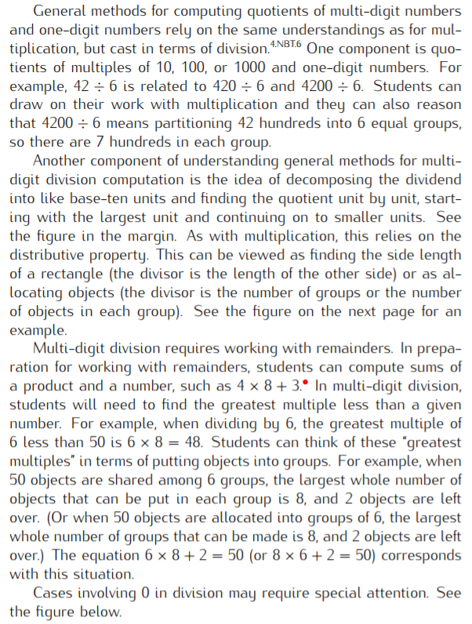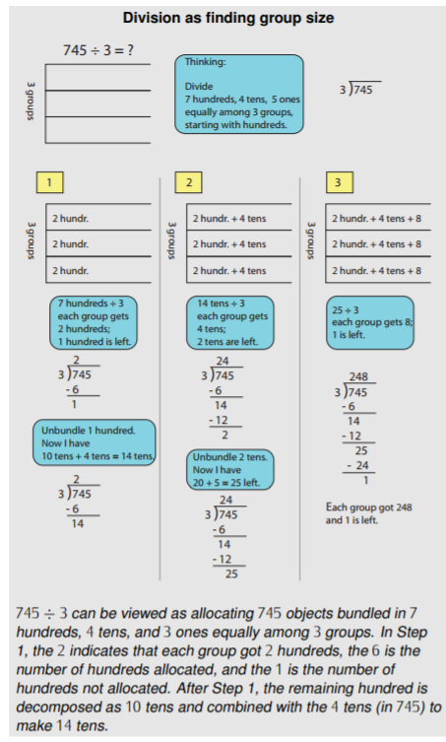  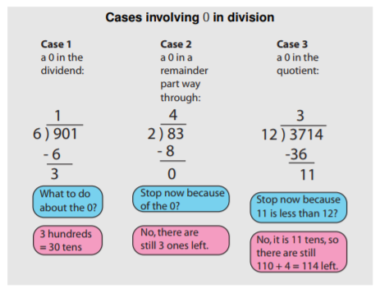  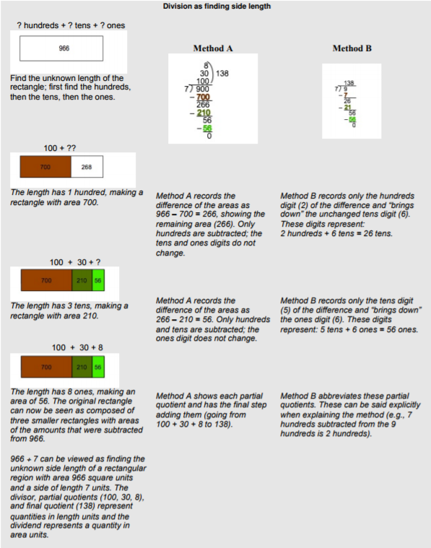  (See pp. 16–17 in the NBT Progressions.)
Essential Question(s) | How can place value understanding and properties of operations be used to divide multi-digit numbers?  How can arrays, area models, and/or equations be used to explain multi-digit division?

Anchor Tasks
Task | Explanation
5-1 Solve and Share with Look Back! | This problem starts students with a familiar sharing division problem, using a known fact multiple of 10. It is a good connection between division students did in grade 3 and dividing with larger numbers.
5-2 Solve and Share | This is another familiar sharing division problem, 3-digits divided by 1-digit. It emphasizes students using any strategy that makes sense to them.
5-3 Solve and Share | This problem moves to 4-digits divided by 1-digit; the 4-digit number is 3,000, which offers opportunities for students to use strategies based on place value.
5-4 Solve and Share | This problem allows have the students to consider the remainder in division problems.
5-5 Solve and Share | This division problem emphasizes rows and could be an opportunity for students to use the area model for division.
5-6 Visual Learning Bridge | This division problem emphasizes rows and could be an opportunity for students to use the area model for division.
5-7 Solve and Share | This division problem brings in measurement with an area problem involving square feet of a room.

Topic Rules of Thumb
Rule | Why?
Emphasis for division should be on dividing using place value understanding and properties of operations, giving students opportunities to use tools such as place value blocks, area models and equations. | Interpreting quotients is introduced in grade 3 (3.OA.A.2).
Strategies and models should be presented to students as options, and they should use methods they understand and can explain. Instruction should emphasize how visual representations such as area and array diagrams that students draw connect to equations and other written numerical work. Place value reasoning should be supported with diagrams of arrays or areas as students develop and practice using the patterns in relationships among quotients. | While standard algorithm is a strategy based on place value, it is not required until 6th grade (6.NS.B.2). [Also see NBT progression above.]

Assessment Guidance, Topic 5
- Topic Assessment
Performance Assessment
Item #/Action | Why?
- Delete | 4.NBT.B.5 does not require Application.
- Delete | Item requires a specific model.
- As Is
- Delete | Item requires a specific model.
- As Is
- Delete | Item requires a specific model.
- As Is
- As Is
- As Is
- Delete | Repeats content from other items.
- Delete | Repeats content from other items.
- As Is
- Delete | Item requires a specific model.
- Delete | 4.NBT.B.5 does not require Application.
- As Is
- Delete | Item requires a specific model.
- Delete | Repeats content from other items.
- Delete | Item requires a specific strategy.
- Delete | 4.NBT.B.5 does not require Application.
- Delete | Item requires a specific model.
- Delete | 4.NBT.B.5 does not require Application.
- As Is
- Delete | Repeats content from other items.

Grade 4, Topic 6: Use Operations With whole Numbers to Solve Problems

Standards addressed | Primary in this topic:  4.OA.A.2: Multiply or divide to solve word problems involving multiplicative comparison, e.g., by using drawings and equations with a symbol for the unknown number to represent the problem, distinguishing multiplicative comparison from additive comparison.  4.OA.A.3: Solve multistep word problems posed with whole numbers and having whole-number answers using the four operations, including problems in which remainders must be interpreted. Represent these problems using equations with a letter standing for the unknown quantity. Assess the reasonableness of answers using mental computation and estimation strategies including rounding.  Secondary in this topic:  4.NBT.B.5: Multiply a whole number of up to four digits by a one-digit whole number, and multiply two two-digit numbers, using strategies based on place value and the properties of operations. Illustrate and explain the calculation by using equations, rectangular arrays, and/or area models.  4.NBT.B.6: Find whole-number quotients and remainders with up to four-digit dividends and one-digit divisors, using strategies based on place value, the properties of operations, and/or the relationship between multiplication and division. Illustrate and explain the calculation by using equations, rectangular arrays, and/or area models.
Aspects of Rigor targeted by the standards | Primary in this topic:  Application  Secondary in this topic:  Conceptual Understanding
Applicable information from the progression documents | 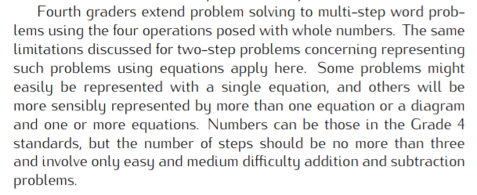  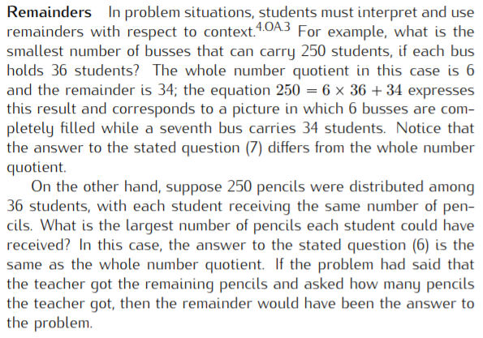  (See pp. 29–30 in the OA Progressions.)
Essential Question(s) | What strategies can be used to solve multi-step word problems?  What strategies can be used to check the reasonableness of answers?

Anchor Tasks
Task | Explanation
6-3 Solve and Share and Look Back! | This is a good entry task for the work of two-step problems defined by 4.OA.A.3 with tight connections to students’ work in 4.NBT with division.
6-4 Solve and Share | This problem provides a nice contrast to the one in the prior lesson, this time connecting to students’ work in 4.NBT with multiplication. This problem also contrasts the 6-3 problem since the two numbers in the problem cannot be combined first so students really need to make sense of the problem and what it is asking them to do before diving in.
6-5 Solve and Share and Look Back! | The 4.OA.A.1 interpretation of a multiplication equation as a comparison is reflected in this problem and nicely integrates the work of 4.NBT with addition/subtraction and multiplication/division. The complexity of the problem provides a nice ceiling for the work of 4.OA.A.3.

Topic Rules of Thumb
Rule | Why?
Strategies and models should be presented to students as options, with extra emphasis on strategies and models that are generalizable, such as strategies based on place value and the area model. | Program RoT #3

Assessment Guidance, Topic 6
- Topic Assessment
Performance Assessment
Item #/Action | Why?
- Modify: Delete Part A, B and C. | Does not align to central concern of 4.OA.A.3.
- As Is
- Modify: Delete bar diagrams. | Item requires a specific model.
- As Is
- As Is
- As Is
- Modify: Add text “Each carton has the same number of markers.” | Item is not mathematically accurate.
- As Is
- As Is
- As Is

Grade 4, Topic 7: Factors and Multiples

Standards addressed | Primary in this topic:  4.OA.B.4: Find all factor pairs for a whole number in the range 1–100. Recognize that a whole number is a multiple of each of its factors. Determine whether a given whole number in the range 1–100 is a multiple of a given one-digit number. Determine whether a given whole number in the range 1–100 is prime or composite.
Aspects of Rigor targeted by the standards | Primary in this topic:  Procedural Skill and fluency  Secondary in this topic:  Conceptual Understanding
Applicable information from the progression documents | 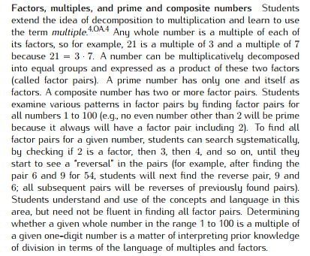  (See p. 30 in the OA Progressions.)
Essential Question(s) | N/A

Assessment Guidance, Topic 7
- Topic Assessment
Performance Assessment
Item #/Action | Why?
- Delete | 4.OA.B.4 does not require application.
- As Is
- As Is
- As Is
- Delete | Does not align to the central concern of 4.OA.B.4.
- As Is
- Delete | Does not align to the central concern of 4.OA.B.4.
- As Is
- As Is
- As Is
- As Is
- As Is
- As Is

Grade 4, Topic 8: Extend Understanding of Fraction Equivalence and Ordering

Standards addressed | Primary in this topic:  4.NF.A.1: Explain why a fraction a/b is equivalent to a fraction (n × a)/(n × b) by using visual fraction models, with attention to how the number and size of the parts differ even though the two fractions themselves are the same size. Use this principle to recognize and generate equivalent fractions.  4.NF.A.2: Compare two fractions with different numerators and different denominators, e.g., by creating common denominators or numerators, or by comparing to a benchmark fraction such as 1/2. Recognize that comparisons are valid only when the two fractions refer to the same whole. Record the results of comparisons with symbols >, =, or <, and justify the conclusions, e.g., by using a visual fraction model.
Aspects of Rigor targeted by the standards | Primary in this topic:  Conceptual Understanding  Secondary in this topic:  Procedural Skill and Fluency
Applicable information from the progression documents | 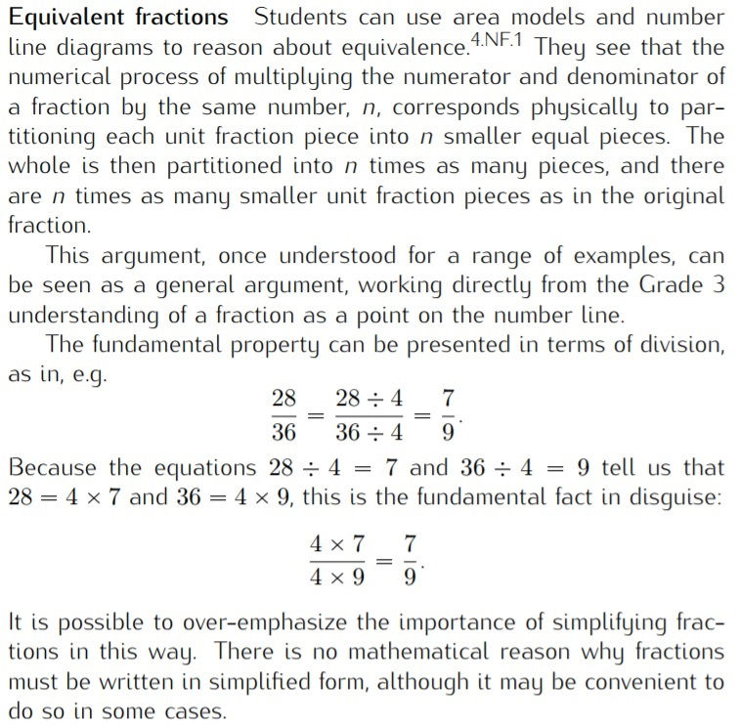  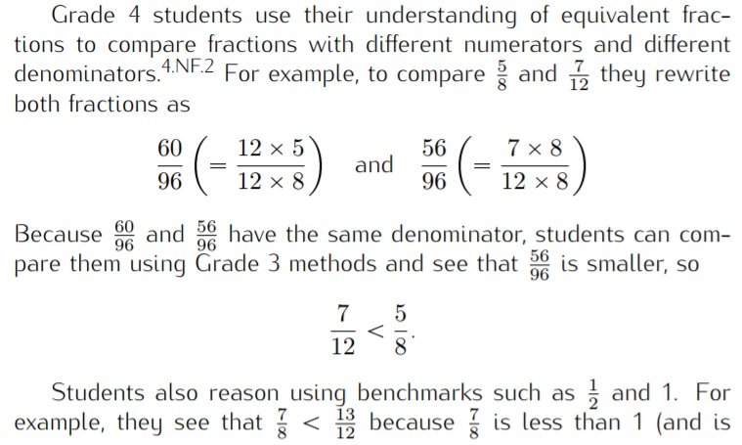  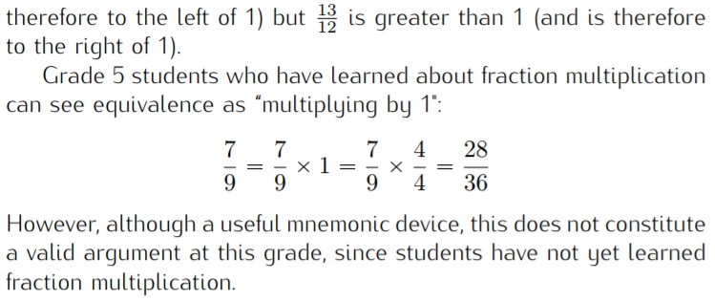  (See p. 6 in the NF Progressions.)
Essential Question(s) | Why do different fractions represent the same quantity?  How can equivalent fractions and benchmark fractions help when comparing fractions?

Anchor Tasks
Task | Explanation
Explaining Fraction Equivalence with Pictures | Uses a visual model of equivalent fractions to build on grade 3 work.
Fractions and Rectangles | Uses a visual model of equivalent fractions to move toward the procedure for generating equivalent fractions.
8-7 Solve and Share | Build on work with comparing unit fractions in grade 3. This task reinforces the importance of the size of the whole when comparing.
8-5 Visual Learning Bridge | Students can use benchmarks (8-7) to compare fractions with unlike denominators and numerators.
8-6 Solve and Share | Students can use benchmarks (8-7) and equivalence to compare fractions with unlike denominators and numerators.
Listing Fractions in Increasing Size | Provides opportunity to reach the full depth of 4.NF.A.2.

Topic Rules of Thumb
Rule | Why?
When explaining and finding equivalent fractions, emphasis should be placed on the numerical process of multiplying the numerator and denominator of a fraction by the same number, n, which corresponds physically to partitioning each unit fraction piece into n smaller equal pieces, (n x a)/(n x b). Multiplying or dividing by 1, including referring to the identity property, is reserved for fifth grade. (This should be avoided in 8-3 and 8-4.) | 4.NF.A.1 describes the connection between the conceptual understanding and procedural skill of generating and recognizing equivalent fractions, while 5.NF.B.4 introduces the concept of multiplying fractions by whole numbers.
Encourage multiple approaches (e.g., benchmarks, distance from benchmarks, equivalent fractions, common numerator, common denominator) to compare fractions so students can use strategies flexibly based on the specific fractions they are comparing. | 3.NF.A.3d requires students to compare two fractions with the same numerator or the same denominator by reasoning about their size, while 4.NF.A.2 does not put any restriction on the type of fractions students should compare.

Assessment Guidance, Topic 8
- Topic Assessment
Performance Assessment
Item #/Action | Why?
- As Is
- Delete | 4.NF.A.2 does not require Application.
- As Is
- As Is
- As Is
- As Is
- As Is
- Delete | 4.NF.A.2 does not require Application.
- As Is
- Delete | Aligned to 3.NF.A.3d (comparing fractions with the same whole).
- Delete | Item requires specific strategy.
- As Is
- Modify: Delete text, Use text “compare $\frac{3}{8}$ and $\frac{4}{6}$ .“ | Item requires specific model.

Grade 4, Topic 9: Understand Addition and Subtraction of Fractions

Standards addressed | Primary in this topic:  4.NF.B.3a: Understand addition and subtraction of fractions as joining and separating parts referring to the same whole.  4.NF.B.3b: Decompose a fraction into a sum of fractions with the same denominator in more than one way, recording each decomposition by an equation. Justify decompositions, e.g., by using a visual fraction model. Examples: 3/8 = 1/8 + 1/8 + 1/8 ; 3/8 = 1/8 + 2/8 ; 2 1/8 = 1 + 1 + 1/8 = 8/8 + 8/8 + 1/8.  4.NF.B.3c: Add and subtract mixed numbers with like denominators, e.g., by replacing each mixed number with an equivalent fraction, and/or by using properties of operations and the relationship between addition and subtraction.  4.NF.B.3d: Solve word problems involving addition and subtraction of fractions referring to the same whole and having like denominators, e.g., by using visual fraction models and equations to represent the problem.
Aspects of Rigor targeted by the standards | Primary in this topic:  Conceptual Understanding and Application  Secondary in this topic:  Procedural Skill
Applicable information from the progression documents | 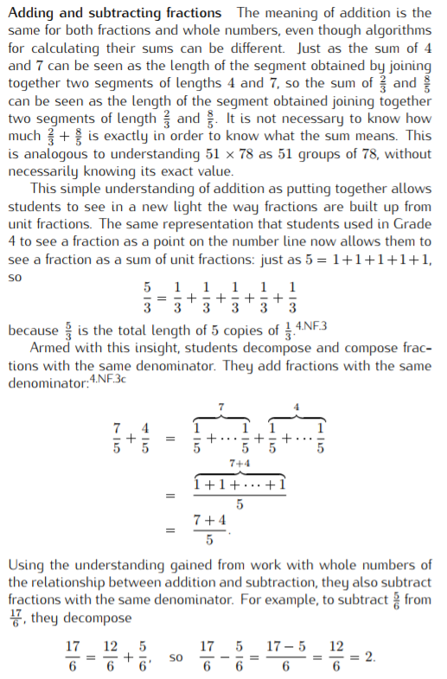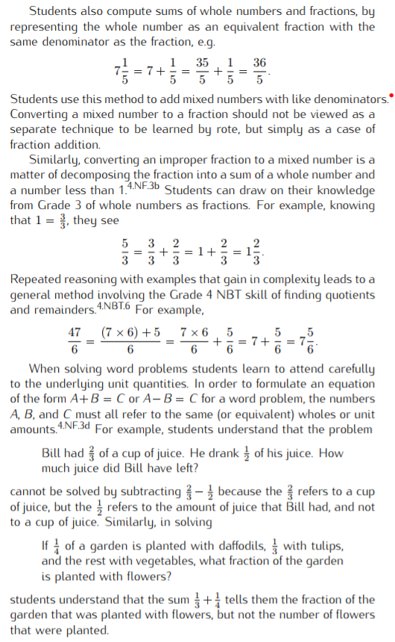  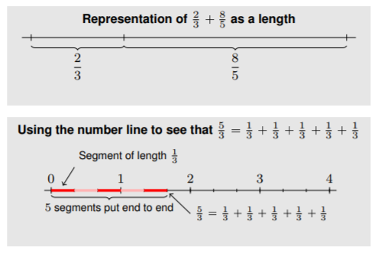  (See p. 7 in the NF Progressions.)
Essential Question(s) | How is adding and subtracting fractions like adding and subtracting whole numbers?  How do you add and subtract fractions?

Anchor Tasks
Task | Explanation
9-2 Solve and Share | Supports building the idea of decomposing non-unit fractions into a sum of fractions.
9-1 Solve and Share | Builds on understanding of whole number addition.
9-4 Solve and Share | Builds on understanding of whole number addition subtraction.
9-6 Visual Learning Bridge (Problem only) | Context lends itself to thinking about the number line.
9-3 Solve and Share | Opportunity to reinforce applying understanding of whole number operations to fractions.
9-5 Solve and Share | Opportunity to reinforce applying understanding of whole number operations to fractions.
9-8 Solve and Share and Visual Learning Bridge  (Problem only) | Opportunity to practice addition and subtraction with mixed numbers.
9-9 Solve and Share | Opportunity to reinforce applying understanding of whole number operations to fractions.
9-10 Solve and Share | Opportunity to reinforce applying understanding of whole number operations to fractions.

Topic Rules of Thumb
Rule | Why?
Strategies and models should be presented to students as options, with extra emphasis on strategies and models that are generalizable, such as number line and making a whole. | Students should choose the strategy or model that makes sense to them.

Assessment Guidance, Topic 9
- Topic Assessment
Performance Assessment
Item #/Action | Why?
- As Is
- As Is
- Modify: Make clear the assumption that Cole only had homework in Spanish and history. | Item is not mathematically accurate.
- As Is
- As Is
- Modify: Delete text “Use benchmark fractions to.” | Item requires a specific strategy.
- As Is
- Delete | Item requires a specific model.
- Delete
- Modify: Delete Part A. | Item requires a specific model.

Grade 4, Topic 10: Extend Multiplication Concepts to Fractions

Standards addressed | Primary in this topic:  4.NF.B.4a: Understand a fraction a/b as a multiple of 1/b. For example, use a visual fraction model to represent 5/4 as the product 5 × (1/4), recording the conclusion by the equation 5/4 = 5 × (1/4).  4.NF.B.4b: Understand a multiple of a/b as a multiple of 1/b, and use this understanding to multiply a fraction by a whole number. For example, use a visual fraction model to express 3 × (2/5) as 6 × (1/5), recognizing this product as 6/5. (In general, n × (a/b) = (n × a)/b.)  4.NF.B.4c: Solve word problems involving multiplication of a fraction by a whole number, e.g., by using visual fraction models and equations to represent the problem. For example, if each person at a party will eat 3/8 of a pound of roast beef, and there will be 5 people at the party, how many pounds of roast beef will be needed? Between what two whole numbers does your answer lie?  Secondary in this topic:  4.NF.B.3d: Solve word problems involving addition and subtraction of fractions referring to the same whole and having like denominators, e.g., by using visual fraction models and equations to represent the problem.  4.MD.A.2: Use the four operations to solve word problems involving distances, intervals of time, liquid volumes, masses of objects, and money, including problems involving simple fractions or decimals, and problems that require expressing measurements given in a larger unit in terms of a smaller unit. Represent measurement quantities using diagrams such as number line diagrams that feature a measurement scale.
Aspects of Rigor targeted by the standards | Primary in this topic:  Conceptual Understanding, Application
Applicable information from the progression documents | 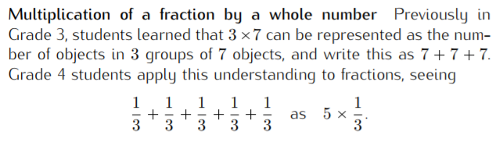  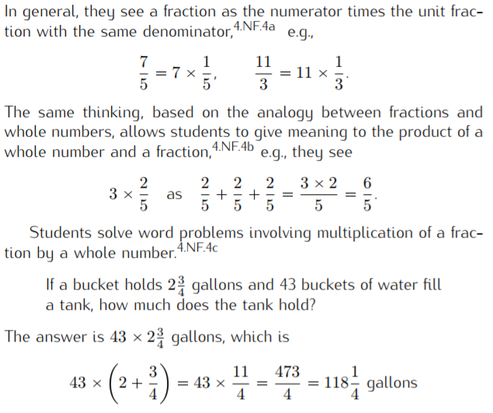  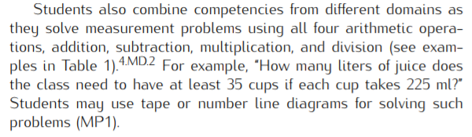  (See pp. 8–9 in the NF Progressions.)
Essential Question(s) | How is a non-unit fraction a multiple of a unit fraction?  How can understanding the relationship between unit and non-unit fractions be used to multiply a fraction by a whole number?  What strategies can you use to solve word problems involving multiplication of fractions by whole numbers?

Anchor Tasks
Task | Explanation
10-1 Solve and Share | Builds the understanding that a non-unit fraction is a multiple of a unit fraction.
10-2 Solve and Share | Introducing multiplication of fractions by whole numbers, reinforcing previous work with whole number multiplication with an equal groups story.
10-3 Solve and Share | Multiplication of fractions by whole numbers, reinforcing previous work with whole number multiplication with an equal groups story.
10-4 Solve and Share | Opportunity to practice multiplication of mixed numbers by whole numbers.
10-5 Visual Learning Bridge | Opportunity to practice multiplication of mixed numbers by whole numbers.

Topic Rules of Thumb
Rule | Why?
Strategies and models should be presented to students as options, with extra emphasis on strategies and models that are generalizable, such as the equal groups meaning of multiplication. | Students should choose the strategy or model that makes sense to them.

Assessment Guidance, Topic 10
- Topic Assessment
Performance Assessment
Item #/Action | Why?
- As Is
- As Is
- As Is
- As Is
- As Is
- As Is
- As Is
- As Is
9. As Is
10. As Is
11. As Is

Grade 4, Topic 11: Represent and Interpret Data on Line Plots

Standards addressed | Primary in this topic:  4.MD.B.4: Make a line plot to display a data set of measurements in fractions of a unit (1/2, 1/4, 1/8). Solve problems involving addition and subtraction of fractions by using information presented in line plots. For example, from a line plot find and interpret the difference in length between the longest and shortest specimens in an insect collection.  Secondary in this topic:  4.NF.B.3d: Solve word problems involving addition and subtraction of fractions referring to the same whole and having like denominators, e.g., by using visual fraction models and equations to represent the problem.  4.NF.A.1: Explain why a fraction a/b is equivalent to a fraction (n × a)/(n × b) by using visual fraction models, with attention to how the number and size of the parts differ even though the two fractions themselves are the same size. Use this principle to recognize and generate equivalent fractions.
Aspects of Rigor targeted by the standards | Primary in this topic:  Application  Secondary in this topic:  Conceptual Understanding, Procedural Skill and Fluency
Applicable information from the progression documents | 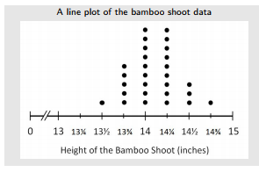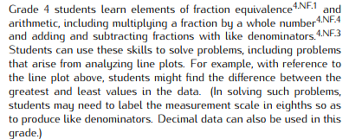  (See p. 10 in the MD Progressions.)
Essential Questions(s) | N/A

Assessment Guidance, Topic 11
- Topic Assessment
Performance Assessment
Item #/Action | Why?
- As Is
- As Is
- As Is
- As Is
- As Is
- Delete | 4.MD.B.4 requires data to be measurements in fractions of a unit.
- Delete | 4.MD.B.4 requires data to be measurements in fractions of a unit.
- As Is
- Delete | Aligns to 8.SP (outliers).

Grade 4, Topic 12: Understand and Compare Decimals

Standards addressed | Primary in this topic:  4.NF.C.5: Express a fraction with denominator 10 as an equivalent fraction with denominator 100, and use this technique to add two fractions with respective denominators 10 and 100.4 For example, express 3/10 as 30/100, and add 3/10 + 4/100 = 34/100.  4.NF.C.6: Use decimal notation for fractions with denominators 10 or 100. For example, rewrite 0.62 as 62/100; describe a length as 0.62 meters; locate 0.62 on a number line diagram.  4.NF.C.7: Compare two decimals to hundredths by reasoning about their size. Recognize that comparisons are valid only when the two decimals refer to the same whole. Record the results of comparisons with the symbols >, =, or <, and justify the conclusions, e.g., by using a visual model.  Secondary in this topic:  4.MD.A.2: Use the four operations to solve word problems involving distances, intervals of time, liquid volumes, masses of objects, and money, including problems involving simple fractions or decimals, and problems that require expressing measurements given in a larger unit in terms of a smaller unit. Represent measurement quantities using diagrams such as number line diagrams that feature a measurement scale.
Aspects of Rigor targeted by the standards | Primary in this topic:  Conceptual Understanding  Secondary in this topic:  Application
Applicable information from the progression documents | 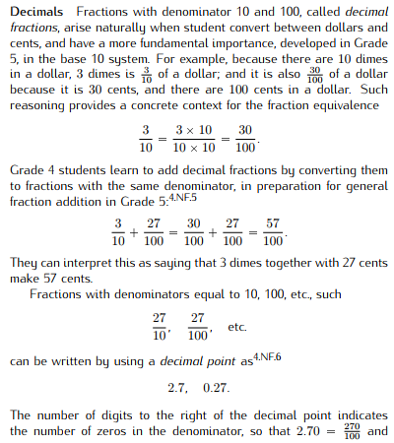  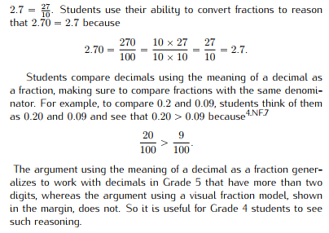  (See p. 9 in the NF Progressions.)
Essential Question(s) | How can fractions can be expressed as decimal fractions?  How can fraction understanding be used to read, write, and compare decimal fractions?

Anchor Tasks
Task | Explanation
Dimes and Pennies | This task brings in the familiar context of money to emphasize the decimal fraction relationship.
Expanded Fractions and Decimals | This task reinforces the decimal fraction relationship with attention to place value.
12-3 Solve and Share | Comparing decimal fractions
12-4 Solve and Share | Addition of decimal fractions, the problem asks students to add a fraction with 10 as denominator and 100 as denominator, which continues to reinforce decimal fractions and place value
12-5 Visual Learning Bridge | This is an addition problem involving money, reinforcing the decimal fraction relationship.

Topic Rules of Thumb
Rule | Why?
Strategies and models should be presented to students as options, with extra emphasis on strategies and models that are generalizable, such as the equal groups meaning of multiplication. | Students should choose the strategy or model that makes sense to them.

Assessment Guidance, Topic 12
- Topic Assessment
Performance Assessment
Item #/Action | Why?
- Modify: Revise text. Replace “that shows “with “that is equivalent to.” | Item is mathematically ambiguous.
- As Is
- Modify: Delete text “Draw or use coins and bills to solve.” | Item requires specific model.
- As Is
- As Is
- As Is
- As Is
- As Is
- Delete | Aligns to 3.NF.A.2B (placing fractions on a number line).
- As Is
- As Is
- Delete | 4.NF.C.6 does not require Application.

Grade 4, Topic 13: Measurement: Find Equivalence in Units of Measure

Standards addressed | Primary in this topic:  4.MD.A.1: Know relative sizes of measurement units within one system of units including km, m, cm; kg, g; lb, oz.; l, ml; hr, min, sec. Within a single system of measurement, express measurements in a larger unit in terms of a smaller unit. Record measurement equivalents in a two-column table. For example, know that 1 ft is 12 times as long as 1 in. Express the length of a 4 ft snake as 48 in. Generate a conversion table for feet and inches listing the number pairs (1, 12), (2, 24), (3, 36), ...  4.MD.A.2: Use the four operations to solve word problems involving distances, intervals of time, liquid volumes, masses of objects, and money, including problems involving simple fractions or decimals, and problems that require expressing measurements given in a larger unit in terms of a smaller unit. Represent measurement quantities using diagrams such as number line diagrams that feature a measurement scale.  Secondary in this topic:  4.NBT.B.5: Multiply a whole number of up to four digits by a one-digit whole number, and multiply two two-digit numbers, using strategies based on place value and the properties of operations. Illustrate and explain the calculation by using equations, rectangular arrays, and/or area models.  4.NF.B.3d: Solve word problems involving addition and subtraction of fractions referring to the same whole and having like denominators, e.g., by using visual fraction models and equations to represent the problem.  4.NF.B.4c: Solve word problems involving multiplication of a fraction by a whole number, e.g., by using visual fraction models and equations to represent the problem. For example, if each person at a party will eat 3/8 of a pound of roast beef, and there will be 5 people at the party, how many pounds of roast beef will be needed? Between what two whole numbers does your answer lie?
Aspects of Rigor targeted by the standards | Primary in this topic:  Application, Conceptual Understanding  Secondary in this topic:  Procedural Skill and Fluency
Applicable information from the progression documents | 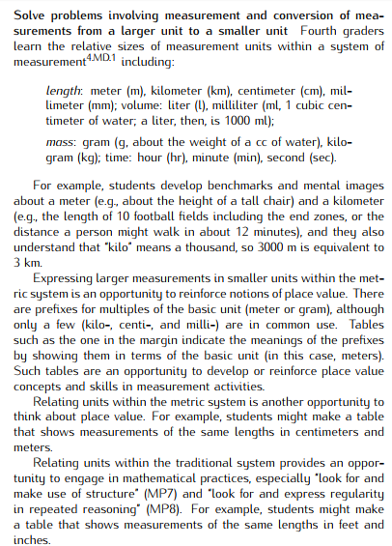  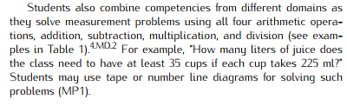  (See p. 20 in the MD Progressions.)
Essential Question(s) | N/A

Assessment Guidance, Topic 13
- Topic Assessment
Performance Assessment
Item #/Action | Why?
Give students a list of conversions necessary for completing the problems on the assessment, such as those found on page 723 in the reteaching section. | The assessment contains more measurement quantities than listed in the standard (e.g., pints, quarts, tons).
- As Is
- As Is
- As Is
- As Is | Note: Prompt does not require a variable; accept answer that shows 7x5=35 as the equation and 35 square feet as the area.
- As Is
- As Is
- As Is
- As Is
- As Is
- As Is
- As Is
- As Is
- Delete | Repeats content from previous items.

Grade 4, Topic 14: Algebra: Generate and Analyze Patterns

Standards addressed | Primary in this topic:  4.OA.C.5: Generate a number or shape pattern that follows a given rule. Identify apparent features of the pattern that were not explicit in the rule itself. For example, given the rule “Add 3” and the starting number 1, generate terms in the resulting sequence and observe that the terms appear to alternate between odd and even numbers. Explain informally why the numbers will continue to alternate in this way.
Aspects of Rigor targeted by the standards | Primary in this topic:  Conceptual Understanding
Applicable information from the progression documents | 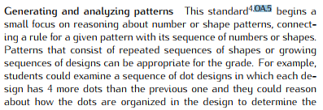  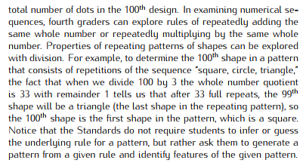  (See pp. 30–31 in the OA Progressions.)
Essential Question(s) | N/A

Assessment Guidance, Topic 14
- Topic Assessment
Performance Assessment
Item #/Action | Why?
- As Is
- Delete | 4.OA.C.5 does not require Application.
- As Is
- As Is
- As Is
- Delete | Mathematically inaccurate: The “numbers” are technically “digits” in this case that need to be composed to form numbers.
- Delete | Mathematically inaccurate: Rule is never given/stated in a way that could generate a pattern.
- As Is
- Delete | Not aligned to central concern of 4.OA.C.5.
- Delete | Aligned to 6.RP.A (ratios).
- As Is
- As Is

Grade 4, Topic 15: Geometric Measurement: Understand Concepts of Angles and Angle Measurement

Standards addressed | Primary in this topic:  4.MD.C.5: Recognize angles as geometric shapes that are formed wherever two rays share a common endpoint, and understand concepts of angle measurement:  4.MD.C.5a: An angle is measured with reference to a circle with its center at the common endpoint of the rays, by considering the fraction of the circular arc between the points where the two rays intersect the circle. An angle that turns through 1/360 of a circle is called a “one-degree angle,” and can be used to measure angles.  4.MD.C.5b: An angle that turns through n one-degree angles is said to have an angle measure of n degrees.  4.MD.C.6: Measure angles in whole-number degrees using a protractor. Sketch angles of specified measure.  4.MD.C.7: Recognize angle measure as additive. When an angle is decomposed into non-overlapping parts, the angle measure of the whole is the sum of the angle measures of the parts. Solve addition and subtraction problems to find unknown angles on a diagram in real world and mathematical problems, e.g., by using an equation with a symbol for the unknown angle measure.  4.G.A.1: Draw points, lines, line segments, rays, angles (right, acute, obtuse), and perpendicular and parallel lines. Identify these in two-dimensional figures.
Aspects of Rigor targeted by the standards | Primary in this topic:  Conceptual Understanding, Procedural Skill and Fluency  Secondary in this topic:  Application
Applicable information from the progression documents | 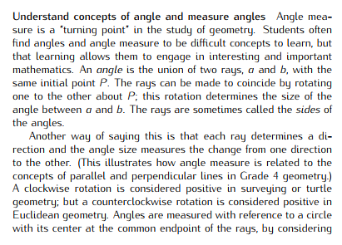  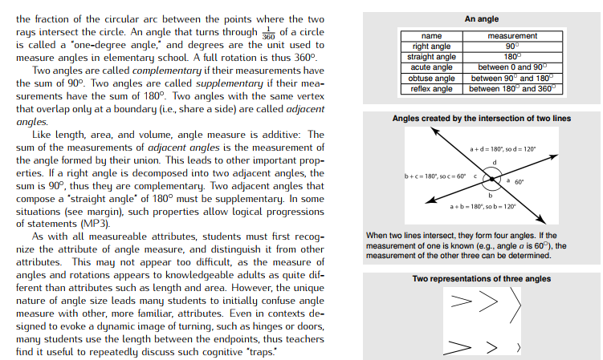  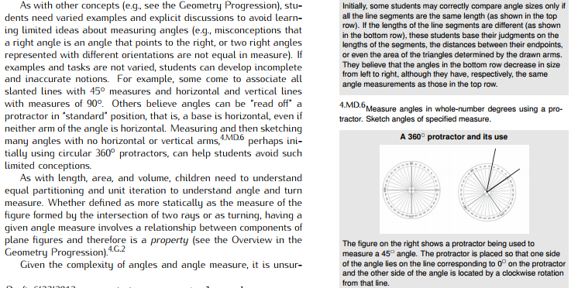  (See pp. 22–23 in the MD Progressions.)
Essential Questions(s) | N/A

Anchor Tasks
- Topic Assessment
Performance Assessment
Item #/Action | Why?
- As Is
- As Is
- As Is
- Delete | Does not align to central concern of 4.G.A.1.
- Delete | Does not align to central concern of 4.G.A.1.
- Delete | Vocabulary used in question is not an expectation for grade 4 students.
- Delete | Vocabulary used in question is not an expectation for grade 4 students.
- As Is
9. Delete | Mathematical Accuracy: The idea of “more open” vs. “less open” is in conflict with the development of angle measure within a circle. The terms lose meaning for angles with measure >180 degrees.
10. As Is
11. Delete | Mathematical Accuracy: Stars are a poor representation of the undefined term “point” in geometry.
12. As Is
13. As Is

Grade 4, Topic 16: Lines, Angles, and Shapes

Standards addressed | Primary in this topic:  4.G.A.1: Draw points, lines, line segments, rays, angles (right, acute, obtuse), and perpendicular and parallel lines. Identify these in two-dimensional figures.  4.G.A.2: Classify two-dimensional figures based on the presence or absence of parallel or perpendicular lines, or the presence or absence of angles of a specified size. Recognize right triangles as a category, and identify right triangles.  4.G.A.3: Recognize a line of symmetry for a two-dimensional figure as a line across the figure such that the figure can be folded along the line into matching parts. Identify line-symmetric figures and draw lines of symmetry.
Aspects of Rigor targeted by the standards | Primary in this topic:  Conceptual Understanding, Procedural Skill and Fluency
Applicable information from the progression documents | 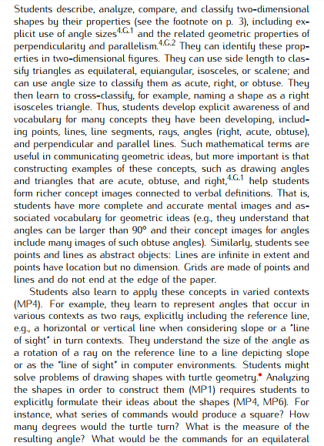  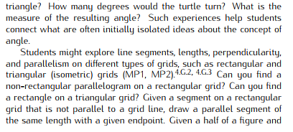  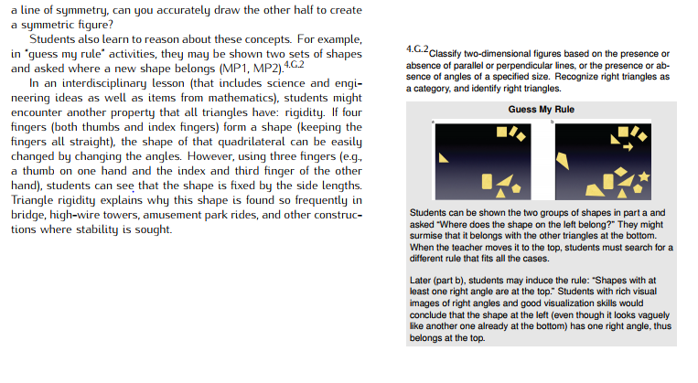  (See pp. 15–16 in the G Progressions.)
Essential Question(s) | N/A

Assessment Guidance, Topic 16
- Topic Assessment
Performance Assessment
Item #/Action | Why?
- As Is | Note: Square, rectangle, and rhombus are also correct answers.
- As Is
- As Is
- Delete | Item is not mathematically accurate.
- As Is
- As Is
- As Is
- As Is
- Delete | Aligned to 7.G.A.2 (angle relationships).
- Delete | Does not align to central concerns of 4.G.A.2.
- Delete | Item is not mathematically accurate.
- As Is
- As Is

