Grade 5, Topic 1: Understand Place Value

Standards addressed | Primary in this topic:  5.NBT.A.1: Recognize that in a multi-digit number, a digit in one place represents 10 times as much as it represents in the place to its right and 1/10 of what it represents in the place to its left.  5.NBT.A.2: Explain patterns in the number of zeros of the product when multiplying a number by powers of 10, and explain patterns in the placement of the decimal point when a decimal is multiplied or divided by a power of 10. Use whole-number exponents to denote powers of 10.  5.NBT.A.3: Read, write, and compare decimals to thousandths.  5.NBT.A.3.a: Read and write decimals to thousandths using base-ten numerals, number names, and expanded form, e.g., 347.392 = 3 × 100 + 4 × 10 + 7 × 1 + 3 × (1/10) + 9 × (1/100) + 2 × (1/1000).  5.NBT.A.3.b: Compare two decimals to thousandths based on meanings of the digits in each place, using >, =, and < symbols to record the results of comparisons.  Secondary in this topic:  5.NBT.A.4: Use place value understanding to round decimals to any place.
Aspects of Rigor targeted by the standards | Primary in this topic:  Conceptual Understanding  Secondary in this topic:  Procedural Skill and Fluency
Applicable information from the progression documents | Understand the place value system  Students extend their understanding of the base-ten system to the relationship between adjacent places, how numbers compare, and how numbers round for decimals to thousandths.  New at Grade 5 is the use of whole number exponents to denote powers of 10. Students understand why multiplying by a power of 10 shifts the digits of a whole number or decimal that many places to the left. For example, multiplying by 10^4 is multiplying by 10 four times. Multiplying by 10 once shifts every digit of the multiplicand one place to the left in the product (the product is ten times as large) because in the base-ten system the value of each place is 10 times the value of the place to its right. So multiplying by 10 four times shifts every digit 4 places to the left. Patterns in the number of 0s in products of a whole number and a power of 10 can be explained in terms of place value. Because students have developed their understandings of and computations with decimals in terms of multiples (consistent with 4.OA.4) rather than powers, connecting the terminology of multiples with that of powers affords connections between understanding of multiplication and exponentiation.  (See p. 18 in the NBT Progressions.)
Essential Question(s) | What are some relationships and patterns within the place value system?

Anchor Tasks
Task | Explanation
1-1 Intervention Activity | Supports moving between exponential form, standard form, and product of factors.
1-2 Solve and Share (Remove bold statement mandating use of place-value chart.) | Focuses on understanding the relationship between places as 10 times as much or 1/10 of the value of a digit to the right or left.
1-3 Intervention Activity | Supports relating fractions and decimals to the thousandths.
Are these equivalent to 9.52? | Addresses many parts of the “Understand Place Value” cluster in 5.NBT.
1-5 Solve and Share | Focuses on comparing decimals.
Drawing Pictures to Illustrate Decimals | Provides a visual representation to compare decimals.
1-6 Solve and Share | Uses the number line and place value understanding to compare and round decimals

Topic Rules of Thumb
Rule | Why?
Select problems in lessons 1-2 and 1-3 that highlight that a digit in one place represents 10 times as much as it represents in the place to its right and 1/10 of what it represents in the place to its left. | To meet the full intent of 5.NBT.A.1: Recognize that in a multi-digit number, a digit in one place represents 10 times as much as it represents in the place to its right and 1/10 of what it represents in the place to its left.
Skip lesson 1.7. | 5.NBT does not have any standards that require Application.

Assessment Guidance, Topic 1
→ Topic Assessment
Performance Assessment
For more comprehensive assessments of 5.NBT.A.4, consider additionally using Question 4-6 of the Performance Assessment.
Item #/Action | Why?
- As Is
- As Is
- As Is
- As Is
- As Is
- As Is
- Delete | Aligns to 8.EE.A.3 (scientific notation).
- As Is
9. As Is
10. As Is | Note: Acceptable answers include writing expanded form using multiplication by powers of 10 or multiplication of decimals as well (see 5.NBT.A.3.a).
11. As Is
12. As Is | Note: Sample explanation does not relate to place value understanding as required by 5.NBT.A.4.

Grade 5, Topic 2: Add and Subtract Decimals to Hundredths

Standards addressed | Primary in this topic:  5.NBT.B.7: Add, subtract, multiply, and divide decimals to hundredths, using concrete models or drawings and strategies based on place value, properties of operations, and/or the relationship between addition and subtraction; relate the strategy to a written method and explain the reasoning used.
Aspects of Rigor targeted by the standards | Primary in this topic:  Conceptual understanding  Secondary in this topic:  Procedural
Applicable information from the progression documents | Because of the uniformity of the structure of the base-ten system, students use the same place value understanding for adding and subtracting decimals that they used for adding and subtracting whole numbers. Like base-ten units must be added and subtracted, so students need to attend to aligning the corresponding places correctly (this also aligns the decimal points).  (See p. 19 in the NBT Progressions.)
Essential Question(s) | How can we use what we know about adding and subtracting whole numbers to add and subtract decimals?

Anchor Tasks
Task | Explanation
2-3 Visual Learning Bridge | Choose addends that students will not be able to add mentally in order to focus on solidifying how adding decimals is the same as adding whole numbers using models and drawings to understand the standard algorithm.
Grade 5, Module 1, Lesson 9 | Links models and drawings to the standard algorithm.
2-4 Another Example (without the steps)  OR  use any example where the decimal points don’t naturally line up | Focuses on solidifying how adding decimals is the same as adding whole numbers using models and drawings to understand the standard algorithm with the inclusion of addends that do not have the same number of decimal places.
2-5 Visual Learning Bridge  (problem only; include directions to “solve any way you choose.”) | Extends understanding to subtracting decimals.
2-6 Visual Learning Bridge (part C only) | Focuses on regrouping with decimals as an extension of regrouping with whole numbers
2-1 Solve and Share | Once students understand how addition/subtraction of decimals is an extension of whole number addition/subtraction, students are exposed to using mental math as a more efficient method to use when possible.

Topic Rules of Thumb
Rule | Why?
Encourage students to use mental math, to assess the reasonableness of answers, and to round to estimate throughout the lessons in the topic, not just in isolated places. | MP1 states that mathematically proficient students check their answers to problems using a different method, and they continually ask themselves, “Does this make sense?”
Over the course of Lessons 2-3 and 2-4, continue to connect concrete models or drawings to the standard algorithm. | 5.NBT.B.7: students use the same place value understanding for adding and subtracting decimals that they used for adding and subtracting whole numbers. Like base-ten units must be added and subtracted, so students need to attend to aligning the corresponding places correctly (this also aligns the decimal points).  (See p. 19 in the NBT Progressions.)
Make explicit connections in Topic 2 to students’ understandings from grade 4, including students’ use of the standard algorithm with whole numbers, their understanding of the connection between fractions and decimals, and the work they did with comparing decimals. | The coherence map shows a direct connection between 5.NBT.B.7 and 4.NBT.B.4 which is connected to the concepts in the 4.NF.C standards.
The majority of problems students solve should focus only on computation. | 5.NBT.B.7 does not require Application.

Assessment Guidance, Topic 2
→ Topic Assessment
Performance Assessment
Item #/Action | Why?
- As Is
- As Is
- As Is
- As Is
- Modify: Delete everything after “What was the total amount he spent?” | 5.NBT.B.7 does not require a specific model.
- As Is
- As Is
- Modify: Delete text just use the number sentence “40.44-8.6=___” | 5.NBT.B.7 does not require Application.
- Delete | 5.NBT.B.7 does not require Application nor a specific model.
- As Is

Grade 5, Topic 3: Fluently Multiply Multi-Digit Whole Numbers

Standards addressed | Primary in this topic:  5.NBT.B.5: Fluently multiply multi-digit whole numbers using the standard algorithm.  **removed lesson aligned to 5.NBT.A.2
Aspects of Rigor targeted by the standards | Primary in this topic:  Procedural Skill and Fluency
Applicable information from the progression documents | At Grade 5, students fluently compute products of whole numbers using the standard algorithm. Underlying this algorithm are the properties of operations and the base-ten system.  (See p. 18 in the NBT Progressions.)
Essential Question(s) | What are the standard procedures for finding products of multi-digit numbers?

Anchor Tasks
Task | Explanation
3-3 Solve and Share | Focuses on bridging students’ understanding of grade 4 multiplication strategies (4.NBT.B.5) to the standard algorithm.
Elmer’s Multiplication Error | Focuses on solidifying students’ understanding of the standard algorithm through error analysis.

Topic Rules of Thumb
Rule | Why?
Move lesson 3-1 to beginning of Topic 4. | 5.NBT.A.2 is more coherently connected to Topic 4.
Encourage students to use mental math, to assess the reasonableness of answers, and to round to estimate throughout the lessons in the topic. | MP1 states that mathematically proficient students check their answers to problems using a different method, and they continually ask themselves, “Does this make sense?”
Use anchor task from 3-3 to make connections between various multiplication strategies to the standard algorithm. Use independent practice problems from lessons 3-3 to 3-5 to allow students opportunities for practice. (See also: fluency supports) | 5.NBT.B.5 specifically names being fluent in the standard algorithm.
Throughout the topic, teachers should consistently have students connect their previous understandings of multiplication and the strategies they used in grade 4 (4.NBT.B.5) to the standard algorithm. | The coherence map shows a direct connection from 4.NBT.B.5 and 5.NBT.B.5.
De-emphasize lessons and problems that require multiplication in context. | Application is not required by 5.NBT.B.5.

Assessment Guidance, Topic 3
Replace textbook assessment with Multi-Digit Multiplication Using the Standard Algorithm. | Nine of the 12 questions on the textbook assessment are Application questions; 5.NBT.B.5 is a Procedural Skill and Fluency standard.

Grade 5, Topic 5: Use Models and Strategies to Divide Whole Numbers

Standards addressed | Primary in this topic:  5.NBT.B.6: Find whole-number quotients of whole numbers with up to four-digit dividends and two-digit divisors, using strategies based on place value, the properties of operations, and/or the relationship between multiplication and division. Illustrate and explain the calculation by using equations, rectangular arrays, and/or area models.
Aspects of Rigor targeted by the standards | Primary in this topic:  Conceptual understanding
Applicable information from the progression documents | Division in Grade 5 extends Grade 4 methods to two-digit divisors. Students continue to decompose the dividend into base-ten units and find the quotient place by place, starting from the highest place. They illustrate and explain their calculations using equations, rectangular arrays, and/or area models. Estimating the quotients is a new aspect of dividing by a two-digit number. Even if students round the dividend appropriately, the resulting estimate may need to be adjusted up or down. Sometimes multiplying the ones of a two-digit divisor composes a new thousand, hundred, or ten. These newly composed units can be written as part of the division computation, added mentally, or as part of a separate multiplication computation. Students who need to write decomposed units when subtracting need to remember to leave space to do so.  (See p. 18 in the NBT Progressions.)
Essential Question(s) | How can you use place value to divide?

Anchor Tasks
Task | Explanation
5-1 Solve and Share | Supports beginning understandings of division by utilizing the relationship between multiplication and division as well as patterns in multiples of ten.
5-2 Solve and Share | Focuses on the understanding of how estimation plays a role in students’ ability to know about where the quotient will fall.
5-3 Solve and Share | Opportunity to connect multiplication and division using concrete models such as the area model.
5-4 Visual Learning Bridge | Opportunity to develop understanding of partial quotients and their connection to an area model.
5-5 Solve and Share | Opportunity to work with quotients that include a remainder.
5-6 Solve and Share | Opportunity to develop an understanding that reasoning about the size of the quotient allows you to use strategies based on place value to divide efficiently.

Topic Rules of Thumb
Rule | Why?
Use Lesson 5-7 to continue practicing using estimation to reason about the size of the quotient as well as area models and partial quotients. If the standard algorithm is going to be introduced (despite it not being required by the standards until grade 6), it should be done with a clear connection made to area model, partial quotients, reasoning about size of the quotients, and any other strategies students used based on place value. | 5.NBT.B.6 specifically names students are to illustrate and explain calculations by using equations, rectangular arrays, and/or area models.
Skip Lesson 5-8. | Application is not required by 5.NBT.B.6.
De-emphasize lessons and problems that require division in context. | Application is not required by 5.NBT.B.6.

Assessment Guidance, Topic 5
→ Topic Assessment
Performance Assessment
Item #/Action | Why?
- As Is
- Delete | 5.NBT.B.6 does not require estimation.
- Delete | 5.NBT.B.6 does not require Application.
- Delete | 5.NBT.B.6 does not require Application.
- As Is
- As Is
- Delete | 5.NBT.B.6 does not require Application.
- As Is
- Delete | Aligns to 6.RP.A (unit rate).
- As Is
- As Is
- As Is
- Delete | 5.NBT.B.6 does not require Application.
- Delete | 5.NBT.B.6 does not require Application.
- Delete | 5.NBT.B.6 does not require Application.
- Delete | 5.NBT.B.6 does not require Application.
- As Is
18. As Is
19. Delete | 5.NBT.B.6 does not require Application.
20. Delete | Does not align to the central concern of 5.NBT.B.6.
21. Delete | 5.NBT.B.6 does not require a specific strategy.
22. Delete | 5.NBT.B.6 does not require Application.

Grade 5, Topic 8: Apply Understanding of Multiplication to Multiply Fractions

Standards addressed | Primary in this topic:  5.NF.B.4a: Interpret the product (a/b) × q as a parts of a partition of q into b equal parts; equivalently, as the result of a sequence of operations a × q ÷ b. For example, use a visual fraction model to show (2/3) × 4 = 8/3, and create a story context for this equation. Do the same with (2/3) × (4/5) = 8/15. (In general, (a/b) × (c/d) = ac/bd.)  5.NF.B.4b: Find the area of a rectangle with fractional side lengths by tiling it with unit squares of the appropriate unit fraction side lengths, and show that the area is the same as would be found by multiplying the side lengths. Multiply fractional side lengths to find areas of rectangles, and represent fraction products as rectangular areas.  5.NF.B.5a: Compare the size of a product to the size of one factor on the basis of the size of the other factor, without performing the indicated multiplication.  5.NF.B.5b: Explain why multiplying a given number by a fraction greater than 1 results in a product greater than the given number (recognizing multiplication by whole numbers greater than 1 as a familiar case); explaining why multiplying a given number by a fraction less than 1 results in a product smaller than the given number; and relating the principle of fraction equivalence a/b = (n×a)/(n×b) to the effect of multiplying a/b by 1.  5.NF.B.6: Solve real world problems involving multiplication of fractions and mixed numbers, e.g., by using visual fraction models or equations to represent the problem.
Aspects of Rigor targeted by the standards | Primary in this topic:  Conceptual Understanding, Application
Applicable information from the progression documents | 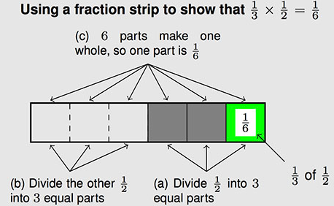  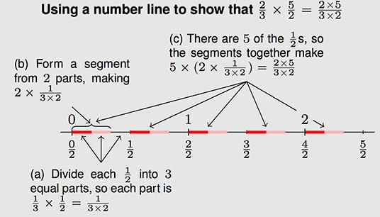  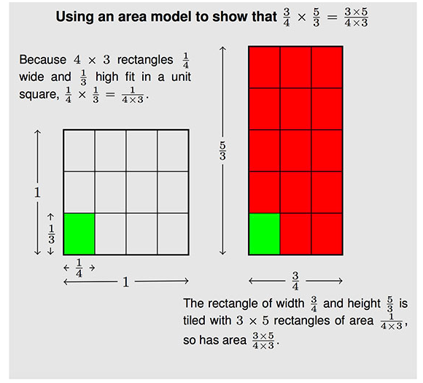  In preparation for Grade 6 work in ratios and proportional relationships, students learn to see products such as 5 x 3 or 1/2 x 3 as expressions that can be interpreted in terms of a quantity, 3, and a scaling factor, 5 or 1/2. Thus, in addition to knowing that 5 x 3 = 15, they can also say that 5 x 3 is 5 times as big as 3, without evaluating the product. Likewise, they see 1/2 x 3 as half the size of 3.  Grade 5 work with multiplying by unit fractions, and interpreting fractions in terms of division, enables students to see that multiplying a quantity by a number smaller than 1 produces a smaller quantity, as when the budget of a large state university is multiplied by 1/2, for example.  (See pp. 12–13 in the NF Progressions.)
Essential Question(s) | How can I apply and extend my previous understanding of multiplication to multiply fractions?

Anchor Tasks

Task | Explanation
8-2 Solve and Share | Provides opportunity to multiply a whole number by a fraction.
8-3 Visual Learning Bridge (Part A only) | Provides opportunity to extend understanding from grade 4 and lesson 8-2 to multiply fractions and wholes numbers.
8-4 Solve and Share | Provides opportunity to develop the conceptual understanding of what it means to multiply a fraction (less than one) by another fraction (less than one).
8-6 Solve and Share  (Remove grid.) | Ensures a strong foundation in concrete models before introducing and connecting multiplication of fractions to an algorithm.
8-5 Visual Learning Bridge | Provides opportunity to apply an algorithm to multiply fractions.
8-7 Visual Learning Bridge | Provides opportunity to extend understanding of area model and distributive property to fractions greater than one.
8-8 Visual Learning Bridge | Provides opportunity use conceptual understanding to decide whether multiplying by a scale factor results in a product that is greater than or less than the original number.
8-9 Solve and Share | Provides opportunity for solely application with multiplying fractions (greater than and less than one).

Topic Rules of Thumb
Rule | Why?
There are no topic-specific Rules of Thumb.

Assessment Guidance, Topic 8
→ Topic Assessment
Performance Assessment
Item #/Action | Why?
- As Is
- Delete | Item requires using a specific model.
- As Is
- As Is
- As Is
- As Is
- As Is
- Modify: Delete text “Use the number line to help.” Delete the number line. | Item requires using a specific model.
- As Is
- Delete | 5.NF.B.5a and 5.NF.B.5b do not require Application.
- As Is
- As Is
- As Is
- As Is
- As Is
- As Is

Grade 5, Topic 9: Apply Understanding of Division To Divide Fraction

Standards addressed | Primary in this topic:  5.NF.B.3: Interpret a fraction as division of the numerator by the denominator (a/b = a ÷ b). Solve word problems involving division of whole numbers leading to answers in the form of fractions or mixed numbers, e.g., by using visual fraction models or equations to represent the problem. For example, interpret 3/4 as the result of dividing 3 by 4, noting that 3/4 multiplied by 4 equals 3, and that when 3 wholes are shared equally among 4 people each person has a share of size 3/4. If 9 people want to share a 50-pound sack of rice equally by weight, how many pounds of rice should each person get? Between what two whole numbers does your answer lie?  5.NF.B.7a: Interpret division of a unit fraction by a non-zero whole number, For example, create a story context for (1/3) ÷ 4, and use a visual fraction model to show the quotient. Use the relationship between multiplication and division to explain that (1/3) ÷ 4 = 1/12 because (1/12) × 4 = 1/3.  5.NF.B.7b: Interpret division of a whole number by a unit fraction, and compute such quotients. For example, create a story context for 4 ÷ (1/5), and use a visual fraction model to show the quotient. Use the relationship between multiplication and division to explain that 4 ÷ (1/5) = 20 because 20 × (1/5) = 4.  5.NF.B.7c: Solve real world problems involving division of unit fractions by non-zero whole numbers and division of whole numbers by unit fractions, e.g., by using visual fraction models and equations to represent the problem. For example, how much chocolate will each person get if 3 people share 1/2 lb of chocolate equally? How many 1/3-cup servings are in 2 cups of raisins?
Aspects of Rigor targeted by the standards | Primary in this topic:  Conceptual Understanding, Application
Applicable information from the progression documents | In Grade 5, [students] connect fractions with division, understanding that 5 div 3 = 5/3, or, more generally, a/b = a div b for whole numbers a and b, with b not equal to zero.  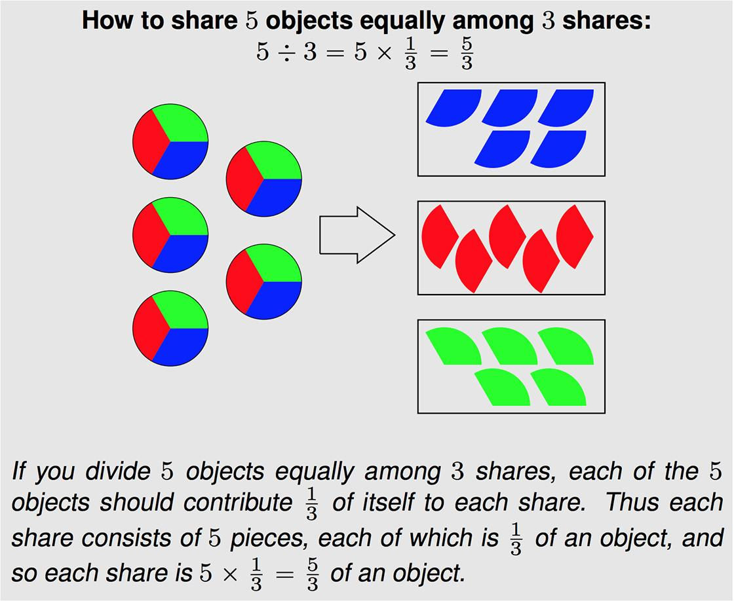  In Grade 5, they connect fractions with division, understanding that 5$÷$3 $=\frac{5}{3}$ , or, more generally, $\frac{a}{b}$= a$÷$b for whole numbers a and b, with b not equal to zero.^{5.NF.3} They can explain this by working with their understanding of division as equal sharing (see figure in margin). They also create story contexts to represent problems involving division of whole numbers. For example, they see that:  If 9 people want to share a 50-pound sack of rice equally by weight, how many pounds of rice should each person get?  can be solved in two ways. First, they might partition each pound among the 9 people, so that each person gets 50$×\frac{1}{9}$= $\frac{50}{9}$pounds. Second, they might use the equation 9$×$5 = 45 to see that each person can be given 5 pounds, with 5 pounds remaining. Partitioning the remainder gives  5$\frac{5}{9}$pounds for each person.  (See p. 12 in the NF Progressions.)
Essential Question(s) | How are fractions related to division? How can you divide with whole numbers and unit fractions?

Anchor Tasks
Task | Explanation
9-1 Visual Learning Bridge | Provides opportunity to relate fractions to division with quotients less than one.
9-2 Solve and Share | Provides opportunity to relate fractions to division with quotients greater than one.
9-3 Solve and Share  (problem only) | Provides opportunity to relate dividing by a unit fraction to multiplication.
9-4 Visual Learning Bridge | Uses area models and number lines to support understanding of division of a whole number by a unit fraction.
9-5 Visual Learning Bridge | Uses area models and number lines to support understanding of division a unit fraction by a non-zero whole number.
Banana Pudding | Allows for solving a real-world problem involving division of a whole number by a unit fraction.

Topic Rules of Thumb
Rule | Why?
In Lessons 9-4 through 9-6, allow opportunities for students to create context for whole number divided by unit fraction and unit fraction divided by whole number. | 5.NF.B.7a: Interpret division of a unit fraction by a non-zero whole number, For example, create a story context for (1/3) ÷ 4, and use a visual fraction model to show the quotient.  5.NF.B.7b: Interpret division of a whole number by a unit fraction, and compute such quotients. For example, create a story context for 4 ÷ (1/5), and use a visual fraction model to show the quotient.
Use 9-6 as an opportunity to practice using models and number lines to divide unit fractions by whole numbers and whole numbers by unit fractions. | 5.NF.B.7a and 5.NF.B.7b
Skip Lesson 9-7. | The standard does not require multi-step application.

Assessment Guidance, Topic 9
→ Topic Assessment
Performance Assessment
Item #/Action | Why?
- Delete | Aligns to 6.RP.A.3 (unit rate).
- As Is
- As Is
- As Is
- As Is
- As Is
- As Is
- As Is
- As Is
- As Is
- As Is
- As Is
13. As Is | Note: Equivalent expressions should be accepted, including 1/15.
14. As Is

Grade 5, Topic 4: Use Models and Strategies to Multiply Decimals

Standards addressed | Primary in this topic:  5.NBT.B.7: Add, subtract, multiply, and divide decimals to hundredths, using concrete models or drawings and strategies based on place value, properties of operations, and/or the relationship between addition and subtraction; relate the strategy to a written method and explain the reasoning used.  5.NBT.A.2: Explain patterns in the number of zeros of the product when multiplying a number by powers of 10, and explain patterns in the placement of the decimal point when a decimal is multiplied or divided by a power of 10. Use whole-number exponents to denote powers of 10.
Aspects of Rigor targeted by the standards | Primary in this topic:  Conceptual
Applicable information from the progression documents | General methods used for computing products of whole numbers extend to products of decimals. Because the expectations for decimals are limited to thousandths and expectations for factors are limited to hundredths at this grade level, students will multiply tenths with tenths and tenths with hundredths, but they need not multiply hundredths with hundredths. Before students consider decimal multiplication more generally, they can study the effect of multiplying by 0.1 and by 0.01 to explain why the product is ten or a hundred times as small as the multiplicand (moves one or two places to the right). They can then extend their reasoning to multipliers that are single-digit multiples of 0.1 and 0.01 (e.g., 0.2 and 0.02, etc.).  (See p. 19 in the NBT Progressions.)
Essential Question(s) | How can we use what we know about multiplying whole numbers to multiply decimals?

Anchor Tasks
Task | Explanation
3-1 Solve and Share  (Do not present short cut rule.) | Builds coherence between 3-1 and 4-1 around patterns of zeros as the movement of decimals.
4-1 Visual Learning Bridge | Solidifies the idea around movement of decimal in relations to powers of ten. Use both tasks in order to encompass multiplying by powers of 10 greater and less than one.
4-3 Solve and Share | Provides opportunity to use a model to multiply a decimal by a whole number
4-4 Visual Learning Bridge | Provides opportunity to multiply a whole number by a decimal
4-5 Solve and Share | Model the overlay shown in VISUAL LEARNING BRIDGE 4-5 when debriefing. This model can be used for all multiplication of decimals.
4-6 Visual Learning Bridge (Present problem without the context.) | Provides opportunity to use model to multiply decimals larger than 1.
4-8 Solve and Share | Provides opportunity to use number sense when multiplying decimals.

Topic Rules of Thumb
Rule | Why?
Encourage students to use estimation to understand the decimal placement in multiplication throughout the lessons in the topic. | MP1 states that mathematically proficient students check their answers to problems using a different method, and they continually ask themselves, “Does this make sense?”
Avoid problems that use rates for decimal multiplication (e.g., 4-4 Solve and Share and #21). | Unit rates are first introduced in grade 6 in the RP domain.
Throughout lessons on multiplication of decimals by decimals, students should have access to models to solve problems; the standard algorithm is not required until grade 6 and therefore should not be mandated in lesson 4-9. | 5.NBT.B.7: Add, subtract, multiply, and divide decimals to hundredths, using concrete models or drawings and strategies based on place value, properties of operations, and/or the relationship between addition and subtraction; relate the strategy to a written method and explain the reasoning used.
Don’t require students to use a specific model or strategy in each lesson for Lessons 4-3 to 4-8, but rather emphasize using concrete models or drawings and place value strategies throughout. Use these six lessons as an opportunity for students to make sense of the strategies and apply them to appropriate multiplication problems. Students should be able to relate their strategies to written methods and explain their reasoning. | 5.NBT.B.7: Add, subtract, multiply, and divide decimals to hundredths, using concrete models or drawings and strategies based on place value, properties of operations, and/or the relationship between addition and subtraction; relate the strategy to a written method and explain the reasoning used.

Assessment Guidance, Topic 4
→ Topic Assessment
Performance Assessment
Item #/Action | Why?
- As Is
- As Is
- As Is
- As Is
- Delete | 5.NBT.B.7 does not require Application.
- As Is
- As Is
- As Is
- As Is
- As Is
- Delete | 5.NBT.B.7 does not require Application.
- As Is
- As Is
- As Is
- As Is
- Delete | 5.NBT.B.7 does not require Application
- As Is
- As Is
19. As Is
20. As Is
21. Delete | 5.NBT.B.7 does not require Application.

Grade 5, Topic 6: Patterns for Dividing with Decimals

Standards addressed | Primary in this topic:  5.NBT.B.7: Add, subtract, multiply, and divide decimals to hundredths, using concrete models or drawings and strategies based on place value, properties of operations, and/or the relationship between addition and subtraction; relate the strategy to a written method and explain the reasoning used.  Secondary in this topic:  5.NBT.A.2: Explain patterns in the number of zeros of the product when multiplying a number by powers of 10, and explain patterns in the placement of the decimal point when a decimal is multiplied or divided by a power of 10. Use whole-number exponents to denote powers of 10.
Aspects of Rigor targeted by the standards | Primary in this topic:  Conceptual Understanding
Applicable information from the progression documents | General methods used for computing quotients of whole numbers extend to decimals with the additional issue of placing the decimal point in the quotient.  As with decimal multiplication, students can first examine the cases of dividing by 0.1 and 0.01 to see that the quotient becomes 10 times or 100 times as large as the dividend (see also the Number and Operations—Fractions Progression). For example, students can view 70/0.1 l as asking how many tenths are in 7. Because it takes 10 tenths to make 1, it takes 7 times (5.NF.7b) as many tenths to make 7, so 70/0.1 = 70.  (5.NF.7b Apply and extend previous understandings of division to divide unit fractions by whole numbers and whole numbers by unit fractions. b Interpret division of a whole number by a unit fraction, and compute such quotients.)  Or students could note that 7 is 70 tenths, so asking how many tenths are in 7 is the same as asking how many tenths are in 70 tenths, which is 70. In other words, 7 0.1s is the same as 70 1s. So dividing by 0.1 moves the number 7 one place to the left, the quotient is ten times as big as the dividend. As with decimal multiplication, students can then proceed to more general cases. For example, to calculate 70/0.2, students can reason that 0.2 is 2 tenths and 7 is 70 tenths, so asking how many 2 tenths are in 7 is the same as asking how many 2 tenths are in 70 tenths. In other words, 7 0.2s is the same as 70 2s; multiplying both the 7 and the 0.2 by 10 results in the same quotient. Or students could calculate 7 0.2s by viewing 0.2 as 2 0.1s, so they can first divide 7 by 2, which is 3.5, and then divide that result by 0.1, which makes 3.5 ten times as large, namely 35. Dividing by a decimal less than 1 results in a quotient larger than the dividend (5.NF.5) and moves the digits of the dividend one place to the left.  5.NF.5 Interpret multiplication as scaling (resizing), by:  a) Comparing the size of a product to the size of one factor on the basis of the size of the other factor, without performing the indicated multiplication.  b) Explaining why multiplying a given number by a fraction greater than 1 results in a product greater than the given number (recognizing multiplication by whole numbers greater than 1 as a familiar case); explaining why multiplying a given number by a fraction less than 1 results in a product smaller than the given number; and relating the principle of fraction equivalence to the effect of multiplying ab by 1.  Students can summarize the results of their reasoning as specific numerical patterns, then as one general overall pattern such as “when the decimal point in the divisor is moved to make a whole number, the decimal point in the dividend should be moved the same number of places.”  (See p. 20 in the NBT Progressions.)
Essential Question(s) | How can you use place value to divide?

Anchor Tasks
Task | Explanation
6-1 Solve and Share | Provides opportunity to develop an understanding of movement of decimal when dividing by powers of ten.
6-2 Visual Learning Bridge | Provides opportunity to develop ability to reason about the size of the quotient.
6-3 Solve and Share | Provides opportunity to use place value models to divide.
6-6 Visual Learning Bridge | Provides opportunity to understand reasoning about the size of the quotient when dividing by decimals smaller than 1 AND greater than 1.
6-7 Visual Learning Bridge (Part A only) | Supports understanding of what it means to divide by a decimal, provides students practice with a problem that will lend itself to modeling (as does the “Do You Know How” tasks), and requires students to analyze why rewriting a new equivalent expression is a strategy for dividing by decimals.

Topic Rules of Thumb
Rule | Why?
Explicitly connect the operations of multiplication and division (see progressions excerpt) and build understanding of multiplying and dividing decimals based on students’ prior work with and understanding of multiplying and dividing fractions. | 5.NBT.B.7: Add, subtract, multiply, and divide decimals to hundredths, using concrete models or drawings and strategies based on place value, properties of operations, and/or the relationship between addition and subtraction; relate the strategy to a written method and explain the reasoning used.
In Lesson 6-3, emphasize the use of place value models to divide as opposed to introducing the standard algorithm. Use Lessons 6-4, 6-5, and 6-8 to continue practicing using the place value models and strategies to divide. If standard algorithm is going to be introduced (despite it not being required by the standards until grade 6), it should be done with a clear connection made to place value models for division and explicitly stated that this is a way to relate the place value model to a written method. | 5.NBT.B.7: Add, subtract, multiply, and divide decimals to hundredths, using concrete models or drawings and strategies based on place value, properties of operations, and/or the relationship between addition and subtraction; relate the strategy to a written method and explain the reasoning used.
Skip 6-9. | Standard doesn’t require Application.

Assessment Guidance, Topic 6
→ Topic Assessment
Performance Assessment
Item #/Action | Why?
- As Is
- As Is
- As Is
- As Is
- Delete | 5.NBT.B.7 does not require Application.
- Delete | 5.NBT.B.7 does not require Application.
- As Is
- Delete | Item requires a specific model.
- Delete | Aligns to 6.RP.A.3b (unit rate).
- As Is
- As Is
- As Is
- As Is
- Delete | 5.NBT.B.7 does not require Application.
- As Is
- As Is
- Delete | 5.NBT.B.7 does not require Application.
- Delete | 5.NBT.B.7 does not require Application.
- Delete | Repeats content from other questions.
- Delete | 5.NBT.B.7 does not require Application.
- Delete | 5.NBT.B.7 does not require Application.
- Delete | 5.NBT.B.7 does not require Application.

Grade 5, Topic 7: Use Equivalent Fractions to Add and Subtract Fractions

Standards addressed | Primary in this topic:  5.NF.A.1: Add and subtract fractions with unlike denominators (including mixed numbers) by replacing given fractions with equivalent fractions in such a way as to produce an equivalent sum or difference of fractions with like denominators. For example, 2/3 + 5/4 = 8/12 + 15/12 = 23/12. (In general, a/b + c/d = (ad+bc)/db)  5.NF.A.2: Solve word problems involving addition and subtraction of fractions referring to the same whole, including cases of unlike denominators, e.g., by using visual fraction models or equations to represent the problem. Use benchmark fractions and number sense of fractions to estimate mentally and assess the reasonableness of answers. For example, recognize an incorrect result 2/5 + 1/2 = 3/7, by observing that 3/7 < 1/2.
Aspects of Rigor targeted by the standards | Primary in this topic:  Conceptual Understanding, Procedural Skill and Fluency, Application
Applicable information from the progression documents | In Grade 4, students have some experience calculating sums of fractions with different denominators...where one denominator is a divisor of the other, so that only one fraction has to be changed. Grade 5 students extend this reasoning to situations where it is necessary to re-express both fractions in terms of a new denominator. For example, in calculating $\frac{2}{3}$ + $\frac{5}{4}$ they reason that if each third in $\frac{2}{3}$ is subdivided into fourths, and if each fourth in $\frac{5}{4}$ is subdivided into thirds, then each fraction will be a sum of unit fractions with denominator 3 x 4 = 4 x 3 = 12:  $\frac{2}{3}$ + $\frac{5}{4}$ = $\frac{2×4}{3×4}$ + $\frac{5×3}{4×3}$ = $\frac{8}{12}$ + $\frac{15}{12}$ = $\frac{23}{12}$  Students make sense of fractional quantities when solving word problems, estimating answers mentally to see if they make sense. For example in the problem  Ludmilla and Lazarus each have a lemon. They need a cup of lemon juice to make hummus for a party. Ludmilla squeezes $\frac{1}{2}$ a cup from hers and Lazarus squeezes $\frac{2}{5}$ of a cup from his. How much lemon juice do they have? Is it enough?  Students estimate that there is almost but not quite one cup of lemon juice, because $\frac{2}{5}$ <$\frac{1}{2}$. They calculate $\frac{1}{2}$ + $\frac{2}{5}$ =$\frac{9}{10}$, and see this as$\frac{1}{10}$ less than 1, which is probably a small enough shortfall that it will not ruin a recipe.  (See p. 11 in the NF Progressions)
Essential Question(s) | How do we use equivalent fractions to add and subtract fractions?

Anchor Tasks
Task | Explanation
7-1 Solve and Share | Provides opportunity to introduce estimation strategies to be used throughout addition and subtraction.
7-6 Solve and Share | Allows all fraction work (fractions less than and greater than one) to be experienced together to show fractions and mixed numbers as one concept.
7-3 Visual Learning Bridge | Allows for numbers that lend themselves to using a model as opposed to the simpler more common fractions found in the Solve and Share.
7-7 Visual Learning Bridge | Allows all fraction work (fractions less than and greater than one) to be experienced together to show fractions and mixed numbers as one concept. Numbers used in VISUAL LEARNING BRIDGE allows for numbers that lend themselves to using a model as opposed to the simpler more common fractions found in the Solve and Share.
7-4 Visual Learning Bridge | Provides opportunity to use a model to subtract fractions with unlike denominators.
7-9 Visual Learning Bridge | Provides opportunity to use a model to subtract fractions with unlike denominators.
7-12 Solve and Share | Provides opportunity for solely application with adding and subtracting fractions.

Topic Rules of Thumb
Rule | Why?
Throughout the topic, make explicit connections between the work of grade 4 around generating equivalent fractions to support the grade 5 work of adding and subtracting fractions with unlike denominators. | 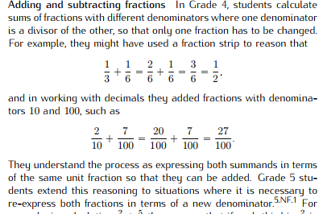  (See p. 11 in the NF Progressions.)
Identify and present opportunities for students to add two fractions less than 1 that result in a sum greater than 1 and also to subtract fractions less than 1 and greater than 1 from a whole number. | Allows for full scope of numbers expected by 5.NF.A.1 and 5.NF.A.2.
Identify and present opportunities for students to recognize equivalent fractions in their solutions for sums or differences. Despite answer keys showing all final answers in ‘simplest form’; the standard does not require sums and differences to be in ‘simplest form’. | “It is not necessary to find a least common denominator to calculate sums of fractions, and in fact the effort of finding a least common denominator is a distraction from understanding algorithms for adding fractions.”  (See p. 11 in the NF Progressions.)  4.NF.A.1: Explain why a fraction a/b is equivalent to a fraction (n x a)/(n x b) by using visual fraction models, with attention to how the number and size of the parts differ even though the two fractions themselves are the same size. Use this principle to recognize and generate equivalent fractions.
Use Lessons 7-5, 7-8, 7-10, 7-11 to practice adding and subtracting fractions (less than or greater than 1). These should be grounded in the anchor tasks for 7-3, 7-7, 7-4, and 7-9 depending on the needs of students. | 5.NF.A.1: Add and subtract fractions with unlike denominators (including mixed numbers) by replacing given fractions with equivalent fractions in such a way as to produce an equivalent sum or difference of fractions with like denominators. For example, 2/3 + 5/4 = 8/12 + 15/12 = 23/12. (In general, a/b + c/d = (ad+bc)/db)  5.NF.A.2: Solve word problems involving addition and subtraction of fractions referring to the same whole, including cases of unlike denominators, e.g., by using visual fraction models or equations to represent the problem. Use benchmark fractions and number sense of fractions to estimate mentally and assess the reasonableness of answers. For example, recognize an incorrect result 2/5 + 1/2 = 3/7, by observing that 3/7 < 1/2.

Assessment Guidance, Topic 7
→ Topic Assessment
Performance Assessment
Item #/Action | Why?
- As Is
- As Is
- As Is
- As Is
- Delete | Question requires using a specific model.
- As Is
- As Is
- As Is
- As Is
- As Is
- As Is
- As Is
- As Is
- Delete | Question requires using a specific model.
- Delete | Mathematical accuracy: This problem can also be solved by recognizing ⅞ as ¾ + ⅛ and subtracting ¾ and subtracting ⅛. The idea that one “must rename” a particular fraction is misleading and inconsistent with strategies students have learned in the OA and NBT domains.
- As Is
- Delete | Repeats content from other questions.
- Delete | Repeats content from other questions.
- Delete | Repeats content from other questions.
- Delete | Repeats content from other questions.
- Delete | Repeats content from other questions.
- As Is
- As Is
- Delete | Question requires using a specific model.
- Delete | Not aligned to the central concern of 5.NF.A.1.

Grade 5, Topic 10: Understand Volume Concepts

Standards addressed | Primary in this topic:  5.MD.C.3a: A cube with side length 1 unit, called a “unit cube,” is said to have “one cubic unit” of volume, and can be used to measure volume.  5.MD.C.3b: A solid figure which can be packed without gaps or overlaps using n unit cubes is said to have a volume of n cubic units.  5.MD.C.4: Measure volumes by counting unit cubes, using cubic cm, cubic in, cubic ft, and improvised units.  5.MD.C.5a: Find the volume of a right rectangular prism with whole-number side lengths by packing it with unit cubes, and show that the volume is the same as would be found by multiplying the edge lengths, equivalently by multiplying the height by the area of the base. Represent threefold whole-number products as volumes, e.g., to represent the associative property of multiplication.  5.MD.C.5b: Apply the formulas V = l × w × h and V = b × h for rectangular prisms to find volumes of right rectangular prisms with whole number edge lengths in the context of solving real world and mathematical problems.  5.MD.C.5c: Recognize volume as additive. Find volumes of solid figures composed of two non-overlapping right rectangular prisms by adding the volumes of the non-overlapping parts, applying this technique to solve real world problems.
Aspects of Rigor targeted by the standards | Primary:  Conceptual Understanding  Secondary:  Procedural Skill and Fluency, Application
Applicable information from the progression documents | “Packing” volume is more difficult than iterating a unit to measure length and measuring area by tiling. Students learn about a unit of volume, such as a cube with a side length of 1 unit, called a unit cube (5.MD.C.3). They pack cubes (without gaps) into right rectangular prisms and count the cubes to determine the volume or build right rectangular prisms from cubes and see the layers as they build (5.MD.C.4).  Students understand that multiplying the length times the width of a right rectangular prism can be viewed as determining how many cubes would be in each layer if the prism were packed with or built up from unit cubes. They also learn that the height of the prism tells how many layers would fit in the prism (5.MD.C.5).  (See p. 26 in the MD Progressions.)
Essential Question(s) | What is the meaning of volume of a solid? How can the volume of a rectangular prism be found?
Anchor Tasks
Task | Explanation
10-1 Intervention Activity | Develops conceptual understanding of volume using packing and improvised units
10-1 Visual Learning Bridge | Provides opportunity to introduce concepts of volume.
10-3 Intervention Activity | Provides opportunity to connect concept of volume to derivation of formula of V = B x h.
10-2 Solve and Share | Supports students in building of formula V= l x h x w.
10-4 Solve and Share | Provides opportunity to see volume as additive.
10-5 Visual Learning Bridge | Provides opportunity to apply volume formulas to a real-world problem.

Topic Rules of Thumb
Rule | Why?
There are no topic-specific Rules of Thumb.

Assessment Guidance, Topic 10
→ Topic Assessment
Performance Assessment
Item #/Action | Why?
- As Is
- As Is
- As Is
- As Is
- As Is
- As Is
- Modify: Delete Part A. | Not aligned to central concern of 5.MD.C.5b.
- As Is
- As Is
- As Is

Grade 5, Topic 11: Convert Measurements

Standards addressed | Primary in this topic:  5.MD.A.1: Convert among different-sized standard measurement units within a given measurement system (e.g., convert 5 cm to 0.05 m), and use these conversions in solving multi-step, real world problems.  Secondary in this topic:  5.NBT.A.2: Explain patterns in the number of zeros of the product when multiplying a number by powers of 10, and explain patterns in the placement of the decimal point when a decimal is multiplied or divided by a power of 10. Use whole-number exponents to denote powers of 10.  5.NBT.B.5: Fluently multiply multi-digit whole numbers using the standard algorithm.  5.NBT.B.6: Find whole-number quotients of whole numbers with up to four-digit dividends and two-digit divisors, using strategies based on place value, the properties of operations, and/or the relationship between multiplication and division. Illustrate and explain the calculation by using equations, rectangular arrays, and/or area models.
Aspects of Rigor targeted by the standards | Primary in this topic:  Conceptual Understanding  Secondary in this topic:  Application, Procedural Skill and Fluency
Applicable information from the progression documents | Convert like measurement units within a given measurement system; in Grade 5, students extend their abilities from Grade 4 to express measurements in larger or smaller units within a measurement system (4.MD.1, 5.MD.1). This is an excellent opportunity to reinforce notions of place value for whole numbers and decimals, and connection between fractions and decimals (e.g., 2 $\frac{1}{2}$ meters can be expressed as 2.5 meters or 250 centimeters). For example, building on the table from Grade 4, Grade 5 students might complete a table of equivalent measurements in feet and inches.  Grade 5 students also learn and use such conversions in solving multi-step, real world problems (see example in the margin).  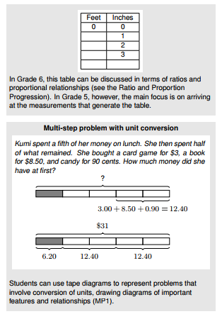  (See p. 26 in the MD Progressions.)
Essential Question(s) | N/A

Assessment Guidance, Topic 11
→ Topic Assessment
Performance Assessment
Item #/Action | Why?
- As Is
- Modify: Delete Part A. | Allow students to engage in MP.1.
- As Is
- As Is
- As Is
- As Is
- As Is
- As Is
9.As Is
10.As Is
11.Modify: Delete Part A. | Allow students to engage in MP.1.
12. As Is
13. As Is

Grade 5, Topic 12: Represent and Interpret Data

Standards addressed | Primary in this topic:  5.MD.B.2: Make a line plot to display a data set of measurements in fractions of a unit (1/2, 1/4, 1/8). Use operations on fractions for this grade to solve problems involving information presented in line plots. For example, given different measurements of liquid in identical beakers, find the amount of liquid each beaker would contain if the total amount in all the beakers were redistributed equally.  5.NF.A.2: Solve word problems involving addition and subtraction of fractions referring to the same whole, including cases of unlike denominators, e.g., by using visual fraction models or equations to represent the problem. Use benchmark fractions and number sense of fractions to estimate mentally and assess the reasonableness of answers. For example, recognize an incorrect result 2/5 + 1/2 = 3/7, by observing that 3/7 < 1/2.  Secondary in this topic:  5.NBT.B.6: Find whole-number quotients of whole numbers with up to four-digit dividends and two-digit divisors, using strategies based on place value, the properties of operations, and/or the relationship between multiplication and division. Illustrate and explain the calculation by using equations, rectangular arrays, and/or area models.
Aspects of Rigor targeted by the standards | Primary in this topic:  Application  Secondary in this topic:  Procedural Skill and Fluency
Applicable information from the progression documents | Grade 5 students grow in their skill and understanding of fraction arithmetic, including multiplying a fraction by a fraction (5.NF.4), dividing a unit fraction by a whole number or a whole number by a unit fraction (4.NF.7), and adding and subtracting fractions with unlike denominators (5.NF.1). Students can use these skills to solve problems (5.NF.2, 5.NF.6, 5.NF.7c), including problems that arise from analyzing line plots. For example, given five graduated cylinders with different measures of liquid in each, students might find the amount of liquid each cylinder would contain if the total amount in all the cylinders were redistributed equally. (Students in Grade 6 will view the answer to this question as the mean value for the data set in question.)  (See p.11 in the MD Progressions.)
Essential Question(s) | N/A

Assessment Guidance, Topic 12
Topic Assessment
→ Performance Assessment
Item #/Action | Why?
- Modify: Delete Part D. | Aligns to 8.SP (outliers).
- As Is

Grade 5, Topic 13: Write and Interpret Numerical Expressions

Standards addressed | Primary in this topic:  5.OA.A.1: Use parentheses, brackets, or braces in numerical expressions, and evaluate expressions with these symbols.  5.OA.A.2: Write simple expressions that record calculations with numbers, and interpret numerical expressions without evaluating them. For example, express the calculation “add 8 and 7, then multiply by 2” as 2 × (8 + 7). Recognize that 3 × (18932 + 921) is three times as large as 18932 + 921, without having to calculate the indicated sum or product.
Aspects of Rigor targeted by the standards | Primary in this topic:  Conceptual Understanding, Procedural Skill and Fluency
Applicable information from the progression documents | As preparation for the Expressions and Equations Progression in the middle grades, students in Grade 5 begin working more formally with expressions (5.OA.1, 5.OA.2). They write expressions to express a calculation, e.g., writing 2 x (8+7) to express the calculation “add 8 and 7, then multiply by 2.” They also evaluate and interpret expressions, e.g., using their conceptual understanding of multiplication to interpret 3 x (18932 + 921) as being three times as large as 18932 + 921, without having to calculate the indicated sum or product. Thus, students in Grade 5 begin to think about numerical expressions in ways that prefigure their later work with variable expressions (e.g., three times an unknown length is 3 x L). In Grade 5, this work should be viewed as exploratory rather than for attaining mastery; for example, expressions should not contain nested grouping symbols, and they should be no more complex than the expressions one finds in an application of the associative or distributive property, e.g., (8 + 27) + 2 or (6 x 30) + (6 x 7). Note however that the numbers in expressions need not always be whole numbers.  (See p. 32 in the OA Progressions.)
Essential Question(s) | N/A

Assessment Guidance, Topic 13
→ Topic Assessment
Performance Assessment
Item #/Action | Why?
- As Is
- As Is
- As Is
- As Is
- As Is
- As Is
- As Is
- As Is
- As Is
- As Is
- As Is
- As Is
- As Is
- As Is

Grade 5, Topic 14: Graph Points on the Coordinate Plane

Standards addressed | Primary in this topic:  5.G.A.1: Use a pair of perpendicular number lines, called axes, to define a coordinate system, with the intersection of the lines (the origin) arranged to coincide with the 0 on each line and a given point in the plane located by using an ordered pair of numbers, called its coordinates. Understand that the first number indicates how far to travel from the origin in the direction of one axis, and the second number indicates how far to travel in the direction of the second axis, with the convention that the names of the two axes and the coordinates correspond (e.g., x-axis and x-coordinate, y-axis and y-coordinate).  5.G.A.2: Represent real world and mathematical problems by graphing points in the first quadrant of the coordinate plane, and interpret coordinate values of points in the context of the situation.
Aspects of Rigor targeted by the standards | Primary in this topic:  Conceptual Understanding, Application  Secondary in this topic:  Procedural Skill and Fluency
Applicable information from the progression documents | Thus, spatial structuring underlies coordinates for the plane as well, and students learn both to apply it and to distinguish the objects that are structured. For example, they learn to interpret the components of a rectangular grid structure as line segments or lines (rather than regions) and understand the precision of location that these lines require, rather than treating them as fuzzy boundaries or indicators of intervals. Students learn to reconstruct the levels of counting and quantification that they had already constructed in the domain of discrete objects to the coordination of (at first) two continuous linear measures. That is, they learn to apply their knowledge of number and length to the order and distance relationships of a coordinate grid and to coordinate this across two dimensions (5.G.1). Although students can often “locate a point,” these understandings are beyond simple skills. For example, initially, students often fail to distinguish between two different ways of viewing the point (2, 3), say, as instructions: “right 2, up 3”; and as the point defined by being a distance 2 from the y-axis and a distance 3 from the x-axis. In these two descriptions the 2 is first associated with the x-axis, then with the y-axis. They connect ordered pairs of (whole number) coordinates to points on the grid, so that these coordinate pairs constitute numerical objects and ultimately can be operated upon as single mathematical entities. Students solve mathematical and real-world problems using coordinates. For example, they plan to draw a symmetric figure using computer software in which students’ input coordinates that are then connected by line segments (5.G.2).  (See. p. 17 in the G Progressions.)
Essential Question(s) | N/A

Assessment Guidance, Topic 14
→ Topic Assessment
Performance Assessment
Item #/Action | Why?
- As Is
- As Is
- As Is
- As Is
- Delete | Aligns to 7.RP (graphing relationships).
- As Is
- As Is
- Delete | Aligns to 7.RP (graphing relationships).
- As Is
- As Is
- As Is

Grade 5, Topic 15: Algebra: Analyze Patterns and Relationships

Standards addressed | Primary in this topic:  5.OA.B.3: Generate two numerical patterns using two given rules. Identify apparent relationships between corresponding terms. Form ordered pairs consisting of corresponding terms from the two patterns, and graph the ordered pairs on a coordinate plane. For example, given the rule “Add 3” and the starting number 0, and given the rule “Add 6” and the starting number 0, generate terms in the resulting sequences, and observe that the terms in one sequence are twice the corresponding terms in the other sequence. Explain informally why this is so.  Secondary in this topic:  5.G.A.2: Represent real world and mathematical problems by graphing points in the first quadrant of the coordinate plane, and interpret coordinate values of points in the context of the situation.
Aspects of Rigor targeted by the standards | Primary in this topic:  Conceptual Understanding  Secondary in this topic:  Application
Applicable information from the progression documents | Students extend their Grade 4 pattern work by working briefly with two numerical patterns that can be related and examining these relationships within sequences of ordered pairs and in the graphs in the first quadrant of the coordinate plane.5.OA.3. This work prepares students for studying proportional relationships and functions in middle school.  (See p. 32 in the OA Progressions.)
Essential Question(s) | N/A

Assessment Guidance, Topic 15
Topic Assessment
→ Performance Assessment
Item #/Action | Why?
- As Is
- As Is
- As Is

Grade 5, Topic 16: Geometric Measurement: Classify Two-Dimensional Figures

Standards addressed | Primary in this topic:  5.G.B.3: Understand that attributes belonging to a category of two dimensional figures also belong to all subcategories of that category. For example, all rectangles have four right angles and squares are rectangles, so all squares have four right angles.  5.G.B.4: Classify two-dimensional figures in a hierarchy based on properties.
Aspects of Rigor targeted by the standards | Primary in this topic:  Conceptual Understanding
Applicable information from the progression documents | 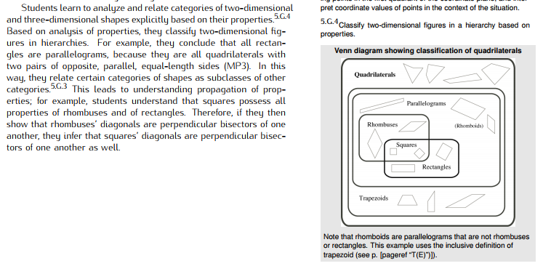  (See p. 18 in the G Progressions.)
Essential Question(s) | N/A

Assessment Guidance, Topic 16
→ Topic Assessment
Performance Assessment
Item #/Action | Why?
- As Is
- Delete | Aligns to 7.G.A.2 (angle relationships).
- As Is
- As Is
- Delete | Mathematical accuracy: The figure shown is not a rhombus.
- Delete | Mathematical accuracy: It is best not to give a particular definition of trapezoid, but rather show students that there is currently not a fully agreed upon definition in mathematics. (See for example, https://www.illustrativemathematics.org/content-standards/tasks/1504.)
- As Is
- As Is
- As Is
- As Is
- As Is
- Delete | Aligns to 7.G.A.2 (angle relationships).

