Title/Author: The Day You Begin by Jacqueline Woodson
Suggested Time to Spend: 5 Days (Recommendation: 30 minutes/day)
Common Core Grade-level ELA/Literacy Standards: RL.1.1, RL.1.2, RL.1.3, RL.1.4, RL.1.7; W.1.2, W.1.8; SL.1.1, SL.1.2, SL.1.3; L.1.1, L.1.2, L.1.4

Lesson Objective:
Students will listen to an illustrated text read aloud and use literacy skills (reading, writing, discussion, and listening) to demonstrate their understanding of the big idea.
Teacher Instructions
Before the Lesson
- Read the Big Ideas and Key Understandings and the Synopsis below. Please do not read this to the students. This is a description to help you prepare to teach the book and be clear about what you want your children to take away from the work.
Big Ideas/Key Understandings/Focusing Question
Our differences make us special and unique. Sharing our stories with others can help us find community.
How was the little girl in the story, Angelina, brave?
Synopsis
This beautiful picture book is about staying true to yourself, even when it is hard to fit in. Throughout the book, a little girl tells how she felt moving to a new school where she was different than everyone else. When all of the other students in the class were sharing about their summer travels, the narrator feels sad because her summer was so different from everyone else. She did not spend it traveling like all the other students, she spent it taking care of her little sister. Through looking at other characters who also stand out from their classmates in a range of ways, the author shows the readers that it is okay to be different. The little girl decides to do a brave thing and tell her class about her summer and how they read books about so many things it was like they traveled! Once she shared, she was able to talk with her classmates and make new friends.
- Go to the last page of the lesson and review “What Makes this Read-Aloud Complex.” This was created for you as part of the lesson and will give you guidance about what the lesson writers saw as the sources of complexity or key access points for this book. You will of course evaluate text complexity with your own students in mind, and make adjustments to the lesson pacing and even the suggested activities and questions.
- Read the entire book, adding your own insights to the understandings identified. Also note the stopping points for the text-inspired questions and activities. Hint: you may want to copy the questions vocabulary words and activities over onto sticky notes so they can be stuck to the right pages for each day’s questions and vocabulary work.

The Lesson – Questions, Activities, and Tasks
The majority of questions, activities, and tasks should be based on the writing, pictures and features unique to this text (be text specific). Questions that address text-to-self or text-to-world connections - what we like to call text inspired questions or activities - should be held until after the children have really gotten to know the book.

Questions/Activities/Vocabulary/Tasks | Expected Outcome or Response (for each)
FIRST READING:  Read aloud the entire book (or chapter) with minimal interruptions. Stop to provide word meanings or clarify only when you know the majority of your students will be confused. | The goal here is for students to enjoy the book, both writing and pictures, and to experience it as a whole. This will give them some context and sense of completion before they dive into examining the parts of the book more carefully.
SECOND READING:  The purpose of this reading is to make sure students understand the plot of the story. The questions/activities tasks will allow students to clearly identify the main elements of the text so that in later readings, the understanding can move beyond the text. Teachers will use a plot structure diagram to track the plot throughout the readings.  Read pages 1-4.  How is the girl different than everyone at school?  Read pages 5-6.  What does the author mean when she says, “There will be times when no one understands the way words curl from your mouth”?  Why do you think the author included Rigoberto’s school experience in this story?  Read pages 7-8.  What made Rigoberto feel better at school?  Read the sentence on the page again. What does “homeland” mean?  Show students the illustrations on pages 7-8. How does the illustrator help us understand the text?  Read pages 9-10.  What does the teacher ask the students to do in class?  What did the other students in class have in common?  Read page 9 and define unknown words for students (see vocabulary chart at the end of this lesson)  Read the sentence “A boy named Jonathan holds out a jar filled with tiny shells so fragile, they look like they’ll turn to dust in your own untraveled hand.”  What does “fragile” mean? How does the author help you understand the meaning of fragile in the sentence?  Why did the author call the girls’ hands untraveled? What does that mean?  Read pages 11-12.  What did the little girl do over the summer?  How is the girl feeling? How do you know?  At the end of the second reading, the teacher will lead students in filling out the plot structure diagram (see diagram at end of this lesson) to help students keep track of the main plot. Teacher will have it projected or blown up in some way in the front of the room, and students will have a copy at their desks. The students will focus on the first two sections of the diagram after the second reading:  Fill out the first box with: A little girl goes to school; new class  Fill out the second box with: The teacher asks the students to share about their summer vacation. The girl is scared to share because she did not travel like the other students who shared. | She does not know anyone. She looks different. She is walking into a new class at school and she does not know anyone in the class.  It means that there will be times that no one understands the language you speak.  *Explain to the students that the author uses flowery, poetic language in the story. Use this question as an opportunity to highlight this language.  The author included Rigoberto to show another way you may feel alone when you are new to a school.  His teacher said his name and it reminded him of his homeland and he thought it sounded beautiful. It made him feel better to hear her say his name and his homeland.  Homeland is your native land, where you were born and grew up.  The illustrator included pictures of flowers blooming and musical notes to help us understand the text.  The teacher asks the students to share their stories from summer vacation.  They all had traveled over the summer. They went on trips.  Fragile means easily broken. The author says that the tiny shells are so fragile they’ll turn to dust in your own hand, helping us grasp just how tiny and fragile the shells were.  The author called them untraveled hands, because the little girl did not go on a trip over the summer. Untraveled means not having traveled much.  She took care of her sister at home and read many books.  The girl is feeling nervous and anxious to share her story because it is different than the other students’ stories. They all traveled, but she stayed home and read books.  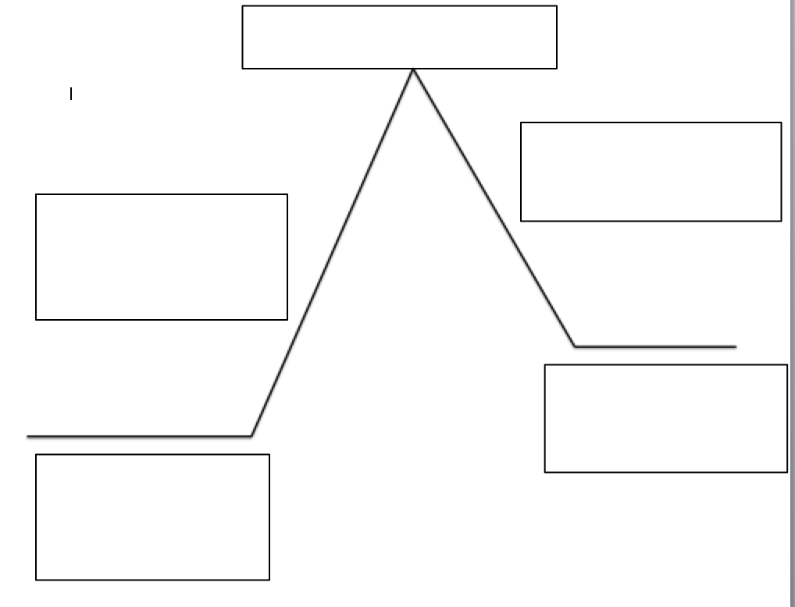
THIRD READING:  Teacher will begin with a quick review of the plot diagram from the day before, so students are familiar with what is happening in the text up to today’s reading.  The third reading will focus on the ways that students may feel different at school. Students will spend some time thinking about how it may feel to be different and lonely, so that they will better understand the message of the story.  Read pages 13-14.  The author calls the girl’s lunch “strange” and “unfamiliar” What does “unfamiliar” mean?  Look at the illustration on page 13. What are the students doing?  How is this making the little girl feel? How can you tell?  Read pages 15-16.  What does it mean to wrinkle your nose? Why did Nadja wrinkle her nose at the girl’s lunch?  The girl is confused as to why her friend thinks her lunch is strange? Why?  Read pages 17-18.  Now the author is showing us another way that you may feel lonely or different.  Why is the boy standing against the tree by himself?  How is the boy different from the rest of the students?  Read pages 19-20.  Why isn’t the boy playing with the other kids?  “when the world feels like a place that you’re standing all the way outside of…” what does this mean?  Read pages 21-22.  “all that stands beside you is your own brave self”  What does it mean to be brave?  What do you notice about the illustration on this page 21?  Why do you think the illustrator did this?  Activity:  The characters in the story feel lonely because they are different. Has there ever been a time where you have felt this way?  Pair the students and let them discuss the question in partners before having them respond in writing. The students will use pictures and words to tell about a time when they felt different. | *Before reading, point out the change in plot to the students. Explain that the author is trying to tell us more about how it feels to be different at school, so she incorporated other stories as well as the main plot.  Unfamiliar means not well- known.  The students are all looking at the little girl, and one girl is whispering to another girl.  She is feeling nervous, self-conscience about her lunch. She is holding her lunchbox close to her body, and she is slumped down in her chair. She is looking at the other students staring at her.  Wrinkling your nose is a way to show you don’t understand or like something. Take a minute to practice wrinkling your nose with the students so they know what it looks like. She wrinkled her nose because she thought her lunch was strange and different.  Rice is the most popular food in the world, so she does not understand why her friend thinks it is strange.  He is not able to play the games that the other student are playing at recess. He is standing alone because he has no one to play with.  The boy is not able to climb the bars or run too fast, and they are all on the climbing bars and running fast.  He is not playing because the kids said they didn’t want him on their team and said he could just watch. (Teacher may need to flip back to page 18 here)  He is lonely and does not have anyone to play with, so he feels like an outsider.  Being brave means showing courage to do something even when it is not easy to do.  In the illustration, the boy is smiling and holding a book in the reflection in the water.  The illustrator is showing us that there is hope. The boy will not always feel so alone.
FOURTH AND BEYOND:  This reading will focus on the Angelina’s bravery in sharing her story with the class. After this reading, the students should be able to identify the message of the book.  Read pages 23-24.  How did Angelina show bravery?  Even though she didn’t go on a trip, how did the girl “go EVERYWHERE?”  Why do you think she said this?  Read pages 25-26.  What happened after Angelina shared her story?  How does this change her feelings of loneliness?  How have the other students in the class changed?  Read pages 27-28.  What happened as a result of Angelina sharing in front of the class?  What does the word “fabulously” mean?  “where every new friend has something a little like you—and something else so fabulously not quite like you at all”  What does this mean?  Activity:  After the fourth reading, the teacher will lead students in completing the plot structure diagram with the students. Students may use the diagram for support as they complete the culminating task.  Top (Third) Box: She tells the class how she read books with her sister over the summer.  Fourth Box: She makes friends with Rigoberto  Final (Fifth) Box: Angelina learns that it is a good thing to be different. | She decided to share her story from her summer vacation even though her story was different from everyone else’s story.  The little girl said that reading books and telling stories made it feel like they went EVERYWHERE.  Because when you read and learn about a place in a book, it is like you’ve been there.  Rigoberto tells her that she and his sister have the same name.  She doesn’t feel so alone. She feels like a part of the class more now.  Instead of laughing or staring, they are paying attention and smiling. Rigoberto even makes a connection between her name and his sister’s name.  She started making friends once she was brave and told her story.  Fabulously means amazingly good.  Once you open up and make friends, you learn that even though someone is different than you, you still have things in common. You can appreciate your differences as a positive rather than a negative.

FINAL DAY WITH THE BOOK - Culminating Task
- How did Angelina show bravery? Students will use pictures and words to answer this question. Remind students to use text evidence in their answer. Students that need a little extra support can use the plot diagram to help them write.
- See standards on page 1-2 for more information about expectations for student writing.
Español:
¿Cómo demostró valentía Angelina? Los estudiantes usarán imágenes y palabras para responder esta pregunta. Recuerde a los estudiantes que usen evidencia de texto en su respuesta. Los estudiantes que necesitan un poco de apoyo adicional pueden usar el diagrama de argumento a para ayudarlos a escribir.
Vocabulary
These words merit less time and attention  (They are concrete and easy to explain, or describe events/  processes/ideas/concepts/experiences that are familiar to your students ) | These words merit more time and attention  (They are abstract, have multiple meanings, and/or are a part  of a large family of words with related meanings. These words are likely to describe events, ideas, processes or experiences that most of your student will be unfamiliar with)
Page 8 - homeland – your native land, where you were born and grew up.  Page 8 - blooming – to produce flowers  Page 9 - fragile – easily broken  Page 9 – untraveled - not having traveled much.  Page 9 – souvenir – something that serves as a reminder of a place you have visited  Page 9 – journey – traveling from one place to another  Page 14 - unfamiliar – not well-known  Page 15 – kimchi – a spicy vegetable dish from South Korea  Page 22 – steady – secure, not moving  Page 22 – steel – a hard, strong metal | Page 9 – triumph – a great victory or success  Page 22 - brave – to show courage to do something difficult  Page 28 – fabulously – amazingly good

Fun Extension Activities for this book and other useful Resources
- Pair this story with Spaghetti in a Hot Dog Bun: Having the Courage to Be Who You Are by Maria Dismondy to further the study on bravery and courage to be yourself.
- Have a classroom discussion about the differences among the students in your classroom, and how they are special and unique.
- The illustrator does a wonderful job of making the text come alive in the story. Take a page of the text to have the students draw a picture of, practicing making the text come alive as the illustrator in this story does.
Note to Teacher
- This story would be great for early in the school year. The message of appreciating diversity and making friends despite differences are all things that would help creative a healthy, safe, inclusive classroom community.
What Makes This Read-Aloud Complex?
- Quantitative Measure
Go to http://www.lexile.com/ and enter the title of your read-aloud in the Quick Book Search in the upper right of home page. Most texts will have a Lexile measure in this database.

AD980L________
Most of the texts that we read aloud in K-2 should be in the 2-3 or 4-5 band, more complex than the students can read themselves.
2-3 band 420-820L
4-5 band 740-1010L

- Qualitative Features
Consider the four dimensions of text complexity below. For each dimension*, note specific examples from the text that make it more or less complex.

Implicit/Complex Meaning
Celebration of diversity
Bravery in opening up to others
Complex structure/Character and Shifts
The book shifts from one main plot, to a few supporting plots and characters. Even though they connect, there is a possibility for students to get confused as to what the main plot is.

Imagery and flowery language, complex sentence
structure, and unconventional use of punctuation/mechanics.
“And in that room, where no one else is quite like you, you’ll look down at your own empty hands and wonder What good is this when other students were flying and sailing and going somewhere.”

Unfamiliar experiences; Not every student may have experienced feeling lonely and different.
“There will be times when the lunch your mother packed for you is too strange or too unfamiliar for others to love as you do.” Assumed background knowledge of

Meaning/Purpose
Structure

Language
Knowledge Demands

- Reader and Task Considerations
What will challenge my students most in this text? What supports can I provide?

The structure of this text will be challenging for the students. The way it shifts in character and plot from time to time could be confusing for students. Using the plot structure diagram on the second reading for the book should help with this. The message in this text is also both implicit and complex. The questions throughout the readings will help students discover the lesson in this story.

How will this text help my students build knowledge about the world?

This text will allow students to appreciate and celebrate their uniqueness. Bravery, courage, and acceptance are all traditional values explored in this text.

- Grade level
What grade does this book best belong in? First Grade

