Seesaw Task

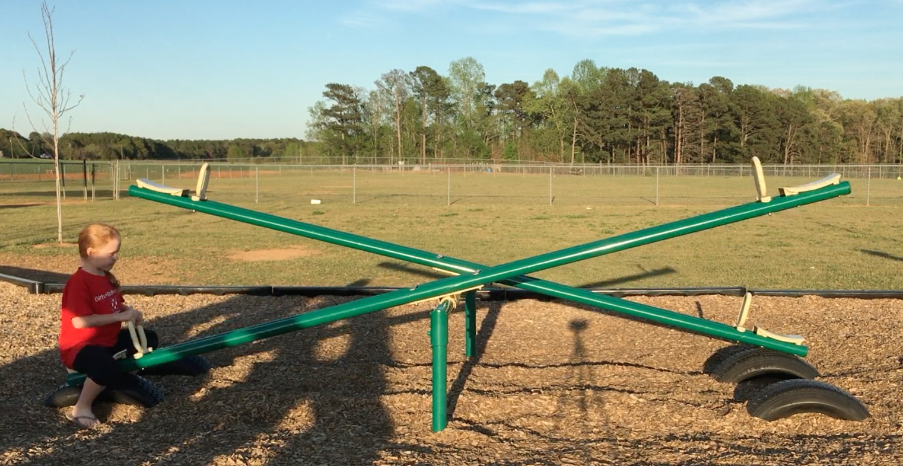

What do you notice, or see, in the picture above?

I notice that ___________________________________________

_____________________________________________________

What do you wonder, or want to know about, the picture above?

I wonder what/if ________________________________________

_____________________________________________________

What question will you answer based on the video?

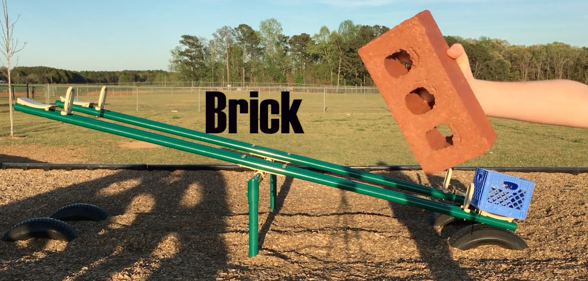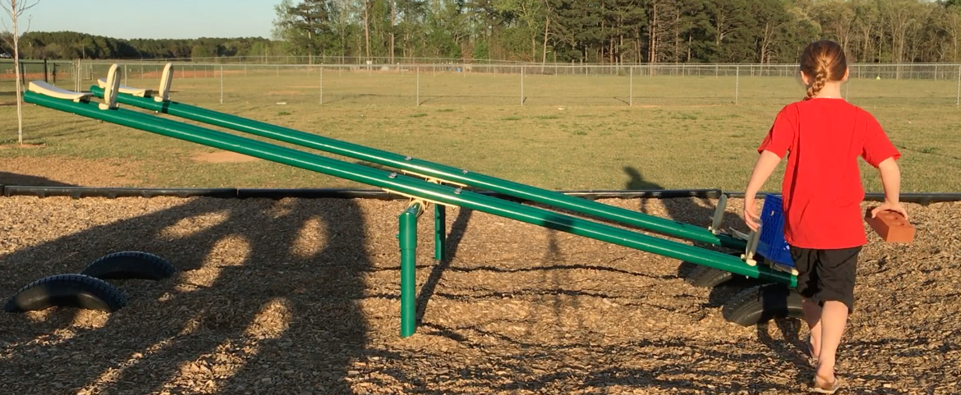

Our question is _________________________________________

_____________________________________________________

low
estimate
high
estimate

my
estimate
Make an estimate,
or a good and
reasonable guess.

Our model:

The answer to our question:

__________________________________________________________________________________________________________
Go back. Were you precise like Polly Sy? Did you remember your labels and units? Remember, 25 cats: 25 is the quantity, or how many, and cats is the unit, or what are we counting.

Yes, we were precise.

No, we forgot some things, but we went back and added them.

