K–2 Planning Guide

The Proudest Blue/ Kindergarten
Estimated pacing: About 1 week of whole-class lessons

For more information, see the Text Analysis Toolkit resource page.

This resource is… | This resource is not…
- Guidance for multiple reads of a grade-level anchor text (in this case read-aloud).  - A place to highlight some key aspects of culturally relevant pedagogy (e.g., exploring self/others, connecting to community, thinking critically about the world) and standards-aligned work (e.g., sequenced text-dependent questions and tasks, attention to academic vocabulary/language, building knowledge). | - A scripted lesson plan. This resource includes key instructional elements, but leaves you with room to customize.  - Everything you/students will need. For example, there is a sample graphic organizer included, but you will likely want to modify and/or create additional resources, tasks, or scaffolds with your specific students in mind.  - All the ways you could use this text to connect with the lives and identities of your students, school, and community.

This resource contains blank templates to create guidance for:

Connecting to Text Analysis | Important things to note about the complexity of, and opportunities/cautions with, this anchor text
The Big Ideas | Text-based big ideas to guide planning/instruction
Culminating Tasks | Three culminating task opportunities for students to demonstrate understanding of the text/topic in varied formats
Vocabulary | Suggested words to spend more and less time on, cognates
Juicy Sentence Protocols | Rich sentences from the text to deconstruct and reconstruct with students
Essential Questions | Guiding questions to tie together experiences
Multiple-Reads Guidance | Questions and tasks for four reads of this text, including pre-reading activities
Text Set Resources | A set of topically-connected text and multimedia resources to build related knowledge of this topic in whole-group, small-group, partner, or independent settings
Additional Student Supports | Sample ways to support all students with this text and content
Standards Addressed | College- and career-ready standards and Social Justice standards

Connecting to Text Analysis
(Either complete below or connect back to your complete analysis.)
Text: The Proudest Blue by Ibtihaj Muhammad with S.K. Ali; Art by Hatem Aly
Quantitative Level: 500L (in 2-3 grade band, appropriate for use as read-aloud)
Connections to Qualitative Analysis (Structure, Meaning, Language, Knowledge)
Structure  - Several times in the text the chronological story pauses and the narration shifts to Mama talking about the meaning of the hijab. The illustrations also shift to the hijab as the sky or the ocean. | Language  - The use of the subtle figurative language such as “Asiaya’s hijab is like the sky on a sunny day” may require more scaffolding for students to understand. Beyond this, the language used in the book will be familiar to many of my students.
Meaning/Purpose  - There are multiple themes in this book, including understanding the cultural significance of the hijab, the first day of school, sibling relationships, teasing/othering, and more. The text explores the idea of pride in one’s culture, including explicitly exploring the tradition, enthusiasm, and challenges of wearing hijab in the school setting.  - Symbolism used within the text as well (e.g., the color blue and its symbolism in Islam). | Knowledge  - Connect to and/or learn about Muslim culture and hijabs. The text explicitly explores the tradition, enthusiasm, and challenges of wearing hijab in the school setting.
Opportunities/Cautions for Culturally Relevant Pedagogy
- Highlight joy by displaying the pride that Faizah has in seeing her sister Asiya wearing her hijab. Text and images come together throughout the book to show joy (e.g., Text: “She’s Smiling. Strong.”; Illustrations: Asiya in her hijab waving to another character).
- The book can be used to help students learn about and critically analyze sociopolitical issues related to hijabs and Islamophobia.
- Be thoughtful about the potential for “othering”—while the focus of this text is the hijab, there are many examples of religious and culture-specific clothing, food, etc. Ensure that we are making this connection for students—we all have parts of our culture and lives that make us unique and are different from our peers.
Reader and Task Considerations
- Consider how the different experiences/depictions in the book would make students feel (those who are cultural insiders and those who are not). For example, for Muslim students in the classroom, consider what feelings the scene of Asiya being teased may evoke, especially when considering Islamophobia.
- Offer opportunities for collaborative peer groups (considering classroom community) as well as a chance to connect with their home and family (connecting to individual identity) in processing the various themes of the book.

The Big Ideas
What is worthy of understanding in this text?
- Significance of the hijab for Faizah, Asiya, Ibtihaj Muhammad (author), and S.K. Ali (author) - and the connection to being Muslim
- Pride is shown through wearing the hijab.
- Family support in getting through challenging times
- Teasing: how do we make school an inclusive place?
What knowledge do students need in order to get to those understandings?
- Understand Islam as a religion, including that there are many religious groups around the world (Islam, Christianity, Judaism, Hinduism, and others).
- Knowledge of when girls often begin wearing hijab publicly and why.
- Understand the idea of “othering” and how people in a community respond to differences (including the choice to be an upstander, bystander, or perpetrator).

STOP & THINK: MYSELF
[Modify this section to include learnings from your own research/reflection.]

What knowledge do I need to engage students with this text in an inclusive way? Is this a topic/idea that is familiar to me, or one I need to learn more about?
- Understand and be prepare to engage students around potential misconceptions about Islam. Resource: Debunking Misconceptions about Islam, Learning for Justice.
- The difference between different types of head coverings, and their connection to veiling customs from around the world (e.g., niqab, chador, burqa). Resource: A Brief History of the Veil, Learning for Justice.

What terms, names, events, or places do I need to research to pronounce accurately?
See here for author pronunciation of Asiya and Faizah, as well as author name (Ibtihaj Muhammad).

STOP & THINK: YOUR STUDENTS
[Modify this section to include considerations based on the students in your room.]

What opportunities for connection and community does this text offer?
- Invite students who have a connection to wearing the hijab to share; invite in their family or community members.
- Extend the invitation to encompass students who have other expressions of their background, culture, religion, etc. through clothing to share with the class.

What potential harm to students could I cause that I need to be careful of?
- Be sure that the opportunities for Muslim students to share and/or make connections are presented as choices if they would like to contribute. Be wary of a forced connection or asking children to speak/share without permission.

Culminating Tasks
(How and in what format will students share their cumulative learning?)
- What is a hijab? Engage in a conversation with a peer about what a hijab is and how it can be important to those who wear it (Choose: verbally explain, artistically show, write & draw, etc.).
- Before engaging in this series of lessons: Interview a member of the class or school community to ask what they know and what they want to find out about hijabs.
- After engaging in this series of lessons: Invite students to return to the person they spoke with (and/or identify a new person at home or in the community) to share their new learnings and updated wonderings.
- Note: see section above to plan for how to respond and facilitate discussion if any students bring up harmful, inaccurate, or discriminatory ideas. You may also consider additional resources from the Text Set that could be used to work against potential misconceptions.

- Mama’s Advice: Illustrate Mama’s advice to Faizah, demonstrating understanding of figurative language, and engage in a gallery walk with peers.
  - Ongoing Morning Meeting activity: Use figurative language to describe something you are proud of from your family (Morning Meeting activity and formative assessment).

- Community Project: Have you experienced teasing, bullying, or hurtful words/actions? How will you be an upstander in our community? Write (with dictation support as needed) and/or draw and act out a play about how you would be an upstander.
  - Note: An upstander is someone who recognizes that something is wrong, for example that someone is being treated unfairly or unjustly, and takes action. Upstanders speak up.

Vocabulary
(Learn more about Selecting and Using Academic Vocabulary in Instruction, including supports for English learners here.)
These words merit less time and attention.  [They are concrete and easy to explain, or describe events/processes/ideas/concepts/experiences that are likely to be familiar to your students.] | These words merit more time and attention.  [They are abstract, have multiple meanings, and/or are part of a large family of words with related meanings. These words are likely to describe events, ideas, processes, or experiences that most of your students will be unfamiliar with.]
squint (act it out)  twirling (act it out)  curtsy (act it out)  light up (quick show)  cartwheel (act it out)  wonder (student-friendly definition: think about) | hijab (attended to in pre-reading activities and throughout this lesson sequence)  figurative language phrases throughout the text such as: hijab smiles, like the ocean waving to the sky (attended to in the 3rd read)  From the authors’ notes:  othered  commotion  children of color  testimony / testament  cherished
Additional vocabulary to support, as needed:
pretend, whisper, strong, regular, nearby, tablecloth, hurtful
Cognates:
hijab - hiyab (Spanish); hijab - hijab (French); hijab - الحجاب alhijab (Arabic)
ocean - oceano (Spanish); ocean - océan (French)

Juicy Sentence Protocols
(Learn more about Juicy Sentences here.)
“Because Asiya’s hijab is like the ocean and the sky, no line between them, saying hello with a loud wave.” (second to last page of the text)

Chunks to discuss with students [marked in brackets]:
“[Because Asiya’s hijab is like the ocean] [and the sky,] [no line between them,] [saying hello with a loud wave.]”

Activities:
Show additional visual of the ocean and a wave. Go chunk by chunk, discussing with students the meaning of each part, before putting the entire meaning of the sentence together. Questions that may support students to unpack the meaning:
- What is Ibtihaj Muhammad comparing Asiya’s hijab to?
- Can you picture the ocean and the sky together? What could the phrase “no line between them” mean?
- What is “them” referring to in the phrase “no line between them”? How do you know?
- What could the word “wave” mean here? What word or adjective describes the wave? Why does Ibtihaj Muhammad use that description?

Essential Questions
(What are the most important ideas students should understand from this set of lessons?)
Why is wearing a hijab important to [Faizah and Asiya]*? What is a hijab, and what does it mean to the people who wear it?
*change [Faizah and Asiya] to [Ibtihaj Muhammad and S.K. Ali] during focus on author’s notes in the fourth read.

How do Asiya, Faizah, Mama, and Faizah’s friends support each other? How can we make school an inclusive place?

Opportunities to Integrate Supports for Multilingual Learners
Throughout this series of lessons, there are many opportunities for multilingual learners to read, speak, and write using their full language resources, inclusive of home language(s) and dialect. Translanguaging can happen at any time when driven by the child, but there are moves teachers can make to support this as well. Within this lesson, consider the ways in which you can integrate the following:

Opportunities for students to write in their language of choice
Opportunities for home language partnerships for conversation and discussion
Opportunities for students to read supporting texts in languages other than English
Opportunities for home language partnerships for group work or collaboration

Multiple-Reads Guidance
(Use your discretion to determine how each read will translate into days of instruction.)
 | Pre-Reading Activities | Focus: Building knowledge of hijab & connecting to the topic
 | First Read | Focus: Understanding big ideas and flow of the text itself  Recommend minimal interruptions, only as needed to preserve meaning. Note: Do not read the authors’ notes during the first read; this will be a focus of the fourth read.
 | Second Read | Focus: Unpacking the structure and noticing how the author varies text structure throughout the text (the chronological narrative vs. mama’s advice)
 | Third Read | Focus: Imagery & figurative language, especially how the author describes the hijab throughout the story
 | Fourth Read | Focus: Reading the authors’ notes to better understand their perspective and connection to the text, engage in opportunities to connect this text to students' identities/experiences and criticality.
 | Throughout | Focus: Build and connect to knowledge about this topic through use of topically-connected text set resources

STOP & THINK: YOUR STUDENTS
[Modify this section to include considerations based on the students in your room.]

In these lessons, additional support may need to be provided for:

- Multilingual learners, especially during the third read with a focus on figurative language. Consider adjustments needed in terms of scaffolds for oral language support.

Pre-Reading Activities
Focus: Building knowledge of hijab & connecting to the topic

Questions, Activities, and Tasks:

- See-Think-Wonder: What do you know about wearing a hijab?
  - Use Wearing Hijab video
  - Discuss:
    - What do you see?
    - What do you think about that?
    - What does it make you wonder?
- Concept/mind map: Co-construct a chart as a class to summarize content learned.

Note: these schema-building activities are especially supportive of multilingual learners.
First Read
Focus: Understanding big ideas and flow of the text itself
Recommend minimal interruptions, only as needed to preserve meaning. Note: Do not read the authors’ notes during the first read; this will be a focus of the fourth read.

Questions, Activities, and Tasks:

- Invite students to act out the following words as they appear in the text: twirling, curtsy, cartwheel (or, teacher or peers model first, followed by the rest of the class).
- Quick define: “light ups” (acting out the steps Faizah takes)
- Closing Discussion: [connection to the See-Think-Wonder map from Pre-Reading Activities]
  - Turn & Talk: What do you notice today about hijabs and our characters in the Proudest Blue? What would you add to our See-Think-Wonder map?
  - After discussing with a partner and charting with the class, invite students to Draw & Write about their thinking. Extra language support: Visual word bank.
Second Read
Focus: Unpacking the structure and noticing how the author varies text structure throughout the text (the chronological narrative vs. mama’s advice)

Questions, Activities, and Tasks:

- Reread the story from the beginning.
- Pause after reading the pages that say “Asiya’s hijab isn't a whisper…The first day of wearing hijab is important, Mama had said. It means to be strong.”
  - What is the author doing on these pages? Before this, we were going through Faizah’s day. What happened here that’s different? How do you know?
  - Let’s look at the advice from mama (“Asiya’s hijab isn’t a whisper. Asiyah’s hijab is like the sky on a sunny day…The first day of a hijab is important, Mama had said. It means being strong”). What do mama’s words mean here?
- Continue re-reading, repeating this method of questioning when mama’s advice is given. *(Note connection to day 3, where students will dive into the meaning of the figurative language and imagery.)
- After reading the third instance of Mama’s advice (illustration of “blue only blue”), project all three pages of metaphorical illustrations/Mama’s advice.
- What do you notice about these three pages? Invite students to discuss what they notice about all three pages. (Students might bring up illustrations, italic font for Mama’s advice, the repetition of the image/advice each time.)
- After reading: draw attention to the importance of volume in how characters are speaking.
  - Did anyone notice times when the author talked about how loud or quiet the characters were when speaking?
  - Possible prompts include:
      - Whisper - Why is the girl in front of her whispering?
      - “After school I look around. I look for whispers, laughs, and shouts...like it’s a regular day.” What does it mean?
      - “She says it so loud…” earlier we talked about the girl whispering. Why is she loud now? What does that mean about how they are feeling?
  - Closing task: Musical Circles (or turn and talk, group discussion or exit slip): Focus on author’s choice of using words and the type of voice that matches the meaning/feeling.
    - Round 1: Imagine Faizah is telling her mother about her day after school. What would she say? What kind of voice will she use? How will she describe using Mama’s advice?
    - Round 2 Identity Connection: Think of something you are worried/unhappy/concerned about today. Tell your partner about it in a voice that matches your emotion.
    - Round 3 Identity Connection: Think of something you are proud of today. Tell your partner about it in a voice that matches your emotion.
Third Read
Focus: Imagery & figurative language, especially how the author describes the hijab throughout the story

Questions, Activities, and Tasks:

- Reread from the beginning, charting throughout the read how the author refers to the hijab and how the illustrator shows the hijab throughout the text.
  - While we are reading, let’s listen closely to the authors’ words and closely “read” the illustrations. What words are used to describe the hijab? How is the illustrator showing the hijab? What might that mean?
Possible lines to chart include:
Sky on a sunny day | Smiling hijab | Special and regular
It means being strong | Important | Isn’t a laugh
Like the ocean waving to the sky | Strong, friendly | Princesses
- Provide students with a graphic organizer (see samples), where they can “draw” and label the language used each time. (Differentiation note: students could get a blank graphic organizer and chart while reading, or some of the rows or columns could be complete in advance for students to follow along.)
- Small-group discussion after reread: What is the author telling us? What is the illustrator showing us?
  - Extra language support: Use Bounce Cards (Bounce, Sum it Up, Inquire) to support listening and discourse.
- Identity Connection: Draw or discuss, continue in follow up lessons, future Morning Meetings, etc.:
  - What is something that is a part of your identity, home, or culture that you think is “special and regular”? Can you use any figurative language from our book or your own choosing to show how special it is?
Fourth Read
Focus: Reading the authors’ notes to better understand their perspective and connection to the text, engage in opportunities to connect this text to students' identities/experiences and criticality.

Questions, Activities, and Tasks:

- Show a video or pictures of Ibtihaj Muhammad and S. K. Ali to students.
- Read the authors’ notes and discuss:
  - Why did Ibtihaj Muhammad and S.K. Ali write this book?
  - What lesson were they trying to show us?
  - Can you connect this to what happened in The Proudest Blue?
- Let’s look back at that page where someone laughs (Text: Someone laughs from nearby. A boy, pointing at Asiya.).
  - What do you notice about how the boy and his friends are shown in the illustration?
  - How does that compare to Asiya and her friends?
  - Why did the illustrator draw them in this way?
- Identity Connection: Invite students to act out scenarios that demonstrate their thinking.
  - Which character on this page is most like you? Why?

- Additional activities: Community project: Have you experienced teasing? How will you be an upstander about teasing in our community? Write (with dictation support as needed) and/or draw and act out a play about how you would be an upstander.
STOP & THINK: YOUR STUDENTS
[Modify this section to include considerations based on the students in your room.]

What additional or modified texts/resources could allow students to:
- Connect this content to their existing funds of knowledge and many identities?

- Engage in social justice work that is relevant to their experiences and school community?

- See additional perspectives related to this topic?

Text Set Resources
These resources can be used throughout work with The Proudest Blue in whole-group, small-group, partners, and/or independent reading/viewing.
Text or Resource | Description of connection
What is Hijab? Hear from a Muslim Woman.  (video- suggest stopping at :59 sec) | Video exploring the cultural tradition of wearing a hijab.
Map of World Religions (click Menu > Islam to show Islam-only map) | Explore the interactive maps together, adding to the KWL chart (pre-reading) as needed.  Potential misconceptions to work against:  - Muslims do not live here.  - There are not many Muslim people.
Types of headscarves, Facing History and Ourselves  Additional photos:  - Sarah Attar at the Olympics, Getty Images  - Jasmine Simone/ Habiba DaSilva/ Shahd Batal/ Maria Alia, Instagram/Illustration by Clara Hendler  - Representative Ilhan Omar, US Congress | Ask students: Have you ever seen a hijab covering before? What did it look like?  Explore the illustrations together noting connections to the KWL chart (pre-reading activities).  Potential misconceptions to work against:  - All Muslim girls/women wear hijab.  - Girls/women are forced to wear hijab.
Under My Hijab (read-aloud) by Hena Khan,  Illustrations by Aaliya Jaleel  Video Epic! | A young girl observes the many ways that the family and people around her wear hijab.
Zarah’s Hijab, Learning for Justice | A story about Zahrah, a third grader, and her experience starting to wear the hijab to school.

Additional Student Supports
(Note: the supports listed below are samples.)
- Project the text so students can read and re-read along with the teacher. Where possible, make copies of the key illustrations featured in re-reads so students can have their own copy.
- Allow for student discussion before any writing, and make use of sentence starters as needed for students to capture their ideas.
- Provide a student interview form (translated as needed) for the pre-reading interview.
- Consider support for translanguaging for students throughout.

Standards Addressed
Common Core State Standards:
- CCSS.ELA-LITERACY.RL.K.1 With prompting and support, ask and answer questions about key details in a text.
- CCSS.ELA-LITERACY.RL.K.2 With prompting and support, retell familiar stories, including key details.
- CCSS.ELA-LITERACY.RL.K.6 With prompting and support, name the author and illustrator of a story and define the role of each in telling the story.
- CCSS.ELA-LITERACY.RL.K.7 With prompting and support, describe the relationship between illustrations and the story in which they appear (e.g., what moment in a story an illustration depicts).
- CCSS.ELA-LITERACY.RL.K.10 Actively engage in group reading activities with purpose and understanding.
- CCSS.ELA-LITERACY.W.K.2 Use a combination of drawing, dictating, and writing to compose informative/explanatory texts in which they name what they are writing about and supply some information about the topic.
- CCSS.ELA-LITERACY.W.K.8 With guidance and support from adults, recall information from experiences or gather information from provided sources to answer a question.
- CCSS.ELA-LITERACY.SL.K.1 Participate in collaborative conversations with diverse partners about kindergarten topics and texts with peers and adults in small and larger groups.
- CCSS.ELA-LITERACY.SL.K.2 Confirm understanding of a text read aloud or information presented orally or through other media by asking and answering questions about key details and requesting clarification if something is not understood.
- CCSS.ELA-LITERACY.L.K.4 Determine or clarify the meaning of unknown and multiple-meaning words and phrases based on kindergarten reading and content.
- CCSS.ELA-LITERACY.L.K.5 With guidance and support from adults, explore word relationships and nuances in word meanings.
- CCSS.ELA-LITERACY.L.K.6 Use words and phrases acquired through conversations, reading and being read to, and responding to texts.
Learning for Justice Social Justice Standards:
- Identity 5, ID.K-2.5, 5 I see that the way my family and I do things is both the same as and different from how other people do things, and I am interested in both.
- Diversity 8, DI.K-2.8, I want to know about other people and how our lives and experiences are the same and different.
- Justice 13, JU.K-2.13, I know some true stories about how people have been treated badly because of their group identities, and I don’t like it.
- Action 19, AC.K-2.19, 9 I will speak up or do something if people are being unfair, even if my friends do not.

Sample Student-Facing Resources
Note: Please modify these templates as needed (e.g., add spacing and/or handwriting support).

VISUAL WORD BANK FOR WRITING AFTER FIRST READ

hijab | Faizah | Asiya
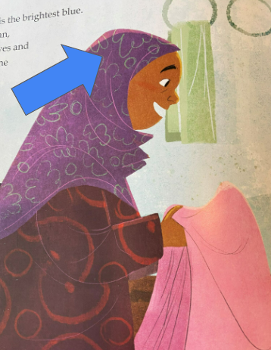 | 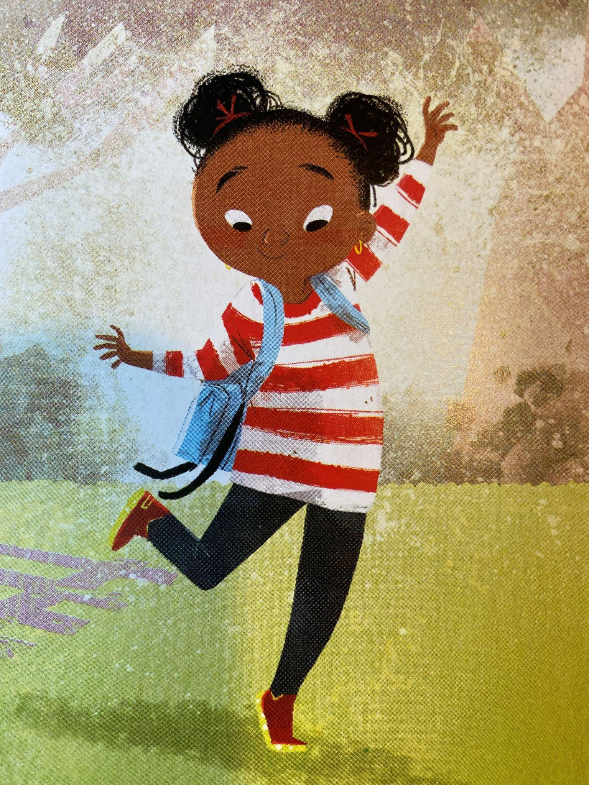 | 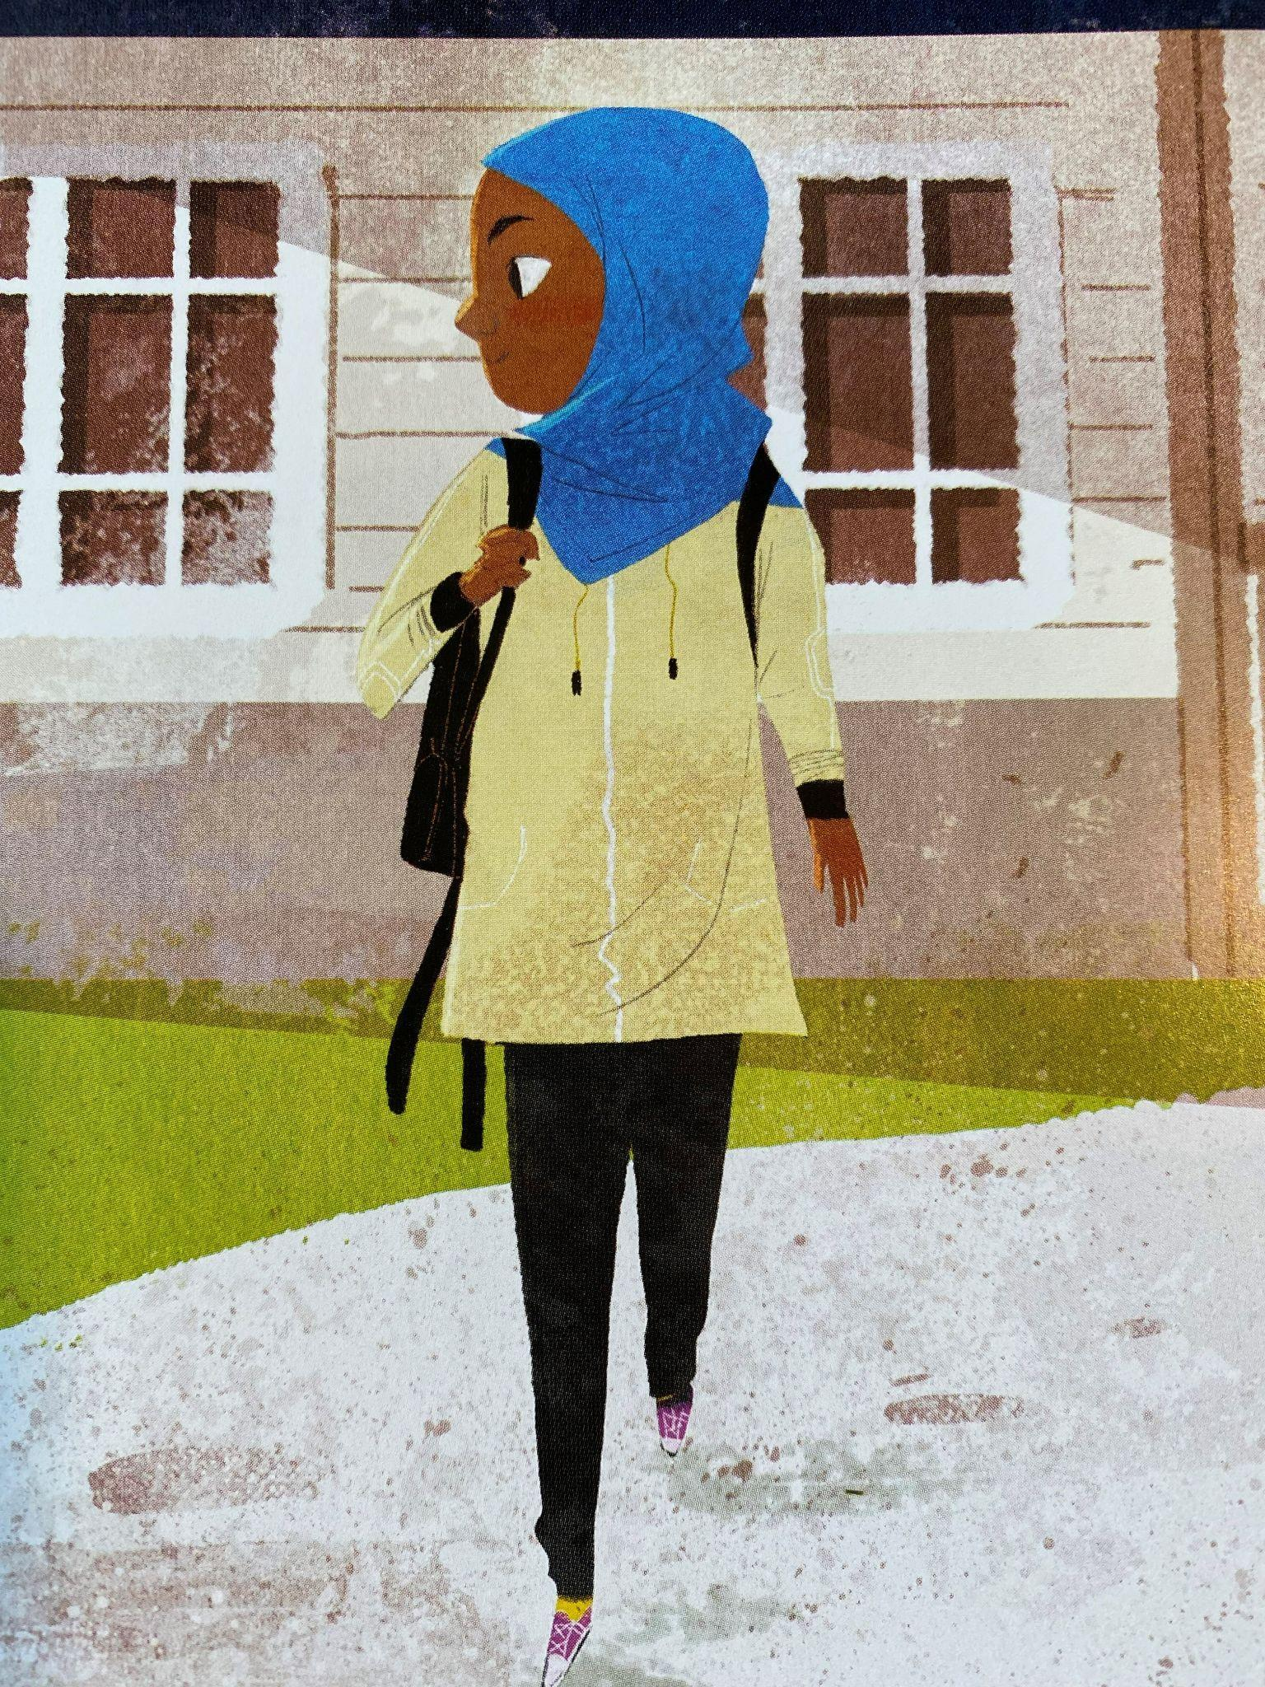
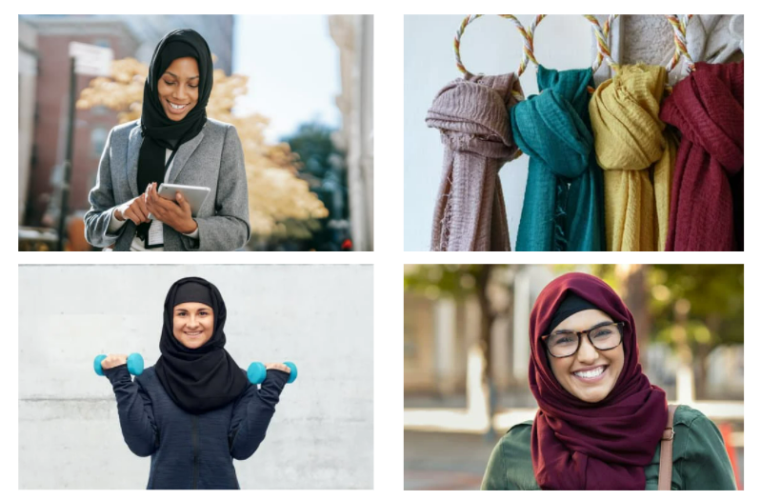

SAMPLE GRAPHIC ORGANIZERS FOR THIRD READ

General graphic organizer:
Author’s description of hijab | Literal image | Meaning
Sky on a sunny day
Smiling hijab
Saying hello with a loud wave

More supportive graphic organizer (sample authors’ words and illustrated provided):
Authors’ description of hijab | Illustration | Literal image | Meaning
smiling hijab | 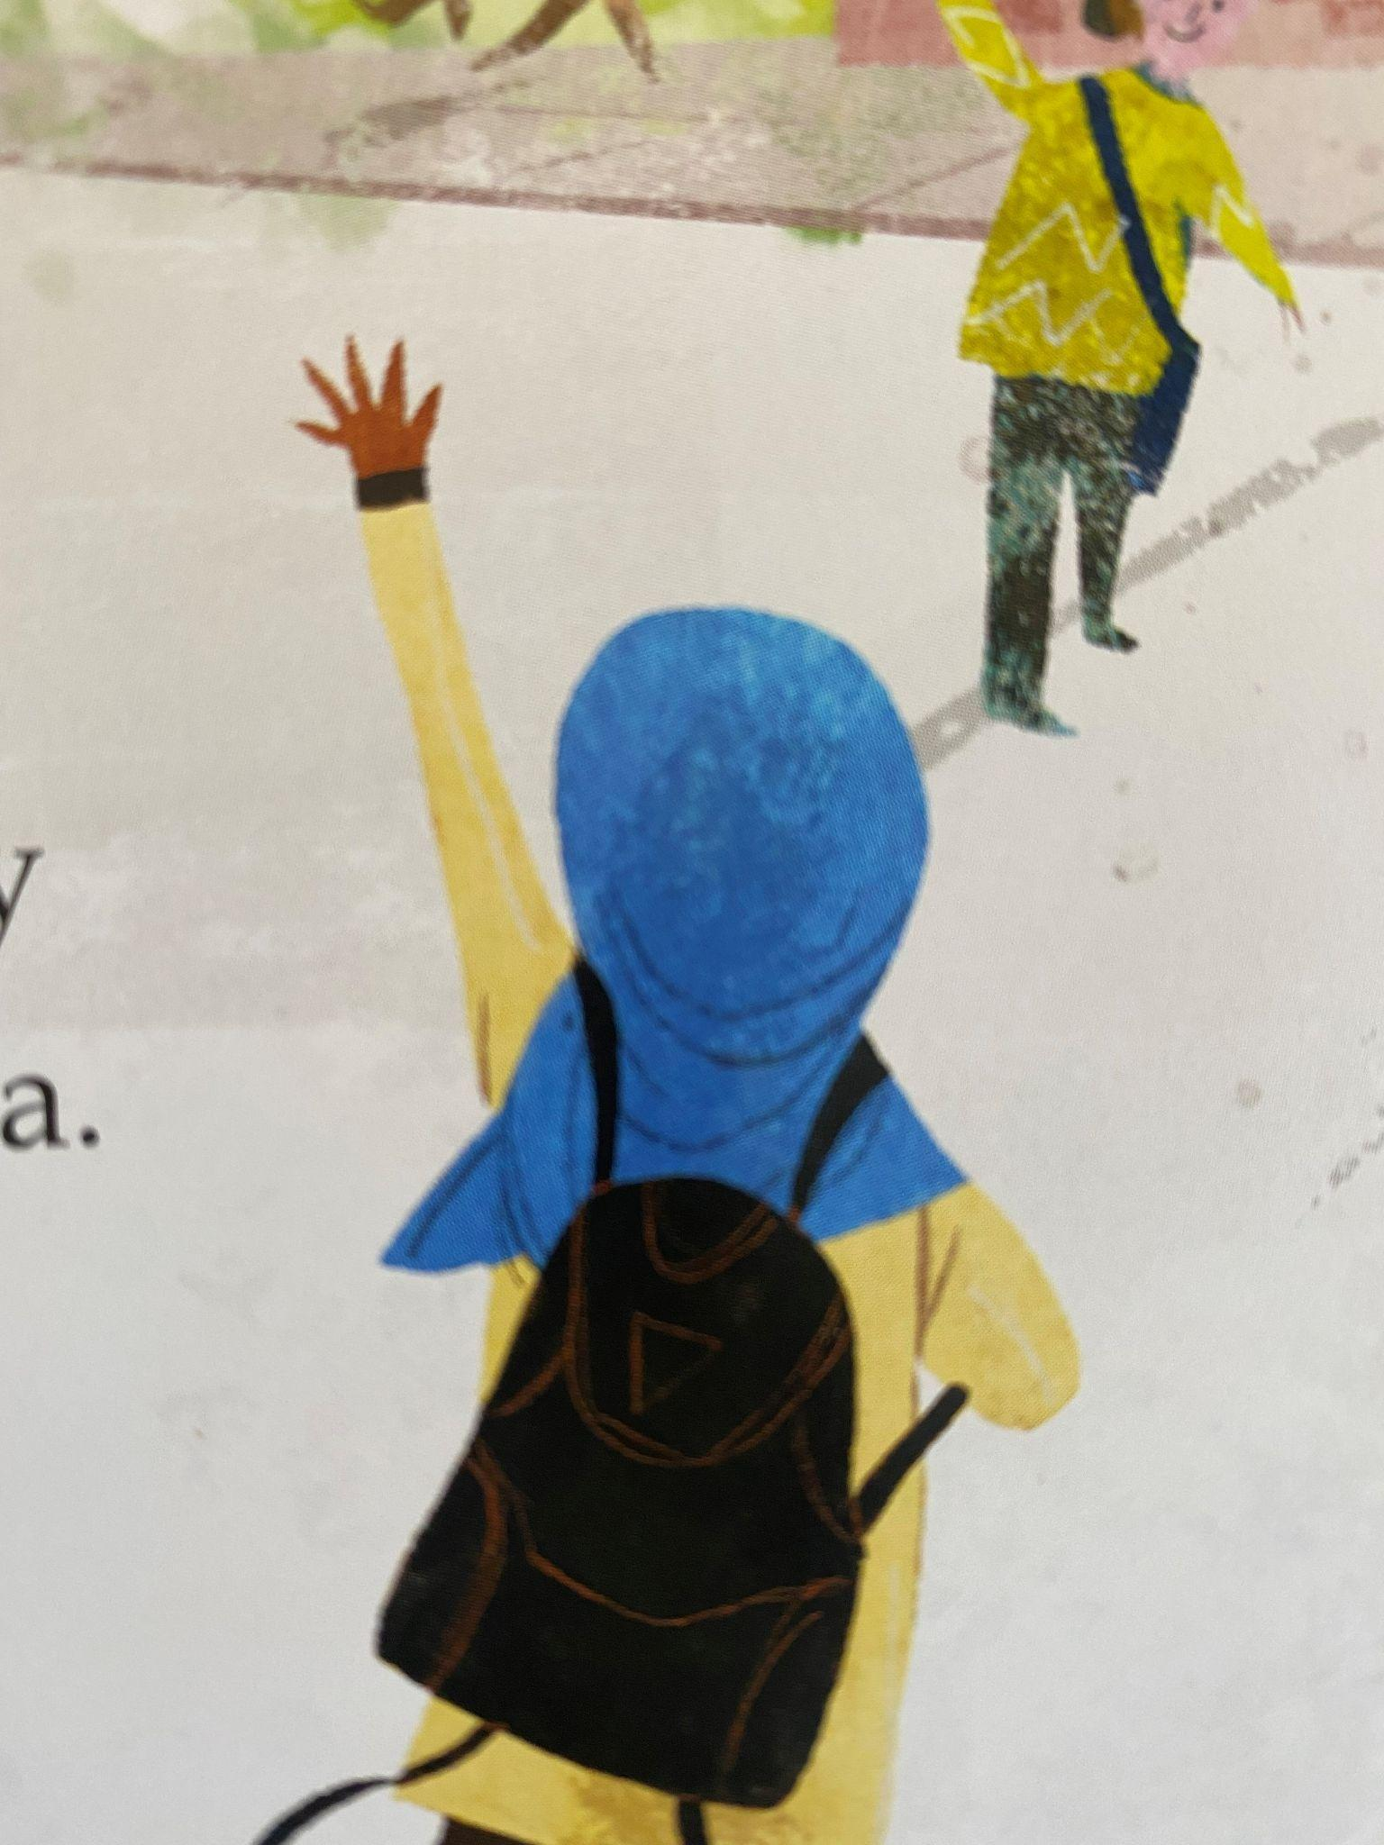
like the ocean waving to the sky | 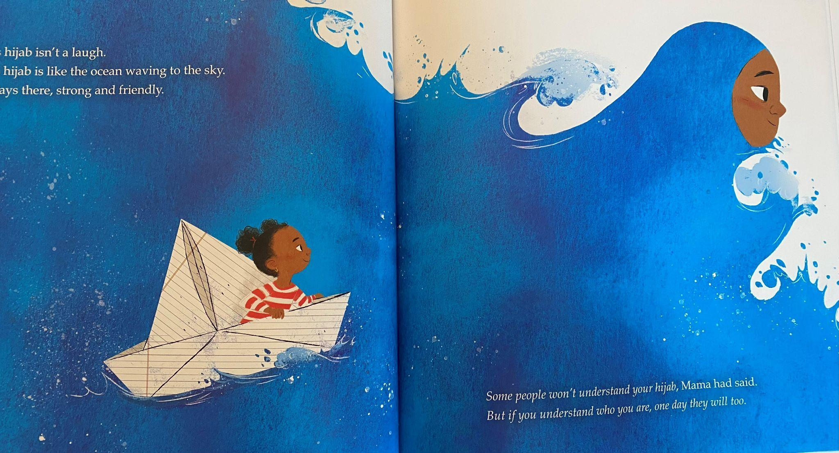
two princesses in hijab | 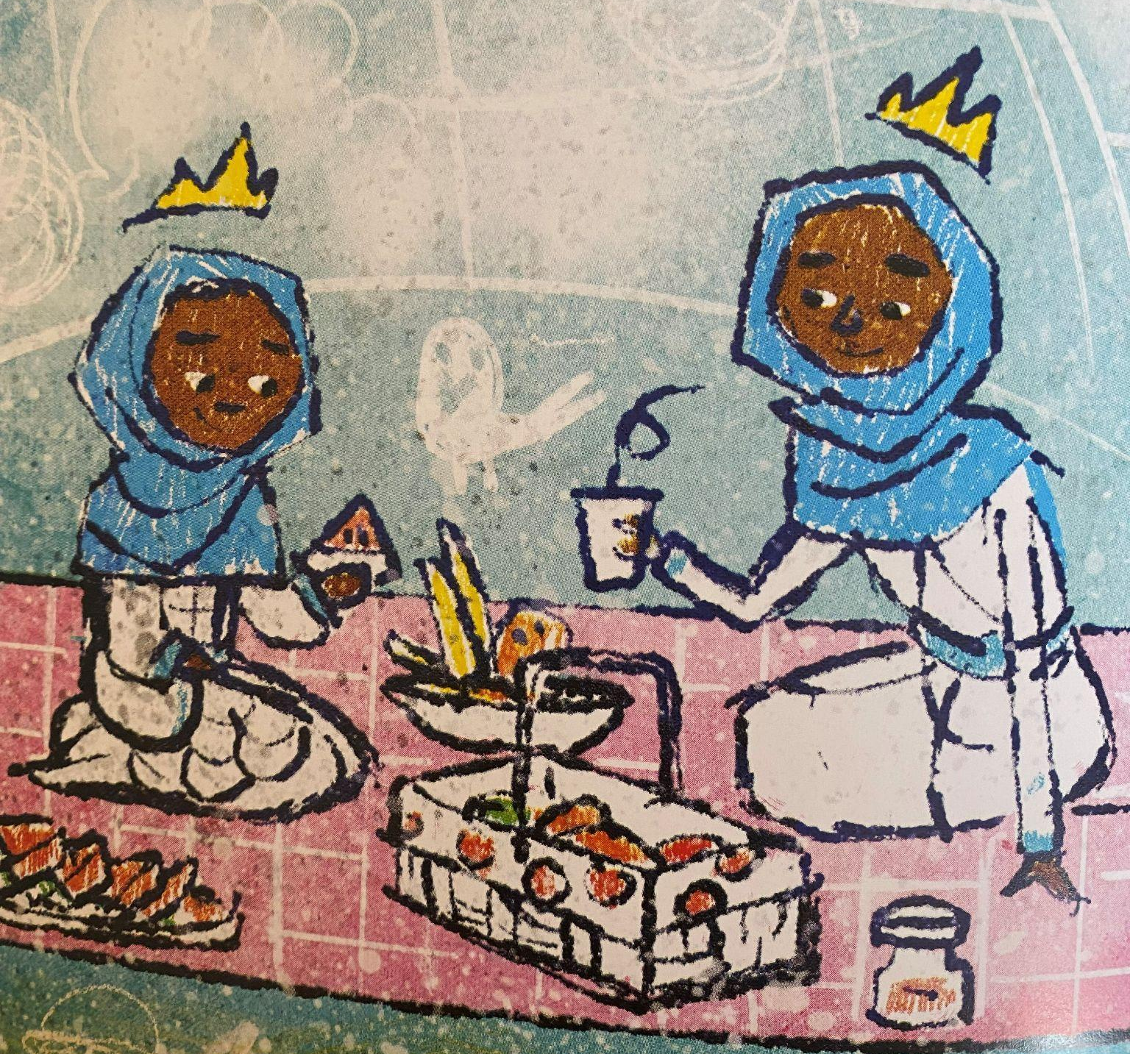
[add your own]

A video read-aloud of this text by one of the authors, Ibitjah Muhammad, is available here.
The juicy sentence is a strategy developed by Dr. Lily Wong Fillmore, specifically to address the needs of ELLs and accessing complex text, and it is a tool that is useful for helping all students learn to deconstruct and reconstruct sentences, and to understand how different language features contribute to meaning.
Learn more about Writing & Discussion Supports for English Learners here.
“The cards provide three ways for students to participate in a conversation by adding on to what someone said (Bounce), summarizing or paraphrasing to add clarity (Sum It Up), or asking questions (Inquire).” Learn more about Bounce Cards from the English Learner Success forum here.

