Grades 6-12, Prompt for Narrative Writing
Common Core Standard W.CCR.3

Great historical events often have deep effects upon the people who live through them. Depending on the person and the situation, those effects can be very different.

You are going to read a short article about the Dust Bowl days in American history titled “Black Blizzard.” You will also look at some photographs taken during that time period. As you read and study the photographs, think about how this experience may have affected the individual people who lived through it.

Finally, you will write a narrative, showing how a particular small moment during this experience affected one person.

Remember, a good narrative:
- Establishes a clear point of view
- Focuses closely on one character or characters
- Uses strong sensory details to make the character(s) and event come alive
- Uses precise language
May use dialogue and description to capture the character(s) and event
- Concludes effectively

Here are your choices for your narrative:
- A young child watching the “black blizzard” rolling in over the plains
- A young child, watching a tractor knock down his family home in Oklahoma, several years into the Dust Bowl drought
- A mother sitting on her front steps in a migrant camp in California
- An unemployed father, arriving at a squatter camp in California from Oklahoma

You will have three class periods to complete this reading/thinking/writing task. The narrative will have a single draft, and you may want to take some time to plan your writing before you begin work. When you have finished, be sure to proofread.

Narrative Writing
Common Core Standard W.CCR.3
6-12

Teacher Directions

- The article and photographs provide the information needed to address the prompt, and students should read the text independently before writing. Encourage students to refer back to the text while writing and to take notes.

- Students should be given three sessions for the prompt. Allow approximately 45 minutes for each, but the prompt should not be strictly timed. Students should be given as much time as needed to plan, write, and proofread.

- The writing must be done without help, but students may have access to personal dictionaries, or any other resources to support spelling and mechanics that they are accustomed to using while writing.
  - Be sure students have paper to take notes or do whatever pre-planning they might choose to do.
  - If students are writing by hand, provide lined paper from your classroom for writing. If they are using a word processor, make sure they save their work so it can be accessed the next day.

- This will be first draft writing, but encourage students to proofread and correct any errors they find.

Black Blizzard
From Teaching Students to Read Nonfiction, Scholastic, 2003
Used by permission of Teaching Students to Read Nonfiction

Imagine this: You’re eating breakfast one Tuesday morning, minding your own business. You chance to look out the window.
“Ma! Dad!” you yell, “It’s back. Take cover!”
Even though it’s nine A.M., the sky in the distance is pitch black. A dry tidal wave of dust and dirt – 7,000 feet high – is rolling, howling towards you. Your parents race to cram wet towels in the spaces under doors and windows, as the huge black cloud rumbles closer.
It’s an eerie sight. In front of the cloud, birds fly and rabbits run, terrified. Soon the cloud is here. The sky is pure black. The wind is screaming, pelting your tiny house with dirt. Your mom hands you a wet towel, which you put over your face, but you can still taste the dust, feel it with every breath, gritty between your teeth. You huddle in the middle of the room with your family in total darkness, waiting for the dust storm to end.

A Natural Disaster
In the mid 1930’s, large areas of Oklahoma, Texas, Kansas, New Mexico, and Colorado were hit by hundreds of these storms. Together, these storms made up some of the worst natural disasters in America’s history.
The dust storms destroyed the land, ruined the economy of the whole area, and threatened the lives of most of the population. Everyone who could picked up and moved west. It became the greatest peacetime migration ever in America. How did it happen?
From 1900 to 1930, many families bought or leased small parcels of land in the Plains states, and built farms. The area was mostly dry grasslands, where crops are difficult to grow. With hard work, the farmers were able to grow wheat and corn, and to raise cattle.
But in 1931, a terrible drought fell across the middle of the nation. America was already suffering from the stock market crash of 1929 and the Great Depression. Now, from 1931 to 1935, farmers got almost no rain at all.
For five years in a row, their corn and wheat crops failed. Farmers had no income, and couldn’t pay their mortgages. And soon their financial troubles were matched by the horror of their surroundings.

The Soil Blew Away
With no rainfall, the soil in the area became loose, dry, and dusty. The region’s native wild grasses, which had served to hold the soil together, had been replaced long ago by crops, which now dried up and blew away.
Soon, heavy winds began to howl, picking up the dust and soil. When the winds reached 50 or 60 miles an hour, they picked up the topsoil right off the ground. The flying dust buried roads. It flew through the walls and windows of flimsy farmhouses. It killed cattle, and ruined the engines of vehicles. Old people and children caught outside were suffocated. Thousands of others died slowly of “dust pneumonia.”
The dust storms were the last straw for many area farmers. They had already suffered through five years with little or no income because of the drought. Now, banks and mortgage companies took their farms, sending tractors to knock their houses down and run them off the land. The farmers, with no other choice, packed up their families and meager belongings and headed west.
More than one million people migrated west from the Plains states during that time. Poor, dirty, and hungry, they rumbled down Route 66, searching for work picking crops, digging roads – anything that would keep their families from starving.

Tough Times
But things were tough in the West, too. There were not enough jobs for all the new arrivals. Few could afford housing. Most of the migrant families camped or “squatted” where they could.
Many native Californians resented the migrants, calling them “Okies,” and spreading rumors that they were mentally retarded. They felt the migrants were ruining local schools with overcrowding. Mobs of local men, armed with clubs and ax handles, raided the squatters’ camps and tried to beat the migrants into leaving.
Eventually, as America came out of the Great Depression, things began to improve for the migrants in California. Within a few years, the rains returned to the Dust Bowl, and people began farming again. Over the decades since, there have been several other serious droughts in the Plains states. But the Dust Bowl of the 1930’s will always be remembered as the worst of all.

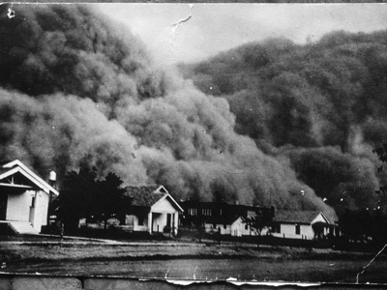
Dust storm coming in.
National Geographic
Used by permission of National Geographic

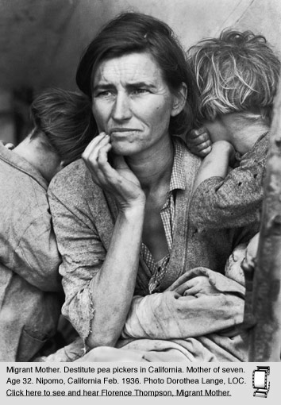
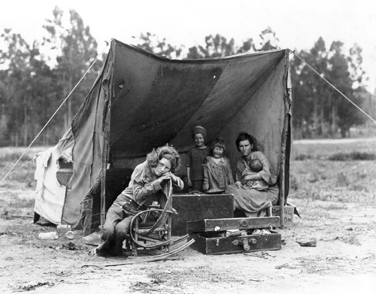
Top left: squatters tent in California. California State University, Bakersfield
Used by permission of California State University, Bakersfield

Top right: Migrant Mother with children, Dorothea Lange photograph, 1936
Used by permission of Dorothea Lange photograph

Bottom left: migrant child, Oklahoma (History.com, Dust Bowl Photo Gallery)
Used by permission of (History.com, Dust Bowl Photo Gallery)
