Proportional Relationships

7.RP.A Conceptual Understanding and Application Mini-Assessment by Student Achievement Partners

OVERVIEW

This mini-assessment is designed to illustrate the concepts in 7.RP.A, which sets an expectation for students to analyze proportional relationships and use them to solve real-world and mathematical problems. This mini-assessment is designed for teachers to use either in the classroom, for self-learning, or in professional development settings to:

* **Evaluate students’ understanding** of 7.RP.A to prepare to teach this material or to check for student ability to demonstrate understanding and apply these concepts;
* **Gain knowledge** about assessing conceptual understanding at the depth expected at grade 7;
* **Illustrate CCR-aligned** assessment problems;
* **Illustrate best practices** for writing tasks that allow access for all learners; and
* **Support mathematical language acquisition** by offering specific guidance.

MAKING THE SHIFTS

**7.RP.A.** Analyze proportional relationships and use them to solve real-world and mathematical problems.

This mini-assessment attends to **focus** as it addresses proportional relationships, which are at the heart of the grade 7 standards and a key component of the Major Work of the Grade.[1] It addresses **coherence** across grades as it builds on rate concepts from grade 6 and uses rational numbers to support learning of 7.NS.A. Cluster 7.RP.A and this mini-assessment target *conceptual understanding* and *application*, two of the three elements of **rigor**, through a variety of problems.

A CLOSER LOOK

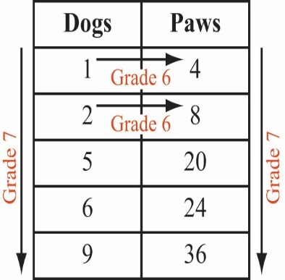Proportional relationships as described in cluster 7.RP.A are a critical link between the work with equivalent ratios in grade 6 and the work with equations in the form $y=mx+b$ in grade 8. In grade 7, students are looking at relationships between two quantities or variables. Equivalent ratios in grade 6 show examples of a relationship, such as 1 dog: 4 paws, 2 dogs: 8 paws, etc., whereas grade 7 students relate the number of dogs to the number of paws. Now there is a proportional relationship between two variables. The table to the right details how grade 6 focuses on the rows (examples of the relationship), while in grade 7, students look down the columns and see the multiplicative relationship between Dogs and Paws. For further reading on this topic, read pages 6–8 of the progression document, [*6–7, Ratios and Proportional Relationships*](https://commoncoretools.files.wordpress.com/2012/02/ccss_progression_rp_67_2011_11_12_corrected.pdf#page=6).

Standard 7.RP.A.2C gives the example, “total cost *t* is proportional to the number *n* of items purchased at a constant price *p*, the relationship between the total cost and the number of items can be expressed as $t = pn$.” The constant of proportionality (or unit rate), *p*, expresses the relationship between the columns noted above. Students work with graphs, tables, and equations to understand the constant of proportionality from a variety of perspectives. These perspectives connect fundamentally with grade 7 work with expressions and equations (7.EE.B) where students both set up and solve real-world and mathematical problems which requires an understanding of the constant of proportionality.

The following assessment should take 30–45 minutes, and students may use a calculator to facilitate some of these calculations, as rational number computation is not the focus of this mini-assessment.

SUPPORT FOR ENGLISH LANGUAGE LEARNERS

This lesson was designed to include specific features that support access for all students and align to best practice for English Language Learner (ELL) instruction and assessment. Go [here](https://achievethecore.org/page/3165/support-for-the-english-language-learner-adaptation-project-annotated-bibliography) to learn more about the research behind these supports. Features that support access in this mini-assessment include:

* Tasks that allow for multi-modal representations, which can deepen understanding of the mathematics and make it easier for students, especially ELLs, to give mathematical explanations.
* Tasks that avoid unnecessarily complex language to allow students, especially ELLs, to access and demonstrate what they know about the mathematics of the assessment.

Prior to this mini-assessment, ensure students have had ample opportunities in instruction to read, write, speak, listen for, and understand the mathematical concepts that are represented by the following terms and concepts:

* **mile**
* **hour**
* **proportional relationship**
* **assumptions**
* **median**
* **equation**
* **variables**
* **graph**
* **scale**
* **vertical axis**
* **point**
* **width**
* **length**
* **distance**
* **equal**
* **line segment**
* **precise**

Students should engage with these terms and concepts in the context of mathematical learning, not as a separate vocabulary study. Students should have access to multi-modal representations of these terms and concepts, including: pictures, diagrams, written explanations, gestures, and sharing of non-examples. These representations will encourage precise language, while prioritizing students’ articulation of concepts. These terms and concepts should be reinforced in teacher instruction, classroom discussion, and student work (for example, through engagement in [mathematical routines](https://achievethecore.org/page/3164/mathematical-language-routines)).

ELLs may need support with the following vocabulary words found in this mini-assessment:

* **speed**
* **explain**
* **show**
* **relationship**
* **survey**
* **on average**
* **relates**
* **describe**
* **complete**
* **resized**
* **original**
* **record**
* **membership**
* **monthly**
* **salary**
* **wage**

In preparation for giving this mini-assessment, teachers should strive to use these words in context so they become familiar to students. It will be important to offer synonyms, rephrasing, visual cues, and modeling of what these words mean in the specific contexts represented in the items in this mini-assessment. Additionally, teachers may offer students the use of a student-friendly dictionary, or visual glossary to ensure they understand what is being asked of them in each item.

|  |  |
| --- | --- |
| Sketch |  |
| Point | • |
| Locate | • |

*An example of a visual glossary for student use*

Name: Date:

This assessment requires a standard inch/centimeter ruler.

1. [problem adapted from: <https://www.illustrativemathematics.org/content-standards/7/RP/A/1/tasks/1176>]
   1. Joseph runs 2/3 of a mile in 8 minutes. If Joseph runs at that speed, how long will it take him to run one mile? Show your work.
   2. If Joseph continues running at that same speed, how long will it take him to run 4 miles? Show your work.
   3. Hector runs 2 ¾ miles in ½ hour. Who runs faster, Joseph or Hector? Explain your answer using numbers, words, and/or pictures.

2. The table shows the relationship between the number of spinning classes a person takes at a gym in one month and the total cost of gym membership for that month.

|  |  |
| --- | --- |
| Number of Spinning Classes Taken in One Month | Monthly Cost of Gym Membership |
| 2 | 42 |
| 4 | 56 |
| 6 | 68 |
| 8 | 80 |

Is this a proportional relationship? Explain your answer using numbers, words and/or pictures.

3. Would you expect the relationship between the number of books a person buys at a bookstore and the total cost of the books to be proportional? Explain your answer and include any assumptions you made.

|  |
| --- |
|  |

4. A survey found that company Chief Executive Officers (CEOs) earn a salary that is on average 140 times more than the median salary of other employees at the same company.

Use the given information to respond to parts (a) – (c).

1. Write an equation that relates the CEO’s salary for a particular company to that of an employee earning the median salary. Describe the meaning of any variables you use.
2. Complete the graph to show the relationship between the salary of an employee earning the median wage and the salary of the company CEO. Include an appropriate scale for the vertical axis.  
     
   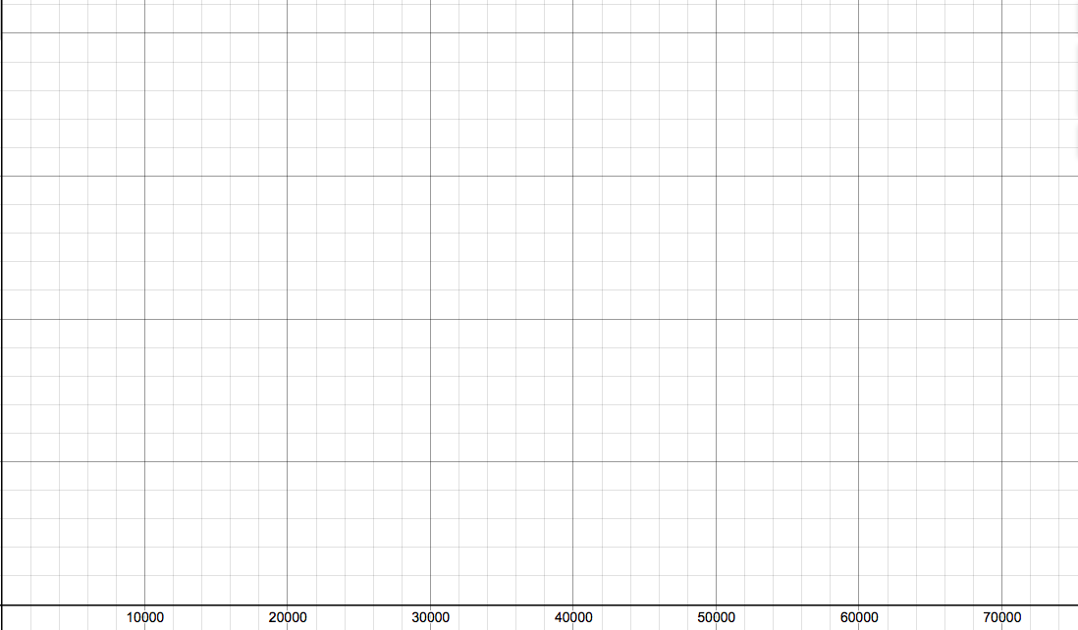

Salary of the Company CEO

Salary of Employee Earning the Median Wage

c. Complete the statement.

The point (1, _____) is on my graph and means that

____________________________________________________________

___________________________________________________________

5. Jordan put a photograph on a copy machine and resized it by 150%. The original photograph and the resized photograph are shown below.

**Original Photograph Photograph Resized by 150%**

 

1. Draw the original photograph resized by 200%. Draw all parts of the resized photograph to scale.

**Photograph resized by 200%**

1. Draw the original photograph resized by 75%. Draw all parts of the resized photograph to scale.

**Photograph resized by 75%**

1. Use a ruler to measure the width of each of the four photographs. Record your answers in the table.

|  |  |
| --- | --- |
| Photograph | Width of photo (to nearest tenth of a centimeter) |
| Original |  |
| Resized by 150% |  |
| Resized by 200% |  |
| Resized by 75% |  |

1. Write an equation that can be used to find the length of any distance in the photograph resized by 75% based on the length of the same distance in the original photograph. Describe the meaning of any variables you use.

1. Show how to use your equation from part (d) to compute the width of the photograph resized by 75% based on the width of the original photograph. If the result from the equation differs from the measurements you listed in part (d), explain why.

6. George needs to cut a 12-inch long string into 7 pieces that have the same length. Draw a line segment above the ruler below to show how long one piece of string will be. Be as precise as possible.



Name: Date:

1. [problem adapted from: <https://www.illustrativemathematics.org/content-standards/7/RP/A/1/tasks/1176>]

1. Joseph runs 2/3 of a mile in 8 minutes. If Joseph runs at that speed, how long will it take him to run one mile? Show your work.

Student provides correct answer of 12 minutes with supporting work.

Sample Student Response:  
  
 4 min 4 min 4 min

|  |  |  |
| --- | --- | --- |
| 1/3 mile | 1/3 mile | 1/3 mile |

Since 2/3 of a mile takes 8 minutes, each 1/3 mile takes 4 minutes. Since 3/3 is a whole mile, my diagram shows that this will take 4+4+4, or 12 minutes.

1. If Joseph continues running at that same speed, how long will it take him to run 4 miles? Show your work.

Sample Student Response: One mile takes Joseph 12 minutes so 4 miles takes 12*4 = 48 minutes.

1. Hector runs 2 ¾ miles in ½ hour. Who runs faster, Joseph or Hector? Explain your answer using numbers, words, and/or pictures.

Sample Student Response:  
Hector runs 2 ¾ miles in ½ hour, so if I double that distance I know that he runs 2 ¾ * 2 = 6 ½ miles in one hour. Joseph runs 4 miles in 48 minutes. Since he runs one mile in 12 minutes, he will run 5 miles in 60 minutes, or 5 miles in one hour. Therefore, Hector is running faster.

2. The table shows the relationship between the number of spinning classes a person takes at a gym in one month and the total cost of gym membership for that month.

|  |  |
| --- | --- |
| Number of Spinning Classes Taken in One Month | Monthly Cost of Gym Membership |
| 2 | 42 |
| 4 | 56 |
| 6 | 68 |
| 8 | 80 |

Is this a proportional relationship? Explain your answer using numbers, words and/or pictures.

Sample Student Response:  
This relationship is not proportional because there is no number that I can multiply the number of spinning classes by that will always produce the correct monthly cost. For example, 2*21=42, but if I multiply 4*21 I get 84, not 56.   
  
  
  
  
3. Would you expect the relationship between the number of books a person buys at a bookstore and the total cost of the books to be proportional? Explain your answer and include any assumptions you made.

Sample Student Response 1: I would not expect this to be a proportional relationship because a set of books rarely have the same exact cost per book.

Sample Student Response 2: I would expect this to be a proportional relationship because most books cost the same amount, so the total amount will be the cost of one book times the number of books.

|  |
| --- |
|  |

4. A survey found that company Chief Executive Officers (CEOs) earn a salary that is on average 140 times more than the median salary of other employees at the same company.

Use the given information to respond to parts (a) – (c).

1. Write an equation that relates the CEO’s salary for a particular company to that of an employee earning the median salary. Describe the meaning of any variables you use.

Sample Student Response:  
C = 140w

Where C is the salary of the company CEO and w is the salary of an employee earning the median

1. Complete the graph to show the relationship between the salary of an employee earning the median wage and the salary of the company CEO. Include an appropriate scale for the vertical axis.  
     
   

8 million

6 million

4 million

2 million

Salary of the Company CEO

Salary of Employee Earning the Median Wage

1. Complete the statement.

The point (1, 140) is on my graph and means that

For each $1 that the median employee makes, the company CEO makes $140.

5. Jordan put a photograph on a copy machine and resized it by 150%. The original photograph and the resized photograph are shown below.

Please Note: Since this problem includes scale drawings, any alteration to the word version may result in different answers and the scales of the existing images should be verified to be to the correct scale.

**Original Photograph Photograph Resized by 150%**

 

1. Draw the original photograph resized by 200%. Draw all parts of the resized photograph to scale.

**Photograph resized by 200%**



1. Draw the original photograph resized by 75%. Draw all parts of the resized photograph to scale.

**Photograph resized by 75%**



1. Use a ruler to measure the width of each of the four photographs. Record your answers in the table.

|  |  |
| --- | --- |
| Photograph | Width of photo (to nearest tenth of a centimeter) |
| Original | 3.7 |
| Resized by 150% | 5.5 |
| Resized by 200% | 7.5 |
| Resized by 75% | 2.8 |

1. Write an equation that can be used to find the length of any distance in the photograph resized by 75% based on the length of the same distance in the original photograph. Describe the meaning of any variables you use.

N = .75r

N is the length of the distance in the photograph resized by 75% and r is the length of the same distance in the original photograph

1. Show how to use your equation from part (d) to compute the width of the photograph resized by 75% based on the width of the original photograph. If the result from the equation differs from the measurements you listed in part (d), explain why.

N = .75 (3.7) = 2.775 ≈ 2.8

The equation correctly computed the width of the photograph resized to 75% after rounding the computed value to the nearest tenth. Measurement precision may cause small variation in the computed value(s).

6. George needs to cut a 12-inch long string into 7 pieces that have the same length. Draw a line segment above the ruler below to show how long one piece of string will be. Be as precise as possible.

Student generates a line segment that is between 1 11/16 and 1 12/16 inches long



1. For more on the Major Work of the Grade, see [achievethecore.org/focus](http://achievethecore.org/focus).