Two-Step Problems Using the Four Operations
3.OA.D.8 Application Mini-Assessment by Student Achievement Partners

OVERVIEW
This mini-assessment is designed to illustrate the standard 3.OA.D.8, which sets an expectation for students to solve two-step word problems using the four operations. This mini-assessment is designed for teachers to use either in the classroom, for self-learning, or in professional development settings to:
- Evaluate students’ understanding of 3.OA.D.8 prior to teaching this material or to check students’ abilities to demonstrate understanding of and to apply these concepts;
- Gain knowledge about assessing applied problem solving at the depth expected at grade 3;
- Illustrate CCR-aligned assessment problems;
- Illustrate best practices for writing tasks that allow access for all learners; and
- Support mathematical language acquisition by offering specific guidance.

MAKING THE SHIFTS
This mini-assessment attends to focus as it addresses problems with all four operations, including assessing the reasonableness of answers, which is at the heart of the grade 3 standards and a key component of the Major Work of the Grade. It addresses coherence across grades as it builds on problem solving with addition and subtraction (2.OA.A.1) and prepares students for multi-step problem solving (4.OA.A.3). Standard 3.OA.D.8 and this mini-assessment target application, one of the three elements of rigor, through word problems.
3.OA.D.8. Solve two-step word problems using the four operations. Represent these problems using equations with a letter standing for the unknown quantity. Assess the reasonableness of answers using mental computation and estimation strategies including rounding.

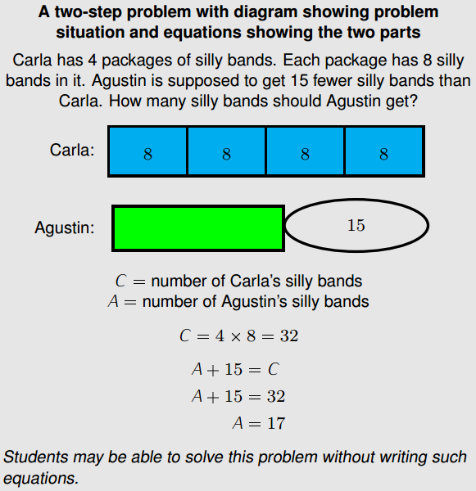
A CLOSER LOOK
Standard 3.OA.D.8 encompasses a significant amount of work for grade 3, including a variety of problem types and all four operations. Each of the problems on this mini-assessment uses the addition and subtraction situations and the multiplication and division situations (see pages 9 and 10). Because the problem-solving demands are high and the operations are paired together, this mini-assessment focuses on multiplication situations using equal groups, not arrays or measurement quantities.
Visual representations are a part of standard 3.OA.D.8, but they are included as a means to an end, not an end in themselves. Consequently, no questions explicitly ask students to use visual representations to show how they solved the problems. However, looking at students’ solution strategies may be helpful for teachers to plan instruction.
If you feel additional scaffolding is needed, you may tell students to “Draw a picture if it helps.” One example of a representation students may use is shown to the right.
It is likely to take students around 25–30 minutes to answer the 7 questions on this mini-assessment.

SUPPORT FOR ENGLISH LANGUAGE LEARNERS
This lesson was designed to include specific features that support access for all students and align to best practice for English Language Learner (ELL) instruction and assessment. Go here to learn more about the research behind these supports. Features that support access in this mini-assessment include:
- Tasks that allow for multi-modal representations, which can deepen understanding of the mathematics and make it easier for students, especially ELLs, to give mathematical explanations.
- Tasks that avoid unnecessarily complex language to allow students, especially ELLs, to access and demonstrate what they know about the mathematics of the assessment.
Prior to this mini-assessment, ensure students have had ample opportunities in instruction to read, write, speak, listen for, and understand the mathematical concepts that are represented by the following terms and concepts:
- total
- have left
- how many
Students should engage with these terms and concepts in the context of mathematical learning, not as a separate vocabulary study. Students should have access to multi-modal representations of these terms and concepts, including: pictures, diagrams, written explanations, gestures, and sharing of non-examples. These representations will encourage precise language, while prioritizing students’ articulation of concepts. These terms and concepts should be reinforced in teacher instruction, classroom discussion, and student work (for example, through engagement in mathematical routines).
Additionally, ELLs may need support with the following words in order to fully understand each word problem:
- birdhouse
- postcards
- gum/pack of gum

Name: Date:

- There were 56 birdhouses at school. Today, 4 classes made more birdhouses. Each class made 8 birdhouses. How many total birdhouses are there now?
- Mr. Dent had 32 markers in his classroom. He buys new boxes of markers that have 9 markers in each box. Now, he has 86 markers. How many new boxes did he buy?
- Jayson had 274 postcards in his collection. He wanted to give Sam some of his postcards. Jayson gave Sam 8 postcards from each set below:
- Arts
- Sports
- Schools
- Parks
- Beaches
- Sunsets

How many postcards does Jayson have left?

- Adeline buys 8 packs of Fun Gum. Each pack has 7 pieces of gum. Marisol buys Juicy Gum. Each Juicy Gum pack has 9 pieces of gum.
Adeline has 11 more pieces of gum than Marisol.
How many packs of gum did Marisol buy?
- Students in 3 art classes cut 728 inches of ribbon into 8-inch long pieces. Two of the classes together cut 656 inches of ribbon. How many 8-inch long pieces of ribbon did the other class cut?
- Last summer, Jon’s family found 152 shells at the beach. This summer they were at the beach for 7 days. Each day they found 9 shells. How many fewer shells did they find this year than last year?

Shells
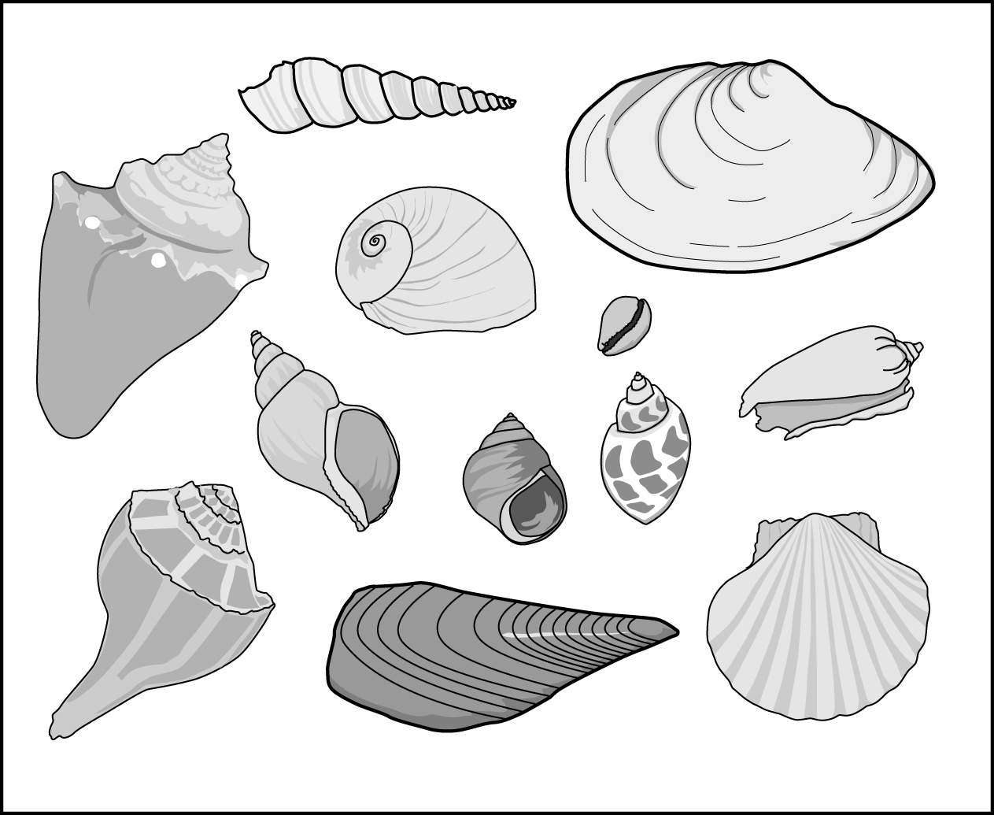

- Sheldon is baking 2-inch cookies. He has 3 trays that are the same size. On one tray, he makes 5 rows with 4 cookies in each row. He cannot fit any more cookies on the tray. He fills the second tray completely and only part of the third tray.

How many cookies could Sheldon have made?

Explain your answer using numbers, words, and/or pictures

Note: The annotations below reference the structures of the addition/subtraction step and the multiplication/division step as described on pages 88 and 89 of the Common Core State Standards for Mathematics, and included for reference on pages 9 and 10.

- There were 56 birdhouses at school. Today, 4 classes made more birdhouses. Each class made 8 birdhouses. How many total birdhouses are there now?
Students may solve by:
The structure of the addition/subtraction step is Add To with Result Unknown. The structure of the multiplication/division step is Equal Groups with Product Unknown. These are two of the simplest structures with all numbers within 100.
4 × 8 = ___
32 = ___
56 + 32 = ___
88 = ___

88 total birdhouses
- Mr. Dent had 32 markers in his classroom. He buys new boxes of markers that have 9 markers in each box. Now, he has 86 markers. How many new boxes did he buy?
Students may solve by:
The structure of the addition/subtraction step is Add To with Change Unknown. The structure of the multiplication/division step is Equal Groups with Number of Groups Unknown. These are more complex structures with all numbers within 100.
32 + ___ = 86
___ = 54
___ x 9 = 54
___ = 6
6 new boxes of markers
- Jayson had 274 postcards in his collection. He wanted to give Sam some of his postcards. Jayson gave Sam 8 postcards from each set below:
- Arts
The structure of the addition/subtraction step is Take From with Change Unknown, which is complex. The structure of the multiplication/division step is Equal Groups with Product Unknown, which is simpler.
- Sports
- Schools
- Parks
- Beaches
- Sunsets

How many postcards did Jayson have left?
Students may solve by:
6 × 8 = ___
48 = ___
274 – 48 = ___
226 = ___
226 postcards
- Adeline buys 8 packs of Fun Gum. Each pack has 7 pieces of gum. Marisol buys Juicy gum. Each Juicy Gum pack has 9 pieces of gum.
Adeline has 11 more pieces of gum than Marisol.
How many packs of gum did Marisol buy?
The structure of the addition/subtraction step is Compare with Smaller Unknown (language with “more”). The structure of the multiplication/division step is Equal Groups with Number of Groups Unknown. These are very complex structures for grade 3 when combined, so the magnitude of numbers is kept small in this question.
Students may solve by:
Adeline – 11 = Marisol
8 × 7 – 11 = Marisol
56 – 11 = Marisol
45 = Marisol
45 ÷ 9 = ___
5 = ___

5 packs of gum
- Students in 3 art classes cut 728 inches of ribbon into 8-inch long pieces. Two of the classes together cut 656 inches of ribbon. How many 8-inch long pieces of ribbon did the other class cut?
The structure of the addition/subtraction step is Put Together/Take Apart with Addend Unknown. The structure of the multiplication/division step is Equal Groups with Number of Groups Unknown. Both steps are complex and the numbers reflect the full intent of 3.NBT and 3.OA.
Students may solve by:
728 – 656 = ___
72 = ___
72 ÷ 8 = 9
9 lengths of ribbon
- Last summer, Jon’s family found 152 shells at the beach. This summer they were at the beach for 7 days. Each day they found 9 shells. How many fewer shells did they find this year than last year?
Jon’s Sea Shells
Students may solve by:
7 × 9 = ___
63 = ___
152 – 63 = ___
89 = ___
The structure of the addition/subtraction step is Compare with Difference Unknown, a complex structure. The structure of the multiplication/division step is Equal Groups with Product Unknown, a simpler structure.
89 fewer shells this year

- Sheldon is baking 2-inch cookies. He has 3 trays that are the same size. On one tray, he makes 5 rows with 4 cookies in each row. He cannot fit any more cookies on the tray. He fills the second tray completely and only part of the third tray.

How many cookies could Sheldon have made?

Students may solve by:
5 × 4 = 20
5 x 4 = 20
20 + 20 = 40
40 + __ < 60

Any whole number answer between 41-59

Explain your answer using numbers, words, and/or pictures:

Assessing the reasonableness of an answer is an important part of mathematical proficiency, and stated explicitly as a goal in grade 3 as students are solving two-step word problems. This problem addresses this part of the standard by asking students to think about providing a reasonable answer within a broader range. Sometimes two students could use correct and different reasoning to arrive at their conclusions which could lead to a full class discussion. This also allows for students to engage with MP1 as they think about reasonableness and unreasonableness throughout the problem solving process.

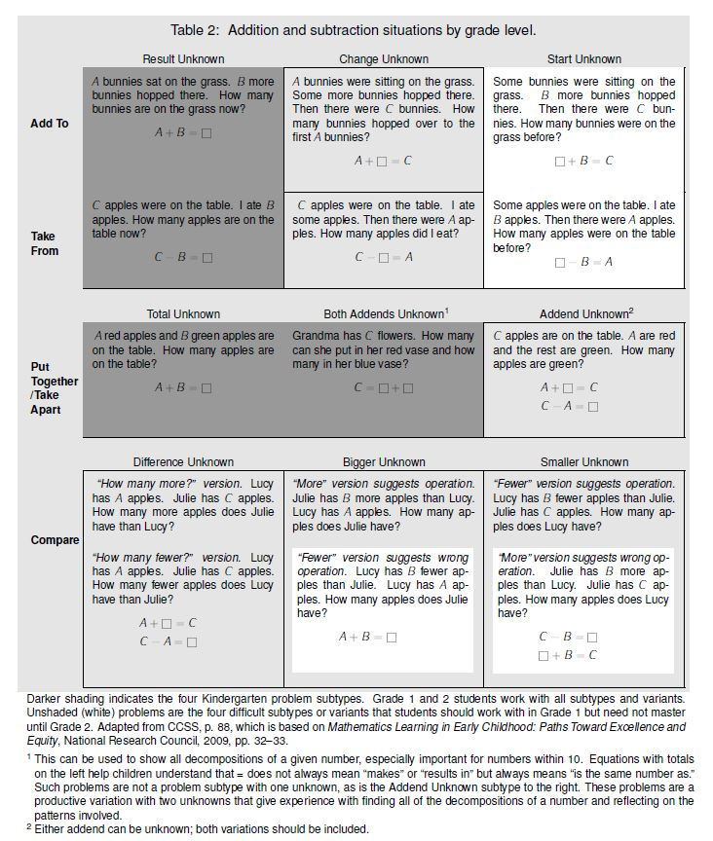

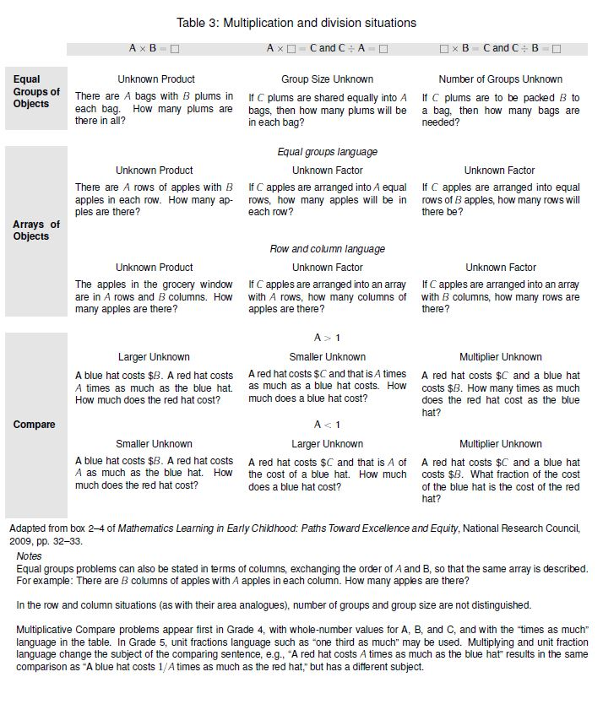

For more on the Major Work of the Grade, see achievethecore.org/focus.
This example originally appeared in the progression document, K, Counting and Cardinality; K–5 Operations and Algebraic Thinking (pg. 28).

