Multi-Domain Application Mini-Assessment
Grade 5 Application Mini-Assessment by Student Achievement Partners

OVERVIEW
This mini-assessment illustrates important content spanning multiple domains in grade 5 and draws on problem solving capacities developed in grades K–4. This mini-assessment is designed for teachers to use either in the classroom, for self-learning, or in professional development settings to:
- Evaluate students’ ability to solve real-world and mathematical problems with grade-appropriate content;
- Gain knowledge about assessing applied problem solving at the depth expected at grade 5;
- Illustrate CCR-aligned assessment problems;
- Illustrate best practices for writing tasks that allow access for all learners; and
- Support mathematical language acquisition by offering specific guidance.

MAKING THE SHIFTS
This mini-assessment attends to focus as it addresses content spanning several clusters within the Number and Operations in Base Ten (NBT), Number and Operations—Fractions (NF), and Measurement and Data (MD) domains. These are all key components of the Major Work of grade 5. It addresses coherence across grades by drawing on the problem solving work of grades K–4 using the four operations. It sets the stage for solving multistep problems using the full system of rational numbers (e.g., negative integers). This mini-assessment targets application, one of the three elements of rigor, through word problems.

A CLOSER LOOK
This mini-assessment centers on applications of math in the grade 5 standards. For example, problem 6 is aligned to a standard that mentions solving word problems. Another example is problem 5, spanning two or more domains, in which students solve a word problem using calculation skills detailed in 5.NBT. The problems students encounter in this mini-assessment highlight topics such as place value understanding, the four operations on fractions, and volume, in order to illustrate connections across domains.
5.NBT.A: Understand the place value system.
5.NBT.B: Perform operations with multi-digit whole numbers and with decimals to hundredths.
5.NF.A: Use equivalent fractions as a strategy to add and subtract fractions.
5.NF.B: Apply and extend previous understandings of multiplication and division to multiply and divide fractions.
5.MD.A: Convert like measurement units within a given measurement system.
5.MD.C: Geometric measurement: understand concepts of volume and relate volume to multiplication and to addition.
5.G.A: Graph points on the coordinate plane to solve real-world and mathematical problems.

This mini-assessment as a whole is considered multi-domain. Due to the variety of content on this mini-assessment, teachers should use it toward the end of the year – as a measure of the cumulative knowledge and skills from K–5. This mini-assessment is not meant to be comprehensive, but rather offers a representative sampling of the types of questions on integrated content a fifth grade student should be able to do towards the end of the school year.

SUPPORT FOR ENGLISH LANGUAGE LEARNERS
This lesson was designed to include specific features that support access for all students and align to best practice for English Language Learner (ELL) instruction and assessment. Go here to learn more about the research behind these supports. Features that support access in this mini-assessment include:
- Tasks that allow for multi-modal representations, which can deepen understanding of the mathematics and make it easier for students, especially ELLs, to give mathematical explanations.
- Tasks that avoid unnecessarily complex language to allow students, especially ELLs, to access and demonstrate what they know about the mathematics of the assessment.
Prior to this mini-assessment, ensure students have had ample opportunities in instruction to read, write, speak, listen for, and understand the mathematical concepts that are represented by the following terms and concepts:
- how many
- product
- least
- greatest
- total amount
- dimensions
- feet
- cubic feet
- miles
- farther
- length
- inches
- data
- points
- graph
- coordinates
- month
- graph
- equally
Students should engage with these terms and concepts in the context of mathematical learning, not as a separate vocabulary study. Students should have access to multi-modal representations of these terms and concepts, including: pictures, diagrams, written explanations, gestures, and sharing of non-examples. These representations will encourage precise language, while prioritizing students’ articulation of concepts. These terms and concepts should be reinforced in teacher instruction, classroom discussion, and student work (for example, through engagement in mathematical routines).
ELLs may need support with the following Tier 2 words found in this mini-assessment:
- order
- original
- explain
- challenge/challenged
- left (as in left over)
In preparation for giving this mini-assessment, teachers should strive to use these words in context, so they become familiar to students. It will be important to offer synonyms, rephrasing, visual cues, and modeling of what these words mean in the specific contexts represented in the items in this mini-assessment. Additionally, teachers may offer students the use of a student-friendly dictionary, or visual glossary to ensure they understand what is being asked of them in each item.
Sketch | 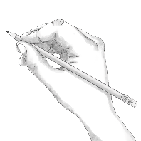
Point | •
Locate | •
An example of a visual glossary for student use.

Name: Date:

- A store owner ordered 24 packages of candy. Each package contains 72 candies. He plans to make bags of candy with 18 candies in each bag to sell.

How many bags of candy can he make?

- Order the products below from least to greatest.

A B C D
$\frac{3}{4}×\frac{3}{4}$ $\frac{5}{8}×\frac{5}{8}$ $\frac{3}{4}×1\frac{1}{4}$ $1\frac{1}{4}×1\frac{1}{4}$

___________________________________________________________________________
Least Greatest

- Callan has $\frac{1}{3}$ of his birthday cake left. He wants to share it equally between himself and 3 other boys. How much of the original birthday cake will each of the 4 boys get?

- Evelyn challenged the students in her grade to collect nickels for the entire school year. There are 37 students in her grade.
Each student collected 265 nickels.

  - What is the total amount of money that the students collected? $____________

  - Explain your answer using numbers, words, and/or pictures.

- The diagram below represents a swimming pool with dimensions in feet. How many cubic feet of water are needed to fill the pool all the way to the top?

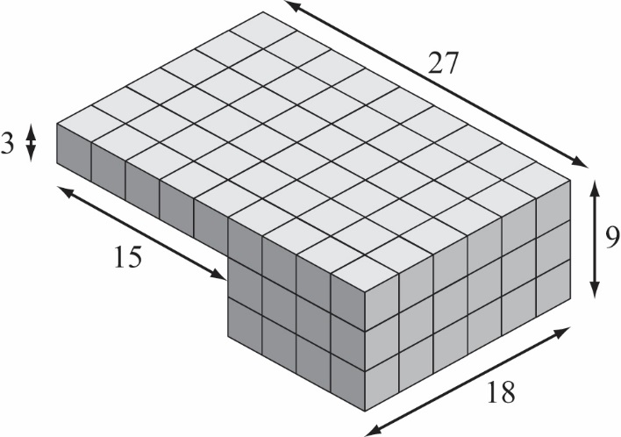

- Giant anacondas can reach a length of 33 feet. What is this length, in inches?

- Jasmine is walking to her friend’s house, which is $2\frac{3}{4}$ miles away. She is $\frac{2}{3}$ of the way there. How much farther, in miles, does Jasmine have to walk?

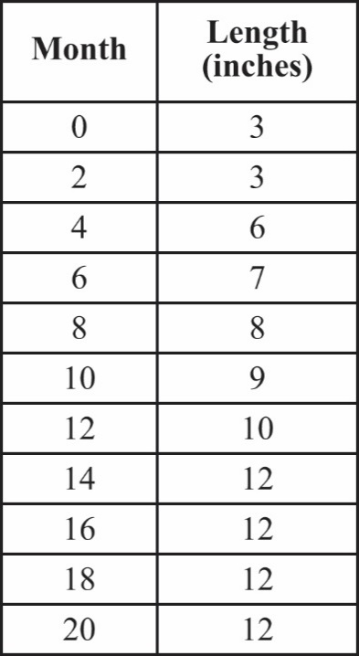
- The data table to the right shows the length of a meerkat measured at different times during its first 20 months of life.

- Graph the set of points to represent the data in the table.

Length (inches)
Month
- What are the coordinates of the point that represents the month when the meerkat was first measured at its adult length (greatest length)?
(_____, ______)
Explain the meaning of the coordinates of this point.

Name: Date:

- A store owner ordered 24 packages of candy. Each package contains 72 candies. He plans to make bags of candy with 18 candies in each bag to sell.

How many bags of candy can he make?

1,728 ÷ 18 = 96 bags of candy

- Order the products below from least to greatest.

A B C D
$\frac{3}{4}×\frac{3}{4}$ $\frac{5}{8}×\frac{5}{8}$ $\frac{3}{4}×1\frac{1}{4}$ $1\frac{1}{4}×1\frac{1}{4}$

B A C D
Least Greatest

Note: Students need not perform the computations here; they should be able to order the products based on the size of the factors.

- Callan has $\frac{1}{3}$ of his birthday cake left. He wants to share it equally between himself and 3 other boys. How much of the original birthday cake will each of the 4 boys get?
$$\frac{1}{3}÷4=\frac{1}{12}$$
$\frac{1}{12}$ of the original cake

- Evelyn challenged the students in her grade to collect nickels for the entire school year. There are 37 students in her grade.
Each student collected 265 nickels. What is the total amount of money that the students collected?
  - $490.25
  - Sample methods/explanations:
Method 1: find total # nickels first Method 2: find individual dollar amount first
265 × 37 = 9805 total nickels 265 ÷ 20 = $13.25 each student collects
9805 ÷ 20 = $490.25 total collected $13.25 × 37 = $490.25 total collected
Method 3: find the total value of cents in nickels and divide by 100.
265 x 37 = 9805 total nickels
9805 x 5 = 49025 total cents in nickels
49025 ÷ 100 = $490.25 total collected

- The diagram below represents a swimming pool with dimensions in feet. How many cubic feet of water are needed to fill the pool all the way to the top?
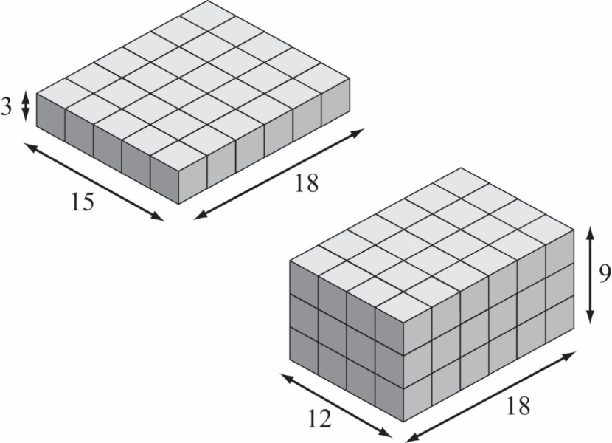

Method 1: divide into two rectangular prisms (3×15×18 and 9×12×18)
First portion: 3 × 15 × 18 = 810 cubic feet
Section portion: 9 × 12 × 18 = 1,944 cubic feet
Total volume: 810 + 1,944 = 2,754 cubic feet

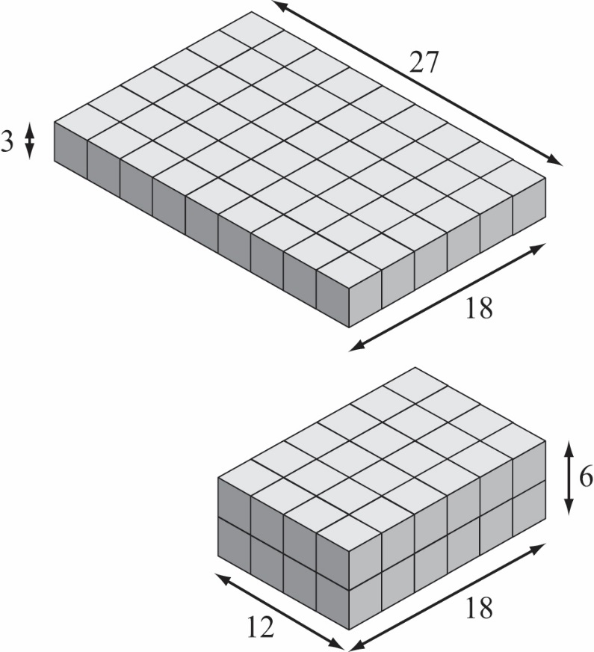

Method 2: divide into two rectangular prisms (3×27×18 and 6×12×18)
First portion: 3 × 27 × 18 = 1,458 cubic feet
Second portion: 6 × 12 × 18 = 1,296 cubic feet
Total volume: 1,458 + 1,296 = 2,754 cubic feet

- Giant anacondas can reach a length of 33 feet. What is this length, in inches?
33 × 12 = 396 inches

- Jasmine is walking to her friend’s house, which is $2\frac{3}{4}$ miles away. She is $\frac{2}{3}$ of the way there. How much farther, in miles, does Jasmine have to walk?

Method 1:
$\frac{2}{3}×2\frac{3}{4}=\frac{2}{3}×\frac{11}{4}=\frac{22}{12}$ miles. This is the distance Jasmine has already walked.
$2\frac{3}{4}-\frac{22}{12}=\frac{11}{4}-\frac{22}{12}=\frac{33}{12}-\frac{22}{12}=\frac{11}{12}$ miles farther for Jasmine to go.

Method 2:
$\frac{1}{3}×2\frac{3}{4}=\frac{1}{3}×\frac{11}{4}=\frac{11}{12}$ miles farther for Jasmine to go.

- The data table to the right shows the length of a meerkat measured at different times during its first 20 months of life.

- Graph the set of points to represent the data in the table.
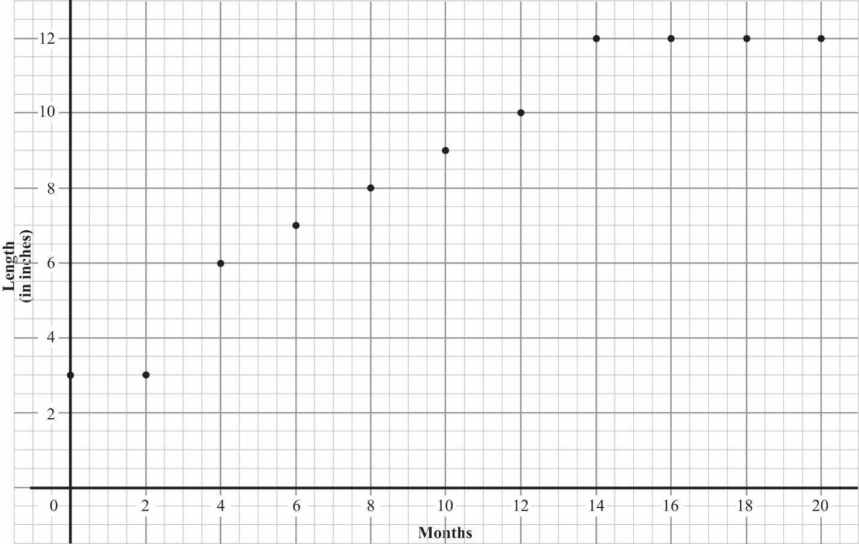

Student work may look different depending on their chosen scale.

- What are the coordinates of the point that represents the month when the meerkat was first measured at its adult length (greatest length)?
(14, 12)
Explain the meaning of the coordinates of this point.

At 14 months, the length of the meerkat was 12 inches.

For more on the Major Work of the Grade, see achievethecore.org/focus.
Although the individual content standards in domain 5.NBT don’t mention word problems, the standards in grades K–4 do invest strongly in word problems, which can be reasonably taken to imply that students should be able to integrate the problem solving skills they learned in previous grades with their increasing computational skill in grade 5.

