Polly Wee Sy
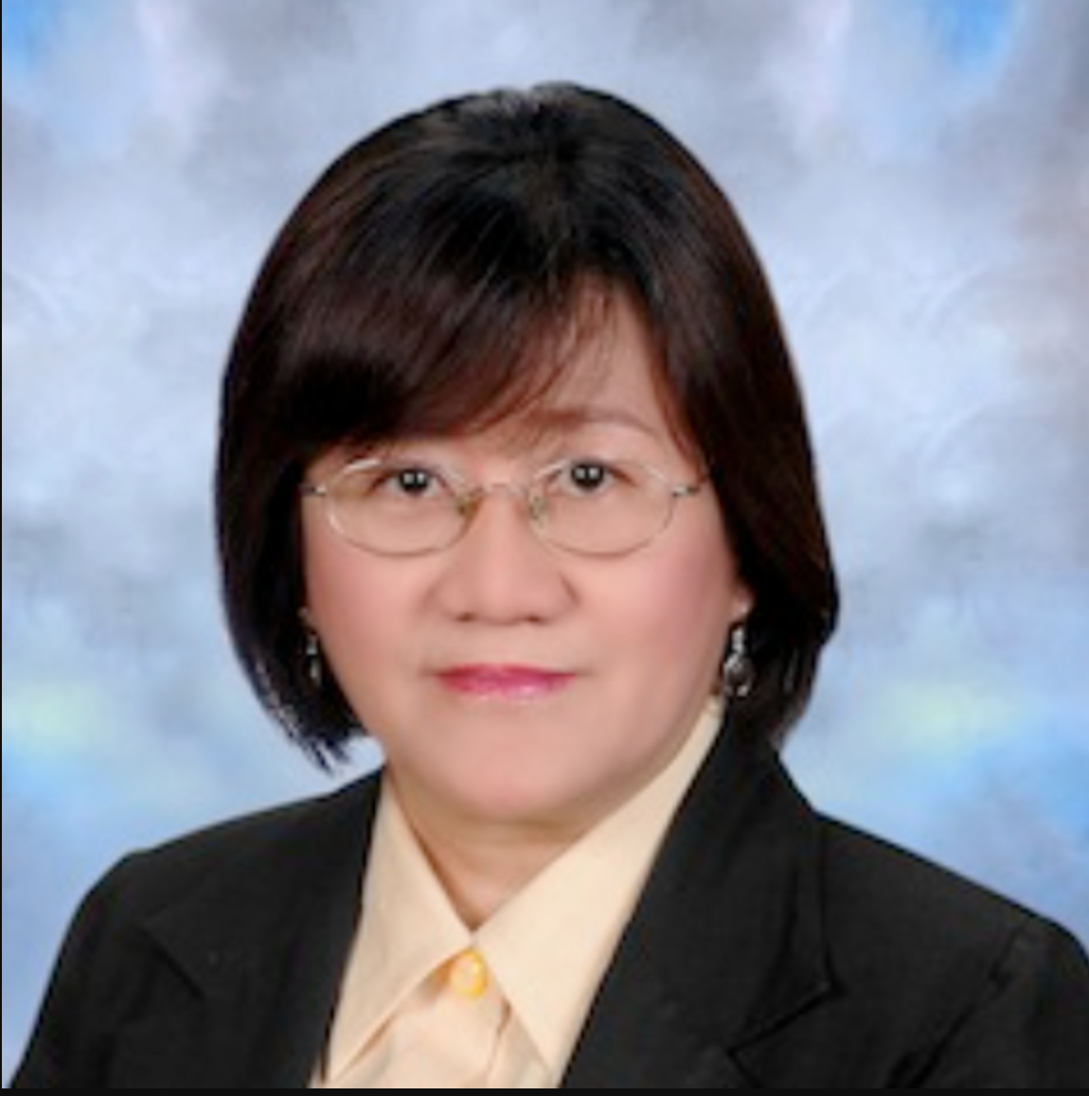

Did you know that Polly Wee Sy is a Filipino mathematician specializing in 3D models? It is very important that she is precise when doing her math and science work. She is a retired mathematics professor from the University of the Philippines Diliman. She won the Outstanding Young Scientist Award from the National Academy of Science and Technology.

