Title/Author: Two Bobbies: A True Story of Hurricane Katrina, Friendship, and Survival by Kirby Larson and Mary Nethery; illustrated by Jean Cassels
Suggested Time to Spend: 4 Days (Recommendation: two sessions per day, at least 20 minutes per day)
Common Core grade-level ELA/Literacy Standards: RL.1.1, RL.1.2, RL.1.3, RL.1.4, RL.1.7, RL.1.9; W.1.2, W.1.8, SL.1.1, SL.1.2; L.1.1, L.1.2, L.1.4

Lesson Objective:
Students will listen to a realistic fiction picture book about two animals that survived the devastating effects of Hurricane Katrina and how volunteers helped them find a new home. Students respond to the text with oral and written answers.

Teacher Instructions
Before the Lesson
- Read the Big Ideas and Key Understandings and the Synopsis below. Please do not read this to the students. This is a description to help you prepare to teach the book and be clear about what you want your children to take away from the work.
Big Ideas/Key Understandings/Focusing Question
- What is the story trying to teach us? One key takeaway is that friendship and service to others can build strong communities and assist in overcoming hardships
- How did the two Bobbies help each other before and after they were rescued? One key takeaway is that Bobbi led the blind cat to food and shelter and protected the cat from harm. Bob Cat provided loyalty and comfort to Bobbi.
- How did the volunteers come together to help rebuild the community? One key takeaway is that volunteers rescued and provided shelter for stranded people and animals, searched homes for survivors, rebuilt homes and public buildings.
Synopsis
This picture book is based on a true story of two animals in New Orleans who were left by their owners during Hurricane Katrina. A dog named Bobbi and his friend, Bob Cat a blind cat met danger and hardship before being rescued and adopted. The animals relied on each other and the kindness of volunteers to survive the trauma and eventually find a new home.
- Go to the last page of the lesson and review “What Makes This Read-Aloud Complex.” This was created for you as part of the lesson and will give you guidance about what the lesson writers saw as the sources of complexity or key access points for this book. You will of course evaluate text complexity with your own students in mind, and make adjustments to the lesson pacing and even the suggested activities and questions.
- Read the entire book, adding your own insights to the understandings identified. Also note the stopping points for the text-inspired questions and activities. Hint: you may want to copy the questions vocabulary words and activities over onto sticky notes so they can be stuck to the right pages for each day’s questions and vocabulary work.
- Consider pairing this series of lessons on Two Bobbies with a text set to increase student knowledge and familiarity with the topic. A custom text set can be found here. Note: This is particularly supportive of ELL students.

Note to teachers of English Language Learners (ELLs): Read Aloud Project Lessons are designed for children who cannot read yet for themselves. They are highly interactive and have many scaffolds built into the brief daily lessons to support reading comprehension. Because of this, they are filled with scaffolds that are appropriate for English Language Learners who, by definition, are developing language and learning to read (English). This read aloud text includes complex features which offer many opportunities for learning, but at the same time includes supports and structures to make the text accessible to even the youngest students.
This lesson includes features that align to best practices for supporting English Language Learners. Some of the supports you may see built into this, and /or other Read Aloud Project lessons, assist non-native speakers in the following ways:

- These lessons include embedded vocabulary scaffolds that help students acquire new vocabulary in the context of reading. They feature multi-modal ways of learning new words, including prompts for where to use visual representations, the inclusion of student-friendly definitions, built-in opportunities to use newly acquired vocabulary through discussion or activities, and featured academic vocabulary for deeper study.
- These lessons also include embedded scaffolds to help students make meaning of the text itself. It calls out opportunities for paired or small group discussion, includes recommendations for ways in which visuals, videos, and/or graphic organizers could aid in understanding, provides a mix of questions (both factual and inferential) to guide students gradually toward deeper understanding, and offers recommendations for supplementary texts to build background knowledge supporting the content in the anchor text.
- These lessons feature embedded supports to aid students in developing their overall language and communication skills by featuring scaffolds such as sentence frames for discussion and written work (more guidance available here) as well as writing opportunities (and the inclusion of graphic organizers to scaffold the writing process). These supports help students develop and use newly acquired vocabulary and text-based content knowledge.

The Lesson – Questions, Activities, and Tasks

Questions/Activities/Vocabulary/Tasks | Expected Outcome or Response (for each)
FIRST READING:  Read aloud the entire book with minimal interruptions. Stop to provide word meanings or clarify only when you know the majority of your students will be confused.  Show students a map of the United States, pinpointing New  Orleans, LA.  Based on your students’ prior knowledge, you may want to read all or portions of an informational text such as Gail Gibbons Hurricanes. Alternatively, show short video clips of a hurricane in action. | The goal here is for students to enjoy the book, both writing and pictures, and to experience it as a whole. This will give them an understanding of the basic context of the story and a sense of completion before they dive into examining the parts of the book more carefully.
SECOND READING:  Focus on the devastating nature of hurricanes.  Include explicit instruction on the word devastation:  - Pronounce the word and have students repeat  - Tap the word into syllables (dev-a-sta-tion) and have students repeat  - Devastation means something is damaged badly or completely.  - Provide examples and non-examples of devastation  Example: In Two Bobbies, devastation means damaged and dangerous. The city of New Orleans was damaged and dangerous for people to inhabit, causing them to abandon their homes.  Non-Example: Spilling your milk at lunchtime, does that show devastation?  - Check for understanding: give me a thumbs up or thumbs down if these are examples of devastation:  - If there is a light rain during recess, is that an example of devastation? (No)  - If strong winds tear down trees in your neighborhood, is that an example of devastation? (Yes)  Reread the first paragraph on page 3: “Winds roared to 110 miles an hour. Rain pounded hard and fast. Strong winds pushed walls of water from the Gulf of Mexico into Lake Pontchartrain. Some of the levees holding back the lake gave way.”  ACTIVITY: Show students a picture of a levee. Students will answer the questions listed below. Have students share answers with a partner. Have a few students share with class.  QUESTION: What do the authors mean by “walls of water?”  QUESTION: What problems did the wall of water create for the residents of New Orleans?  Use a document reader, ask students to look at the illustrations on pages 3 and 4. Have students look for examples and collect evidence of devastation in today’s reading. For example, flood waters, floating car.  Continue reading the remaining paragraphs on page 3.  QUESTION: What do the authors mean by “silent heat?”  Use a document reader before asking the following question to ensure everyone can see the illustrations.  QUESTION: Why did the people have to leave their pets behind? Let’s look at page three in our book and see what the author tells us.  QUESTION: How can the illustrations help you understand what “tethered by a length of chain” means?  Reread page 8: “In the early days after the hurricane, the Two Bobbies tried to make their way around oily water littered with debris. After the waters receded, they traveled the buckled streets…”  ACTIVITY: Show students a picture of a street that buckled.  OPTIONAL ACTIVITY: Distribute pieces of paper to students and encourage them to make the paper buckle. Ask students to share ways in which they made the paper buckle.  Use a document reader before asking the following questions to ensure everyone can see the illustrations.  QUESTION: How can the text and illustrations help you understand what debris means?  QUESTION: Can you find examples from the text.  FINAL THOUGHT: Give me some examples from the text that demonstrate how hurricanes are devastating.  Record answers on circle map. See example of Circle Map in attachments. | STUDENT RESPONSE: The authors use “wall of water” to mean a large wave of water washing over the city.  STUDENT RESPONSE: The wall of water was a problem because it flooded the streets and damaged homes. The wall of water also caused people to leave their homes and pets behind.  STUDENT RESPONSE: The authors use “silent heat” to mean that all of the people were gone, the streets were quiet and the weather was uncomfortably hot and humid.  STUDENT RESPONSE: The author says “They had to say good-bye to everything they loved. Many were told they could not take their pets.” Students may infer that in a hurricane, people have to move quickly and there may not be extra room for pets in emergency vehicles.  STUDENT RESPONSE: The illustrator shows Bobbi chained to the porch post.  STUDENT RESPONSE: The author states the water is oily, and the streets are buckled. The illustrator shows different types of debris littering the road.  STUDENT RESPONSE: Examples of debris includes: fallen trees, dirty looking water, mattress, fridge, shingles, garbage  STUDENT RESPONSE: Examples of devastation include: wall of water, broken levee, silent heat, debris, buckled streets.  Record answers on Circle Map. See example of Circle Map in attachments.
THIRD READING:  Focus on the Two Bobbies’ friendship and how it helped them overcome hardship.  Post a T-Chart as a note taking device to gather information and model note taking throughout the read aloud. See example of T-Chart in attachments.  Reread page 6: “But with so much damage and confusion, the Two Bobbies were not rescued. Their food and water gone, Bobbi finally broke free. She dragged along the broken chain with Bob Cat close beside her.”  QUESTION: What does the text tell us about the hardships the Two Bobbies faced?  QUESTION: Looking at the illustrations I noticed that Bobbi was chained up but Bob Cat was not. Why do you think Bob Cat never left her friend?  Record answers on T-Chart.  As I read the text, think about what ways Bobbi helped his friend Bob Cat.  Reread the first two paragraphs on page 12: “One day in January…” Focus on the second paragraph: “He trimmed Bobbi’s chain, leaving enough to jingle on the ground because Bob Cat liked to follow it. But every time Rich tried to touch Bob Cat, Bobbi growled.”  QUESTION: Why did Bobbi growl?  Record answers on T-Chart.  Use a document reader before asking the following question to ensure everyone can see the illustrations on pages 15-16.  QUESTION: What clues can you find in the illustration to show how the Two Bobbies helped each other?  Record answers on T-Chart.  QUESTION: I noticed the text talks about trimming Bobbi’s chain. Based on that information, why was the chain important to Bob Cat?  Record answers on T-Chart.  QUESTION: Are there clues in the text that lets us know the cat was blind?  Reread page 17. Ask students to identify clues that suggest Bob Cat is blind.  QUESTION: The author let us know another way that Bobbi helped her friend. Tell your neighbor in what way Bobbi helped?  Record answers on T-Chart.  FINAL THOUGHTS: As I reread these pages and was thinking about their adventure, I noticed that Bobbi led Bob Cat, her blind friend to food and shelter as well as protecting him from danger.  ACTIVITY: Post sentence frames. Have students turn to a partner and orally complete the following sentence frame while referring to T-Chart.  Partner A completes this sentence frame, while Partner B looks, leans and listens: Bob Cat helped Bobbi by________. This showed ________.  Partner B completes this sentence frame, while Partner A looks, leans and listens: Bobbi helped Bob Cat by________. This showed ________. | Record answers on T-Chart. See example of T-Chart in attachments.  STUDENT RESPONSE: The text tells us that they were not rescued, they had no food or water and having been chained, Bobbi finally broke free.  STUDENT RESPONSE: Bob Cat was a loyal friend to Bobbi. He helped Bobbi by staying by his side.  STUDENT RESPONSE: Bobbi growled because she was protecting the cat.  STUDENT RESPONSE: The two Bobbies provided comfort to each other by snuggling and staying close.  STUDENT RESPONSE: Bob Cat was blind and relied on the sound of the chain to follow Bobbi and stay safe.  STUDENT RESPONSE: Clues include: Bob Cat stayed close to Bobbi, Bob Cat carefully lifted his paws, and Bob Cat did not blink.  STUDENT RESPONSE: Bobbi had been Bob Cat’s seeing eye dog.  STUDENT RESPONSE: Students complete sentence frames.
FOURTH READING:  Focus on communities coming together to overcome hardship.  - Pronounce the word and have students repeat  - Tap the word into syllables (com-mu-ni-ty) and have students repeat  - Provide examples and non-examples of devastation  Example: A community is a group of people who come together with similar interests or concerns.  Example: our classroom is a community because we are a group of people with similar interests… we want to learn.  Non-Example: Shoppers at the mall are not a community.  - Check for understanding: give me a thumbs up or thumbs down if these are examples of community:  - People getting together for a party to celebrate the Fourth of July – is that an example of community? (Yes)  - Neighbors getting together to clean up trash in their neighborhood, – is that an example of community? (Yes)  - People watching a movie at the movie theatre – is that an example of community? (No)  Reread page 5: “After the storm, volunteers from across the country came to New Orleans to lend a hand. They brought food and water. They rescued people stranded on the roofs of their homes, and they rescued many animals.”  QUESTION: Rescued means to save or help people and animals in danger. Using the text, give some examples of how the volunteers rescued people.  Reread the first two sentences on page 12: “One day in January, four long months later, Bobbi and Bob Cat strayed onto a job site. A construction crew hammered and sawed, fixing up a motel damaged by the hurricane.”  Use a document reader before asking the following question to ensure everyone can see the illustrations.  QUESTION: How can the text and illustrations give you clues about how the volunteers were helping the community?  Reread the entire text on page 14: “Rich drove them to a temporary shelter that Best Friends Animals Society had set up in Celebration Station…”  Use a document reader before asking the following question to ensure everyone can see the illustrations.  QUESTION: Based on evidence from the text and illustrations, how did volunteers help the homeless cats and dogs?  Reread pages 20-24: “The volunteers, and even an ace pet detective, searched for their family…”  QUESTION: Based on evidence from the text and illustrations, how did volunteers try to help the Two Bobbies find a permanent home?  FINAL THOUGHTS: After Hurricane Katrina, many volunteers joined together to help people and pets survive the devastation and rebuild their lives. | STUDENT RESPONSE: The text says the volunteers brought food and water; rescued people stranded on their roofs, and rescued animals from homes. Rescue means to save people and animals.  STUDENT RESPONSE: The text says that a construction crew hammered and sawed, fixing up a motel. The illustrations show workers with building materials and tools.  STUDENT RESPONSE: Volunteers converted a video-game arcade to a shelter, and they provided care and a safe place for the animals to stay.  STUDENT RESPONSE: Volunteers searched for their original family, they made a public appeal on television, they drove the Two Bobbies to Utah, and matched the Two Bobbies with Melinda.

FINAL DAY WITH THE BOOK - Culminating Task

- ACTIVITY: Using evidence from the text, students write sentences and draw a picture that describes how volunteers in the community helped the two Bobbies find a permanent home.
- SAMPLE STUDENT RESPONSES:
  - Volunteers helped the two Bobbies by converting a video-game arcade to a shelter, and they provided care and a safe place for the animals to stay.
  - Volunteers searched for their original family, they made a public appeal on television, they drove the Two Bobbies to Utah, and matched the Two Bobbies with Melinda.

Vocabulary

These words merit less time and attention  (They are concrete and easy to explain, or describe events/  processes/ideas/concepts/experiences that are familiar to your students ) | These words merit more time and attention  (They are abstract, have multiple meanings, and/or are a part  of a large family of words with related meanings. These words are likely to describe events, ideas, processes or experiences that most of your student will be unfamiliar with)
Page 2 – stranded – a person or object is unable to move from the place where they are  Page 3 – levee – a special wall built to stop a river flooding  Page 3 – tether(ed) – to tie an animal to a post so that it can only move around within a limited area  Page 5+ – volunteer – someone who does a job willingly, often without being paid | Page 3 – wall of water – a large wave of water washing over the city.  Page 3 – silent heat – the weather was uncomfortably hot and humid.  Page 8 – buckle(ed) – to become bent or curved because of heat or pressure, or to make something bend or curve in this way  Page 9 – devastate(ed) – to damage something very badly or completely  Page 14 – temporary – intended to be used for only a limited period of time  Community – a group of people who come together with similar interests or concerns.

Extension learning activities for this book and other useful resources
- View Two Bobbies website, created by authors Kirby Lawson and Mary Nethery at http://www.twobobbies.com/

- View the publisher’s website for additional classroom activities at http://media.bloomsbury.com/rep/files/twobobbiesclassroomactivities.pdf

- Read Gail Gibbon’s non-fiction book, Hurricanes for excellent background.

Note to Teacher
- See attached for Circle Map, T-Chart and a photograph of a buckled street.

What Makes This Read-Aloud Complex?
- Quantitative Measure
Go to http://www.lexile.com/ and enter the title of your read-aloud in the Quick Book Search in the upper right of home page. Most texts will have a Lexile measure in this database.

_810L_
Most of the texts that we read aloud in K-2 should be in the 2-3 or 4-5 band, more complex than the students can read themselves.
2-3 band 420-820L
4-5 band 740-1010L

- Qualitative Features
Consider the four dimensions of text complexity below. For each dimension*, note specific examples from the text that make it more or less complex.

Friendship and survival
Sequential structure makes the text less complex.

Use of rich language: “Bobbi’s ribs began to show. Bob Cat’s brown-sugar markings started to fade to a dull white.” Plenty of vocabulary words and interesting phrases: levees, silent heat, debris, receded, devastated. Challenging sentence structures: “With little food to eat or clean water to drink Bobbi’s ribs began to show.”

Students need to understand the level of devastation that hurricanes can cause: “Winds roared to 110 miles an hour. Rain pounded hard and fast. Strong winds pushed walls of water…”

Meaning/Purpose
Structure

Language
Knowledge Demands

*For more information on the qualitative dimensions of text complexity, visit http://www.achievethecore.org/content/upload/Companion_to_Qualitative_Scale_Features_Explained.pdf

- Reader and Task Considerations
What will challenge my students most in this text? What supports can I provide?
  - Students do not have experience with hurricanes; provide students with background information (informational text) about hurricanes and Hurricane Katrina
  - Use of descriptive language; ask text-dependent questions

How will this text help my students build knowledge about the world?
  - Students will understand that natural disasters occur around the United States (e.g. Katrina) and the world (e.g. tsunamis)
  - Communities must come together to overcome natural disasters
  - Acts of services can build community

- Grade level
What grade does this book best belong in?
  - 1st grade

All content linked to within this resource was free for use when this resource was published in March 2018. Over time, the organizations that manage that external content may move or remove it or change the permissions. If the content is no longer available, please email info@studentsachieve.net.

Examples of a Buckled Road
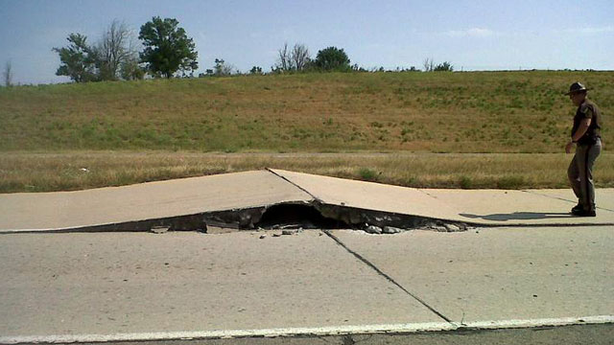
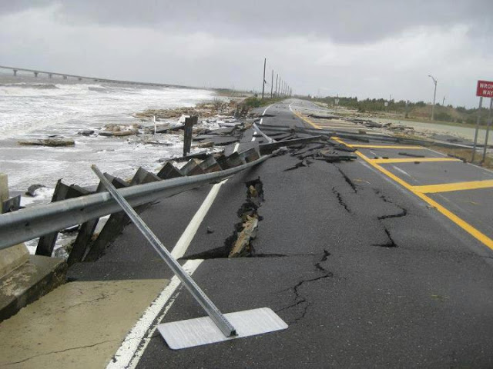
T-Chart: How did the Two Bobbies’ Friendship Help Them Overcome Hardship?
Bobbi, the Dog | Bob Cat
- Bobbi stayed with Bob Cat after she broke free from the chain (instead of running off)  - Bobbi growled because she was protecting the cat  - The two Bobbies provided comfort to each other by snuggling and staying close  - Bob Cat was blind and relied on the sound of the chain to follow Bobbi and stay safe | - Bob Cat stayed by Bobbi’s side on the porch (instead of running off)  - Bob Cat was a loyal friend to Bobbi. He helped Bobbi by staying by his side  - The two Bobbies provided comfort to each other by snuggling and staying close

T-Chart: How did the Two Bobbies’ Friendship Help Them Overcome Hardship?
Bobbi, the Dog | Bob Cat

Circle Map: Examples of Devastation from the Text and Illustrations

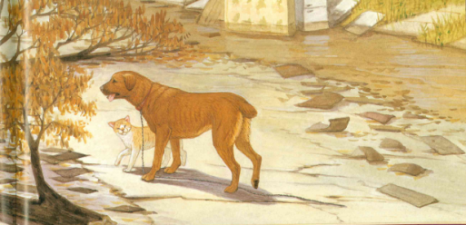
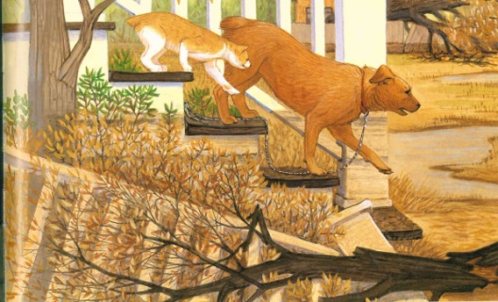
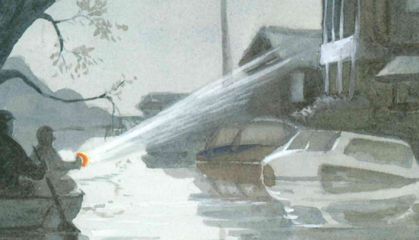
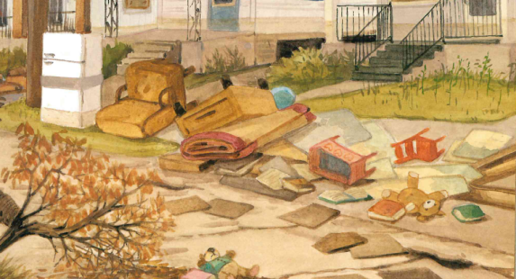
Buckled streets
Uprooted trees
Garbage and debris
Dirty, oily water
Devastation

Circle Map: Examples of Devastation from the Text and Illustrations

Devastation

