Understanding Place Value Within 1000
2.NBT.A Conceptual Understanding Mini-Assessment by Student Achievement Partners

OVERVIEW
This mini-assessment explores the important cluster 2.NBT.A: “Understand place value.” The most important standard in this cluster is 2.NBT.A.1, which sets an expectation that grade 2 students will understand the key ideas of place value for three-digit numbers. The other three standards in this cluster should be thought of as supports for, and evidence of, attaining standard 2.NBT.A.1, rather than as separate items coequal with 2.NBT.A.1 on a to-do list.

This mini-assessment is designed for teachers to use either in the classroom, for self-learning, or in professional development settings. This mini-assessment can help educators:
- See examples of how to assess for conceptual understanding;
- Identify strengths and weaknesses in students’ understanding of place value to 1000—whether before, during, or after teaching aspects of this material;
- Appreciate the intricacies of the place value system;
- Illustrate CCR-aligned assessment problems;
- Illustrate best practices for writing tasks that allow access for all learners; and
- Support mathematical language acquisition by offering specific guidance.

The mini-assessment also shows how teachers can target conceptual understanding with brief problems. Each question is designed in such a way that the best sign of understanding is a correct answer. Teachers can also question students about the thinking that led to their answers, individually or in a group setting (and students can question each other).
2.NBT.A Understand place value.
2.NBT.A.1 Understand that the three digits of a three-digit number represent amounts of hundreds, tens, and ones; e.g., 706 equals 7 hundreds, 0 tens, and 6 ones. Understand the following as special cases:
a. 100 can be thought of as a bundle of ten tens — called a “hundred.”
b. The numbers 100, 200, 300, 400, 500, 600, 700, 800, 900 refer to one, two, three, four, five, six, seven, eight, or nine hundreds (and 0 tens and 0 ones).
2.NBT.A.2 Count within 1000; skip-count by 5s, 10s, and 100s.
2.NBT.A.3 Read and write numbers to 1000 using base-ten numerals, number names, and expanded form.
2.NBT.A.4 Compare two three-digit numbers based on meanings of the hundreds, tens, and ones digits, using >, =, and < symbols to record the results of comparisons.

MAKING THE SHIFTS
This mini-assessment promotes strong focus in the classroom; place value is at the heart of the major work of grade 2. In terms of coherence, cluster 2.NBT.A connects tightly to cluster 2.NBT.B; builds directly on standard 1.NBT.B.2 from first grade; and feeds directly into cluster 3.NBT.A in third grade. This mini-assessment targets conceptual understanding, one of the three elements of rigor.
A CLOSER LOOK
There are three fundamental components of the place value system:

- Base-ten units: Number sense requires having a feel for the sizes of base-ten units of ones, tens, and hundreds.
- Flexible bundling and unbundling: Base-ten units can be broken down and built back up in different ways. By definition, ten ones make a larger unit called “a ten.” By definition, ten tens make a larger unit called “a hundred.” And by definition, ten hundreds make a larger unit called “a thousand.” Therefore, it is equally true that a hundred ones make a hundred; a thousand ones make a thousand, and a hundred tens also make a thousand. Bundling and unbundling are central ideas in developing computation algorithms. Rods, flats, and cubes are good for illustrating the ways to bundle and unbundle base-ten units.
- Positional notation: According to convention, the location of each digit in a multi-digit number corresponds to a particular base-ten unit. Also, the digit itself tells how many copies of that unit are in the number. So, 908 is 9 hundreds and 8 ones.

Understanding place value is having number sense of the base-ten units, understanding how these units are bundled and unbundled at will, and connecting this understanding to the positional notation system. That means understanding all three of these things in connection with one another. So for example, working with rods, flats, and cubes alone won’t by itself teach place value, because these manipulatives do not have any connection to positional notation. The place value system belongs to the art of writing. Working with place value requires writing numbers with an understanding of how they name quantities. That is important as students learn computational algorithms based on principles of place value.
Connecting the Standards for Mathematical Practice to Grade-Level Content
Cluster 2.NBT.A is meaningfully connected to Standards for Mathematical Practice MP2 and MP3. In their work on understanding place value, students reason abstractly and quantitatively (MP2), connecting quantities with symbols in the place-value system. As students work through these ideas in class, they will have important opportunities to construct viable arguments and critique the arguments of others (MP3).

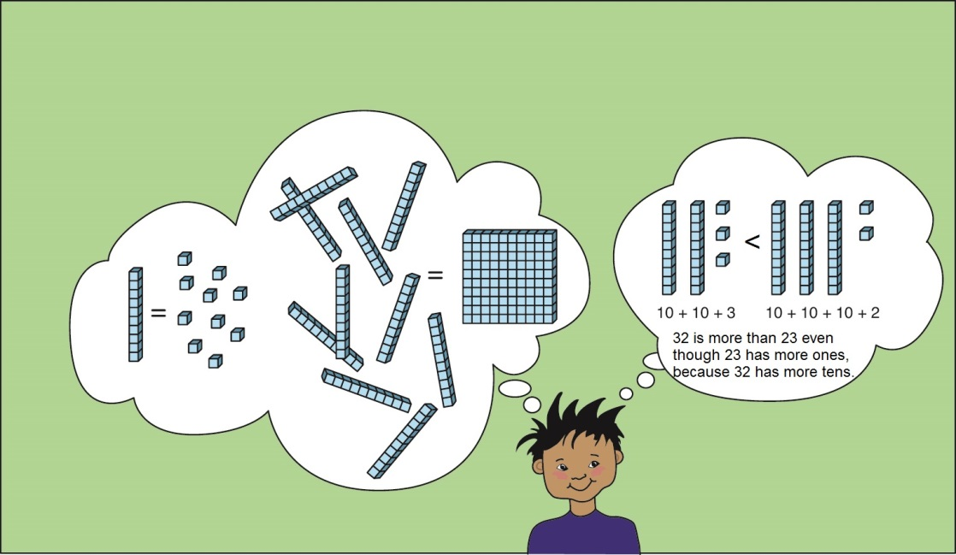

SUPPORT FOR ENGLISH LANGUAGE LEARNERS
This lesson was designed to include specific features that support access for all students and align to best practice for English Language Learner (ELL) instruction and assessment. Go here to learn more about the research behind these supports. Features that support access in this mini-assessment include:
- Tasks that allow for multi-modal representations, which can deepen understanding of the mathematics and make it easier for students, especially ELLs, to give mathematical explanations.
- Tasks that avoid unnecessarily complex language to allow students, especially ELLs, to access and demonstrate what they know about the mathematics of the assessment.
Prior to this mini-assessment, ensure students have had ample opportunities in instruction to read, write, speak, listen for, and understand the mathematical concepts that are represented by the following terms and concepts:
- number
- digit
- comparison
- equation
- comparison
- hundred
- ten
- one
Students should engage with these terms and concepts in the context of mathematical learning, not as a separate vocabulary study. Students should have access to multi-modal representations of these terms and concepts, including: pictures, diagrams, written explanations, gestures, and sharing of non-examples. These representations will encourage precise language, while prioritizing students’ articulation of concepts. These terms and concepts should be reinforced in teacher instruction, classroom discussion, and student work (for example, through engagement in mathematical routines).
ELLs may need support with the following Tier 2 words found in this mini-assessment:
- true
- false
- blank
In preparation for giving this mini-assessment, teachers should strive to use these words in context so they become familiar to students. It will be important to offer synonyms, rephrasing, visual cues, and modeling of what these words mean in the specific contexts represented in the items in this mini-assessment. Additionally, teachers may offer students the use of a student-friendly dictionary, or visual glossary (example below) to ensure they understand what is being asked of them in each item.
Sketch
Point | •
Locate | •

Name: Date:

Make true equations. Write one number in every blank. Draw a picture if it helps.

1) 1 hundred + 4 tens = ______

2) 4 tens + 1 hundred = ______

3) 14 tens = 10 tens + _____ tens

= _____ hundred + 4 tens

= ______

4) 7 ones + 5 hundreds = ______

5) 8 hundreds = ______

6) 106 = 1 hundred + _____tens + _____ones

7) 106 = _____tens + _____ones

8) 106 = _____ones

9) 90 + 300 + 4 = ______

Decide whether each comparison is true or false? Write TRUE or FALSE in each blank.
10) 2 hundreds + 3 ones > 5 tens + 9 ones ______
11) 9 tens + 2 hundreds + 4 ones < 924 ______
12) 456 < 5 hundreds ______
Name: Date:

Make true equations. Write one number in every blank. Draw a picture if it helps.

1) 1 hundred + 4 tens = 140
These two problems have the same answer, 140. This emphasizes that order doesn’t matter in addition – yet order is everything in positional notation! In the second problem, you must really think to encode the quantity in positional notation.

2) 4 tens + 1 hundred = 140

3) 14 tens = 10 tens + 4 tens
In these three problems, the base-ten units in 140 are bundled in different ways. In the first line, “tens” are thought of as units: 14 things = 10 things + 4 things.
= 1 hundred + 4 tens

= 140 ones
By scrambling the usual order, the problem requires students to link the values of the parts with the order of the digits in the positional system. Also, to encode the quantity, the student will have to think: “no tens,” emphasizing the role of 0.

4) 7 ones + 5 hundreds = 507

5) 8 hundreds = 800
When the student writes “8-0-0,” the zeros should come with a silent “no tens and no ones.”

6) 106 = 1 hundred + 0 tens + 6 ones
In these three problems, the base-ten units in 106 are bundled in different ways. This is helpful when learning how to subtract in a problem like 106 – 37, for example.

7) 106 = 10 tens + 6 ones

8) 106 = 106 ones
If the order is always given “correctly,” then all we do is teach students rote strategies without thinking about the size of the units or how to encode them in positional notation.
9) 90 + 300 + 4 = 394

Decide whether each comparison is true or false?
At first, comparisons of numbers should hinge on the sizes of the quantities—not an “alphabetization” strategy of simply comparing digits from left to right. These problems invite the mathematical strategy of looking first for the largest base-ten unit on each side.
A more advanced problem might also involve bundling. For example, True or False: 20 tens + 30 ones > 230.
Write TRUE or FALSE in each blank.
10) 2 hundreds + 3 ones > 5 tens + 9 ones True
11) 9 tens + 2 hundreds + 4 ones < 924 True
12) 456 < 5 hundreds True

See the K-8 Publishers’ Criteria, Criterion #4a, page 10. http://www.corestandards.org/assets/Math_Publishers_Criteria_K-8_Spring%202013_FINAL.pdf
For more on the Major Work of the Grade, see achievethecore.org/focus
By using the word “copies,” we mean to describe an essentially multiplicative notion in terms appropriate to Grade 2.

