Title/Author: My Side of the Mountain by Jean Craighead George (excerpted)
Suggested Time to Spend: 3-4 Weeks (Recommendation: one session per day, at least 30-45 minutes per day)
Common Core grade-level ELA/Literacy Standards: RL.2.1, R.L.2.2, RL.2.3, RL.2.6; W.2.2, W.2.8; SL.2.1, SL.2.2, SL.2.6; L.2.1, L.2.4, L.2.5, L.2.6
Next Generation Science Standards: 2-LS4-1
2-LS4-1: Make observations of plants and animals to compare the diversity of life in different habitats. [Clarification Statement: Emphasis is on the diversity of living things in each of a variety of different habitats.]

Teacher Instructions
Before the Lesson
- Read the Big Ideas and Key Understandings and the Synopsis below. Please do not read this to the students. This is a description to help you prepare to teach the book and be clear about what you want your children to take away from the work.
Big Ideas/Key Understandings/Focusing Question
  - How are communities interdependent?
  - Sam Gribley survives a year in the Catskill Mountains and finds a new community in the wilderness. What challenges does Sam face? What does the community provide to help him survive?
Synopsis
Sam Gribley leaves his home and family in New York City and establishes a home on his family’s wild land in the Catskill Mountains. He finds shelter in a tree cavity, eats wild plants, and hunts for his own food to survive a sometimes lonely year in the wilderness.
- Read the book as excerpted by this lesson. As you read, number the chapters and tab your book with sticky notes to aid in your navigation of the book as you read aloud. (See Chapter Guide below or Brief Chapter Guide in Teacher Notes)
- Also add your own insights to the understandings identified. Note the stopping points for the text-inspired questions and activities. Plan on reading one chapter aloud per day.
- Consider pairing this series of lessons on My Side of the Mountain with a text set to increase student knowledge and familiarity with the topic. A custom text set can be found here. Note: This is particularly supportive of ELL students.

Note to teachers of English Language Learners (ELLs): Read Aloud Project Lessons are designed for children who cannot read yet for themselves. They are highly interactive and have many scaffolds built into the brief daily lessons to support reading comprehension. Because of this, they are filled with scaffolds that are appropriate for English Language Learners who, by definition, are developing language and learning to read (English). This read aloud text includes complex features which offer many opportunities for learning, but at the same time includes supports and structures to make the text accessible to even the youngest students.
This lesson includes features that align to best practices for supporting English Language Learners. Some of the supports you may see built into this, and /or other Read Aloud Project lessons, assist non-native speakers in the following ways:

- These lessons include embedded vocabulary scaffolds that help students acquire new vocabulary in the context of reading. They feature multi-modal ways of learning new words, including prompts for where to use visual representations, the inclusion of student-friendly definitions, built-in opportunities to use newly acquired vocabulary through discussion or activities, and featured academic vocabulary for deeper study.
- These lessons also include embedded scaffolds to help students make meaning of the text itself. It calls out opportunities for paired or small group discussion, includes recommendations for ways in which visuals, videos, and/or graphic organizers could aid in understanding, provides a mix of questions (both factual and inferential) to guide students gradually toward deeper understanding, and offers recommendations for supplementary texts to build background knowledge supporting the content in the anchor text.
- These lessons feature embedded supports to aid students in developing their overall language and communication skills by featuring scaffolds such as sentence frames for discussion and written work (more guidance available here) as well as writing opportunities (and the inclusion of graphic organizers to scaffold the writing process). These supports help students develop and use newly acquired vocabulary and text-based content knowledge.

Chapter Guide – Questions, Activities, Vocabulary, and Tasks

Questions/Activities/Vocabulary/Tasks | Expected Outcome or Response (for each)
CHAPTER 1: In Which I Hole Up in a Snowstorm  - What do you know about the setting (where and when) from reading this chapter?  - Who are the characters the author introduces?  - What clues does the author provide about what Sam is doing here?  Following partner and group discussion of these questions, students should sketch the story’s mountain setting as the author has described, in their notebook. Add labels and details from the story and share with a partner. You may want to pair with one of the books listed in additional resources at this point, depending on student’s knowledge of forest environments. | - Sam is in a snug cave tree home on “my mountain.” He has a bed. It is December 4th or 5th according to the “notches on the aspen pole that is my calendar.” It has snowed; a blizzard began on December 3rd and it is bitter cold. He has been here since May, then through the summer and fall. It says, “When I wrote that last winter…” so we know it is now sometime later.  - Sam Gribley, The Baron (wild weasel), Frightful (trained falcon)  - Sam thought about New York and his family of 11 in the apartment which no one in the family liked. Sam’s dad would tell him stories of Great-Grandfather Gribley’s land in the Catskills (Gribley’s folly). “Here I am three hundred feet from the beech with Gribley carved on it.”  Eight months ago “I ran away from home to live on the land.” I knew the land was just the place for a Gribley.
CHAPTER 2: In Which I Get Started on This Venture  - What is Sam’s venture? How did Sam’s father feel about the plan?  - What challenges does Sam face as he begins his venture? How does he respond to the challenges?  At this point, introduce the public processing chart. Teacher should solicit and add details to the columns (example below).  Then, in partners, students can act out Sam’s first night in the wilderness. Include the details you learned from the story using the chart or teacher rereading to aid recall. | - Sam’s venture is running away from the city to the country. His father laughed at him.  - He is in the forest at 4:00 in the afternoon, finds a stream and whittles a fishhook. There is frost in the ground. He “walked a thousand miles” before finding a pool to fish in and was sure he was “going to starve to death.” He catches some fish but has no fire to cook them. Gathering firewood “was the only thing I did right”. Couldn’t light his fire and he is cold and damp. The whippoorwill kept him away all night, he is thirsty and scared and “cried a little bit.”  He responds by heading for the road and finding a house as soon as it is light. Bill lets him sleep, feeds him and teaches him how to make a fire.
CHAPTER 3: The Manner in Which I Find Gribley’s Farm  - Sam says, “I knew how to make fire, and that was my weapon. With fire I could conquer the Catskills.” What does this mean?  - What else helps Sam conquer the Catskills?  Interactively add to the public processing chart with students contributing content and teacher writing notes.  Print a copy of the last paragraph of the chapter about fire. Partner read with expression for fluency practice. | - Now that he knows how to make a fire and fish, he will not be hungry. The fire is “magic”; it lighted the trees and made them warm and friendly. It made him feel independent rather than scared and crying.  - Miss Turner at the library in Delhi, the only person who believed in him. She helped him find the farm, drew maps and researched. Bill helped him by teaching him how to make a fire.
CHAPTER 5: This is About the Old, Old, Tree  - Describe how Sam spends his days in this chapter.  - Reread paragraph 5 beginning with, “You know those first days…” Why does Sam feel like he was “going in circles”? | - Sam finds a tree to live in and begins digging it out. He burns the rot out to enlarge the cavity. He spends time gathering food “for that body of mine” – bulbs, beans, dandelions, crow eggs.  He finds a pool to rinse in and a spring to drink from. He is passing the days “working, burning, cutting and gathering food.”  - This paragraph describes Sam’s days. He is working and getting hungry. Finding food takes so long and is so much work it is hard to keep energy for any other work.  He thinks about primitive man, who was not “citified” like him and wonders how he survived. It is a lot of work living in the woods!
CHAPTER 7: The King’s Provider – Begin at paragraph 4, “The May Apples…”  - Sam gives Frightful her name, “because of the difficulties we had in getting together.” What are the difficulties they have?  Sketch this “frightful” experience.  - Visit this website to view pictures, videos and audio sounds made by peregrine falcons https://nature.mdc.mo.gov/discover-nature/photos-live-cams/peregrine-falcon-web-camera/falcon-camera-education-material | - After breakfast, Sam is going to climb the very steep cliff to try to get to the baby falcons. He is scared, dizzy, and shaking from exertion from climbing so high. The female falcon attacks Sam once he is near the babies. Words from the text that describe the attack: Wham!, bulletlike dive, 50-60 miles per hour she is flying at him, but he is able to put his foot out and deflect the hit. Also, the baby’s talons dug into him coming down. It was a frightful experience!
CHAPTER 8: A Brief Account of What I Did About the First Man Who Was After Me  - How does Sam react to the man being in his camp?  - What does it mean when Sam says, “My tree was just a pleasant habit”? | - Sam realizes that he does not have to go back to camp and he can settle down anywhere. He retrieves a rabbit from his trap, feeds Frightful, and spends “pleasant hours” alternately watching her and feeding her. He also makes a rabbit stew and falls asleep on some pine boughs. He forgets about the man while focusing on Frightful.  - Sam realizes that he can survive anywhere that he can build a fire and hunt. He is learning to survive in the wild. He is avoiding the man in his camp and taking care of himself. He was perfectly free and capable of settling down anywhere.
CHAPTER 10: How a Door Came to Me  - Sam talks about “one of the nicest things learned in the woods. What are some of the things Sam has learned?  - How does Sam react to the humans in the story? | - Sam has learned to appreciate nature – the weasel “loping around his feet like a bouncing ball”, the earthworms that could, “make a little stir in the world”, the deer meat and the hide, the fish he smokes to eat.  - When the game warden was in the camp, Sam tried to avoid him – he went to another part of the forest. In this chapter, Sam again avoids the hunter. He can see his boots but hopes that “a deer will fall on his boots and he will leave.”
CHAPTER 11: In Which Frightful Learns Her ABC’s (Consider using 2 days for this chapter – it is long)  - What kind of character is The Baron Weasel? What words and phrases does the author use to describe him and his actions?  - What problems does Sam have in the summer? How does he solve them? | - The Baron Weasel is “hard to understand”, he nips at Sam’s ankles, he does not eat the food Sam offers him, yet he stays around, he caused Sam to scream and scare the deer away from the trap. Sam feels he is laughing at him when he “darted, flipped, buckled and disappeared.” He is playful and runs the couple out of the forest when they sit on his rock. He could be described as tricky, playful, mischievous or funny.  - Sam’s clothes are getting “threadbare” and too short. He makes a deerskin suit with pockets for storage. He kept missing when hunting frogs. He crafts a spearhead, “a kind of fork,” from bone. Food was in abundance but his niches could not store anymore food so he burned out another tree. Hikers and vacationers were in the woods so he hid behind his door in the tree. He needs to store food for the winter so he makes flour and teaches Frightful to hunt.
CHAPTER 12: In Which I Find a Real Live Man (EXCERPT: Read from beginning and stop at “…someone they were looking for.” p. 80. Resume at p.84 “Bando had left me saying, “Goodbye...”  - Who is part of Sam’s community?  Return to the chart. Add details of how these characters help each other and Sam, i.e., Frightful helps Sam locate trouble in the forest.  - Why does Sam say, “I had the feeling we were all back together again” on page 85? | - Frightful, Baron Weasel, Jesse Coon James, the frogs, the woodthrush.  - He feels like his wild community is back together after Bando (the human) had left. He talks with Frightful, Jessie Coon James comes to visit, and the Baron comes up on his rock.
CHAPTER 14: In Which We All Learn About Halloween  - Sam decides to have a Halloween party. Who visits the party?  - On page 99 Sam says, “It was Halloween and the goblins were at work.” What does he mean by this? | - Jessie C. James, a big raccoon, a red fox, a mink, a flying squirrel, a white-footed mouse, the skunk  - It felt like the animals were playing tricks on him: the raccoons in his tree, getting sprayed by the skunk and the red fox smiling at him. He is depending on his animal friends for sharing fun and playing.
CHAPTER 16: In Which Trouble Begins  - Why does Sam go into town? Why does he surprise himself?  - Copy and print this chapter for practice reading text and fluency if appropriate for your class  - Consider students taking parts and reading the alternating dialog. | - He goes into town to see people. He may be lonely. He is surprised that his feet take him into town. He doesn’t realize until he meets a boy that he needed to see people.
CHAPTER 18: In Which I Learn About Birds and People  - What language does the author use to compare the wilderness to the city?  Use a class or individual graphic organizer to record all the comparisons | 1. p. 117 “They reminded me of Third Avenue, and I gave them names that fit.” (Sam names the birds by personality using the names of his neighbors on Third Avenue.)  p. “The chickadees, like the people on Third Avenue, had their favorite routes to and from the best food supplies.”  p. 118 “… and then the forest would be as quiet as the apartment house on Third Avenue when all the kids were off the streets and all the parents had said their last words to each other and everyone had gone to their own little hole.” (He compares the bird’s shelters and activities during the day to the apartment building on Third Avenue.)
CHAPTER 19: In Which I Have a Good Look at Winter and Find Spring in the Snow (EXCERPT: Read from beginning and stop at “…screams until it dies.” p. 135.  Resume at p. 142 “January was a fierce month.”and stop at “I was feeling pretty safe.” p. 144  - What challenges did Sam face in the winter and how does he overcome them?  Return to chart of summer problem Sam faces started in Chapter 2. Add winter challenges to it.  Additional Questioning: How do the summer problems compare to the winter ones? | - -Staying warm – he has his fireplace inside his tree to keep him warm and he learns to stay in when there is bad weather.  -Getting around in the snow – he makes snowshoes  -Knowing what weather was coming- he uses the nuthatch bird like a barometer/weatherman.  -He gets sick from vitamin C deficiency – he listens to his craving and eats rabbit liver
CHAPTER 20: More About the Spring in the Winter and the Beginning of My Story’s End  Before reading: If it is spring, take students outside to write/draw signs of spring  Search for signs of spring in the text  - On p. 148 the author says, “Then the activity gathered momentum…” Momentum means to grow stronger or faster as time passes. What is gathering momentum? | - Spring gathered momentum -a strength or force that allows something to continue  Insects, birds built nests, sap ran, ferns unrolled, the valleys turned green
CHAPTER 21: In Which I Cooperate With the Ending  - How did Sam cooperate with the ending? | - He remembers Frightful’s voice in his head, “You want to be found.” He had approached Aaron where last year he wouldn’t have done this. He meets Matt and doesn’t care if he knows the way up the mountain or not. He builds a guest house and that means he’s not a runaway anymore. He enjoys doing things with other people. He asks Bando to bring him jeans and a t-shirt.
CHAPTER 22: In Which the City Comes to Me  - Retell the conclusion to a partner. How does this conclusion end the action in the story? | - Sam’s family comes to the mountain. His family starts to build a house there. With Sam’s family there his adventure has ended. He is no longer a runaway that is hiding and trying to survive in the wilderness. He will have help when there is a challenge.

Processing chart to be developed with students (may also be provided as individual graphic organizer). This is just an example and is not meant to be complete.
What challenges does Sam face? | Who or what helps him? | How does it help him survive?
Chapter 2: Cold, hungry, catches fish but no fire to cook them, gathers firewood but cannot light the fire, cold and damp | Bill – neighbor | Teaches him how to build a fire, lets him sleep inside, feeds him. This keeps him warm, provides hot food. Sam can now cook his own food in the wild and keep himself warm.
Chapter 3:Sam doesn’t know where his grandfather’s land is located | Miss Turner, the librarian in Delhi | She helps him locate the farm by researching then draws maps for him, believes in him. Sam now knows where he can live.
Chapter 5: He needs shelter, food | The forest provides a large tree, wild edible plants, a spring, firewood | He finds shelter to keep him warm, dry and safe. Water to drink, food to eat. Firewood to burn to keep warm and cook.
Chapter 8: A strange man is in his camp. | Sam realizes he can live anywhere in the forest. He can find food (rabbit from the trap), rest on boughs, and make a fire. | Sam can live anywhere in the forest – food, rest, hunt, companionship.
Chapter 10: Sam needs company. He wants to avoid the humans. | The Baron Weasel, earthworms, deer, fish | The animals in the forest provide company, food and clothing for Sam.
Chapter 11: Sam’s clothes are getting old. He is missing frogs while hunting, he is out of storage space in his tree. | Deerskin will be made into clothing, he crafts a spear from bone, he makes a door for his tree out of hide, makes flour for the winter, uses another tree for more storage, teaches Frightful to hunt for him | Stockpiling food for the winter, clothing keeps him warm and dry
Chapter 12: Disturbance in the forest, hunting | “I had learned to look where Frightful looked…”  “Jessie could find mussels where three men could not.” | The animals are helping Sam to protect himself and find food. He is coming to depend on them.
Continue to collect text evidence and examples from chapters 14- 22.
Final Days with the Book - Culminating Task
- Sam overcomes many challenges in this book. Write about the challenges he faces and how his wilderness community contributes to his success living in the wild.
  - Sample response: Sam Gribley faces many challenges when he runs away from his New York City home to live in the wilderness. At first, people help him. The neighbor Bill helps him learn how to build a fire and the librarian helps him with maps to find the land. But, the animals and forest help Sam too. He eats wild plants, and fishes in the creek to survive. He makes a home by digging a cavity out of a tree. His animal friends, Frightful the falcon and The Baron Weasel, keep him company so he doesn’t get too lonely. The animals also help Sam hunt. For example, Jessie finds mussels and Frightful retrieves meat. It was as if the forest was providing everything Sam needed to survive. But eventually Sam missed people. He surprised himself and went into town. The story concludes after Sam has lived in the woods for a year. His family from the city comes to live with him in the wild! Sam will no longer depend on his wild community so much. Now his family will face challenges and continue to survive together in a new community.

Vocabulary Tracker
Note: Below are a few rich vocabulary words pulled from each chapter. The vocabulary in this text is demanding; these are not all of the rich words that you will need to explain to your students while reading. The words below are 1) essential to the student making meaning of each chapter and 2) are worthy of extra time and attention because they are likely to be repeated in future texts. Some of these words are addressed in the questions, activities and tasks in this lesson.

Chapter 1 – to live on the land (pg.4) – Sam ran away from home in New York City
Chapter 1 – inspired (pg.5) – Sam is inspired by the Baron’s fun and copies him
Chapter 1 - folly (pg. 9)– Great Grandpa Gribley’s owning land in the Catskill’s when he discovered he wanted to be a sailor
Chapter 2 – venture (pg. 9)- Sam is setting out to live off the land
Chapter 2 – drained (pg. 17) – the wind drained down from the cold mountaintop
Chapter 2 – glorious (pg.18) –the sun had a wonderfully glorious habit of rising every morning
Chapter 3 – weapon (pg. 20) – Sam says fire is his weapon
Chapter 3 – conquer (pg. 20) – fire will help Sam conquer the Catskills
Chapter 3 – spirits (pg. 23) – Sam climbed back after catching a fish in great spirits
Chapter 3 – independent (pg. 23) – the ability to take care of himself, Sam feels independent
Chapter 5 – cavity (pg. 29) – between two flanges of the tree was a cavity in which Sam made his home
Chapter 5 – primitive (pg. 30) – primitive man had to hunt food and take care of fire and tools
Chapter 5 – citified (pg.34) – he had never lived without a bucket and now had to decide how to learn new ways of getting along
Chapter 6- rewarded (pg. 42) – Sam is rewarded when he is waiting for the falcons and they return
Chapter 6 – exertion (pg. 43) – shaking from exertion climbing up the cliff
Chapter 6 – frightful (pg. 44) – the experience Sam had getting Frightful from the nest
Chapter 8 – pleasant (p. 47) – pleasant hours passed while focused on Frightful
Chapter 8 – capable (p. 47) – Sam was capable of settling down anywhere
Chapter 8 – handle (p. 49) – It is easier to train a falcon when it is handled
Chapter 10 – preserve (p. 55) – to make food able to be stored for long periods without rotting
Chapter 10 – poaching (p. 56)- hunting where or when hunting is not allowed
Chapter 10 – misshapen (p. 57) – Frightful ate deer meat until she was misshapen
Chapter 11 – tethered (p. 59) – Frightful had to be tethered for her training
Chapter 11 – personable (p. 62) – Baron Weasel was a personable fellow
Chapter 11 – abundance (p. 63) – in the summer there was an abundance of food
Chapter 12 – glance (p. 69) - The Baron Weasel would glance furtively at Sam
Chapter 12 – furtively (p. 69) – The Baron Weasel would glance furtively at Sam
Chapter 12 – peculiar (p. 70) – Jessie C. James looked peculiar
Chapter 12 – devoted (p. 70) – The raccoon became a devoted friend
Chapter 14 – lingering (p. 99) – A few guests were lingering at the party
Chapter 14 – dismayed (p. 99) – Sam was not happy with the mess his guests had made
Chapter 14 – indignity (p. 99) – Sam got used to the indignity and the smell of skunk
Chapter 16 – Daniel Boone (p. 109) – Daniel Boone was and American pioneer and explorer. He was known for living in the wilderness.
Chapter 18 – bleakness (p. 116) – the bleakness of winter – unpleasantly cold, dull and windy but also without hope of expectation of improvement
Chapter 18 – scolding (p. 117) – the chickadees were scolding each other
Chapter 21 – cooperate (p. 161) – Sam cooperates with the ending. He lets it happen.

Extension learning activities for this book and other useful resources
- This book could pair well with many books, including A Walk in the Deciduous Forest by Rebecca L. Johnson or Deciduous Forest Food Chains by Julia Vogel
- Chapter 1: http://www.youtube.com/watch?v=owGe00kd38I&app=desktop – wordless video of the Catskill Mountains in the fall builds background of the setting. Note: This is particularly supportive of English Language Learners.
- Chapter 7: Depending on time and student interest, these videos and activities support understanding/knowledge about falcons. Missouri falcon webcam: https://nature.mdc.mo.gov/discover-nature/photos-live-cams/peregrine-falcon-web-camera
- Chapter 20: Consider showing attached pictures related to maple syrup making in color and have a maple syrup tasting

Maple Syrup Making Photos
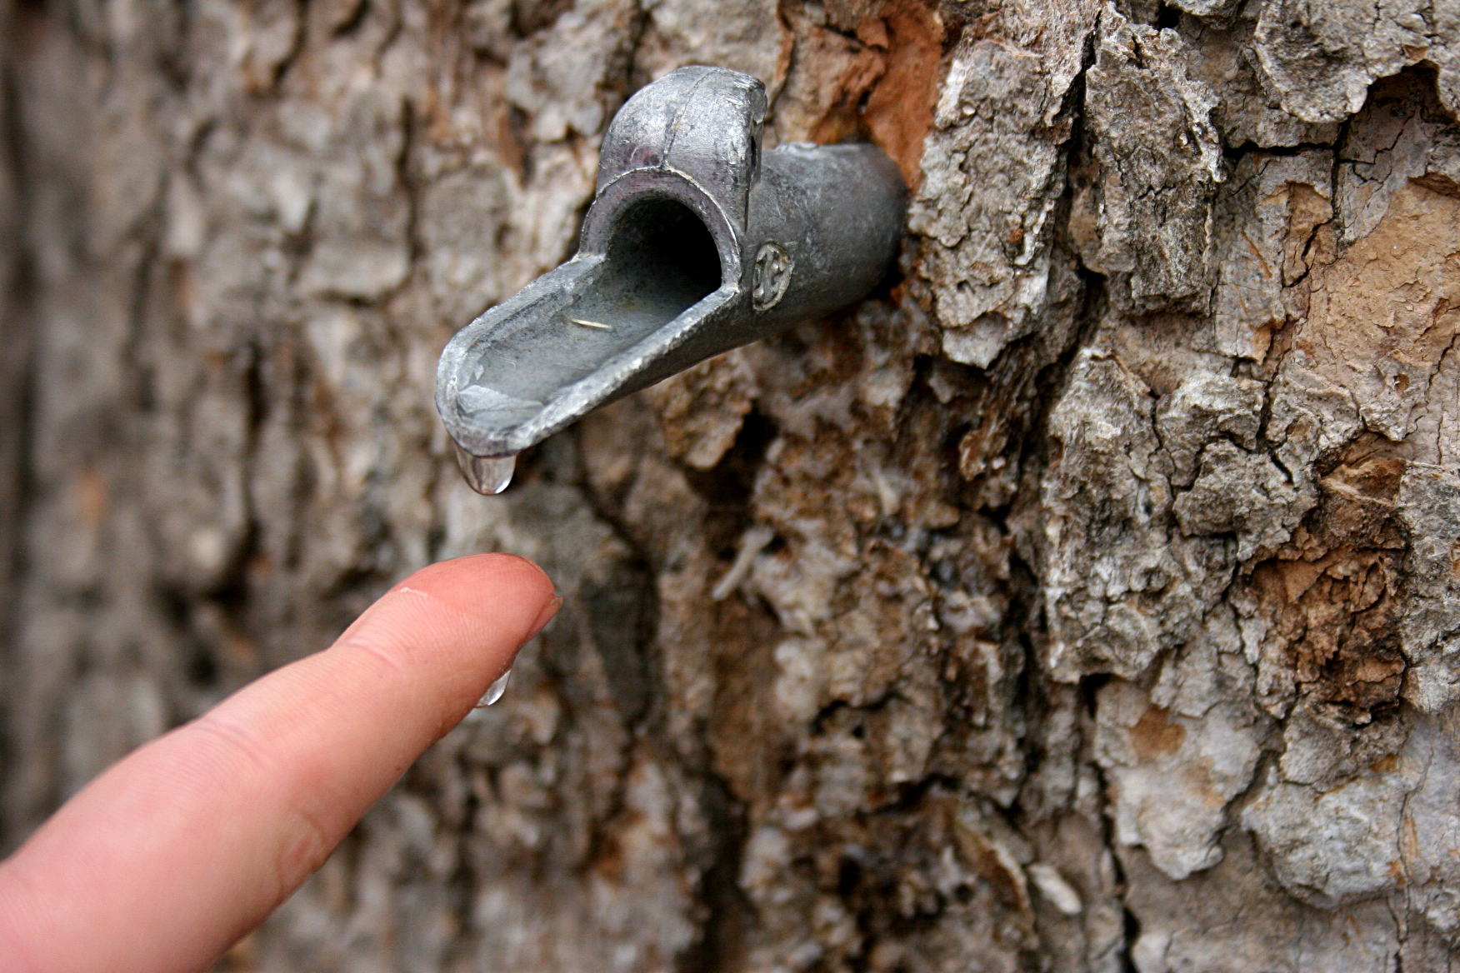
Clear sap runs from the spile (metal spout).
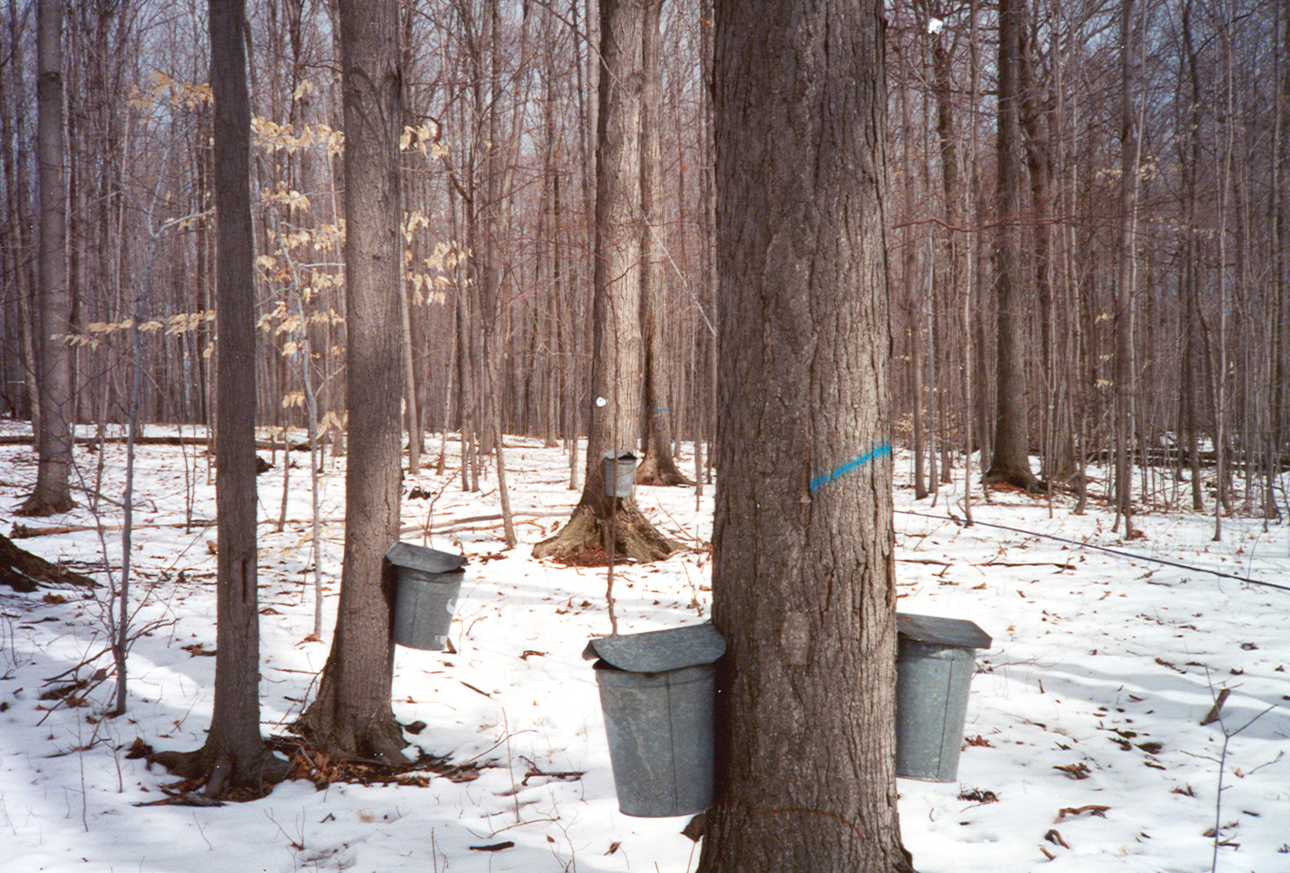
Sap is gathered in buckets
Note to Teacher
- This chapter book is filled with interesting vocabulary which may be challenging to students – consider identifying “tell” words, words you will mention briefly with a synonym, picture or other support as you read. Spend more time with the words identified in the vocabulary section. Reading the non-fiction texts included above will also support students as they build knowledge about the forest environment and specific vocabulary.
- You may want to copy the questions, vocabulary words, and activities over onto sticky notes so they can be stuck to the appropriate pages for each chapter’s questions and vocabulary work.
- The charts developed throughout the story will support students in recalling information and building deeper understanding of the text over multiple days; publicly displaying the charts for reference during the reading of the entire book is an inferred support for all students. Consider having students create their own notebook by stapling blank sheets of paper together with a construction paper cover along with the process chart organizer, to record sketches and notes as the story progresses.

A Brief Chapter Guide
CHAPTER 1: In Which I Hole Up in a Snowstorm CHAPTER 15: SKIP
CHAPTER 2: In Which I Get Started on This Venture CHAPTER 16: In Which Trouble Begins
CHAPTER 3: The Manner in Which I Find Gribley’s Farm CHAPTER 17:SKIP
CHAPTER 4: SKIP CHAPTER 18: In Which I Learn About Birds and People
CHAPTER 5: This is About the Old, Old, Tree CHAPTER 19: In Which I Have a Good Look at Winter and Find
CHAPTER 6: SKIP Spring in the Snow (Excerpted)
CHAPTER 7: The King’s Provider (Excerpted) CHAPTER 20: More About the Spring in the Winter and the
CHAPTER 8: A Brief Account of What I Did About Beginning of My Story’s End
the First Man Who Was After Me
CHAPTER 9: SKIP CHAPTER 21: In Which I Cooperate With the Ending
CHAPTER 10: How a Door Came to Me CHAPTER 22: In Which the City Comes to Me
CHAPTER 11: In Which Frightful Learns Her ABC’s
CHAPTER 12: In Which I Find a Real Live Man (Excerpted)
CHAPTER 13:SKIP
CHAPTER 14: In Which We All Learn About Halloween

What Makes This Book Complex?
- Quantitative Measure
Go to http://www.lexile.com/ and enter the title of your book in the Quick Book Search in the upper right of home page. Most texts will have a Lexile measure in this database.

Most of the texts that we read aloud in K-2 should be in the 2-3 or 4-5 band, more complex than the students can read themselves.
2-3 band 420-820L
4-5 band 740-1010L

810

- Qualitative Features
Consider the four dimensions of text complexity below. For each dimension*, note specific examples from the text that make it more or less complex.
- Tension of independence vs. dependence
- Human need for connection

- Initial chapter serves as a prequel – time shifts
- Some diary-style entries
- Lengthy chapters
- Some more complex sentence structure

- Vocabulary demands – emphatic,
congregate, capable, steep, jesses, sapling, forest terms
- Figurative language, i.e., “it stood tall and bright and held back the night”, “…to see life pump through that little body… just as life pumped through me.” the gathering storm mushroomed up over my mountain, the bird folded its wings and bombed the earth

- New York City and the Catskill Mountains
- Botanical and animal names
- Forest environment may not be familiar to students (spring, plants, animals)
- References to Thoreau, Daniel Boone, hunting

Meaning/Purpose
Structure

Knowledge Demands
Language

*For more information on the qualitative dimensions of text complexity, visit http://www.achievethecore.org/content/upload/Companion_to_Qualitative_Scale_Features_Explained.pdf
- Reader and Task Considerations
What will challenge my students most in this text? What supports can I provide?
- References to New York City and the Catskill Mountains will challenge students as they listen to the text. Videos and photographs can support student basic understanding of the forest environment that can be built upon through reading.
- Vocabulary and language will be addressed through questions and should be supported with ongoing classroom discussion. Acting out or sketching will help students deepen understanding of the action and vocabulary in the story.
How will this text help my students build knowledge about the world?
- Reading and discussing My Side of the Mountain will allow students to more fully understand the forest environment, the idea of community interdependence and survival. It also reinforces the understanding of man’s impact on nature and nature’s importance to man.

- Grade level
What grade does this book best belong in? 2nd

All content linked to within this resource was free for use when this resource was published in March 2018. Over time, the organizations that manage that external content may move or remove it or change the permissions. If the content is no longer available, please email info@studentsachieve.net.

