Micro Models and Reasoned Estimates
7.EE.B.3 Application Mini-Assessment by Student Achievement Partners

OVERVIEW
This mini-assessment explores two forms of mathematical modeling: micro models and making reasoned estimates. Micro models are tasks that use a limited number of steps from the modeling cycle. The mini-assessment is designed for teachers to use in the classroom, for self-learning, or in professional development settings to:
- Evaluate students’ understanding of mathematical modeling in order to prepare to teach this material or to check for student ability to demonstrate understanding and application of these concepts;
- Learn how to assess micro-model and reasoned-estimate application problems;
- Use in professional development as an illustration of CCSS-aligned assessment problems;
- Illustrate best practices for writing tasks that allow access for all learners; and
- Support mathematical language acquisition by offering specific guidance.

MAKING THE SHIFTS
This mini-assessment attends to focus as it addresses problem solving with all forms of rational numbers (positive, negative, fractions, decimals), along with proportional reasoning, which are at the heart of the grade 7 standards. The multi-step application problems highlight coherence because they are a culmination of problem solving standards from earlier grades involving whole numbers, fractions, percentages, and negative numbers. This standard targets application, one of the three elements of rigor by embedding concepts in real-world problems.

Both assessment consortia set expectations for student use of reasoned estimates, which is an important step on the progression to full mathematical modeling:
Reasoned estimates in PARCC:  “Use reasonable estimates of known quantities in a chain of reasoning that yields an estimate of an unknown quantity.” | Reasoned estimates in Smarter Balanced:  “Target A – Apply mathematics to solve problems arising in everyday life, society, and the workplace.” For Claim 4:[“ Making reasoned estimates: These tasks require students to make reasonable estimates of things they do know, so that they can then build a chain of reasoning that gives them an estimate of something they do not know .”]

A CLOSER LOOK
Micro model problems require students to use aspects of the modeling cycle, in preparation for high school where they will use the full modeling cycle. Here, students use mathematics to help approximate a solution, even though the solution will not be an exact answer. Reasoned estimates use known quantities and mathematical reasoning to create a good estimate of an unknown quantity. Although reasoned estimates might be new types of problems for students, they are critical to ensure that students can flexibly apply their mathematical understandings. Some questions in this mini-assessment are scaffolded to give students more structure (e.g., #2 and #5); however, by the end of grade 7, students should be able to solve unscaffolded problems (e.g., #1 and #3).
The mathematical content assessed in this mini-assessment spans several domains for grade 7, including Ratios and Proportional Relationships (RP), The Number System (NS), Expressions and Equations (EE), and Geometry (G). Each problem also directly assesses Standard 7.EE.B.3, which addresses problem solving with whole numbers, fractions, decimals, and percentages. The table below shows the standards and clusters assessed by each problem, along with the specific aspects of the modeling cycle addressed.
Problem | Content Alignment | Aspects of Modeling
1 | 6.EE.A.2c, 7.G.B.4, 7.EE.B.3 | Formulate, Compute
2 | 7.EE.B.3 | Compute
3 | 7.RP.B.3, 7.EE.B.3 | Compute, Interpret
4 | 7.NS.A, 7.EE.B.3 | Compute
5 | 7.EE.B.3, 7.RP.A.3 | Parts A & B: Compute, Part C: Validate
6 | 7.EE.B.3 | Formulate, Compute
The answer key includes sample correct answers and rubrics for scoring student work. Rubrics can show exactly how points are given in a multi-point problem, or provide examples of how students may earn a specific number of points. It is important for teachers to calibrate their scoring across classes for consistency.
CONNECTING THE STANDARDS FOR MATHEMATICAL PRACTICE TO GRADE-LEVEL CONTENT
Reasoned estimates and micro models are meaningfully connected to several Standards for Mathematical Practice. Given a multi-step problem that is not scaffolded, students need to analyze the information given, consider analogous problems, devise a solution path, monitor and evaluate progress, and change course if necessary (MP1 – Make sense of problems and persevere in solving them). Similarly, students are using the mathematics they know and engaging in some aspects of the modeling cycle in order to solve a problem (MP4 – Model with mathematics).

SUPPORT FOR ENGLISH LANGUAGE LEARNERS
This lesson was designed to include specific features that support access for all students and align to best practice for English Language Learner (ELL) instruction and assessment. Go here to learn more about the research behind these supports. Features that support access in this mini-assessment include:
- Tasks that allow for multi-modal representations, which can deepen understanding of the mathematics and make it easier for students, especially ELLs, to give mathematical explanations.
- Tasks that avoid unnecessarily complex language to allow students, especially ELLs, to access and demonstrate what they know about the mathematics of the assessment.
Prior to this mini-assessment, ensure students have had ample opportunities in instruction to read, write, speak, listen for, and understand the mathematical concepts that are represented by the following terms and concepts:
- rectangular prism
- dimensions
- estimate
- approximate
Students should engage with these terms and concepts in the context of mathematical learning, not as a separate vocabulary study. Students should have access to multi-modal representations of these terms and concepts, including: pictures, diagrams, written explanations, gestures, and sharing of non-examples. These representations will encourage precise language, while prioritizing students’ articulation of concepts. These terms and concepts should be reinforced in teacher instruction, classroom discussion, and student work (for example, through engagement in mathematical routines).
ELLs may need support with the following words found in this mini-assessment:
- design
- stand
- describe
- assumptions
- fit
- populated
- download
- earnings
- afford
- expect
In preparation for giving this mini-assessment, teachers should strive to use these words in context so they become familiar to students. It will be important to offer synonyms, rephrasing, visual cues, and modeling of what these words mean in the specific contexts represented in the items in this mini-assessment. Additionally, teachers may offer students the use of a student-friendly dictionary, or visual glossary to ensure they understand what is being asked of them in each item.
Sketch | 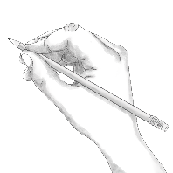
Point | •
Locate | •
An example of a visual glossary for student use.

Name: Date:
- What’s the size of the stand?
Central High School received a trophy for winning the softball championship game. The team would like to make a display stand for the trophy. The stand will be a rectangular prism.
The players want to fit each of their handprints on the stand without overlapping with any other handprints. There are 24 players on the team.

Design a display stand that meets the requirements above. What are its dimensions? Explain your answer using numbers, words, and/or pictures.

- How many students are there?
City | Approximate Population  (as of 2016)
New York City | 8,500,000
Los Angeles | 4,000,000
Chicago | 3,000,000
The three most populated cities in the United States are New York City, Los Angeles, and Chicago.

  - Which number is closest to the number of people in the United States?
    - 30,000,000
    - 300,000,000
    - 3,000,000,000
  - Describe how you would estimate the number of grade 7 students in the United States.
  - Estimate the number of kindergarten through grade 12 students in the United States? Explain your answer using numbers, words, and/or pictures.

- When will this download be done?!
Jonah started listening to an album just as he clicked to download it. The screen image shows the download progress at the end of the first song.
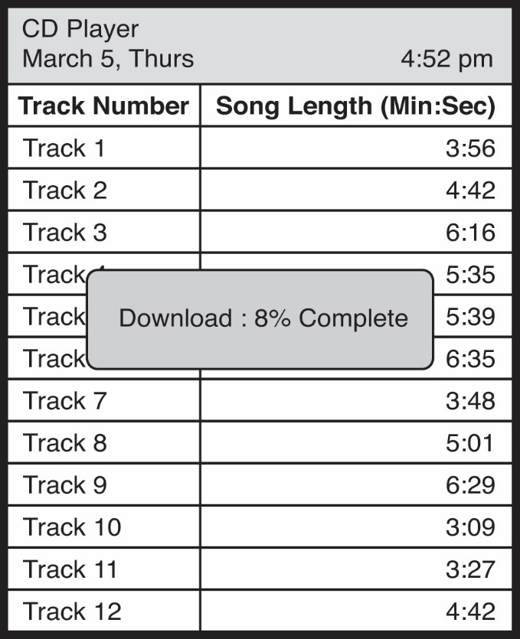
Jonah continues listening to the album in order. Which song will Jonah be listening to when the download of the full album is complete? Explain your answer using numbers, words, and/or pictures.

- Will owning an NBA Team make you rich?
The graph below shows the earnings (the amount the team made or lost) for the Charlotte Bobcats from 2005–2013.
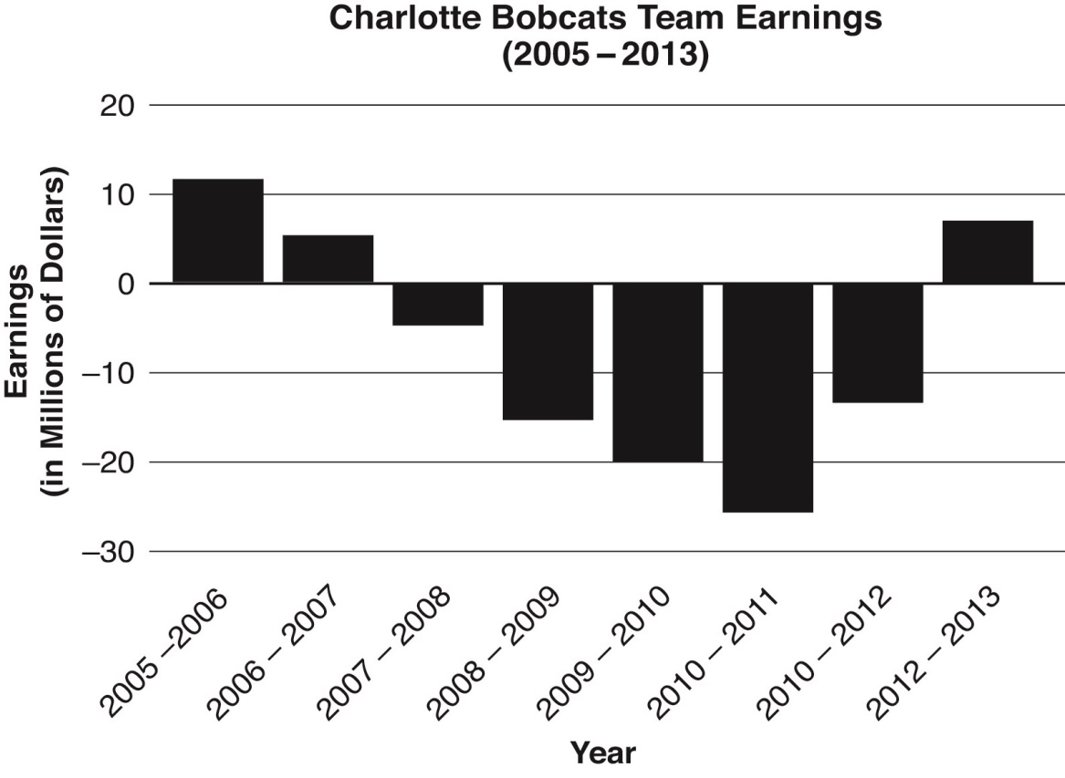
Based on the above graph, estimate the average yearly earnings for the Charlotte Bobcats between 2005 and 2013. Explain your answer with numbers, words, and/or pictures.

- Who is buying this stuff?
You are marketing Bus Buds, a new headphone designed specifically for people riding a bus. Market research shows that teenagers and senior citizens are the two biggest markets for your product.
You will be advertising on television. After doing some research, you find that 0.3% of teenagers and 0.31% of senior citizens who see a commercial will buy Bus Buds.
TV Shows Marketed Toward Teenagers
Things That Make You Go Hmmm |  | Urban Legends
Day | Viewers | Day | Viewers
Monday | 36,787
Tuesday | 37,342 | Tuesday | 155,418
Wednesday | 38,277
Thursday | 37,823
Friday | 36,115
TV Shows Marketed Toward Senior Citizens
The News Show |  | The Sixties
Day | Viewers | Day | Viewers
Monday | 45,519 | Monday | 144,418
Tuesday | 47,351
Wednesday | 42,323
Thursday | 50,721
Friday | 40,492

  - If you can afford to advertise during two shows for one whole week, which two shows will you choose to advertise? Explain your answer.

  - Estimate the number of people you expect to buy Bus Buds based on the two shows you chose in part a. Explain your answer.

- How many texts?
Estimate the total number of text messages that are sent monthly by all Americans. (Use your answer from 2a to complete.) Explain your answer using numbers, words, and/or pictures. Include any assumptions you used.

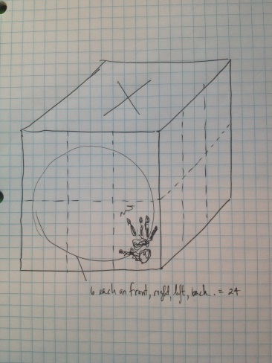
- How Many Hands?
Sample Answer A: I think that an average hand size is around 6 inches tall (base of palm to tip of middle finger) and 4 inches wide (from thumb to pinky finger). So, the painted handprint would need the space of a rectangle that is 4” x 6”. I don’t think that handprints should be painted on the top and bottom since you won’t be able to see them. So, I think the prism could be a 12” x 12” x 12” in cube. Each of the four faces could fit 6 handprints, which gives just enough room for each player’s handprint (see my drawing to the right).
Sample Answer B: I have friends with small hands and friends with large hands. I think it would be safe to estimate that a painted handprint would be at most 6” x 6” or 0.5’ x 0.5’. That would mean I can fit 4 handprints per square foot. Since there are 24 handprints for the display stand, we need 6 square feet of surface area (24 ÷ 4). So, the stand could be 1 foot wide, 1 foot deep, and 1.5 feet tall. The surface area of this rectangular prism would actually give 8 square feet of surface area (1+1+1.5+1.5+1.5+1.5), so there is extra space just in case.
Sample Rubric (total of 2 possible points):
- 1 point: Accurate reasoning process to find the size of one hand OR find how many hands will fit on one face.
- 1 point: Accurate reasoning process that uses an area measurement (a hand, side of the prism, number of hands per square foot, etc.) to determine accurate dimensions of a display stand.

2. How many students are there?
  - (iii) 300,000,000 [Note that the actual number is about 318,000,000 people and there are about 56,000,000 students.]
  - Sample Answer A: I thought that everyone in grade 7 is either 13 or 14, but everyone is born within the same year. I thought that the average person lives to be about 80, so I think about $\frac{1}{80}$ of people are in seventh grade. If $\frac{1}{80}$ of people are in grade 7, then $\frac{1}{80}×300,000,000=3,750,000$ students are in grade 7.
OR
Sample Answer B: Most people do not live past 100, so I think about 1% of people are in seventh grade, which is 3,000,000.
  - Sample Answer A: I multiplied the number of students in grade 7 by the number of grades (13), and I estimate that there are 48,750,000 students.
OR
Sample Answer B: Since 1% of people are each age, I think 13% of people are in elementary through high school. So, 13% of 300,000,000 is 39,000,000.
Sample Rubric (total of 2 possible points)
- 0 points for correctly estimating the number of people in the United States. [Note: In this sample rubric, students are neither rewarded nor penalized for knowing the number of Americans. Teachers may choose to modify this rubric and assign part a one point so that students must estimate this value accurately to gain full credit.]
- 1 point for a correct solution process to estimate the number of Americans in grade 7(teachers may give a point on Part B even if the response has an incorrect starting value from Part A).
- 1 point for a correct solution process to estimate the total number of students (teachers may give a point on Part C even if the response has an incorrect starting value from Part B).

- When will this download be done?!
Sample Answer A: 8% is 3 minutes, 56 seconds, or 3.933 minutes. That means it will take 39.33 minutes to be 80% complete and 49.17 minutes when it is 100% done. This is about one minute and nine seconds into Track 11.
Sample Answer B: I know that 3:56 is about 4 minutes and 8% is around $\frac{1}{12}$. So, the download will take a little more than 48 minutes (4 × 12). Track 10 ends around 48 minutes into the album, so the download will complete in the next track, Track 11.
Sample Answer C: I rounded each of the track lengths to the nearest minute (4, 5, 6, 6, 6, 7, 4, 5, 6, 3, 3, 5) and totaled them to find that there are around 60 minutes of music on the entire album. The download will finish around 50 minutes into the album ($\frac{4 min}{8\%}=\frac{50 min}{100\%}$), so track 10 will be playing when the download completes.
Sample Rubric (total of 3 possible points)
- A student earning full credit will complete the item using 2–4 links in a chain of reasoning (e.g., Sample Answer A uses 3 links) with correct calculations. A student may earn 2 points for correct estimations with minor calculation errors, or for slightly askew estimations with no calculation errors. A student may earn 1 point for both estimation and calculation errors, or for an incomplete solution process.

- Will owning an NBA Team make you rich?
From: http://www.statista.com/statistics/286129/operating-income-charlotte-bobcats-national-basketball-association/
Sample Answer A: I estimated each value to the nearest million and added:
$$12+5+\left(-5\right)+\left(-15\right)+\left(-20\right)+\left(-26\right)+\left(-13\right)+8=-54$$
I divided –54 by the 8 years, but I knew I the scale was “millions of dollars” so the answer is –$6.75 million.
Sample Answer B: I estimated the three positive values as 11,500,000, 5,000,000 and 8,000,000. Then, I estimated the negative values as –4,500,000, –16,000,000, –20,000,000, –24,000,000, and –12,500,000. I added the positive numbers then the negative numbers then I found the total sum:
$$24,500,000+\left(-76,500,000\right)=-52,000,000$$
Which is a yearly average of $–52,000,000÷8=-6,500,000.$

Sample Rubric (total of 2 possible points)
- A student earns 2 points for an accurate estimate for operating profit with appropriate supporting work/explanation.
- A student earns 1 point for only stating an accurate estimate OR providing a correct strategy for finding the average but the work contains some flaws.

- Who is buying this stuff?
  - Students should choose one teenage show and one senior citizen show because the target groups are different and 0.01% different in likelihood to buy is insignificant.
Some students may make the assumption that many of the same people are watching the daily shows each day (which would mean that the number of unique viewers is lower for the daily shows as compared to the weekly shows) while others may make the assumption that the daily show viewers are unique and therefore make the assumption that the daily shows have a higher viewership each week. Both explanations will receive credit because either answer is correct based on a student’s assumptions.
  - The predicted number of purchasers per show (other estimation strategies are acceptable):
- Things That Make You Go Hmmm (rounded to the nearest thousand):
37,000 + 37,000 + 38,000 + 38,000 + 36,000 = 186,000
186,000 × 0.003 = 558
- Urban Legends (front-end estimation to nearest hundred):
10,600 + 121,200 + 8,700 + 7,200 + 7,500 = 155,200
155,200 × 0.3% = 420
- The News Show (front-end estimation to nearest thousand):
45,000 + 47,000 + 42,000 + 50,000 + 40,000 = 224,000
0.0031 × 224,000 = 694.4 (which is 694 people)
- The Sixties (rounded to nearest ten thousand):
100,000 + 4(10,000) = 140,000
$\frac{31}{1000}$ × 140,000 = 434
Sample Rubric (total of 4 possible points)
- 1 point: Correct explanations for two shows.
- 2 points: Accurate estimations for the number of people likely to buy for each show.
- 1 point: Correct explanation that the shows have different audiences.

- How many texts are sent?
Sample Answer A: For question 2a, I estimated that 300,000,000 is the number of people in the United States. Of those, I think about 7 out of 10 own cell phones. I estimated this many to exclude babies and the very young, some very old people, and others who may not use them.
Of the 7 out of 10 Americans who own cell phones, I estimate that only 8 out of 10 of them actually send or receive text messages. I know some of my friends’ parents who do not like to text and would rather just call.
I estimate that people who text send around 25 texts per day
So, my calculations look like this:
$$300,000,000×\frac{7}{10}×\frac{8}{10}×25×30=126,000,000,000$$
So, I would estimate that Americans send approximately 126 billion text messages monthly.
Sample Answer B: I thought there were 300,000,000 Americans and 75% of Americans own cell phones. But, not everyone texts, so I think 60% of Americans text. Most people send 1 or 2 texts a day, but some people send hundreds. I estimate that there is an average of 10 texts per person per day. So, 60% of 300 million is 180 million, which means there are about 1.8 billion texts sent per day or around 54 billion sent per month.
Sample Answer C:
- 300,000,000 - the number of people in the United States
- 300,000,000 (50%) = 150,000,000 –$\frac{1}{2}$ people text
- $150,000,000×600=90,000,000,000$ – texts per month

Sample Rubric (total of 3 points)
- 1 point for clearly showing or explaining how to accurately determine the number of Americans/number of phones sending text messages
- 1 point for clearly showing or explaining how to accurately determine the number of text messages sent per American/phone
- 1 point for accurately solving the problem of estimating the number of text messages sent monthly by Americans
NOTE: Students are not expected to know the proportion of Americans owning cell phones or know how many texts are sent per month, but students are expected to provide sound steps of reasoning to estimate these proportions. Here are some estimates about these values from 2011: http://www.pewinternet.org/2011/09/19/americans-and-text-messaging/.

For more on the Major Work of the Grade, see achievethecore.org/focus.
PARCC Mathematics Evidence Table Grade 7 PBA and MYA (PDF), page 16. Available at: https://parcc-assessment.org/content/uploads/2017/11/Grade7ES-Descriptons-PBA-EOY12-7-14-2.pdf
Smarter Balanced Mathematics Content Specification (PDF), page 62. Available at: https://www.smarterbalanced.org/wp-content/uploads/2015/08/Mathematics-Content-Specifications.pdf
For more on the modeling in high school, read High School—Modeling in the CCSSM (pp. 72 and 73).
https://www.census.gov/popclock/
http://nces.ed.gov/programs/digest/d12/tables/dt12_002.asp

