Multi-Step Problems Using the Four Operations
4.OA.A.3 Application Mini-Assessment by Student Achievement Partners

OVERVIEW
This mini-assessment is designed to illustrate the standard 4.OA.A.3, which sets an expectation for students to solve multi-step word problems using the four operations. This mini-assessment is designed for teachers to use either in the classroom, for self-learning, or in professional development settings to:
- Evaluate students’ understanding of 4.OA.A.3 in order to prepare to teach this material or to check for student ability to demonstrate understanding and apply these concepts;
- Gain knowledge about assessing applied problem solving at the depth expected at grade 4;
- Illustrate CCR-aligned assessment problems;
- Illustrate best practices for writing tasks that allow access for all learners; and
- Support mathematical language acquisition by offering specific guidance.

MAKING THE SHIFTS
4.OA.A.3. Solve multistep word problems posed with whole numbers and having whole-number answers using the four operations, including problems in which remainders must be interpreted. Represent these problems using equations with a letter standing for the unknown quantity. Assess the reasonableness of answers using mental computation and estimation strategies including rounding.

This mini-assessment attends to focus as it addresses problem solving with all four operations, including problems in which remainders must be interpreted, which is at the heart of the grade 4 standards and a key component of the Major Work of the Grade. It addresses coherence across grades because it completes the learning of problem solving skills using the four operations that began in kindergarten. It further sets the stage for solving multi-step problems posed with fractions, decimals, and other rational numbers, which will appear in later grades. Standard 4.OA.A.3 and this mini-assessment target application, one of the three elements of rigor, through word problems.

A CLOSER LOOK
Standard 4.OA.A.3 is a capstone standard in the development of problem solving skills using the four operations, with multiplicative compare situations being the most recently introduced situation type. Questions 4 and 5 highlight clearly worded multiplicative comparison, using the phrases times as many as and times as long as. The questions on this mini-assessment address the variety of multi-step situation types required by the standards (see Tables 1 and 2 in the CCSSM, pp. 88 and 89).

Mathematics is not only about answer-getting. Students need to model situations and attend to meanings of quantities. Traditionally, multi-step word problems have focused almost entirely on the solution; however, standard 4.OA.A.3 has other key components to highlight. For example, question 3 asks students to represent a situation with an equation using a given variable, and question 9 requires students to interpret the meaning of a remainder in order to answer the question.
This mini-assessment also uses some of the skills and understandings from standard 4.MD.A.1.
4.MD.A.1. Know relative sizes of measurement units within one system of units including km, m, cm; kg, g; lb, oz; l, ml; hr, min, sec. Within a single system of measurement, express measurements in a larger unit in terms of a smaller unit. Record measurement equivalents in a two-column table. For example, know that 1 ft is 12 times as long as 1 in. Express the length of a 4 ft snake as 48 in. Generate a conversion table for feet and inches listing the number pairs (1, 12), (2, 24), (3, 36), …
The presence of this content showcases how supporting work reinforces the Major Work of the Grade. For example, questions 2 and 3 require conversions within a single measurement system as one of the steps in solving multi-step problems. These connections show the coherence of the grade 4 standards. The questions in this mini-assessment require students to integrate content from two different domains.

SUPPORT FOR ENGLISH LANGUAGE LEARNERS
This lesson was designed to include specific features that support access for all students and align to best practice for English Language Learner (ELL) instruction and assessment. Go here to learn more about the research behind these supports. Features that support access in this mini-assessment include:
- Tasks that allow for multi-modal representations, which can deepen understanding of the mathematics and make it easier for students, especially ELLs, to give mathematical explanations.
- Tasks that avoid unnecessarily complex language to allow students, especially ELLs, to access and demonstrate what they know about the mathematics of the assessment.
Prior to this mini-assessment, ensure students have had ample opportunities in instruction to read, write, speak, listen for, and understand the mathematical concepts that are represented by the following terms and concepts:
- times
- times as much/many/long
- equation
- distance
- largest
- smallest
Students should engage with these terms and concepts in the context of mathematical learning, not as a separate vocabulary study. Students should have access to multi-modal representations of these terms and concepts, including: pictures, diagrams, written explanations, gestures, and sharing of non-examples. These representations will encourage precise language, while prioritizing students’ articulation of concepts. These terms and concepts should be reinforced in teacher instruction, classroom discussion, and student work (for example, through engagement in mathematical routines).
ELLs may need support with the following words found in this mini-assessment:
- times
- times in a row
- playlist
- album
- packs
- remaining
In preparation for giving this mini-assessment, teachers should strive to use these words in context so they become familiar to students. It will be important to offer synonyms, rephrasing, visual cues, and modeling of what these words mean in the specific contexts represented in the items in this mini-assessment.
Sketch
Point | •
Locate | •
An example of a visual glossary for student use
Name: Date:
Kara Loves Music!
- Kara’s playlist has three songs:
- “Each Day” (3 minutes)
- “Best Friends” (3 minutes)
- “This Weekend” (2 minutes)
How many times can Kara listen to her entire playlist during a 35-minute car ride? ___________
Explain your answer using numbers, words, and/or pictures.

Use this table for problems 2 and 3
Album | Length (in minutes)
Driving Fast | 43
Silent Sister | 58
Forever Funny | 37
Today’s Five | 45
The Barnyard | 52
Free Bison | 48

- This weekend, Kara will take a 2 $\frac{1}{2}$ hour car ride to visit her relatives. She wonders if she can listen to all the albums shown in the table above.
Can Kara listen to all of the albums on her car ride?
Explain your answer using numbers, words, and/or pictures

- Kara decided to listen to the Free Bison album on the 2 $\frac{1}{2}$ hour car ride back home. She started playing it at the beginning of the car ride and just finished listening to it 3 times in a row.
Use M to represent the number of minutes before Kara gets home.

Write an equation that could be solved to determine how many minutes it will be before Kara gets home.
_____
Setting up The Road Runner Race
Last year, Rob set up the Road Runner Race for his school. The race was 1,200 meters long and 188 people signed up to run the race. 38 people did not show up to run.
- This year, there will be 3 times as many runners as last year.

  - How many people will run the race this year? ____________________

  - Explain your answer using numbers, words, and/or pictures.

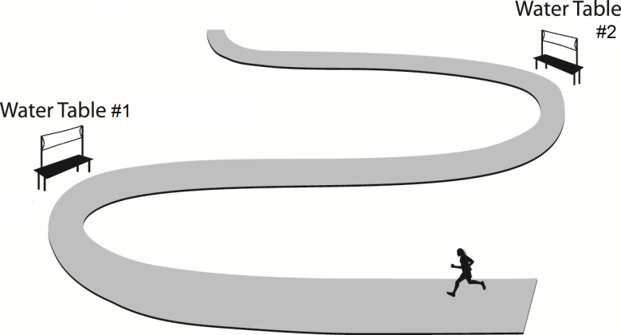
- This year, the race will be 4 times as long as last year. Rob has 6 water tables to use along the race route. The distance between water tables is the same and the last one will be placed at the finish line.

  - How far apart is the distance between water tables #1 and #2?

_________________________

  - Explain your answer using numbers, words, and/or pictures.

- Rob bought 27 packs of cups, with 12 cups in each pack. There are 6 tables and Rob will put the same number of cups on each table.

  - How many cups will be on each table? __________________________________

  - Explain your answer using numbers, words, and/or pictures.

Cookies for Bake Sale Volunteers
This year, Central Middle School is having a bake sale. Two teams of students bake cookies.
- Josie’s team puts cookies in 8 boxes with 36 in each box.
- Rich’s team puts cookies in bags of 20.
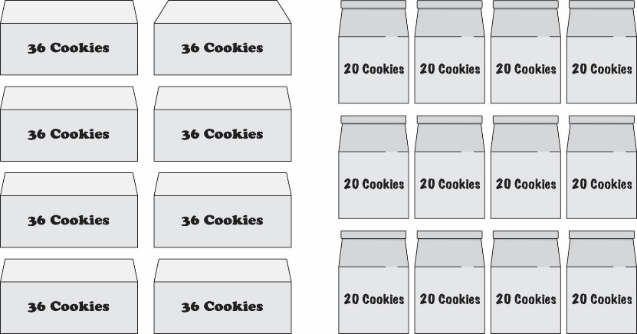
- The two teams bake the number of cookies to fill 8 boxes and 12 bags as shown.
  - How many total cookies did the students bake?
___________________

  - Explain your answer using numbers, words, and/or pictures.

- How many more cookies are in 5 boxes than are in 5 bags?

____________________________________
Explain your answer using numbers, words, and/or pictures.

- After the bake sale, 1 box and 1 bag of cookies remained. The organizers gave the remaining cookies to the 6 students on the teams. Each student received the same number of cookies.

  - What is the largest number of cookies each student could have received?

  - How many extra cookies would be left after each student received that number of cookies?
_____________
Parrots
- The largest parrot in the world can grow to about twelve times as long as the smallest parrot. The largest parrot can grow up to 96 cm.
a. Write an equation you can use to find the length of the smallest parrot.

b. How much longer, in cm, is the largest parrot than the smallest parrot? _________________
c. Explain your answer using numbers, words, and/or pictures.

Scoring. Most questions are worth 2 points: one point for the correct answer and one point for adequate work shown. The exceptions are #3 (worth 1 point) and #10 (worth 3 points). Adequate work may include things such as showing calculations, describing using words, drawing a picture that depicts the situation, or using an equation. In many cases, the question is structured in a way that leaves the form of the correct answer up to the teacher. The teacher could require a number, a phrase, or a complete sentence.

Students should demonstrate their work in a clear way so that teachers are sure what operations they used to solve the problems. Knowing what errors students made helps teachers target interventions in future lessons. For these questions, student errors fall into three broad categories:
- Incorrect operations – Students may choose an incorrect operation in their solution. These students need deeper conceptual understanding of the four operations and more practice with one- and two-step problems involving the problematic situation types.
- Incomplete solutions – Some students may give a step toward the correct solution, but will not complete all the steps. These students should write the units for each number and then compare their solution with the question, to make sure that it answers the given question.
- Miscalculations – Students using the correct operations may still get incorrect answers because of miscalculations. These students need more practice with the procedural skills involved in adding, subtracting, multiplying, and dividing whole numbers.
These items are designed so that there are a variety of solution paths and it’s important for teachers to understand the strategies students are using. This will shed light on which students might need to be led towards using more advanced strategies (e.g., multiplication rather than repeated addition or computational strategies based on place value to simplify their work).
For example, adequate work for question #4 could look like any of these samples; however, the solutions with fewer steps use mathematical understandings to simplify the procedural skill required:
One step using the Distributive Property | Two steps to implicitly use the Distributive Property | Three steps requiring  more computation
188 – 38 = 150 mental math  150 × 3 450 Paper-and-pencil multiplication  450 runners | 188 – 38 150 Paper-and-pencil subtraction  150 × 3 450 Paper-and-pencil multiplication  450 runners | 188 × 3 564 Paper-and-pencil multiplication  38 × 3 114 Paper-and-pencil multiplication  564 – 114 450 Paper-and-pencil subtraction  450 runners

Key
  - Kara can listen to her entire playlist 4 times. (with adequate supporting work)
  - No (with adequate explanation)
Sample student explanation: I know there are 60 minutes in 1 hour, so two-and-a-half hours is 150 minutes. I added the first two album lengths and got 101 minutes. Then, I added the third album and got 138 minutes. When I added the fourth album, it went over 150 minutes. So, Kara can’t listen to all the albums.
  - 48 + 48 + 48 + M = 150 OR 150 – 3 × 48 = M OR 3 × 48 + M = 150 OR equivalent
  - 450 people will run the race this year. (with adequate supporting work)
  - The tables will be 800 meters apart. (with adequate supporting work)
  - 54 cups will be on each table. (with adequate supporting work)
  - The students baked 528 total cookies. (with adequate supporting work)
  - There are 80 more cookies in 5 boxes than in 5 bags. (with adequate supporting work)
  - The largest number of cookies each student could have received is 9.
There would be 2 cookies left after each student received 9 cookies.
  - 96 ÷ 12 = ? OR 96 ÷ 12 = 8 OR equivalent
The largest parrot is 88 cm longer than the smallest parrot. (with adequate supporting work)

For more on the Major Work of the Grade, see achievethecore.org/focus.

