Title/Author: Snow School by Sandra Markle
Suggested Time to Spend: 5-7 Days (Recommendation: one session per day, at least 20 minutes per day)
Common Core grade-level ELA/Literacy Standards: RI.1.1, RI.1.2, RI.1.3, RI.1.4, RI.1.7; W.1.2, W.1.8; SL.1.1, SL.1.2, SL.1.6; L.1.1, L.1.2, L.1.4
Lesson Objective:
Students will actively listen to an illustrated informational narrative read aloud and use literacy skills (reading, writing, discussion, and listening) to understand the lessons of the text.

Teacher Instructions
Before the Lesson
- Read the Big Ideas and Key Understandings and the Synopsis below. Please do not read this to the students. This is a description to help you prepare to teach the book and be clear about what you want your children to take away from the work.
Big Ideas/Key Understandings/Focusing Question
“The lessons their mother taught them will help the young snow leopards survive, hunting alone in their rugged home.”
What are the lessons? How did the snow leopards learn them?
Synopsis
Two snow leopard cubs learn many lessons about survival from their mother as they prepare for life on their own.

- Go to the last page of the lesson and review “What Makes this Read-Aloud Complex.” This was created for you as part of the lesson and will give you guidance about what the lesson writers saw as the sources of complexity or key access points for this book. You will of course evaluate text complexity with your own students in mind, and make adjustments to the lesson pacing and even the suggested activities and questions.
- Read the entire book, adding your own insights to the understandings identified. Also note the stopping points for the text-inspired questions and activities. Hint: you may want to copy the questions vocabulary words and activities over onto sticky notes so they can be stuck to the right pages for each day’s questions and vocabulary work.

Note to teachers of English Language Learners (ELLs): Read Aloud Project Lessons are designed for children who cannot read yet for themselves. They are highly interactive and have many scaffolds built into the brief daily lessons to support reading comprehension. Because of this, they are filled with scaffolds that are appropriate for English Language Learners who, by definition, are developing language and learning to read (English). This read aloud text includes complex features which offer many opportunities for learning, but at the same time includes supports and structures to make the text accessible to even the youngest students.
This lesson includes features that align to best practices for supporting English Language Learners. Some of the supports you may see built into this, and /or other Read Aloud Project lessons, assist non-native speakers in the following ways:

- These lessons include embedded vocabulary scaffolds that help students acquire new vocabulary in the context of reading. They feature multi-modal ways of learning new words, including prompts for where to use visual representations, the inclusion of student-friendly definitions, built-in opportunities to use newly acquired vocabulary through discussion or activities, and featured academic vocabulary for deeper study.
- These lessons also include embedded scaffolds to help students make meaning of the text itself. It calls out opportunities for paired or small group discussion, includes recommendations for ways in which visuals, videos, and/or graphic organizers could aid in understanding, provides a mix of questions (both factual and inferential) to guide students gradually toward deeper understanding, and offers recommendations for supplementary texts to build background knowledge supporting the content in the anchor text.
- These lessons feature embedded supports to aid students in developing their overall language and communication skills by featuring scaffolds such as sentence frames for discussion and written work (more guidance available here) as well as writing opportunities (and the inclusion of graphic organizers to scaffold the writing process). These supports help students develop and use newly acquired vocabulary and text-based content knowledge.

The Lesson – Questions, Activities, and Tasks

Questions/Activities/Vocabulary/Tasks | Expected Outcome or Response (for each)
FIRST READING:  Read aloud the entire book (or chapter) with minimal interruptions. Stop to provide word meanings or clarify only when you know the majority of your students will be confused. | The goal here is for students to enjoy the book, both writing and pictures, and to experience it as a whole. This will give them some context and sense of completion before they dive into examining the parts of the book more carefully.
SECOND READING: Pages 1-13  - (page 1) What are the cubs doing? Where is their mother?  - (page 2) What was the first lesson that the male cub learns? How does he learn this lesson? Use both the text and illustration to support your answer.  - (page 5) What are the cubs doing? Why?  - (page 6) Who is the prey?  - (page 9) What lesson do the cubs learn? Why do the cubs need to leave their scent?  - (page 10) What words show how hard it is for the snow leopard to catch its prey? Why won’t the cubs forget this lesson?  - (page 12) What are two traits of being a good hunter? | - The cubs are sleeping inside their den. The mother is close by, outside the den.  - The male cub learns, “Outside the den, it’s a dangerous world.” The cub learns this when the “eagle swoops down” to attack the cub as described in both the text and the illustration.  - The cubs are playing and wrestling. They are building “strong muscles” and practicing their “hunting skills.”  - The ibex is the prey.  - The cubs learn, “Always leave your scent to claim your favorite hunting places.” They do that to tell other snow leopards it is their territory, to mark their hunting space.  - The words “crouched low,” “steps carefully,” “loose tones tumble” and “ibex scatter” tell how hard it is to catch the prey. Making noise scares away their dinner and the cubs go hungry.  - (page 12) Staying quiet and moving fast are traits of being a good hunter.
THIRD READING: pages 14-28  - (page 16) The lesson is, “Always guard your food until you’re finished eating.” What do you think guard means? Why does the snow leopard need to guard his food?  - (page 19) How does the den protect the cubs?  - (page 20) Why does the ibex move down the mountain to graze? How does it affect the snow leopard?  - (page 23) “Staying safe is more important than having a full stomach.” What does that mean? Students should act out the predators and prey on this page to “feel” being outnumbered.  - (pages 27-28) Have the cubs learned their lessons? How do you know? | - (page 16) Guard means to keep safe. The snow leopard cub did not guard his food and the ravens took it.  - (page 19) The shelter protects the cub from the blizzard outside.  - (page 20) The ibex moves down the mountain to find food because the plants are scarce. The snow leopards need to follow the prey.  - (page 23) The snow leopards are outnumbered by dangerous wolves. If the cubs stay to eat the markhor, they could be attacked by their predators, the wolves.5. (page 27-28)  - The male cub proves he has learned his lessons by killing the ibex and sharing it with his sister and mother. The text says the sister will leave soon after him, leading us to believe that she is almost ready to be on her own.
FOURTH AND BEYOND:  Create a t-chart and fill out along the way. What is the lesson? | How did the cubs learn it?  (page 7) Think-Aloud: As we read, focus on the lessons the cubs learn.  (page 19) Think-Aloud: Notice how the snow leopards were dangerous to other animals. Let’s continue reading to see what dangers snow leopards face.  1. What dangers will the cubs face?  As a group, create subtitles for the beginning, middle, and end of the story. | 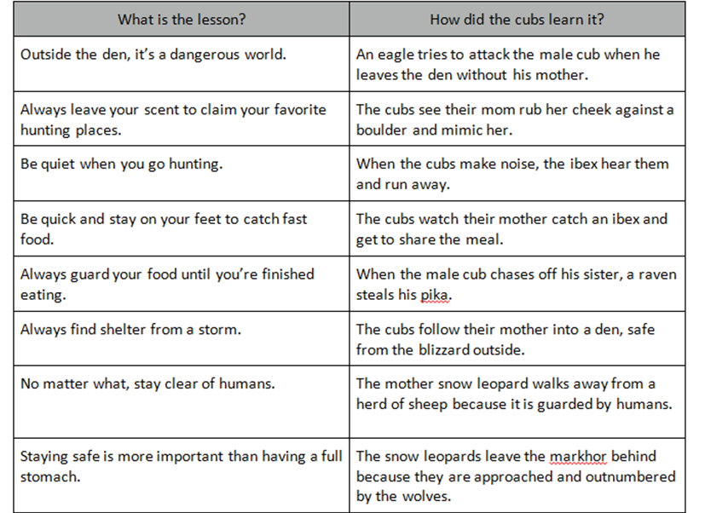  1. Animals and humans are dangerous to the snow leopards.

FINAL DAY WITH THE BOOK - Culminating Task
Why is it important for the cubs to learn the lessons in order to survive? Use pictures and words to answer this question.
Sample response:
The cubs learn the lessons snow leopards need to survive. They must learn how to mark their territory, hunt, and catch their food. They also must learn how to protect themselves from predators, those who want to take their food as well as those who want to eat them. Snow leopards learn how to survive the dangerous weather conditions of their habitat. They must learn these lessons to become independent from their mother and survive to share these lessons with cubs of their own.

Vocabulary
These words merit less time and attention  (They are concrete and easy to explain, or describe events/  processes/ideas/concepts/experiences that are familiar to your students) | These words merit more time and attention  (They are abstract, have multiple meanings, and/or are a part  of a large family of words with related meanings. These words are likely to describe events, ideas, processes or experiences that most of your student will be unfamiliar with)
Page 2- den--cave or shelter of a wild animal  Page 9 – mimics – to copy  Page 13 - pounce – jumps on; like a cat jumps on a mouse  Page 13 - chuff – a sudden sound like the exhaust of a steam engine  Page 19 - blizzard – a large amount of snow at one time with strong winds  Page 20 – scarce – a limited amount of something  Page 20 – crouch – to stoop or bend low | Page 6 - prey – an animal hunted for food  Page 12 - graze – to feed on (growing grass)  Page 16 - guard – keep safe, not let it get hurt  Page 23 - predator – an animal hunting for food

Extension learning activities for this book and other useful resources
- Reread the story. Have students act out the movements of the snow leopards (crouching, swooping, growling, swatting, guarding, pouncing, charging, mimics, etc.). Note: This is particularly supportive of English Language Learners.
- A short video about leopards chasing predators
https://www.youtube.com/watch?v=VBmTTlfGmVo
- A short video about leopards at the zoo
https://whyevolutionistrue.wordpress.com/2009/09/05/caturday-felids-snow-leopard-twins/

Note to Teacher
- The last page of the book has additional information regarding snow leopards.

What Makes This Read-Aloud Complex?
- Quantitative Measure
Go to http://www.lexile.com/ and enter the title of your read-aloud in the Quick Book Search in the upper right of home page. Most texts will have a Lexile measure in this database.
Most of the texts that we read aloud in K-2 should be in the 2-3 or 4-5 band, more complex than the students can read themselves.
2-3 band 420-820L
4-5 band 740-1010L

890

- Qualitative Features
Consider the four dimensions of text complexity below. For each dimension*, note specific examples from the text that make it more or less complex.

This book is an informational narrative that explains how a mother leopard teaches her cubs lessons in survival.

The lessons in the text are identified in italics.
Language Demands
Language is straightforward. Most sentences are declarative. The specialized vocabulary is supported by the detailed illustrations in the text.

Some students may need background information on animal habitats, survival skills, and prey versus predators

Meaning/Purpose
Structure

Knowledge Demands

*For more information on the qualitative dimensions of text complexity, visit http://www.achievethecore.org/content/upload/Companion_to_Qualitative_Scale_Features_Explained.pdf

- Reader and Task Considerations
What will challenge my students most in this text? What supports can I provide?

The text is a non traditional informational text. It is written as a narrative informational; therefore lacks the supportive text features that a traditional information text offers students. Creating subtitles, annotating the text, and analyzing the anchor chart will help students identify the lessons taught.

How will this text help my students build knowledge about the world?

This informational text will help students build on knowledge about various skills needed to survive in their natural habitat.

- Grade level
What grade does this book best belong in?
Grade 1

**The book is advanced for first graders. In DCPS, however, first graders are currently engaged in a unit entitled, “Animals and Survival” and this book is perfect for that theme. I did do a modified version of this lesson plan with my small group of English Language Learners who are first graders. I read Snow Leopards by Jill Esbaum (for National Geographic Kids) first, then read Snow School. They did very well. There may have been more robust discussion with older and or more experienced English speakers, but I do not think it is out of reach with the right support. I will continue to use it with first graders but for the RAP’s purposes am open to 2nd or 3rd as well.

All content linked to within this resource was free for use when this resource was published in March 2018. Over time, the organizations that manage that external content may move or remove it or change the permissions. If the content is no longer available, please email info@studentsachieve.net.

