Grade 2: Unit 5, Lesson 25
Title: From Seed to Plant
Essential Question: How do seeds evolve into food?
Week 1 Comprehension
Knowledge Journal
- Read aloud the selection for the week.
- After you read, stop and think about what you learned and the questions. What did you learn that was new and important about the topic from this resource? Use large public notes (chart paper) or individual note catchers to capture student learning. Use the optional questions to prompt reflection; sample answers provided for teacher reference.
Questions drawn from Think Through the Text, Guided Summary Cards to ask while reading:
Sample Chart Responses
Title: From Seed to Plant
Write, Draw, or List
Questions (optional) | New and Important learning about the topic or evidence
What kind of plant will a rose seed grow into? A corn seed? How do you know? | A rose seed will grow into a rose plant. A corn seed will grow into a corn plant. I know this because the text says that all seeds grow into the same kind of plant that made them.
What part of a flower makes pollen? | According to the text, stamens make yellow powder called pollen.
In what part of the flower do seeds begin to grow? | The seeds begin to grow in the ovule of the flower. The text says, If a pollen grain from a flower lands on the pistil of the same kind of flower, it grows a long tube through the pistil into an ovule. This is the beginning of a seed.
Why do you think the stigma of a flower is sticky? | According to the text, before a seed can begin to grow, a grain of pollen from the stamen must land on the stigma at the top of the pistil of a flower like itself. The stigma is sticky so that the grain of pollen can attach easily to it.
What protects the seeds as they become bigger? | As the seeds become bigger, the fruit or pod grows around them to protect them.
What are some ways that seeds are spread? | Some seeds fall to the ground as the pod breaks open, where they will grow. Sometimes as birds eat berries they will drop seeds. Other seeds fall into streams, ponds, rivers, or oceans. They travel on the water until they stick to dirt along the shore. The wind also scatters seeds. Some seeds have fluff on them that lets them float like a parachute to the ground, others have wings that spin as they fall.
What happens from the time a seed is put into the soil until the first shoot grows up? What happens after the first shoot grows up? | If it gets rain and sunshine, the seed coat breaks open and the seed starts growing. A root grows down into the soil to get water and minerals. After the first shoot grows up, green leaves grow and the plant gets bigger. The leaves make food for the plant.
What happens first, the seed coat breaks open or the root grows down in the soil? | According to the text, the seed coat breaks open and then the root grows down in the soil.
What is germination? | Germination is when the sun shines and warm the ground, the seed coat breaks open and the seed begins to grow.
Near the end of the selection, the author writes, “Buds on the plant open into flowers where new seeds will grow.” Why does she write this near the end of the selection? | The author writes this to show that the cycle will start all over again with new seeds.
Why would you use a glass jar instead of a clay pot through step 4? | The glass jar allows you to see the seeds as they sprout.
What does a plant need to grow? | Plants need water, soil, sunlight and air to grow.

Written Response
Option 1
Using evidence from the text, draw a picture and write a paragraph explaining how seeds evolve into food.

Sample Student Response
Every day we eat foods that evolve from seeds. Before we can eat these foods, the seeds must sprout. Seeds need water, and soil. Seeds also need to go through the process of germination.
First, seeds must be on or in soil. Soil gives the plant nutrients. Then it needs rain or water. Rain or water will moisten the soil and soak the seeds. Finally, when the sun warms the ground, the seed coat breaks open and the seed begins to grow. This is called germination. A root grows down into the soil. The root takes in water and minerals from the soil for food. Up grows the shoot. Green leaves grow up from the shoot toward the sun. The plant grows bigger and bigger. The leaves make food for the plant from the water and minerals in the soil, the sunlight and the air all around the plant. Some of the delicious foods are seeds, fruits, and pods.
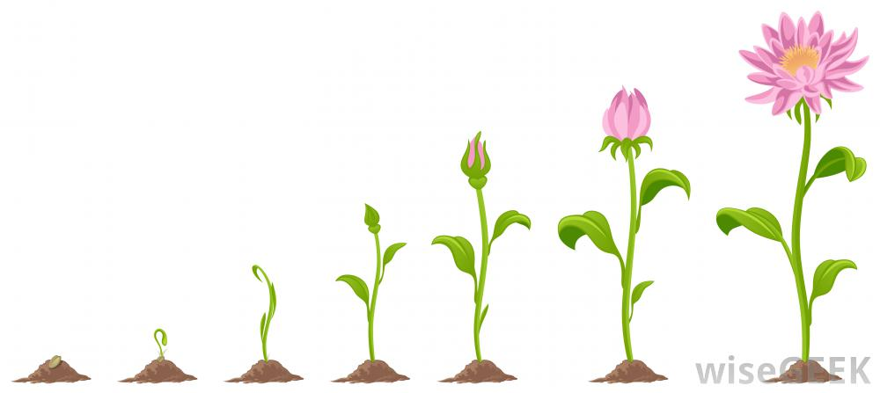

Written Response
Option 2
Imagine you are a farmer and describe how your garden grows into food. Draw a picture of a farmer in their garden.
Sample Student Response
Did you know that when you eat vegetables you are actually eating plants? These plants start off in gardens as tiny little seeds. If I were a farmer, in order for my garden to grow into food, I would need soil, water, sunlight, and air. These are the most important things a seed needs to grow.
First, I have to plant the seeds in nice, rich soil. Soil has minerals that plants need for food. Next, I will water the seeds to soften their protective coats. When the sun comes out, it will warm the ground causing the seeds coats to break open and begin to grow. This is called germination. Then, the roots will start to grow and absorb all the water and minerals in the soil. After that, the shoots will rise up from the ground and leaves will start to grow. The leaves create food for the plants. The plants will continue to get bigger and bigger until finally, they are full grown and ready to eat! With the sun, water, soil, and air working together, my tiny seeds have grown into a beautiful garden.

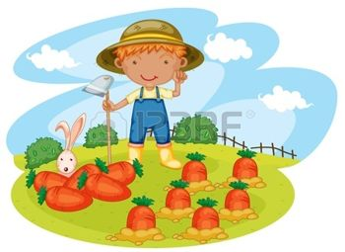

Written Response
Option 3
Create a flip book to explain how a seed grows. Draw pictures to describe each step in the process.
Sample Student Response
Note: This is for the teacher’s use only, not for students. The purpose is to show the teacher what the final piece might look like when students have completed their work.
How a Seed Grows
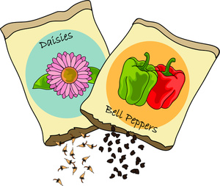
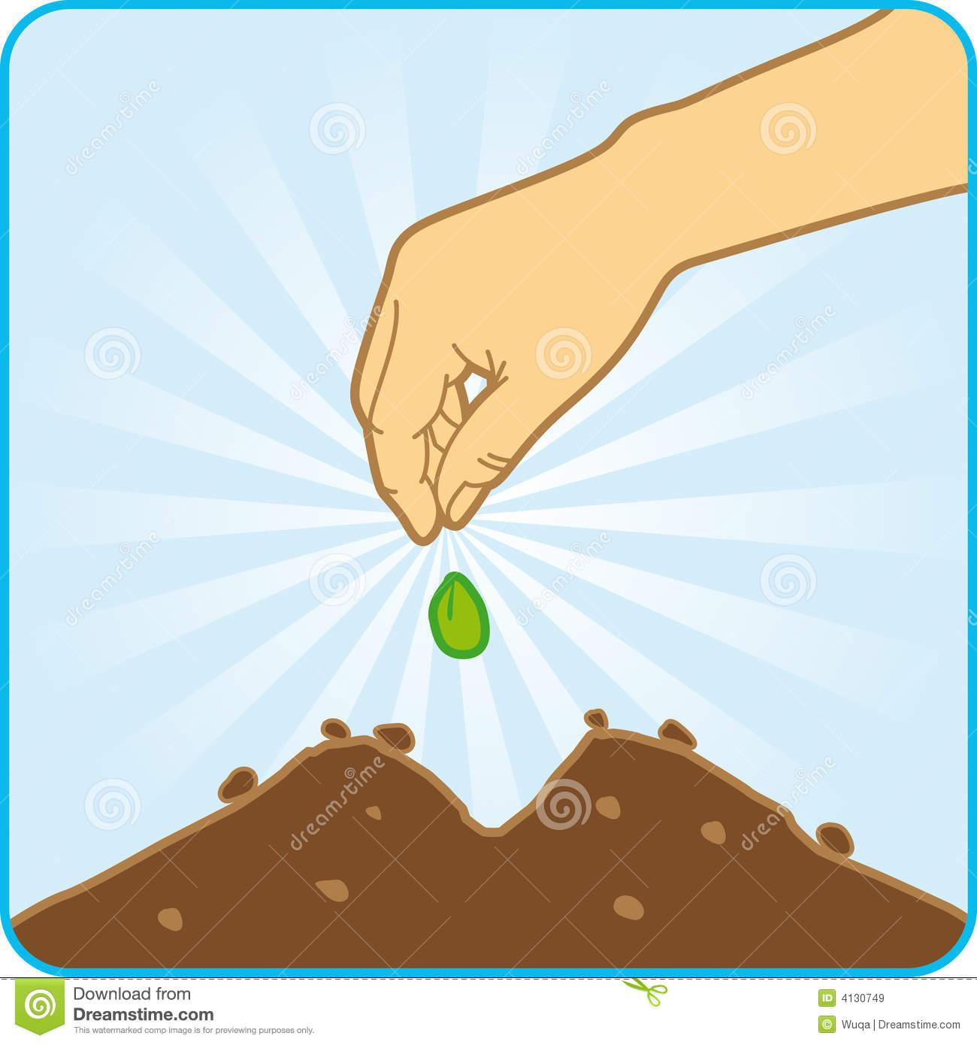
First, a seed is planted in the soil.
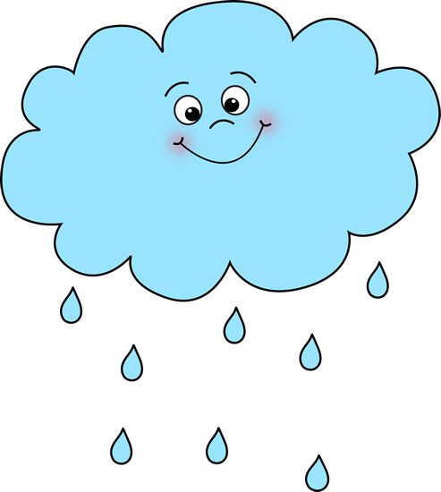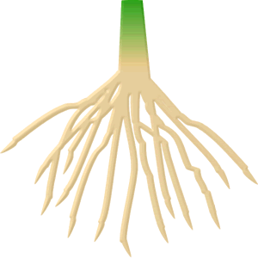
Next, the sun shines and rain falls. The root grows down in the soil.
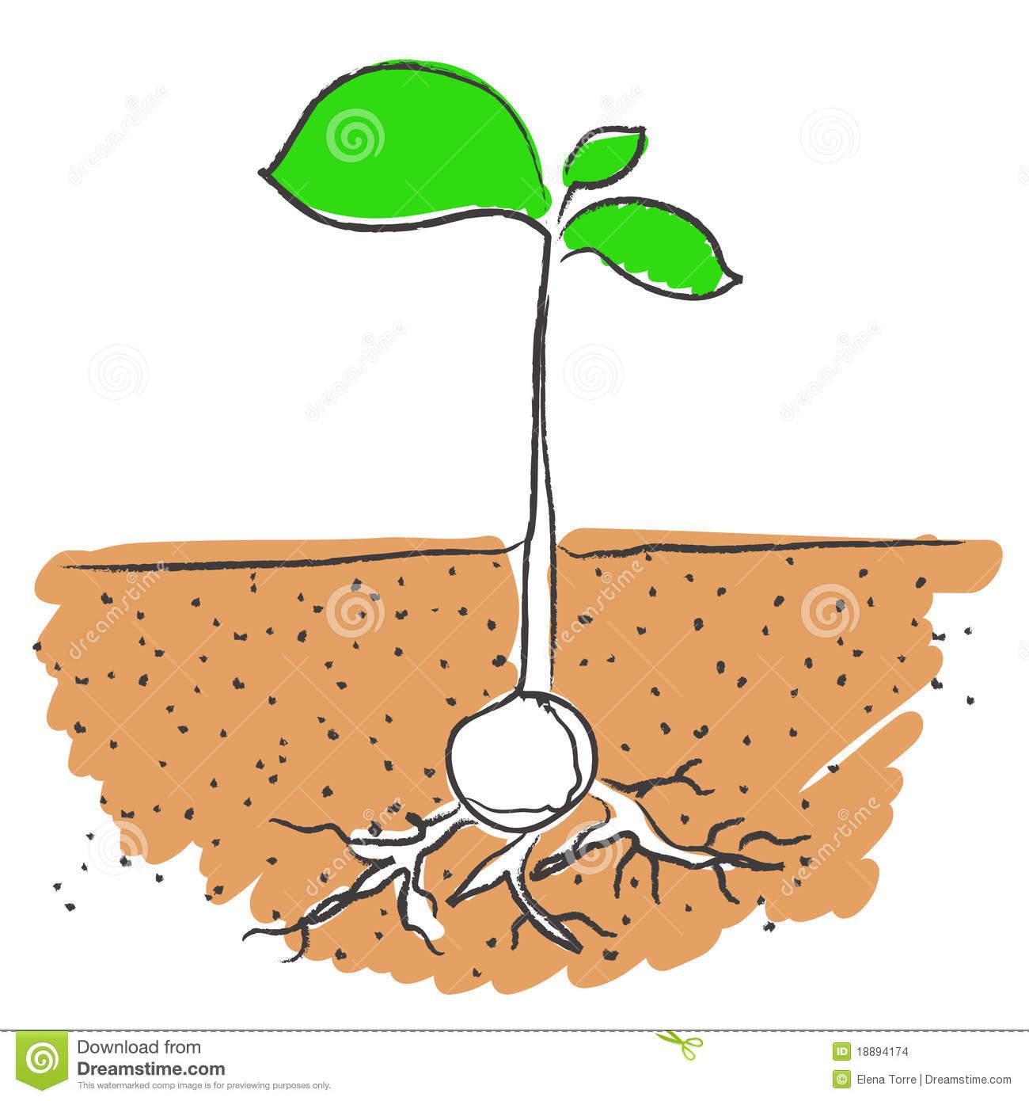
Then, the shoot pushes up through the soil and leaves start to form.
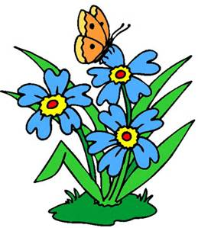
Finally, the water, minerals in the soil, sunlight, and air help the plant to grow bigger and bigger.
Week 2, Building Knowledge: Extending the Topic
Essential Question: How do seeds evolve into food?
Cumulative Activities – The following activities could be completed and updated after reading each resource this week. The purpose of these activities is to capture knowledge building from one resource to the next and to provide a holistic snapshot of central ideas of the content covered in response to the essential question. It is recommended that the class and/or students complete one of the Cumulative Activities (Rolling Knowledge Journal or Rolling Vocabulary) for Week 2.

Rolling Vocabulary: “Fabulous Four” Sample
- Read each resource then, with students, pick 4 important words. The Rolling Vocabulary may be kept as a large public interactive chart with words and pictures or drawings.
- Collaboratively use the 4 words to write about the most important ideas of the text. You should have as many sentences as you do words.
- Continue this activity with EACH selection in the text set.
- After reading all the selections on the topic, go back and review your words.
- Now select the “Fabulous Four” words from ALL the word lists.
- Use the “Fabulous Four” words to write an interesting sentence or sentences about the topic.

Sample Student Response
Title | Four Vocabulary Words & Sentences
From Seed to Plant | Words: shoot, nutrition, pod, pollen  - Green leaves grow up from the shoot to the sun.  - Many foods are full of nutrition.  - A pod grows around a seed.  - A pollen grain grows into an ovule.
Plant and Animal Partners | Words: partners, homes, grains, safe  - Plants and animals are partners.  - Plants can be homes for animals.  - Bees spread grains of pollen to other flowers.  - Plants keep animals safe.
The Life Cycle of a Tree | Words: pod, seeds, soak, tasty  - Trees sometimes come from a pod.  - Plants grow from seeds.  - Soak the seeds in water.  - Food from seeds can be tasty.
The Tiny Seed | Words: burst, petals, seed pod, drift  - The seeds grow so round and full they start to burst open a little.  - Some petals drop from the giant flower.  - Once the wind shakes the flower, the flower’s seed pod opens.  - The wind causes seeds to drift across the earth.
Germination | Words: germination, embryo, endosperm, scarification  - Germination is the process by which a plant grows from a seed.  - An embryo is a tiny plant.  - Endosperm are small leaves which feed the embryo.  - Scarification is when the hard seed coat changes to allow moisture to get in.
Fabulous Four: seed, germination, homes, pod
Summary:

All plants begin as a seed that are within a pod. Seeds go through a process called germination. Animals help to spread seeds and plants provide homes and food for animals.

Rolling Knowledge
- Read each selection in the set, one at a time.
- After you read each resource, stop and think what the big learning was. What did you already know about this from your other reading? Write or draw in the first box. This can be done collaboratively in small groups or individually depending on your students.
- What did you learn that was new and important about the topic from this resource? Write, draw, or list what you learned from the text about (topic).

Sample Student Response (most likely these would be drawings!)
Write, Draw, or List
Title | What I already knew from my other reading… | What I learned from reading this…
From Seed to Plant | Seeds grow into plants and food. | Seeds go through a process called germination.
The Life Cycle of a Tree | Plants have many parts. | Trees have the longest life cycle of any plant.
Plant and Animal Partners | Animals help spread seeds to other flowers. | Plants help keep animals safe.
The Tiny Seed | The wind helps to carry seeds across the Earth. | There are many things that can stop seeds from growing.
Germination | The outside of a seed has a protective coat. | Inside a seed is an embryo, which is a tiny plant, and the endosperm, which are small leaves which feed the embryo.

Written Response Week 2
Continue writing prompts from Week 1 following the Writing Process.

Name______________________________________ Date_______________

Title: From Seed to Plant
Essential Question: How do seeds evolve into food?

Title:
Write, Draw, or List
Questions | New and important learning about the topic or evidence
Writing

Choose one of the following writing prompts.

Prompt #1
Using evidence from the text write a paragraph explaining how seeds evolve into food.

Student Response

______________________________________________________________________________
__________________________________________________________________________________________________________________________________________________________________________________________________________________________________________
______________________________________________________________________________
Prompt #2
Imagine you are a farmer describe how your garden grows into food.

Student Response

______________________________________________________________________________
__________________________________________________________________________________________________________________________________________________________________________________________________________________________________________
______________________________________________________________________________
Prompt #3
Create a flip book to explain how a seed grows. Draw pictures to describe each step in the process.

Student Response

______________________________________________________________________________
__________________________________________________________________________________________________________________________________________________________________________________________________________________________________________
______________________________________________________________________________
Building Knowledge: Extending the Topic

Essential Question: How do seeds evolve into food?
Rolling Vocabulary
As you read each book, keep track of the new words you are learning. Collect the most important words from each book, website or video as you read and learn. Think about the words and write or draw a picture to help you remember them.

Title | Vocabulary Words & Sentences
- From Seed to Plant | Words:
- The Life Cycle of a Tree | Words:
- Plant and Animal Partners | Words:
- The Tiny Seed | Words:
5. Germination | Words:
Fabulous Four:
Summary:

Rolling Knowledge
As you read each book, keep track of what you are learning. Write and draw what you already knew in the box on the left. In the box on the right, write and draw about what you learned from this book.

Write, Draw, or List
Title | What I already knew from my other reading… | What I learned from reading this…
- From Seed to Plant
- The Life Cycle of a Tree
- Plant and Animal Partners
- The Tiny Seed
- Germination

