GO Math! Grade 4 Chapter Test Alignment

This assessment guidance is designed as a companion to the Go Math K-5 Guidance Documents. It provides support for modifying GO Math! Chapter Tests to align to the changes recommended in the Guidance Documents. The changes include rationale, often guided by the Rule of Thumb for Assessments, provided in Part 2 of the Guidance documents:

- Eliminate any questions aligned to lessons/content that have been deleted.
- Add vetted questions aligned to lessons that have been added.
- Remove any directions in questions that require a specific strategy or model. Note: This is the only modification we will be making to questions.

In addition, the aspect(s) of rigor targeted by the standards for the chapter has been identified. Some changes to questions are based on alignment to the appropriate aspect of rigor.

Chapter 1
Based on the standards addressed in the chapter, this assessment should address the following aspects of rigor:
✓Procedural Skill/Fluency
✓Conceptual Understanding
Application

Grade 4 / Chapter 1: Place Value, Addition, and Subtraction to One Million
Problem # | Action (Keep/Modify/Delete) | Details for the Action | Rationale
1 | Keep
2 | Keep
3 | Keep
4 | Keep
5 | Keep
6 | Keep
7 | Keep
8 | Modify | Add equation (43,911 + 40,087=___) | Aspects of Rigor: The standard targets procedural skill, but this is an application question.
9 | Modify | Add equation (89,416 + 72,261 =___) | Aspects of Rigor: The standard targets procedural skill, but this is an application question.
10 | Modify | Add equation (43,911 - 39,634=___) | Aspects of Rigor: The standard targets procedural skill, but this is an application question.
11 | Keep | Question aligns to 4.NBT.A.2
12 | Keep
13 | Keep
14 | Keep
15 | Keep
16 | Keep | Question aligns to 4.NBT.A.2
17 | Keep | Question aligns to 4.NBT.A.2
18 | Keep
19 | Keep
20 | Delete |  | Sufficient questions to assess 4.NBT.A.2

Questions to be added:
Added Lesson | Source | Question
1.5.1 | EngageNY, Grade 4, Module 1, Mid-Module Assessment: #3a | The football stadium at Louisiana State University (LSU) has a seating capacity of 92,542.  According to the 2010 census, the population of San Jose, CA was approximately ten times the amount of people that LSU’s stadium can seat. What was the population of San Jose in 2010?
1.5.1 | EngageNY, Grade 4, Module 1, End of Module Assessment: #1 | Compare the values of each 7 in the number 771,548. Use a picture, numbers, or words to explain.
Chapter 2
Based on the standards addressed in the chapter, this assessment should address the following aspects of rigor:
✓Procedural Skill/Fluency
✓Conceptual Understanding
Application

Grade 4 / Chapter 2: Multiply by 1-Digit Numbers
Problem # | Action (Keep/Modify/Delete) | Details for the Action | Rationale
1 | Keep
2 | Keep
3 | Keep
4 | Keep
5 | Modify | Delete Part A | Assessment Rule of Thumb: Question requires a specific strategy.
6 | Modify | Delete Parts A and B which require understanding the bar diagram. | Assessment Rule of Thumb: Question requires a specific strategy.
7 | Delete |  | Assessment Rule of Thumb: Question requires a specific strategy.
8 | Keep
9 | Modify | Just ask students to find the product of 9 x 354 and show their work. | Assessment Rule of Thumb: Question requires a specific strategy.
10 | Keep
11 | Keep | Question aligns to 2.9.1
12 | Keep
13 | Keep | Question aligns to 2.8.1
14 | Keep | Question aligns to 2.9.1
15 | Delete |  | Guidance Document: Lesson deleted
16 | Keep | Question aligns to 2.12.1
17 | Delete |  | Assessment Rule of Thumb: Question requires a specific strategy.
18 | Delete |  | Assessment Rule of Thumb: Question requires a specific strategy.

Questions to be added:
Added Lesson | Source | Question
2.2.1 | EngageNY, Grade 4, Module 3, End of Module Assessment: #6b | “A new grocery store is opening next week.  b. The store ordered small posters and large posters to promote their opening. 12 times as many small posters were ordered as large posters. If there were 48 large posters, how many more small posters were ordered than large posters? ”
2.2.1 | EngageNY, Grade 4, Module 3, Mid -Module Assessment: #3 | “3. A movie theater has two rooms. Room A has 9 rows of seats with 18 seats in each row. Room B has three times as many seats as Room A. How many seats are there in both rooms? ”
2.3.1 | EngageNY, Grade 4, Module 3, Mid -Module Assessment: #2a-d | “2. Use any place value strategy to multiply. a. 3×68  b. 4×371  c. 7×1,305  d. 6,034×5 ”
2.12.2 | EngageNY, Grade 4, Module 3, Mid -Module Assessment: #4 | “4. The high school art teacher has 9 cases of crayons with 52 boxes in each case. The elementary school art teacher has 6 cases of crayons with 104 boxes in each case. How many total boxes of crayons do both teachers have? Is your answer reasonable? Explain.”

Chapter 3
Based on the standards addressed in the chapter, this assessment should address the following aspects of rigor:
✓Procedural Skill/Fluency
✓Conceptual Understanding
Application

Grade 4 / Chapter 3: Multiply by 2-Digit Numbers
Problem # | Action (Keep/Modify/Delete) | Details for the Action | Rationale
1 | Modify | Delete “using mental math” from question. | Assessment Rule of Thumb: Question requires a specific strategy.
2 | Modify | Use the first paragraph and add “How much will the trip cost for the whole class?” 27x18= _____ Delete Parts A-C. | Assessment Rule of Thumb: Question requires a specific strategy.
3 | Keep
4 | Keep
5 | Keep
6 | Keep
7 | Delete |  | Assessment Rule of Thumb: Question requires a specific strategy.
8 | Modify | Keep text to Part C only. Add statement afterwards “Show your work by using an equation, rectangular array, or area model. | Assessment Rule of Thumb: Question requires a specific strategy.
9 | Delete |  | Assessment Rule of Thumb: Question requires a specific strategy.
10 | Keep
11 | Modify | Delete last sentence. | Assessment Rule of Thumb: Question requires a specific strategy.
12 | Delete |  | Assessment Rule of Thumb: Question requires a specific strategy.
13 | Keep
14 | Keep
15 | Keep
16 | Keep
17 | Keep
18 | Keep
19 | Keep
20 | Keep
21 | Keep

Chapter 4
Based on the standards addressed in the chapter, this assessment should address the following aspects of rigor:
✓Procedural Skill/Fluency
✓Conceptual Understanding
Application

Grade 4 / Chapter 4: Divide by 1-Digit Numbers
Problem # | Action (Keep/Modify/Delete) | Details for the Action | Rationale
1 | Delete |  | Guidance Document: Lesson deleted
2 | Delete |  | Guidance Document: Lesson deleted
3 | Delete |  | Assessment Rule of Thumb: Question requires a specific strategy.
4 | Keep
5 | Keep | Question aligns to 4.3.2
6 | Keep | Question aligns to 4.3.2
7 | Modify | Modify Part A to read “Find the number of trucks needed to carry the dogs in their crates.” Delete Part B & C. | Question aligns to 4.3.2
8 | Keep
9 | Keep
10 | Delete |  | Assessment Rule of Thumb: Question requires a specific strategy.
11 | Keep
12 | Keep
13 | Keep
14 | Keep | Question aligns to 4.3.1 and, if students choose partial quotients, 4.8.1
15 | Modify | Replace last two sentences with “How many full pages will she have? Show your work by using an equation, rectangular array, or area model.” | Question aligns to 4.3.1 and, if students choose partial quotients, 4.8.1
16 | Delete |  | Assessment Rule of Thumb: Question requires a specific strategy.
17 | Keep
18 | Delete |  | Assessment Rule of Thumb: Question requires a specific strategy.
19 | Keep
20 | Delete |  | Sufficient questions to assess 4.NBT.B.6
21 | Keep
22 | Keep

Chapter 5
Based on the standards addressed in the chapter, this assessment should address the following aspects of rigor:
✓Procedural Skill/Fluency
✓Conceptual Understanding
Application
Grade 4 / Chapter 5: Factors, Multiples, and Patterns
Problem # | Action (Keep/Modify/Delete) | Details for the Action | Rationale
1 | Keep
2 | Keep
3 | Keep
4 | Keep
5 | Keep
6 | Keep
7 | Delete |  | Guidance Document: Lesson deleted
8 | Delete |  | Guidance Document: Lesson deleted
9 | Delete |  | Guidance Document: Lesson deleted
10 | Keep
11 | Keep
12 | Keep
13 | Keep
14 | Delete |  | Aspects of Rigor: The standard targets procedural skill, but this is an application question; didn’t modify because there are sufficient questions to assess 4.OA.B.4.
15 | Keep
16 | Keep
17 | Keep
18 | Keep
19 | Keep
20 | Keep
21 | Keep

Chapter 6
Based on the standards addressed in the chapter, this assessment should address the following aspects of rigor:
✓Procedural Skill/Fluency
✓Conceptual Understanding
Application

Grade 4 / Chapter 6: Fraction Equivalence and Comparison
Problem # | Action (Keep/Modify/Delete) | Details for the Action | Rationale
1 | Keep | Question aligns to 6.5.1
2 | Keep
3 | Keep
4 | Keep
5 | Keep
6 | Delete |  | Guidance Document: Lesson deleted
7 | Delete |  | Guidance Document: Lesson deleted
8 | Delete |  | Guidance Document: Lesson deleted
9 | Delete |  | Guidance Document: Lesson deleted
10 | Delete |  | Guidance Document: Lesson deleted
11 | Delete |  | Guidance Document: Lesson deleted
12 | Keep
13 | Delete | Modify Part A include:  ⅞ ____ ¾  Delete Part B. | Aspects of Rigor: The standard targets procedural skill, but this is an application question.
14 | Delete |  | Guidance Document: Lesson deleted
15 | Keep | Question aligns to 6.3.3
16 | Keep
17 | Delete |  | Guidance Document: Lesson deleted
18 | Keep

Questions to be added:
Added Lesson | Source | Question
6.3.1/2 | EngageNY, Grade 4, Module 5, Mid-Module Assessment: #2a-b | 2a.  Using the fractional units shown, identify the fraction of the rectangle that is shaded. Continue this pattern by drawing the next area model in the sequence and identifying the fraction shaded.  2b.  Use multiplication to e Explain why the first two fractions are equivalent.  (see below)
6.3.1/2 | EngageNY, Grade 4, Module 5, Mid-Module Assessment: #3a-c | “Cross out the fraction that is not equivalent to the other three. Show how you know. ”  (see below)
6.3.3 | EngageNY, Grade 4, Module 5, Mid-Module Assessment: #4 (choose from a-h) | “Fill in the circle with <, =, or > to make a true number sentence. Justify each response by drawing a model (such as an area model or a number line), creating common denominators or numerators, or explaining a comparison to a benchmark fraction.”  (see below)
EngageNY Grade 4, Module 5, Mid-Module Assessment Task #2a & b

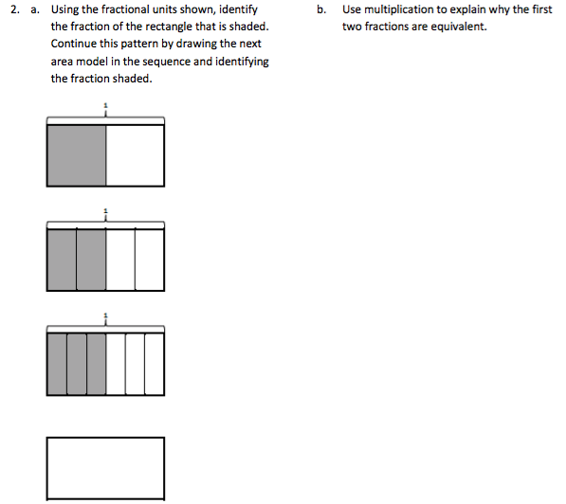

EngageNY Grade 4, Module 5, Mid-Module Assessment Task #3a, b, c

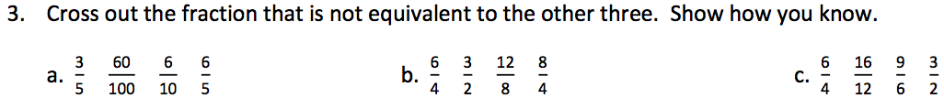

EngageNY Grade 4, Module 5, Mid-Module Assessment Task #4a-h

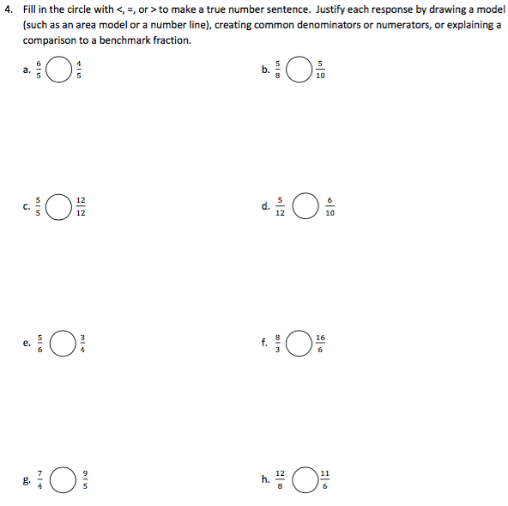
Chapter 7
Based on the standards addressed in the chapter, this assessment should address the following aspects of rigor:
✓Procedural Skill/Fluency
✓Conceptual Understanding
✓Application

Grade 4 / Chapter 7: Add and Subtract Fractions
Problem # | Action (Keep/Modify/Delete) | Details for the Action | Rationale
1 | Keep
2 | Modify | Include equation: 3 ¼ + 1 2/4 + 2 ¾ = | Aspects of Rigor: The standard targets procedural skill, but this is an application question.
3 | Modify | Include equation of Nick’s argument: 3 ¼ - 1 2/4 = 2 1/4 | Aspects of Rigor: The standard targets procedural skill, but this is an application question.
4 | Keep | Question aligns to 7.5.1
5 | Keep
6 | Keep
7 | Keep
8 | Delete |  | Assessment Rule of Thumb: Question requires a specific strategy.
9 | Delete |  | Guidance Document: Lesson deleted
10 | Keep | Question aligns to 4.NF.B.3a
11 | Keep
12 | Keep
13 | Keep
14 | Keep
15 | Keep
16 | Keep
17 | Keep | Question aligns to 7.10.1
18 | Keep | Question aligns to 7.10.1
19 | Keep
20 | Keep
21 | Keep

Questions to be added:
Added Lesson | Source | Question
7.2 | EngageNY, Grade 4, Module 5, Mid-Module Assessment: #1a-b | “1. Let each small square represent 1/4  a.  Using the same unit, draw and shade the following fractions. Represent each as a sum of unit fractions.  Example:  b.  Record the decompositions of Parts (i) and (iii) using only 2 addends. ”  (see below)
EngageNY Grade 4, Module 5, Mid-Module Assessment Task, #1a-b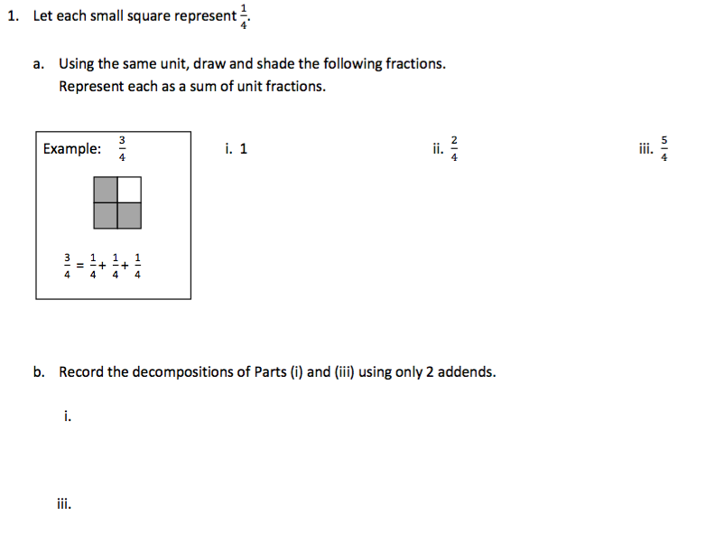

Chapter 8
Based on the standards addressed in the chapter, this assessment should address the following aspects of rigor:
✓Procedural Skill/Fluency
✓Conceptual Understanding
✓Application

Grade 4 / Chapter 8: Multiply Fractions by Whole Numbers
Problem # | Action (Keep/Modify/Delete) | Details for the Action | Rationale
1 | Keep
2 | Keep
3 | Keep
4 | Keep
5 | Keep
6 | Keep
7 | Modify | Delete model and replace last two sentences with “Find the length of a thresher shark. Show your work by using visual fraction models or equations to represent the problem.” | Assessment Rule of Thumb: Question requires a specific strategy.
8 | Keep
9 | Keep
10 | Keep
11 | Keep
12 | Keep
13 | Keep
14 | Keep | Question aligns to 4.NF.B.4b
15 | Keep | Question not tagged in GO Math! guide, aligns to 4.NF.B.4c
16 | Keep
17 | Modify | Delete Part A & B text, replace with “Find the amount of popcorn Maddie needs. Show your work by using visual fraction models or equations to represent the problem.” | Assessment Rule of Thumb: Question requires a specific strategy.
18 | Keep
19 | Keep
20 | Keep
21 | Keep | Question aligns to 4.NF.B.4c
Chapter 9
Based on the standards addressed in the chapter, this assessment should address the following aspects of rigor:
✓Procedural Skill/Fluency
✓Conceptual Understanding
Application

Grade 4 / Chapter 9: Relate Fractions and Decimals
Problem # | Action (Keep/Modify/Delete) | Details for the Action | Rationale
1 | Keep
2 | Keep
3 | Keep
4 | Delete |  | Guidance Document: Lesson deleted
5 | Keep
6 | Keep
7 | Delete |  | Guidance Document: Lesson deleted
8 | Keep
9 | Keep
10 | Delete |  | Guidance Document: Lesson deleted
11 | Keep
12 | Modify | Include equation in Part A: 4/10 + 12/100 = ____ | Aspects of Rigor: The standard targets procedural skill, but this is an application question.
13 | Keep
14 | Keep
15 | Keep
16 | Keep
17 | Keep
18 | Keep
19 | Keep
20 | Keep
21 | Keep

Chapter 10
Based on the standards addressed in the chapter, this assessment should address the following aspects of rigor:
✓Procedural Skill/Fluency
✓Conceptual Understanding
Application

Grade 4 / Chapter 10: Two-Dimensional Figures
Problem # | Action (Keep/Modify/Delete) | Details for the Action | Rationale
1 | Keep
2 | Keep
3 | Keep
4 | Keep
5 | Keep
6 | Keep
7 | Keep
8 | Keep
9 | Keep
10 | Keep
11 | Keep
12 | Keep
13 | Keep
14 | Keep
15 | Keep
16 | Keep
17 | Keep
18 | Keep
19 | Keep
20 | Keep
21 | Keep

Chapter 11
Based on the standards addressed in the chapter, this assessment should address the following aspects of rigor:
✓Procedural Skill/Fluency
✓Conceptual Understanding
Application

Grade 4 / Chapter 11: Angles
Problem # | Action (Keep/Modify/Delete) | Details for the Action | Rationale
1 | Keep
2 | Keep
3 | Keep
4 | Keep
5 | Keep
6 | Keep
7 | Keep
8 | Keep
9 | Keep
10 | Keep
11 | Keep
12 | Keep
13 | Keep
14 | Keep
15 | Keep
16 | Keep
17 | Modify | Delete Part A. | Assessment Rule of Thumb: Question requires a specific strategy.
18 | Keep
19 | Keep
20 | Keep | Question aligns to 4.MD.C.7

Questions to be added:
Added Lesson | Source | Question
11.3.1 | EngageNY, Grade 4, Module 4, Mid-Module Assessment: #6b | “The town of Seaford has a large rectangular park with a biking path around its perimeter and two straight-line biking paths that cut across it as shown in the diagram below.  In the space below, use a protractor to draw an angle with the same measure as ∠DGK. ”

Chapter 12
Based on the standards addressed in the chapter, this assessment should address the following aspects of rigor:
✓Procedural Skill/Fluency
✓Conceptual Understanding
✓Application

Grade 4 / Chapter 12: Relative Sizes of Measurement Units
Problem # | Action (Keep/Modify/Delete) | Details for the Action | Rationale
1 | Keep
2 | Delete |  | Guidance Document: Lesson deleted
3 | Keep
4 | Keep
5 | Keep | Question aligns to 12.5.1
6 | Keep
7 | Keep
8 | Keep
9 | Modify | Delete last sentence and fill-in the blank boxes. | Assessment Rule of Thumb: Question requires a specific strategy.
10 | Keep
11 | Keep | Question aligns to 12.5.1
12 | Keep
13 | Keep
14 | Delete |  | Guidance Document: Lesson deleted
15 | Keep
16 | Delete |  | Guidance Document: Lesson deleted
17 | Keep
18 | Delete |  | Guidance Document: Lesson deleted
19 | Delete |  | Guidance Document: Lesson deleted
20 | Keep
21 | Delete |  | Guidance Document: Lesson deleted
22 | Keep | Question aligns to 12.8.1

Questions to be added:
Added Lesson | Source | Question
12.6.1 | EngageNY, Grade 4, Module 7, End of Module Assessment: #4a | “Convert the following measurements.  - Express the length of a 9 kilometer trip in meters.”
12.11.1/2 | EngageNY, Grade 4, Module 7, End of Module Assessment: #6d-e | “6d. Jacob says that he can find the number of inches in 15 yards by tripling the number of inches in 5 yards. Does his strategy work? Why or why not?  6e. A blue rope in Garret’s camping backpack is 6 yards long. The blue rope is 3 times as long as a red rope. A yellow rope is 2 feet 7 inches shorter than the red rope. What is the difference in length between the blue rope and the yellow rope?”

Chapter 13
Based on the standards addressed in the chapter, this assessment should address the following aspects of rigor:
✓Procedural Skill/Fluency
✓Conceptual Understanding
✓Application

Grade 4 / Chapter 13: Algebra: Perimeter and Area
Problem # | Action (Keep/Modify/Delete) | Details for the Action | Rationale
1 | Keep | Question aligns to 13.1
2 | Modify | After Part A text include “Use the formula for area in your response.” | Question aligns to 13.3
3 | Keep | Question aligns to 13.1
4 | Keep | Question aligns to 13.3
5 | Keep | Question aligns to 13.1
6 | Modify | After question text include “Identify the formula you used to solve.” | Question aligns to 13.3
7 | Keep | Question aligns to 13.1
8 | Modify | After question text include “Use the formula for area in your response.” | Question aligns to 13.1
9 | Keep | Question aligns to 13.3
10 | Keep | Question aligns to 13.3
11 | Modify | Delete question text underneath diagram and include “Find the area of the floor of the laundry room. Use the formula for area in your response and show your work.” | Question aligns to 13.3
12 | Keep | Question aligns to 13.3
13 | Keep | Question aligns to 13.1
14 | Modify | After question text include “Include the appropriate formula in your solution.” | Question aligns to 13.3
15 | Modify | After question text include “Include the appropriate formula in your solution.” | Question aligns to 13.3
16 | Keep | Question aligns to 13.1
17 | Keep | Question aligns to 13.3
18 | Keep | Question aligns to 13.3
19 | Modify | After question text include “Include the appropriate formula in your solution.” | Question aligns to 13.1

Questions to be added:
Added Lesson | Source | Question
13.2 | EngageNY, Grade 4, Module 3, Mid -Module Assessment: #5a-d | “Last year, Mr. Petersen’s rectangular garden had a width of 5 meters and an area of 20 square meters. This year, he wants to make the garden three times as long and two times as wide.  a. Solve for the length of last year’s garden using the area formula. Then, draw and label the measurements of this year’s garden.  b. How much area for planting will Mr. Petersen have in the new garden?  c. Last year, Mr. Petersen had a fence all the way around his garden. He can reuse all of the fence he had around the garden last year, but he needs to buy more fencing to go around this year’s garden. How many more meters of fencing is needed for this year’s garden than last year’s?  d. Last year, Mr. Petersen was able to plant 4 rows of carrots with 13 plants in each row. This year, he plans to plant twice as many rows with twice as many carrot plants in each. How many carrot plants will he plant this year? Write a multiplication equation to solve. Assess the reasonableness of your answer. ”

