GO Math! Grade 5 Chapter Test Alignment

This assessment guidance is designed as a companion to the Go Math K-5 Guidance Documents. It provides support for modifying GO Math! Chapter Tests to align to the changes recommended in the Guidance Documents. The changes include rationale, often guided by the Rule of Thumb for Assessments, provided in Part 2 of the Guidance documents:

- Eliminate any questions aligned to lessons/content that have been deleted.
- Add vetted questions aligned to lessons that have been added.
- Remove any directions in questions that require a specific strategy or model. Note: This is the only modification we will be making to questions.

In addition, the aspect(s) of rigor targeted by the standards for the chapter has been identified. Some changes to questions are based on alignment to the appropriate aspect of rigor.

Chapter 1
Based on the standards addressed in the chapter, this assessment should address the following aspects of rigor:
✓Procedural Skill/Fluency
✓Conceptual Understanding
Application

Grade 5 / Chapter 1: Place Value, Multiplication and Expressions
Problem # | Action (Keep/Modify/Delete) | Details for the Action | Rationale
1 | Delete |  | Guidance document: Lesson deleted
2 | Keep
3 | Keep
4 | Keep
5 | Keep |  | Although this lesson is deleted, it requires students to understand the distributive property of multiplication, which is appropriate for the grade level.
6 | Keep
7 | Modify | Write 1,325x5=? | Aspects of Rigor: The standard targets procedural skill and fluency but this is an application question.
8 | Delete |  | Magnitude of numbers aligns to 4.NBT.B.5
9 | Modify | Delete Part A. | Aspects of Rigor: The standard targets procedural skill and fluency but this is an application question.
10 | Delete |  | Guidance document: Lesson deleted
11 | Keep
12 | Keep
13 | Delete |  | Aspects of Rigor: The standard targets procedural skill and fluency but this is an application question.
14 | Delete |  | Aligned to 3.OA.B
15 | Delete |  | Guidance document: Lesson deleted
16 | Delete |  | Assessment Rule of Thumb: Question requires a specific strategy.
17 | Modify | Add directions, “Solve using the standard algorithm”. Write 157 * 25 = ? | Aspect of Rigor: The standard targets procedural skill and fluency but this is an application question.
18 | Keep
19 | Delete |  | Guidance document: Lesson deleted
20 | Keep
21 | Delete |  | Not aligned to standard
22 | Keep

Questions to be added:
Added Lesson | Source | Question
1.7.1 | EngageNY, Module 2, Mid-module assessment: #4 | 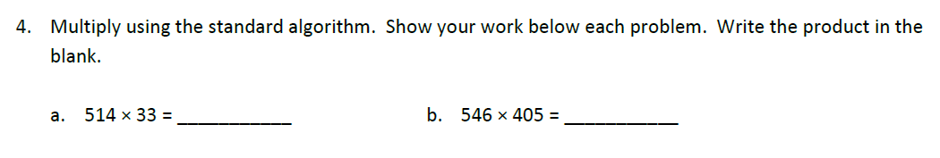
Chapter 2
Based on the standards addressed in the chapter, this assessment should address the following aspects of rigor:
✓Procedural Skill/Fluency
✓Conceptual Understanding
Application

Grade 5 / Chapter 2: Divide Whole Numbers
Problem # | Action (Keep/Modify/Delete) | Details for the Action | Rationale
1 | Delete |  | Guidance document: Lesson deleted
2 | Keep
3 | Keep
4 | Delete |  | Assesses vocabulary. According to the program level Rule of Thumb #6, vocabulary should be integrated into the work of the lesson.
5 | Keep
6 | Modify | Write the equation on test. $3060÷36 {=d}_{}$ | Aspects of Rigor: The standard targets procedural skill and fluency but this is an application question.
7 | Modify | Write the equation on the test. $135÷9 =t$ | Aspects of Rigor: The standard targets procedural skill and fluency but this is an application question.  Note: Magnitude of numbers is aligned to 4.NBT.B.6.
8 | Modify | Delete “by using partial quotients.” | Assessment Rule of Thumb: Question requires a specific strategy.
9 | Keep
10 | Delete |  | Guidance document: Lesson deleted
11 | Keep | Note: The answer key implies that the algorithm should be used, any place value-based strategy is acceptable.
12 | Delete |  | Assessment Rule of Thumb: Question requires a specific strategy.
13 | Modify | Part A: Write in “322/15” Delete “Explain your answer”  Delete Part B. | Aspects of Rigor: The standard targets procedural skill and fluency but this is an application question.
14 | Keep | Note: Application is related to 4.OA.A.3 but magnitude of numbers make it aligned to grade 5.
15 | Delete |  | Guidance document: Lesson deleted
16 | Keep
17 | Delete |  | Guidance document: Estimation is deemphasized as a separate skill.
18 | Delete |  | Aligned to 4.OA.A.2
19 | Delete | Use only the division problem. | Aspects of Rigor: The standard targets procedural skill and fluency but this is an application question

Chapter 3
Based on the standards addressed in the chapter, this assessment should address the following aspects of rigor:
✓Procedural Skill/Fluency
Conceptual Understanding
Application

Grade 5 / Chapter 3: Add and Subtract Decimals
Problem # | Action (Keep/Modify/Delete) | Details for the Action | Rationale
1 | Keep
2 | Keep
3 | Delete |  | Guidance document: Lesson deleted
4 | Keep
5 | Keep
6 | Modify | Add sentence to item. “The large grid represents 1 whole.”
7 | Keep
8 | Modify | Delete last sentence of item. | Assessment Rule of Thumb: Question requires a specific strategy.
9 | Delete |  | Guidance document: Lesson deleted
10 | Keep
11 | Delete |  | Assessment Rule of Thumb: Question requires specific model.
12 | Delete |  | Guidance document: Lesson deleted
13 | Keep
14 | Keep
15 | Keep
16 | Keep
17 | Modify | Part A: Delete all text after “Estimate the weight of the gerbil at the end of the summer.” | Assessment Rule of Thumb: Question requires specific strategy.
18 | Keep
19 | Keep
20 | Keep
21 | Keep

Questions to be added:
Added Lesson | Source | Question
 | EngageNY, Grade 5, Module 1, End of Module Assessment: #3a - e | 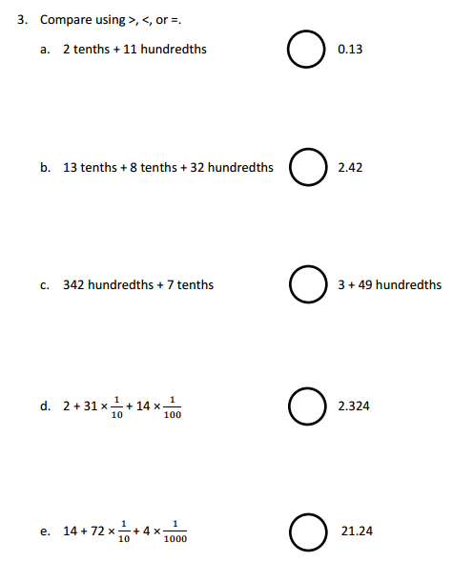

Chapter 4
Based on the standards addressed in the chapter, this assessment should address the following aspects of rigor:
✓Procedural Skill/Fluency
✓Conceptual Understanding
Application

Grade 5 / Chapter 4: Multiply Decimals
Problem # | Action (Keep/Modify/Delete) | Details for the Action | Rationale
1 | Keep
2 | Keep
3 | Keep
4 | Delete |  | Assessment Rule of Thumb: Question requires a specific strategy.
5 | Keep
6 | Keep
7 | Delete |  | Assessment Rule of Thumb: Question requires a specific strategy.
8 | Delete |  | Aligned to 6.RP.A.3
9 | Keep | Note: Students do not have to use the strategy shown in the sample response.
10 | Modify | Add the equation 14.6 x 18 = ? | Aspects of Rigor: The standard targets procedural skill and fluency but this is an application question.
11 | Keep
12 | Keep
13 | Keep
14 | Keep
15 | Modify | Delete first two sentences and the model. | Assessment Rule of Thumb: Question requires a specific model.
16 | Delete |  | Aspects of Rigor: The standard targets procedural skill and fluency but this is an application question.
17 | Keep
18 | Keep
19 | Keep
20 | Modify | Part A: write the equation “16.1x0.25=?  Part B: write the equation 16.1x0.41=? | Aspects of Rigor: The standard targets procedural skill and fluency but this is an application question.
21 | Keep | Note: While the standard does not require application, this question was left to expose students to some application questions.
22 | Keep | Note: While the standard does not require application, this question was left to expose students to some application questions.

Chapter 5
Based on the standards addressed in the chapter, this assessment should address the following aspects of rigor:
✓Procedural Skill/Fluency
✓Conceptual Understanding
Application

Grade 5 / Chapter 5: Divide Decimals
Problem # | Action (Keep/Modify/Delete) | Details for the Action | Rationale
1 | Keep
2 | Keep
3 | Keep
4 | Modify | Delete “Draw a model to show…” | Assessment Rule of Thumb: Question requires a specific strategy.
5 | Keep
6 | Keep
7 | Keep
8 | Keep
9 | Delete |  | Aspects of Rigor: The standard targets procedural skill and fluency but this is an application question.
10 | Modify | Write 5.46 / 6 = ___. | Aspects of Rigor: The standard targets procedural skill and fluency but this is an application question.
11 | Keep
12 | Delete |  | Aligned to 6.NS.B.3
13 | Modify | Delete directions and model and just present 1.8 $÷$ 0.6 = __ | Assessment Rule of Thumb: Question requires a specific strategy.
14 | Modify | Write 3.36/0.84=___ | Aspects of Rigor: The standard targets procedural skill and fluency but this is an application question.
15 | Modify | Write 7.2 / 0.3 = ___ | Aspects of Rigor: The standard targets procedural skill and fluency but this is an application question.
16 | Modify | Write 9.66 / 4.2 = ___ | Aspects of Rigor: The standard targets procedural skill and fluency but this is an application question.
17 | Delete |  | Assessment Rule of Thumb: Question requires a specific strategy
18 | Modify | Write 16.2x12=__ | Aspects of Rigor: The standard targets procedural skill and fluency but this is an application question.
19 | Keep
20 | Delete |  | Aligned to 6.RP.A.3
21 | Delete |  | Aspects of Rigor: The standard targets procedural skill and fluency but this is an application question.
22 | Delete |  | Aspects of Rigor: The standard targets procedural skill and fluency but this is an application question.

Chapter 6
Based on the standards addressed in the chapter, this assessment should address the following aspects of rigor:
✓Procedural Skill/Fluency
Conceptual Understanding
✓Application

Grade 5 / Chapter 6: Operations with Fractions
Problem # | Action (Keep/Modify/Delete) | Details for the Action | Rationale
1 | Keep
2 | Keep
3 | Keep
4 | Keep
5 | Keep
6 | Keep
7 | Delete |  | Assessment Rule of Thumb: Question requires students to use a specific model and strategy.
8 | Keep
9 | Delete |  | Guidance document: Lesson deleted
10 | Keep
11 | Delete |  | Guidance document: Lesson deleted
12 | Keep
13 | Keep
14 | Keep
15 | Keep
16 | Keep

Chapter 7/8
Based on the standards addressed in the chapter, this assessment should address the following aspects of rigor:
✓Procedural Skill/Fluency
Conceptual Understanding
Application

Grade 5 / Chapter 7/8: Multiply Fractions/Divide Fractions
Problem # | Action (Keep/Modify/Delete) | Details for the Action | Rationale
All Ch 7-8 | Delete |  | Chapter 7 and 8 were deleted and replaced with Engage NY Module 4.

Questions to be added:
Added Lesson | Source | Question
Module 4 | EngageNY Module 5, End of module assessment

Chapter 9
Based on the standards addressed in the chapter, this assessment should address the following aspects of rigor:
Procedural Skill/Fluency
✓Conceptual Understanding
✓Application

Grade 5 / Chapter 9 Patterns and Graphing:
Problem # | Action (Keep/Modify/Delete) | Details for the Action | Rationale
1 | Keep
2 | Delete |  | Aligned to 6.SP.B.5c
3 | Delete |  | Guidance document: Lesson deleted
4 | Keep
5 | Keep
6 | Delete |  | Guidance document: See modification to Lesson 9.6
7 | Keep
8 | Keep
9 | Delete |  | Guidance document: Lesson deleted
10 | Delete |  | Aligned to 6.SP.B.5c
11 | Delete |  | Guidance document: Lesson deleted
12 | Modify | Delete second sentence in Part A. | Guidance document: See modification to Lesson 9.6
13 | Delete |  | Guidance document: Lesson deleted
14 | Keep
15 | Delete |  | Guidance document: See modification to Lesson 9.6
16 | Modify | Remove directions “How can making a table help you?”, and replace with “Show your work.” | Assessment Rule of Thumb: Question requires a specific strategy.

Questions to be added:
Added Lesson | Source | Question
9.1.1; 9.2.1 | EngageNY, Module 6, Mid Module Assessment: #1 & #2 | 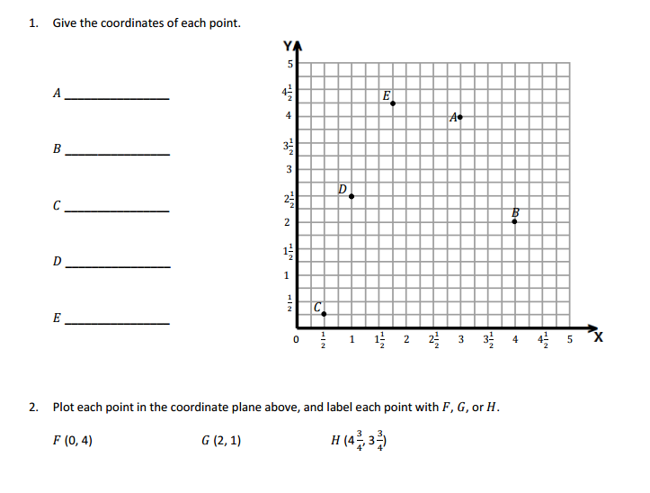  NOTE: Chapter-level rule of thumb

Chapter 10
Based on the standards addressed in the chapter, this assessment should address the following aspects of rigor:
✓Procedural Skill/Fluency
Conceptual Understanding
✓Application

Grade 5 / Chapter 10: Converting Units of Measurement
Problem # | Action (Keep/Modify/Delete) | Details for the Action | Rationale
1 | Keep
2 | Keep
3 | Modify | Delete Part B | Assessment Rule of Thumb: Question requires a specific model.
4 | Keep
5 | Delete |  | Test should be shortened since there are only 6 days of instruction for the unit.
6 | Delete |  | Test should be shortened since there are only 6 days of instruction for the unit.
7 | Delete |  | Test should be shortened since there are only 6 days of instruction for the unit.
8 | Keep
9 | Delete |  | Test should be shortened since there are only 6 days of instruction for the unit.
10 | Modify | Change problem to say each bottle has 1.5 pints of water. | 5.MD.A.1 calls for solving muti-step problems.
11 | Delete |  | Test should be shortened since there are only 6 days of instruction for the unit.
12 | Delete |  | Test should be shortened since there are only 6 days of instruction for the unit.
13 | Keep
14 | Delete |  | Test should be shortened since there are only 6 days of instruction for the unit.
15 | Delete |  | Test should be shortened since there are only 6 days of instruction for the unit.
16 | Keep
17 | Keep
18 | Keep
19 | Delete |  | Test should be shortened since there are only 6 days of instruction for the unit.
20 | Keep
21 | Delete |  | Test should be shortened since there are only 6 days of instruction for the unit.
22 | Keep
Chapter 11
Based on the standards addressed in the chapter, this assessment should address the following aspects of rigor:
✓Procedural Skill/Fluency
✓Conceptual Understanding
✓Application

Grade 5 / Chapter 11: Geometry and Volume
Problem # | Action (Keep/Modify/Delete) | Details for the Action | Rationale
1 | Keep
2 | Keep
3 | Keep
4 | Keep
5 | Keep
6 | Delete |  | Guidance document: Lesson deleted
7 | Keep
8 | Modify | Delete side lengths | Guidance document: Chapter Rule of Thumb. 5MD.C.3 requires conceptual understanding of volume and how cubic units define the volume of a figure.
9 | Keep
10 | Keep
11 | Keep
12 | Delete |  | Guidance document: Lesson deleted
13 | Keep
14 | Keep
15 | Keep
16 | Keep
17 | Keep
18 | Modify | Delete the side lengths | Guidance document: Chapter Rule of Thumb. 5MD.C.3 requires conceptual understanding of volume and how cubic units define the volume of a figure

