Teaching the Core- Exemplar Lesson Plan, Mathematics
.
School Name: Johnson | Teacher Name: Lauren Zafrin
Date: January 23rd and 24th 2014 | Period / Time: 12:30-1:30
Room Number: 25 | Grade Level: 5
Demographics of the class  (e.g., % ELL, % SPED, other relevant): | 5% SPED  21% 504

How will this lesson address the content area standards?

The cluster being addressed is:
CC.5.NF.A: Use equivalent fractions as a strategy to add and subtract fractions.
The standard being addressed is:
CC.5.NF.A.2.- Solve word problems involving addition and subtraction of fractions referring to the same whole, including cases of unlike denominators, e.g., by using visual fraction models or equations to represent the problem. Use benchmark fractions and number sense of fractions to estimate mentally and assess the reasonableness of answers. For example, recognize an incorrect result 2/5 + ½ = 3/7, by observing that 3/7, ½.
The objective of this lesson is:
The students will use models to add fractions with unlike denominators.
Standards for Mathematical Practices targeted in this lesson:
SMP 1- Make sense of problems and persevere in solving them
SMP 2- Reason abstractly and quantitatively
SMP 3- Construct viable arguments and critique the reasoning of others
SMP 4- Model with mathematics

The aspects of rigor called for in the standard are both procedural skill and fluency and conceptual understanding. In this lesson, students will use models to add fractions that have different denominators. Students will build conceptual understanding through their investigation modeling addition with fraction bars. This lesson will build conceptual understanding of addition of fractions as a base to build procedural skill and fluency in future lesson in which students will find common denominators to write equivalent fractions and use equivalent fractions to add and subtract fractions.

How does this learning fit in the sequence of learning or curriculum for this class?

Students will have previous experience with naming of fractions, equivalent fractions, and comparing fractions. Students will also be familiar with adding and subtracting fractions with like denominators, multiplying fractions by a whole number, and an understanding of decimal values and computation. This lesson will be the first in the unit addressing fifth grade fraction standards. Student prior knowledge and understanding was built through experiences in third and fourth grade.

During this lesson students will use models to add fraction with unlike denominators. Students will begin each lesson by modeling addition of fractions with like denominators with fraction equivalency cubes. Students will manipulate the fraction cubes to model examples of addition of fractions with like denominators. Students will then investigate adding fractions with unlike denominators using fraction cubes. Students will use the fraction cubes to develop a model of addition of fractions, allowing the visual to represent fractional parts and equivalent fractions. Students will develop an understanding of building equivalent models of fractions and addition of fractions through visual representation. During this lesson students will practice modeling adding fractions that have different denominators.

After this lesson, students will build on their conceptual understanding of modeling addition and subtraction of fractions to reason abstractly by finding common denominators to add and subtract fractions. Instead of modeling fractions to find equivalents students will begin to use common denominators to find equivalent fractions. Students will develop fluency using the procedural process of multiplying the denominator or listing multiples to find common denominators, and then students will rewrite a pair of fractions using the common denominators. In lessons to come in this unit sequence students will move from the conceptual modeling of addition and subtraction of fractions to building fluency and procedural skills adding and subtracting fractions using equivalents.

Materials used for the lesson:

For whole group warm up/fluency builder, vocabulary, and mini- lesson:
- Virtual manipulatives
- Interactive Whiteboard and Whiteboard
- Whiteboard slates
- Fraction Equivalency cubes / fraction strips
- GoMath! Student Editions
For Tier one small group:
- Fraction Equivalency cubes / fraction strips
- Fraction kit – Area model
- GoMath! Reteach Blackline Masters
- GoMath! Strategic Intervention Teacher Activity Guide
- Chrome Books
Extension Activities:
- GoMath! Enrich Blackline Masters
- Chrome Books
- Plan a Schedule (Fraction Addition Activity):
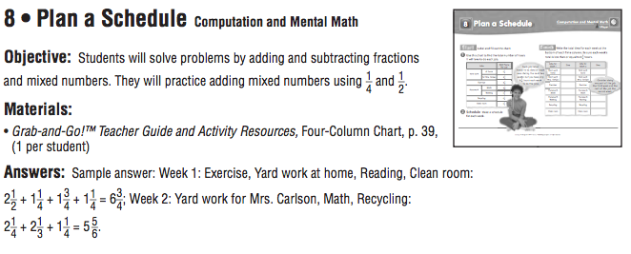
- What’s the Total? (Fraction Subtraction Activity – Adapted for Addition)
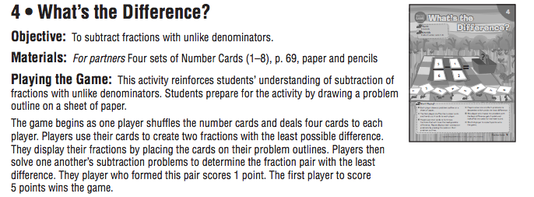

- Picture Problems (Fraction Subtraction Activity - Adapted for Addition)
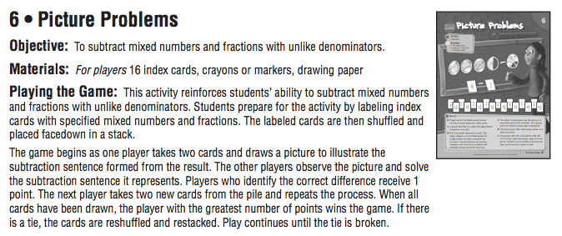

- Picture Problems (Fraction Addition and Subtraction Activity)
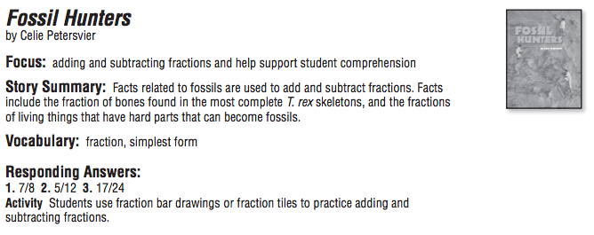
THE LESSON:
Sequence:

5 Min: Warm up-Fluency Builder
5 Min: Vocabulary Review
25 Min: Concept Development, Guided and Independent Practice
15 Min: Continued Practice, Centers and Small group
10 Min: Debrief (Essential Question)

Student/ Teacher Placement:

Note: Student desks are set up in quads-will be used for grouping and partner talk
Activity | Students | Teacher
Warm Up- Fluency Builder Vocabulary Review | Desks- Slates for students/ Quads | Whiteboard & SmartBoard
Concept Development | Desks/Quads | SmartBoard, circulating for guided and independent practice
Activities and Small Groups | Quads for Centers*  With teacher for small group | Small group table
Closure | Desks/Quads | Whiteboard

*Students sit next to purposeful partners for math. These are the partners that they will be working with. Quads are also purposefully set to encourage math talk and collaborative work. Partners and Quads are based on ability, learning style, and social/emotional needs. Students will be further grouped during the lesson through formative assessment.

Warm Up Fluency Builder – 5 min (Day 1 and 2)
Fact Practice and Math Reasoning: (respond on smart pals)
- Find, as many facts as you can that equal a given 2-digit number. Students may use addition, subtraction, multiplication or division. Students may also use a combination of operations to write equations with parenthesis, brackets or braces. Alternative warm up / fluency builder: Five multi-digit whole number multiplication or division computation problems to be completed on slates.
- Students will then have an opportunity to share their thinking. Students share their solutions, strategies, thinking and reasoning about numbers.
  - Teacher orally “collects” solutions/answers
  - Ask if anyone disagrees
    - Who would like to share their thinking?
  - Share several solutions and record
  - Teacher will ask questions such as:
    - How did you think about that?
    - Why did you do that? Tell me more.
    - Did anyone solve it in a different way?
    - Who else used this strategy?
    - What other strategies do you see being used?
    - What strategies seem to be quick, efficient, simple?

Vocabulary Review- 5 min (Day 1 and 2)
- Vocabulary previously introduced through fourth grade curriculum and previously taught vocabulary builder activity includes: fraction, numerator, denominator, benchmark, common denominator, equivalent fractions, simplest form, mixed number, and unit fraction.
- Students copy the fraction 5/10 and are asked to:
  - Circle the numerator
  - Make a box around the denominator
  - Write the fraction in simplest form
- Students copy the fractions ½, ¾, 2/3, and ¼.
  - Which two fractions have common denominators?
  - Why would you want to fractions to have common denominators?
- Review numerator, denominator, common denominators, unit fraction, and simplest form.
- Preview “equivalent fraction” What do you think it is? Consider what you know about the word equivalent? What is an equivalent fraction to 5/10?

Concept Development- Guided and Independent Practice (Day 1):

Engage
- Students prior knowledge will be assessed by reviewing with students how to model addition with fraction strips.
  - Teacher writes 2/6 + 3/6 on the board.
    - How many sixth fraction strips do you need to show 2/6?
    - How many do you need to show 3/6?
  - Students will use fraction strips to represent 2/6 + 3/6
    - How many sixth fraction strips show the sum of 2/6 + 3/6?
    - What is the sum of 2/6 + 3/6?
Teach and Talk
- Investigation 1
  - Students will work with their elbow partner to solve the problems below using fraction strips to model each of the fractions.
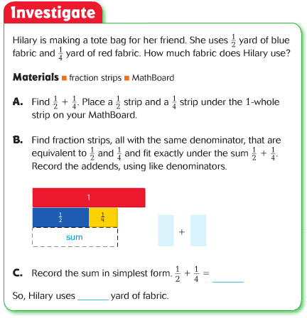
  - Students share solutions, explaining their reasoning, strategies, and justifying their answers.
  - Students then try the following problems ½ + 1/3 and ½ + ¼
    - Guiding Questions
      - Describe how you would determine what fraction strips, all with the same denominator, would fit exactly under ½ + 1/3? What are they?
      - Explain the difference between finding fraction strips with the same denominator for ½ + 1/3 and ½ + ¼?
  - Investigation 2
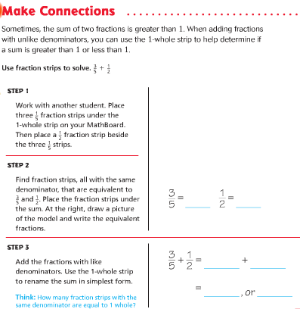
    - Guiding Questions
      - (Step 1) Why are models for 3/5 and ½ placed below a 1-whole strip?
      - (Step 2) Why do we place fraction strips that all have the same denominator under 3/5 and ½? What is the denominator of the fraction strips that fit under 3/5 and ½? Why do you think tenth strips fit under 3/5 and ½? What fraction is equivalent to 3/5? Explain how you know? What fraction is equivalent to ½? Explain how you know.
      - (Step 3) To find the sum 3/5 + ½, what equivalent fractions with like denominators do you add? How does the 1-whole fraction strip help you rename 11/10?
      - How many fraction strips with the same denominator are equal to 1 whole?
      - In what step did you find out that the answer was greater than 1? Explain

Practice (Intervene, On level, Enrich)
- Guided Practice of Grade Level problems – In partnerships students will complete the problems below using fraction strips to find the sum. Students will record their answer in simplest form.
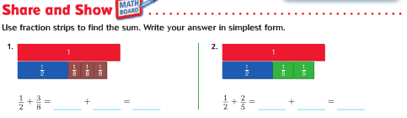
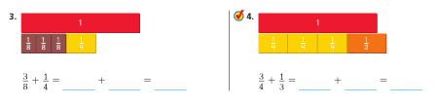
    - Guiding Questions:
- What do the numbers used in this problem represent?
- Will it still work if?
- What do you notice about the solutions you see?
- What is the same and what is different about…?
- What steps in the process are you most confident about?
- Talk me through the steps you have used to get to your answer.
- Extension – Enrichment for students as ready. Students have been assigned an online tutorial, lesson, and activity to continue practice of grade-level problems and exercises.
- MegaMath: Fraction Action - Fraction Flare Up: I. Add Unlike Fractions
  - Lesson Description- Use fraction bars to make all kinds of fractions and explore the relationship between them.
- Small Group – Tier 1 intervention for students who need extra support.
- Give each pair of students two sets of fraction strips. Have the partners find the strips that represent fourths and eights.
  - What is the name of one of the units of each fraction?
  - What is the numerator?
  - What is the denominator?
  - How many units of each fraction would it take to make a whole?
- Have the students represent the fraction 3/8 and ¼ with their fraction strips. Students will then model the addition of these two fractions by lining them up together under 1-whole.
  - Describe how you would determine what fraction strips, all with the same denominator, would fit exactly under ¼ + 3/8? What are they?
  - Why are models for ¼ and 1/8 placed below a 1-whole strip?
  - Why do we place fraction strips that all have the same denominator under ¼ and1/8? What is the denominator of the fraction strips that fit under ¼ and 1/8? Why do you think eights strips fit under ¼ and 1/8? What fraction is equivalent to 1/8? Explain how you know? What fraction is equivalent to ¼? Explain how you know.
  - Describe what you see. How many eighths are in ¼?
  - How can you find ¼ + 3/8?
  - To find the sum ¼ + 1/8, what equivalent fractions with like denominators do you add?
- Repeat above with 2/3 + 1/6

Concept Development- Guided and Independent Practice (Day 2):

Engage
- Students prior knowledge will be assessed by reviewing with students how to model addition with fraction strips.
  - Teacher writes 2/6 + 1/3 on the board.
    - How many sixth fraction strips do you need to show 2/6? To show 1/3?
  - Students will use fraction strips to represent 2/6 + 1/3
    - What is the denominator of the fraction strips that fit under 2/6 and 1/3? Why do you think third strips fit under 2/6 and 1/3? What fraction is equivalent to 1/3? How do you find the sum?
Teach and Talk
- Investigation
  - Students will work with their elbow partner to solve the problems below using fraction strips to model each of the fractions.
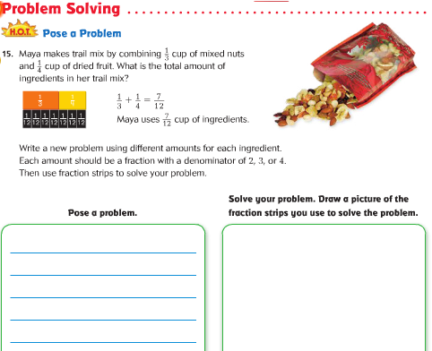
  - Students share solutions, explaining their reasoning, strategies, and justifying their answers.
    - Guiding Questions
      - Describe how you would determine what fraction strips, all with the same denominator, would fit exactly under 1/3 + ¼? What are they?
      - Why are models for 1/3 and ¼ placed below a 1-whole strip?
      - Why do we place fraction strips that all have the same denominator under 1/3 and ¼? What is the denominator of the fraction strips that fit under 3/5 and ½? Why do you think twelfths strips fit under 1/3 and ¼? What fraction is equivalent to 1/3? Explain how you know? What fraction is equivalent to ¼? Explain how you know.
      - To find the sum 1/3 + ¼, what equivalent fractions with like denominators do you add?
      - Will the sum of the fractions always be less than 1?
      - How many fraction strips with the same denominator are equal to 1 whole?
      - Suppose you add a third ingredient to the recipe and the amount of the ingredients are ½, ¼, and 1/6. Which fraction strips would you use to find the sum? Why?
    - Students will share their problems with their quads or with the class. Each partnership will read their problem aloud and model the picture of the fraction strips or use fraction strips to solve the problem.
      - Explain why chose the amounts you did for your problem?
      - What strategies did you use to solve the problem?
      - Use guiding questions from above

Practice (Intervene, On level, Enrich)
- Guided Practice of Grade Level problems – In partnerships students will complete the problems below using fraction strips to find the sum. Students will record their answer in simplest form.

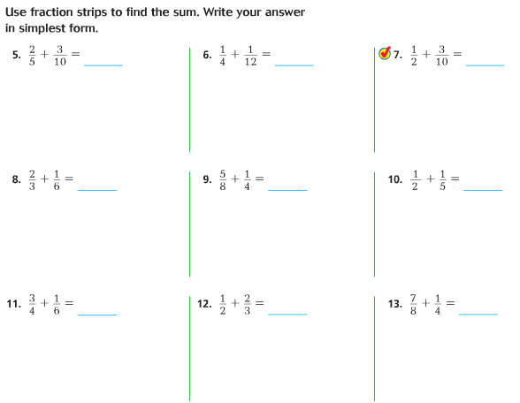
    - Guiding Questions:
- What do the numbers used in this problem represent?
- Will it still work if?
- What do you notice about the solutions you see?
- What is the same and what is different about…?
- What steps in the process are you most confident about?
- Talk me through the steps you have used to get to your answer.
- Partnership Activity – Activity for students to complete after grade-level practice problems are completed. Allows for continued practice of grade-level exercises, orchestrates conversations in which students talk about each other’s thinking, explaining their own thinking, and justifying their answers.
- “What’s the total?” (described above)
- Extension - Enrichment for students as ready, determined through formative assessments. Allows for continued practice of grade-level exercises, orchestrates conversations in which students talk about each other’s thinking, explaining their own thinking, and justifying their answers.
- “Plan a Schedule” (described above)
- Small Group – Tier 1 intervention for students who need extra support. Based on formative assessments from the prior lesson I will chose from below to intervene
- Students have been assigned an online tutorial, lesson, and activity to continue practice of grade-level problems and exercises.
  - Soar to Success 20.28: Add Unlike Fractions
- Give each pair of students two sets of fraction strips. Have the partners find the strips that represent a variety of models for addition of fractions. Will use similar models as above guided practice problems.
  - Guiding Questions
    - What is the name of one of the units of each fraction?
    - What is the numerator?
    - What is the denominator?
    - How many units of each fraction would it take to make a whole?
- Have the students represent the fractions with their fraction strips. Students will then model the addition of these two fractions by lining them up together under 1-whole.
  - Guiding Questions
    - Describe how you would determine what fraction strips, all with the same denominator, would fit exactly under each fraction? What are they?
    - Why are models for each fraction placed below a 1-whole strip?
    - Why do we place fraction strips that all have the same denominator under the fractions? What is the denominator of the fraction strips that fit under the fractions? Why do you think that fraction strip fits under those fractions? What fractions are equivalent to each fraction? Explain how you know.
    - Describe what you see.
    - How can you find the sum?

Closure (Day 1 and 2):
- Turn and talk to your partners. Then share out with the class.
  - Explain how using fraction strips with like denominators make it possible to add fractions with unlike denominators?
  - How can you use models to add fractions that have different denominators?
  - What is one thing you like about the method you learned today?
  - If you worked in a center, explain how you it helped you fraction addition?

Reflect on the lesson you have just planned and note which of the Core Action indicators you think this lesson illustrates particularly well.

The lesson I planned addresses all indicators in Core Action 1. The lesson is focused on the fifth grade-level cluster and grade-level content standards. The major grade-level cluster this lesson focuses on is “use equivalent fractions as a strategy to add and subtract fractions”. This lesson will intentionally relate the new concept of adding and subtraction fractions with like denominators to adding and subtracting fractions with un-like denominators. It will also link the students’ prior skills and knowledge of fractions to new concepts of fractions. The aspect of rigor that this lesson will target will be conceptual understanding to build to procedural skill and fluency. Students will also be asked to apply the skill of addition and subtraction of fractions to solve real-world problems.

As the teacher I will also address Core Action 2. An indicator that will be addressed in the lesson is indicator A, “teacher uses explanations, representations…”. During this lesson I have planned to specifically use models to represent fraction addition using equivalent fractions and common denominators. I will model these representations to the students through the use of SmartBoard GoMath! resources, and both hands-on and virtual manipulatives. During the fluency builder, concept development, guided practice, centers, small group, and closure I will be addressing Core Action 2 (B and D) by posing high quality questions and problems to prompt students to share thinking and the variation in their solution methods. Students will have opportunities to share their thinking with the class, partner, and table group. The students will be asked to not only share solutions but also their strategies, thinking and reasoning about their solution methods. Core Action 2C will also be addressed when students are given the opportunity and time to work on grade-level practice problems and exercises. Finally I will address Core Action 2F during the lesson closure. Students thinking will be guided to focus on the essential question, “How can you use models to add / subtract fractions that have different denominators?”. Students will need to summarize the mathematics of the lesson by sharing their work and thinking.

During this lesson I also plan to demonstrate indicators from Core Action 3. The specific indicators that will be evident are indicators B, C, D, and F. I believe I have created the culture in my mathematics classroom that supports these indicators. Students know that the expectation is that they explain their thinking through collaborative conversations and justify their work. Students will have the opportunity to explain their work and justify their solutions in multiple aspects of this lesson including the fluency builder, concept development, guided practice, centers, small group, and closure. I will use strategies such as “Math Talk Moves” to orchestrate mathematical conversations. These math talk moves include, re-voicing, asking students to restate someone else’s reasoning, asking students to apply their reasoning to someone else’s reasoning, prompting students for further participation, and using wait time. I will also use these strategies to connect students’ informal language to precise mathematical language appropriate for the grade-level content standards.

