
Practice Problems

- Jonas needs a cell phone. He has a choice between two companies with the following monthly billing policies. Each company’s monthly billing policy has an initial operating fee and charge per minute.

 | Operating Fee | Charge per Minute
Terri’s Telephone | $30.00 | $0.25
Carrie’s Connection | $20.00 | $1.00

At how many minutes is the monthly cost the same? What is the equal monthly cost of the two plans? Use the graph to justify your answer.

Graph the equations. What is the solution to the system of equations?

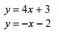
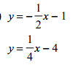
2. 3.

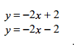
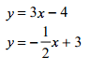
4. 5.

