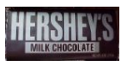

Ms. Redd decided to purchase bags of M&Ms and Hershey Bars for all of her students. Each bag of M&M cost $3.00, while each Hershey Bar costs $2.00. She ended up spending $16.00 on her purchase of 6 items.

**Part 1:**

1. 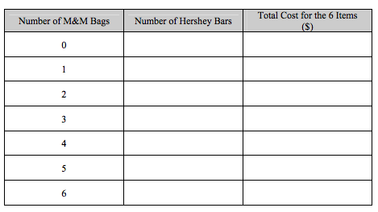Using the candy, complete the following table:
2. Circle the row that has the total cost Ms. Redd spent.
3. How many bags of M&Ms did Ms. Redd purchase?
4. How many Hershey Bars did Ms. Redd purchase?

**Part 2: Solving algebraically**

1. Define your variables (bags of M&Ms and Hershey Bars)
2. Write a system of equations.

Use substitution to solve:

**Part 3:**

1. Old McDonald had a farm that had Chickens and Ducks. Everyday Mr. McDonald collects 19 eggs, and he knows that each Duck lays 2 eggs, while each Chicken lays 3 eggs. But each week, every Duck eats 3 pounds of feed, while every chicken eats 4 pounds of feed, for a total of 26 pounds of feed.
   * What do the two variables in this system represent?
   * Write a system of equations to represent the model.
   * How many ducks are there? How many chickens are there? Use mathematics to explain how you determined your answer.

8. At the local Convenience store William and Sarah are getting snacks for the friends. William buys 3 soft drinks and 2 hot dogs at a cost of $7.70, while Sarah buys 2 soft drinks and 1 hot dog at cost of $ 4.55.

* + What do the two variables in this system represent?
  + Write a system of equations to represent the model.
  + What is the cost of 1 soft drink? What is the cost of 1 hot dog?