Function Rules Note-taker Name________________________________________
Part 1: Block Patterns(NLVM) – Table/Graph/Algebraic Rule for a Function
Activity 1:
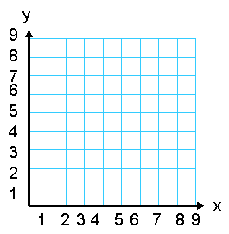
Fill in the table Create a scatter plot Write a function rule
x | y
1
2
3
4
5

How do you know it is correct?

Activity

Activity 2:
Fill in the table Create a scatter plot Write a function rule
x | y
1
2
3
4
5

How do you know it is correct?

Part 2: Algebraic Rules for Functions
I noticed… | I noticed…
I wonder… | I wonder…
Summary of writing an algebraic rule/ Things I need to know

Linear Functions (arithmetic patterns)
y= -2x+5y= -2x+5 Algebraically

Numerically
X | -2 | -1 | 0 | 1 | 2 | 3 | 4
f(x) | 9 | 7 | 5 | 3 | 1 | -1 | -3

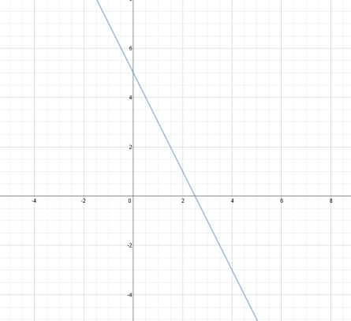
Graphically

Exponential Functions (geometric patterns)
I noticed… | I noticed…
I wonder… | I wonder…
Summary of writing an algebraic rule/ Things I need to know

y= 4(3)xy= 4(3)x Algebraically

Numerically
X | -2 | -1 | 0 | 1 | 2 | 3 | 4
f(x) | 4/9 | 4/3 | 4 | 12 | 36 | 144 | 324

Graphically

Quadratics Functions
I noticed… | I noticed…
I wonder… | I wonder…
Summary of things I need to know

Algebraically
$y=x^{2}+3$

Numerically
X | 0 | 1 | 2 | 3 | 4 | 5
f(x) | 3 | 4 | 7 | 12 | 19 | 28

Graphically

