**Teaching the Core- Exemplar Lesson Plan**

**.**

|  |  |
| --- | --- |
| School Name: Johnson | Teacher Name: Amy Weed |
| Date: January 8, 2013 | Period / Time: 12:30-1:30 |
| Room Number: 5 | Grade Level: 4 |
| Demographics of the class  (e.g., % ELL, % SPED, other relevant): | No sped or ell |

How will this lesson address the content area standards?

The **cluster** being addressed is:

**CC.4.NBT.B:** *Use place value understanding and properties of operations to perform multi-digit arithmetic.*

The **standard** being addressed is:

**CC.4.NBT.6-** *Find whole number quotients and remainders up to four digit dividends and one-digit divisors, using strategies based on place value, the properties of operations, and/or the relationship between multiplication and division. Illustrate and explain the calculation using equations, rectangular arrays, and/or area models.*

The **objective** of this lesson is:

*The students will use the partial quotients method to divide 3-digit dividends by one -digit divisors*.

**Standards for Mathematical Practices** targeted *i*n this lesson:

**SMP 1-** *Make sense of problems and persevere in solving them*

**SMP 2**- *Reason abstractly and quantitatively*

**SMP 3-** *Construct viable arguments and critique the reasoning of others*

**SMP 4-** *Model with mathematics*

The aspects of rigor called for in the standard are both procedural skill and fluency and conceptual understanding. In this lesson, students will use the partial quotients method in order to divide 3-digit dividends by one-digit divisors without remainders. Long division is an abstract concept for students. The partial quotients method is a conceptual approach. Students will often find the standard algorithm for division difficult, since it requires them to get an exact answer in the quotient for every step. Using this method, students ask themselves how many groups of the divisor are in the entire dividend. They are able to choose multiples of the divisor as long as they are less than the dividend. They then subtract from the dividend until less than the divisor remains. The partial quotients are added to find the total quotient.

How does this learning fit in the sequence of learning or curriculum for this class?

Students will have previous experience with utilizing the distributive property to find quotients using models such as grid paper and base ten blocks. Students will also be familiar with modeling the distributive property from their work with multiplication. They have experience with breaking the dividend into two numbers and dividing each number by the divisor to get two quotients. They will have seen that the sum of the two quotients is the same as the quotient for the original dividend. Students also will have experience with division using repeated subtraction and multiples to find quotients. They will have used number lines and counters to show the actual process of dividing and see divisor-sized chunks being used to count back from the dividend, marking chunks while dividing and counting to find the quotient. The partial quotients method uses both of these ideas to allow for an efficient and flexible method that allows for multiple solution pathways. In partial quotients division, it takes several steps to find the quotient. At each step, students find a partial answer (Partial quotient). They find the product of the partial quotient and the divisor and subtract it from the dividend. Once the dividend is less than the divisor, the final step is to add all of the partial quotients. Even students with limited basic facts knowledge and limited estimation skills can find answers using this approach. As students move through the process, they will discover that the better their estimates, the fewer the steps.

After this lesson, the students will use place value to determine where to place the first digit in the quotient in order to set the stage for using the traditional algorithm later. They will consider methods that work for them as they continue to divide up to four-digit dividends by one-digit divisors with and without remainders. They will use what they know to solve multistep division problems.

Materials used for the lesson:

For whole group warm up/fluency builder, number talk, and mini- lesson:

* Virtual manipulatives
* Interactive Whiteboard and Whiteboard
* Smart pals and markers (for students)

For Tier one small group:

* Counters and Smart pals

For Centers:

* Divide All Five (game):

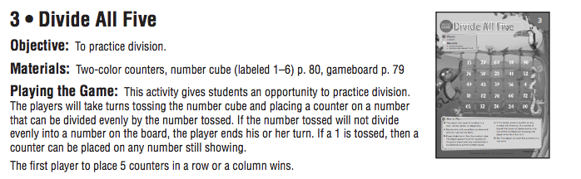

* Divide to Win (game)

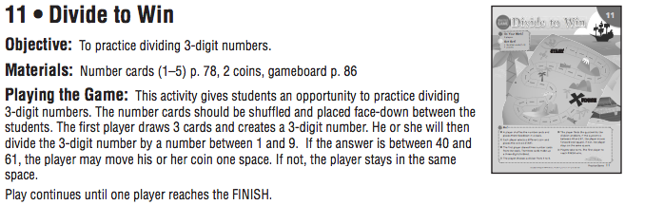

For enrichment group

* Spinners and Whiteboard/Smart-pals (for enrichment Activity)
* Dividend Rolls (card 9) (for challenge activity)

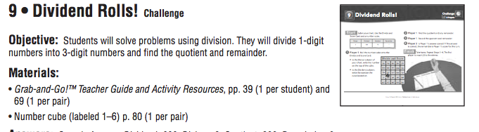

THE LESSON:

Sequence:

5 Min: Warm up-Fluency Builder/Vocabulary Review

5 Min: Number Talks

25 Min: Concept Development, Guided and Independent Practice

15 Min: Centers and Small group

10 Min: Debrief

Student/ Teacher Placement:

Note: Student desks are set up in quads-will be used for grouping and partner talk

|  |  |  |
| --- | --- | --- |
| Activity | Students | Teacher |
| Warm Up- Fluency Builder/Vocabulary Review | Desks- Smart Pals for students/Quads, | Whiteboard |
| Number Talks | Desks/Quads- Use Smart pals | Whiteboard |
| Concept Development | Desks/Quads | Smart board, circulating for guided and independent practice |
| Centers and Small Groups | Quads for Centers*  With teacher for small group | Small group table |
| Debrief | Desks/Quads | Whiteboard |

*Students at They will move to different “tables” depending on the center they are using

Warm Up – 5 min

Start with mental math: (respond on smart pals)

* How many 5’s are in 45?
* What number times 9 = 27?
* How many 4’s in 32?
* True or False?
  + There are at least 2 (5s) in 11
  + There are at least 10 (8s) in 92
  + There are at least 9 (8s) in 67
  + There are at least 8 (9s) in 75

Vocabulary Review-

* Teacher writes 72 divided by 9 on the board (In the form of a basic fact with the quotient)
* Students copy and are asked to:
  + Circle the divisor
  + Make a box around the quotient
  + Underline the dividend
* Review multiples, product, remainder
* Preview “Partial Quotient” What do you think it is? Consider what you know about “Partial Product”

Number Talks- 5 min:

Number talks provide opportunities for the children to work with computation in meaningful ways, share their solution strategies, and reason about numbers.

* Pose a problem such as 39 divided by 3
* Students solve using any method that works for them- they can do it mentally, but should show their thinking on smart pals- (The thinking is that some will use the distributive property, some will use repeated subtraction, number line, some will draw a picture…)
* Teacher orally “collects” solutions/answers
* Ask if anyone disagrees
  + Who would like to share their thinking?
* Share several solutions and record
* Teacher will ask questions such as:
  + How did you think about that?
  + Why did you do that? Tell me more.
  + Did anyone solve it in a different way?
  + Who else used this strategy?
  + What other strategies do you see being used?
  + What strategies seem to be quick, efficient, simple?

Concept Development- Guided and Independent Practice:

Start with introduction of the Partial Quotients by drawing comparisons to the Partial Products.

Guide the students through an example such as the following: (Set in the context of a problem) This is just an example of how I will model it.

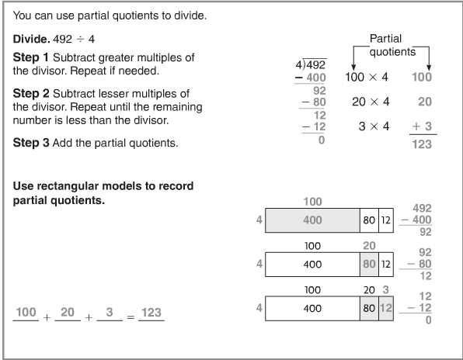

Note: I am unsure whether I will introduce the rectangular models. I would like to see how my students respond to the method before introducing it. I like the idea of the rectangular model because it ties directly to using the distributive property to multiply, in which some of the students used rectangular models to solve. This model makes the relationship between multiplication and division clear.

The baker has 492 donuts to pack. Each box holds 4 donuts. How many boxes will the baker need?

To build understanding, I will start by explaining that with this method, students will be making mental estimates. They may find it helpful to make a list of multiplication facts for the divisor. As a part of my initial modeling, I will encourage students to record “easy” multiples in order to aid them in solving the problem at hand. For example, for the above problem, we would write to following on the side as a guide:

4 x 100 = 400

4 x 10 = 40

4 x 5 = 20

4 x 2 = 8

Use the following guiding questions:

* When you make your first estimate, what question must you ask yourself?
  + How many 4’s are there in 492. How many times can you make a box of 4?
* Why is a multiple of 10 or 100 a good number to start with?
  + Because multiples of 100 or 10 are easy numbers to work with?
* Where should you record your partial quotients?
  + In a separate column- to the right of the problem
* How do you find the final quotient (the answer) and where is it recorded?
  + You find the sum of the partial quotients and record it as a sum of the column.

I will remind students that they need to look at the whole number and try to decide “about” how many 4’s are in 492.

Do another for 354 divided by 6. (The roller coaster holds six passengers. There are 354 people in line. How many times will the roller coaster need to run so that all passengers get a ride?)

Problem for partnerships: 225/3

Have 3 partnerships model their answers on the board side by side- Compare solutions.

Possible Teacher questions as students share their solutions and talk about their thinking:

* What do the numbers used in this problem represent?
* Will it still work if?
* What do you notice about the solutions you see?
* What is the same and what is different about…?
* What number model could you construct to represent the problem
* What steps in the process are you most confident about?
* Talk me through the steps you have used to get to your answer.

Problem for independent: 428/4, 738/6- Use as a formative assessment. Take group from students who need reinforcement. Do Tier 1 activity.

Other students- Independent practice:

Rob wants to put 8 baseball cards on each page in an album. How many pages will he fill if he has 248 cards? Use the partial quotients method to solve. Show the steps you used.

Move on to: Centers or challenge (See above)

De-brief:

Turn and talk to your partners.

* What is one thing you like about the method you learned today?
* If you worked in a center, explain how you it helped you practice division

Reflect on the lesson you have just planned and note which of the Core Action indicators you think this lesson illustrates particularly well.

As the lesson should, it meets all of the indicators in Core Action 1. When considering Core Action 2, I feel that indicator B is a focus for me. I have carefully planned “questions and problems that prompt students to share their developing thinking about the content of the lesson”. The number talk portion will allow students to talk to one another and share their thinking in a very purposeful way. Additionally, the partner work and share portion will give the students and opportunity to share their thinking. Indicator C will be met in the context of the independent practice and in the centers. During the lesson portion that highlights to different solution pathways after partner work is shared, indicator D will be met. I will meet indicator E with my questions, formative assessments using smart-pals, and small group work. During the de-brief, I hope to meet indicator E.

Core Action 3 is met by highlighting the mathematical practices throughout my instruction. I feel I will have the most strength around indicator B and C- “ establishing a culture in which students explain their thinking” and “orchestrating conversations in which students talk about each other’s thinking”