Grade K, Topic 1: Numbers 0 to 5
Standards addressed | Primary in this topic:  K.CC.A.3: Write numbers from 0 to 20. Represent a number of objects with a written numeral 0–20 (with 0 representing a count of no objects).  K.CC.B.4a: When counting objects, say the number names in the standard order, pairing each object with one and only one number name and each number name with one and only one object.  K.CC.B.4b: Understand that the last number name said tells the number of objects counted. The number of objects is the same regardless of their arrangement or the order in which they were counted.  K.CC.B.5: Count to answer “how many?” questions about as many as 20 things arranged in a line, a rectangular array, or a circle, or as many as 10 things in a scattered configuration; given a number from 1–20, count out that many objects.  Secondary in this topic:  K.CC.B.4.C: Understand that each successive number name refers to a quantity that is one larger.  K.OA.A.3: Decompose numbers less than or equal to 10 into pairs in more than one way, e.g., by using objects or drawings, and record each decomposition by a drawing or equation (e.g., 5 = 2 + 3 and 5 = 4 + 1).
Aspects of Rigor targeted by the standards | Primary in this topic:  Conceptual Understanding, Procedural Skill and Fluency
Applicable information from the progression documents |  | 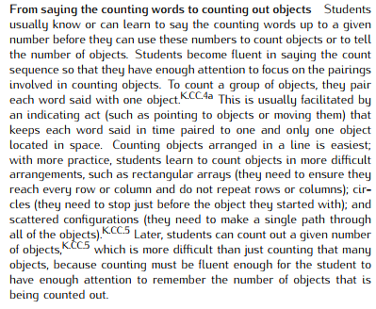  (See p. 4 in the CC /OA Progressions.)
Essential Question(s) |  | How can numbers from 0 to 5 be counted, read, and written?

Anchor Tasks
Task | Explanation
1-1 Intervention Activity | Provides opportunity to count concrete objects.
Topic Center: Big Collectors (p. 1M)  (limit the groups to 1, 2, or 3 objects) | Provides opportunity for students to create, count, resort, and recount groups of objects.
Topic Centers: Show Off! (p. 1N) | Allows multiple opportunities for students to build sets.
1-6 Solve and Share | Encourages students to connect numeral with multiple representations of a specific quantity.
1-7 Intervention Activity | Starts with 5 cubes and removes until 0 are left (opposite of the Solve & Share which starts with 0 and may be confusing).
1-9 Intervention Activity | Allows for many more opportunities for students to count to 5 and count parts of 5 compared to the Solve and Share.
The Napping House | Concretely connects counting and the understanding of hierarchical inclusion for students.

Topic Rules of Thumb
Rule | Why?
Give students multiple experiences throughout the topic to count orally (e.g., Choral Counting). | Students become fluent in saying the count sequence so that they have enough attention to focus on the pairings involved in counting objects.  (See p. 4 in the CC/OA Progressions.)
Throughout the topic, allow students to work with bins of materials instead of counting out the exact number of counters each student will need. | K.CC.B.5 requires students to count out sets of objects.
Give students opportunities to use multiple ways to represent and record the count of objects. | Students need experiences in the concrete before jumping to symbols.

Assessment Guidance, Topic 1
→ Topic Assessment
Performance Assessment
Item #/Action | Why?
- As Is
- Optional | There is only one lesson on K.OA.A.3 in the topic. Since it will be addressed in later topics use discretion on assessing now.
- As Is
- As Is
- Modify: Use oral direction: “How many basketballs are in each row? Write the numbers to tell how many.” | The item does not lend itself to making a math argument.
- As Is
- As Is
- As Is | Note: This item aligns to K.CC.A.3.
- Optional | There is only one lesson on K.OA.A.3 in the topic. Since it will be addressed in later topics use discretion on assessing now.
- As Is
- As Is | Note: This item aligns to K.CC.A.3.
- As Is

Grade K, Topic 2: Compare Numbers 0 to 5
Standards addressed | Primary in this topic:  K.CC.6: Identify whether the number of objects in one group is greater than, less than, or equal to the number of objects in another group, e.g., by using matching and counting strategies.  K.CC.7: Compare two numbers between 1 and 10 presented as written numerals.
Aspects of Rigor targeted by the standards | Primary in this topic:  Conceptual Understanding, Procedural Skill and Fluency
Applicable information from the progression documents | 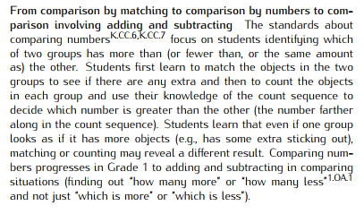  (See p. 5 of the CC/OA Progressions.)
Essential Question(s) | How can we compare quantities?

Anchor Tasks
Task | Explanation
More and Less Handfuls  (Begin with large counters to ensure students grab fewer than five in a handful and their resulting two handfuls are a small enough number to manage.) | Allows students multiple concrete experiences with comparing groups.
Illustrative Mathematics Unit 2, Lesson 5 Make groups of more, fewer, or the same | Students make groups that have more, fewer, or the same number of objects as another group.
2-5 Intervention Activity | K.CC.7 requires comparing numerals. Solve and Share has the visual of counters/objects while the Intervention Activity focuses on strategies for comparing numerals only.
Topic Center: Ordering Numbers (p. 85L) | Builds on beginning understanding of hierarchical inclusion (K.CC.B.4c) started in the first topic and connects to comparisons.

Topic Rules of Thumb
Rule | Why?
Give students plenty of experiences matching and comparing objects before moving on to comparisons with numerals. Students should orally identify which set is greater than, less than, or the same using the objects to make the comparison, as needed. | 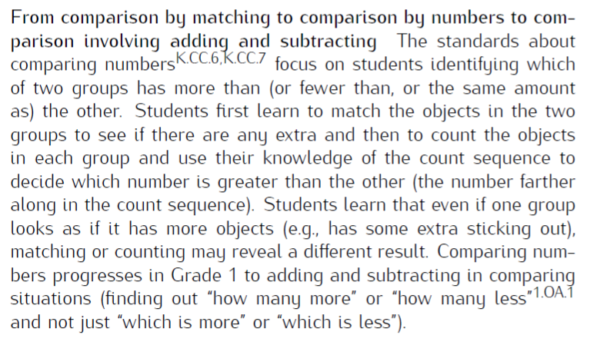  (See p. 5 in the CC/OA Progressions.)  K.CC.C cluster requires students to compare numbers.
Throughout the topic, allow students to work with bins of materials instead of counting out the exact number of counters each student will need. | K.CC.B.5 requires students to count out sets of objects.
Consistently use the language of “greater than,” “less than,” or “equal to” rather than “less/greater than the other number.” | K.CC.C.6 requires students to identify groups with equal quantities as well as groups with more and fewer.

Assessment Guidance, Topic 2
→ Topic Assessment
Performance Assessment
Item #/Action | Why?
- Modify: Use oral direction: “Which basketballs are greater than the number of footballs?” | Use language specific to K.CC.C.6.
- As Is
- Modify: Use oral direction: “Have students draw a circle around the number that is greater, or draw a circle around both numbers if they are equal. Then have students draw pictures to show how they know.” | Use language specific to K.CC.C.6.
- As is | Note: This item aligns to K.CC.C.6 only.
- Modify: Use oral direction: “Draw a group of toys that is less than the group of toy airplanes shown.” | Use language specific to K.CC.C.6.
- Modify: Use oral direction: Marcus has 4 toy frogs and 3 toy elephants. Color the cubes to show how many of each type of toy, and then draw a circle around the cube train that has a greater number of cubes.” | Use language specific to K.CC.C.6.

Grade K, Topic 3: Numbers 6 to 10
Standards addressed | Primary in this topic:  K.CC.A.3: Write numbers from 0 to 20. Represent a number of objects with a written numeral 0–20 (with 0 representing a count of no objects).  K.CC.B.4.A: When counting objects, say the number names in the standard order, pairing each object with one and only one number name and each number name with one and only one object.  K.CC.B.4.B: Understand that the last number name said tells the number of objects counted. The number of objects is the same regardless of their arrangement or the order in which they were counted.  K.CC.B.5: Count to answer "how many?" questions about as many as 20 things arranged in a line, a rectangular array, or a circle, or as many as 10 things in a scattered configuration; given a number from 1–20, count out that many objects.  Secondary in this topic:  K.OA.A.3: Decompose numbers less than or equal to 10 into pairs in more than one way, e.g., by using objects or drawings, and record each decomposition by a drawing or equation (e.g., 5 = 2 + 3 and 5 = 4 + 1).
Aspects of Rigor targeted by the standards | Primary in this topic:  Conceptual Understanding, Procedural Skill and Fluency
Applicable information from the progression documents | (See p. 4 of the CC/OA Progressions.)
Essential Question(s) | How can numbers from 6 to 10 be counted, read, and written?

Anchor Tasks
Task | Explanation
3-1 Solve and Share | Uses the 5-frame to highlight 5 as an anchor.
3-3 Solve and Share | Uses the 10-frame to highlight 10 as an anchor.
Topic Center: Tower Power (p.135N) | Allows for many hands-on experiences with numerals and creating sets.
Shake and Spill | Provides for many opportunities to document number combinations.

Topic Rules of Thumb
Rule | Why?
Throughout the topic, allow students to work with bins of materials instead of counting out the exact number of counters each student will need. | K.CC.B.5 requires students to count out sets of objects.
Give students opportunities to use multiple ways to represent and record the count of objects. | Students need experiences in the concrete before jumping to symbols.

Assessment Guidance, Topic 3
→ Topic Assessment
Performance Assessment
Item #/Action | Why?
- As Is | Note: This item aligns to K.CC.B.5.
- As Is | Note: This item aligns to K.CC.B.5.
- As Is | Note: This item aligns to K.CC.B.4a.
- As Is
- As Is
- As Is
- As Is
- As Is
- Delete | Item aligns to K.OA.A.4 which is not covered in this topic.
- Delete | Item requires finding all of the combinations to make a number.

Grade K, Topic 4: Compare Numbers 0 to 10

Standards addressed | Primary in this topic:  K.CC.6: Identify whether the number of objects in one group is greater than, less than, or equal to the number of objects in another group, e.g., by using matching and counting strategies.  K.CC.7: Compare two numbers between 1 and 10 presented as written numerals.  Secondary in this topic:  K.CC.B.4.C: Understand that each successive number name refers to a quantity that is one larger.  K.CC.A.2: Count forward beginning from a given number within the known sequence (instead of having to begin at 1).
Aspects of Rigor targeted by the standards | Primary in this topic:  Conceptual Understanding, Procedural Skill and Fluency
Applicable information from the progression documents | (See p. 5 of the CC/OA Progressions.)
Essential Question(s) | How can we compare quantities?

Anchor Tasks
Task | Explanation
More and Less Handfuls | Allows students multiple concrete experiences with comparing groups.
4-4 Intervention Activity | Allows students to partner and discuss their reasoning as they work with matching manipulatives to compare groups.
Guess the marbles in the bag | “The iteration of greater than, less than, and equal to with a specific "target number" will help strengthen the concept. It is important that all the numerals used in the game are written down both to aid in comparison and to meet the standard.” (From Illustrative Mathematics Task Commentary)
Which number is greater? Which number is less? How do you know? | “This task requires students to explain their reasoning which will strengthen their understanding and number sense.” (From Illustrative Mathematics Task Commentary)
Topic Centers: More or Less? (p.245K).  (Remove the time constraint) | Although this activity is from the next topic, it would challenge students to continually reassess the relationship of their quantity to the desired 10 cubes. It will allow for additional practice of the concepts of more and less in a hands-on manner.
Anchor Tasks from Topic 2 could also be repeated using quantities through 10. | Provides repeated exposure to tasks to deepen understanding.

Topic Rules of Thumb
Rule | Why?
Include experiences matching and comparing objects before moving on to comparisons with numerals. Students should orally identify which set is greater than, less than, or the same using the objects to make the comparison, as needed. | K.CC.C.6 requires students to compare numbers.
Throughout the topic, allow students to work with bins of materials instead of counting out the exact number of counters each student will need. | K.CC.B.5 requires students to count out sets of objects.
Consistently use the language of “greater than,” “less than,” and “equal to” rather than “less/greater than the other number.” | K.CC.C.6 requires students to identify groups with equal quantities as well as groups with more and fewer.

Assessment Guidance, Topic 4
→Topic Assessment
Performance Assessment
Item #/Action | Why?
- Modify: In oral direction, replace “greater in number than the group” with “greater than.” | Use language specific to K.CC.C.6.
- As Is
- As Is
- As Is
- Modify: In oral direction, replace “less in number than the group” with “less than.” | Use language specific to K.CC.C.6.
- As Is

Grade K, Topic 5: Classify and Count Data

Standards addressed | Primary in this topic:  K.MD.B.3: Classify objects into given categories; count the numbers of objects in each category, and sort the categories by count.  K.CC.C.6: Identify whether the number of objects in one group is greater than, less than, or equal to the number of objects in another group, e.g., by using matching and counting strategies.  K.CC.C.7: Compare two numbers between 1 and 10 presented as written numerals.  Secondary in this topic:  K.CC.B.5: Count to answer "how many?" questions about as many as 20 things arranged in a line, a rectangular array, or a circle, or as many as 10 things in a scattered configuration; given a number from 1-20, count out that many objects. Compare numbers.
Aspects of Rigor targeted by the standards | Primary in this topic: Conceptual Understanding  Secondary in this topic: Procedural Skill and Fluency
Applicable information from the progression documents | 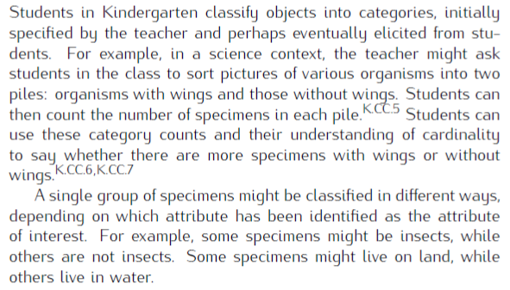  (See p. 5 in the MD Progressions.)
Essential Question(s) | How can we classify and count the number of objects in a category?
Anchor Tasks
Task | Explanation
Sort and Count 1 | Provides opportunity for students to engage in a concrete sorting activity.
5-3 Intervention Activity | Provides opportunity for students to sort the actual objects, yellow and red counters, rather sorting pictures and using counters to stand for the pictures.
Sort and Count 2 | Provides opportunity for students to engage in a concrete sorting activity.
5-4 Solve and Share | Requires students to explain their reasoning.

Topic Rules of Thumb
Rule | Why?
Limit the amount of instructional time spent on drawing. | K.MD.B.3, K.CC.C.6 and K.CC.B.5 call for students to classify, identify, and count. They do not require students to create pictorial representations.
Instructional time: Use manipulatives (or pictures) with attributes that are visible on the objects they are sorting. Counters should contain multiple attributes that could be sorted so there is some choice. This allows for multiple ways to sort the same set. Students should not be asked to use counters to stand for the objects or pictures to be sorted. At this age, students need to use the objects themselves or pictures of the objects to sort. Example: Buttons could be sorted by size, number of holes, color, shank/no shank. Students should sort by one attribute at a time. | enVisionmath 2.0 asks students to match counters to pictures of items to be sorted and then count the counters to determine. This might lead to confusion.  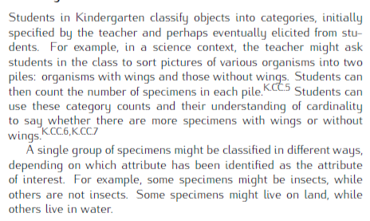  (See p. 5 in the MD Progressions.)
In 5-2, de-emphasize the importance of/use of tally marks. | Students should choose the strategy or model that makes sense to them.
Assessment Guidance, Topic 5
→Topic Assessment
Performance Assessment
Item #/Action | Why?
- Delete | Repeats content of question #4.
- As Is
- Delete | Repeats content of question #2.
- Modify: Use oral direction: “Write the number to show how many pails have stars. Write the number to show how many pails don’t have stars.” Do not require students to create a tally chart. | Item requires students to make a data display.
- Delete | Repeats content of question #4.
- As Is

Grade K, Topic 6: Understand Addition

Standards addressed | Primary in this topic:  K.OA.A.1: Represent addition and subtraction with objects, fingers, mental images, drawings, sounds (e.g., claps), acting out situations, verbal explanations, expressions, or equations.  K.OA.A.2: Solve addition and subtraction word problems, and add and subtract within 10, e.g., by using objects or drawings to represent the problem.  Secondary in this topic:  K.CC.A.2: Count forward beginning from a given number within the known sequence (instead of having to begin at 1).  K.OA.A.5: Fluently add and subtract within 5.
Aspects of Rigor targeted by the standards | Primary in this topic:  Conceptual Understanding, Application  Secondary in this topic:  Procedural Skill and Fluency
Applicable information from the progression documents | 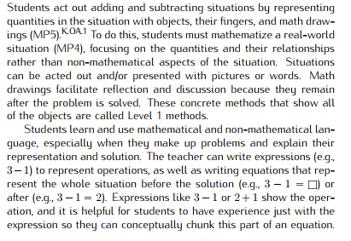  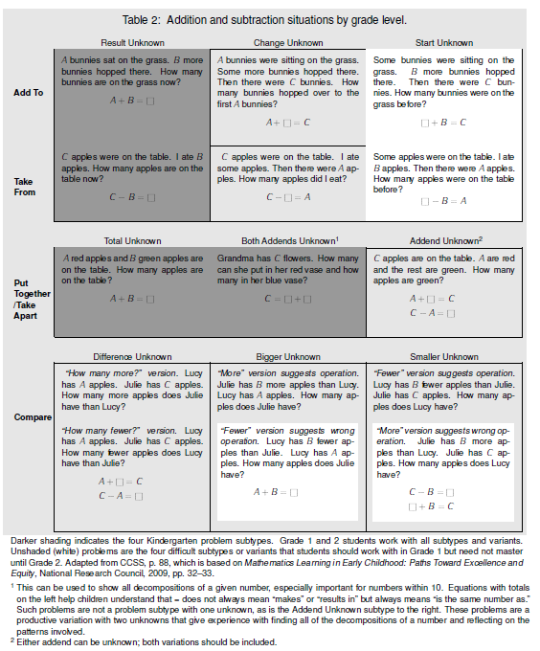  (See pp. 8–9 in the CC/OA Progressions.)
Essential Question(s) | What is addition?

Anchor Tasks
Task | Explanation
6-2 Intervention Activity | Allows for multiple opportunities to engage different numbers and using representations and as listed in the standard K.OA.A.1.
6-9 Intervention Activity | Allows for students to have multiple experiences working with combing quantities using their bodies to model the addition.
Ten-Frame Addition | Allows for students to have multiple experiences working with combing quantities below ten and uses the ten frame as a tool to visually support their addition. Could start with dice with only one, two, or three dots.

Topic Rules of Thumb
Rule | Why?
Do not have students use the Visual Learning Bridge, Guided Practice, Independent Practice, Reteaching, Leveled Assignment pages for lessons 6-4 through 6-10. Teacher should read the problem orally and have students represent the problem using manipulatives, drawings, or act it out. If students are presented with the pictures, they may count instead of thinking of the situation as addition. The addends in the illustrations are mathematically confusing since the addends and total images do not line up with the equation. | K.OA.A.1 requires students to model addition with objects.
Minimize the emphasis on writing equations. | 1.OA.D.7 requires students to understand the meaning of the equal sign; in kindergarten, emphasis should be on understanding the meaning of the operations.  In the K.OA standards, equations are offered as an option vs. a requirement. Students are required to use equations in grade 1. The language of the standards in K is “drawings, objects, or equations” while in grade 1, the language reads “drawings, objects, and equations.”
Use all kindergarten representations listed in Standards for addition and subtraction. | K.OA.A.1 requires students to use objects, fingers, mental  images, drawings, sounds, acting out situations, verbal explanations, expressions, or equations  (See p. 8 in the CC/OA Progressions.)
Use a variety of phrases when posing oral and written word problems. There is an overuse of the words “in all” and “and” in story problems throughout the topic. Vary stems with “all together,” “total,” “now,” “how many.”  Additionally, Lessons 6-3 (Solve and Share) and 6-4 (Solve and Share) direct teachers to ask students what word indicates joining; bring emphasis to the word “and” as a signal for addition. | MP1 requires students to make sense of problems.

Assessment Guidance, Topic 6
→Topic Assessment
Performance Assessment
Item #/Action | Why?
- As Is
- As Is
- As Is
- As Is
- As Is
- As Is
- As Is
- As Is
- As Is
- As Is
- Delete | Item does not assess fluency, which is required by K.OA.A.5.

Grade K, Topic 7: Understand Subtraction

Standards addressed | Primary in this topic:  K.OA.A.1: Represent addition and subtraction with objects, fingers, mental images, drawings, sounds (e.g., claps), acting out situations, verbal explanations, expressions, or equations.  K.OA.A.2: Solve addition and subtraction word problems, and add and subtract within 10, e.g., by using objects or drawings to represent the problem.  Secondary in this topic:  K.OA.A.5: Fluently add and subtract within 5.
Aspects of Rigor targeted by the standards | Primary in this topic:  Conceptual Understanding, Application  Secondary in this topic:  Procedural Skill and Fluency
Applicable information from the progression documents | 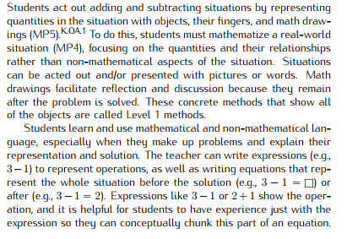  (See p. 8 in the CC/OA Progressions.)
Essential Question(s) | What is subtraction?

Anchor Tasks

Task | Explanation
7-1 Intervention Activity | Develops conceptual understanding of subtraction.
7-2 Intervention Activity | Develops conceptual understanding of subtraction.
7-9 Intervention Activity | Allows for students to have multiple experiences working with the numbers.

Topic Rules of Thumb

Rule | Why?
Do not have students use the workbook pages for lessons 7-2 through 7-9. Teacher should read the problem orally and have students represent the problem using manipulatives, drawings, or act it out. If students are presented with the pictures, they may count instead of thinking of the situation as addition. The illustrations are mathematically confusing. | K.OA.A.1 requires students to model subtraction with objects.
Minimize the emphasis on writing equations. | 1.OA.D.7 requires students to understand the meaning of the equal sign; in kindergarten, emphasis should be on understanding the meaning of the operations.
Use all kindergarten representations listed in standards for addition and subtraction. | K.OA.A.1 requires students to use objects, fingers, mental images, drawings, sounds, acting out situations, verbal explanations, expressions or equations (See p. 8 in the CC/OA Progressions.)
Use a variety of phrases when posing oral and written word problems. There is an overuse of the words “are left” and “take away throughout the topic. Vary stems with “can there be,” “total,” “now,” “how many.”  Additionally, Lesson 7-9 (Visual Learning pp. 415–416) instructs students to listen for words that indicate whether to add or subtract. In the instructions for Items 3-6 on the Independent Practice, it is explicitly stated that students need to listen for these words. | MP1 requires students to make sense of problems.

Assessment Guidance, Topic 7
→Topic Assessment
Performance Assessment
Item #/Action | Why?
- As Is
- As Is
- As Is
- As Is
- As Is
- As Is
- As Is
- Delete | K.OA.A.5 requires fluency, which is not assessed by this item.
- As Is
- As Is
- As Is
- As Is

Grade K, Topic 8: More Addition and Subtraction

Standards addressed | Primary in this topic:  K.OA.A.3: Decompose numbers less than or equal to 10 into pairs in more than one way, e.g., by using objects or drawings, and record each decomposition by a drawing or equation (e.g., 5 = 2 + 3 and 5 = 4 + 1).  K.OA.A.4: For any number from 1 to 9, find the number that makes 10 when added to the given number, e.g., by using objects or drawings, and record the answer with a drawing or equation.  K.OA.A.5: Fluently add and subtract within 5.  Secondary in this topic:  K.OA.A.1: Represent addition and subtraction with objects, fingers, mental images, drawings, sounds (e.g., claps), acting out situations, verbal explanations, expressions, or equations.  K.OA.A.2: Solve addition and subtraction word problems, and add and subtract within 10, e.g., by using objects or drawings to represent the problem.
Aspects of Rigor targeted by the standards | Primary in this topic:  Conceptual Understanding, Procedural Skill and Fluency  Secondary in this topic:  Application
Applicable information from the progression documents | 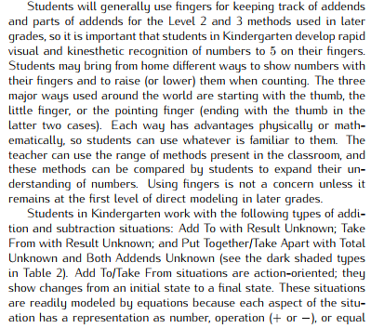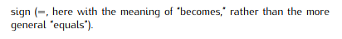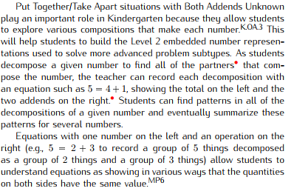  (See p. 10 in the CC/OA Progressions.)
Essential Question(s) | How do we use addition and subtraction to solve problems?
Anchor Tasks
Task | Explanation
8-5 Intervention Activity | Repetition with these activities builds fluency required by K.OA.A.5.
8-6 Intervention Activity | Repetition with these activities builds fluency required by K.OA.A.5.
8-7 Intervention Activity | Repetition with these activities builds fluency required by K.OA.A.3 and K.OA.A.4.
8-10 Solve and Share | Repetition with these activities builds fluency required by K.OA.A.4.

Topic Rules of Thumb
Rule | Why?
Delete lesson 8-2. | Lesson aligns to 1.OA.B.3.
Use all kindergarten representations listed in standards for addition and subtraction. | K.OA.A.1 requires students to use objects, fingers, mental images, drawings, sounds, acting out situations, verbal explanations, expressions, or equations (See p. 8 in the CC/OA Progressions.)

Assessment Guidance, Topic 8
→Topic Assessment
Performance Assessment
Item #/Action | Why?
- As Is
- As Is
- As Is
- As Is
- Delete | Repeats content from question #10.
- As Is
- Delete
- As Is
- Delete | Repeats content from question #8.
- As Is
- As Is
- As Is
- As Is

Grade K, Topic 9: Count Numbers to 20

Standards addressed | Primary in this topic:  K.CC.A.2: Count forward beginning from a given number within the known sequence (instead of having to begin at 1).  K.CC.A.3: Write numbers from 0 to 20. Represent a number of objects with a written numeral 0–20 (with 0 representing a count of no objects).  K.CC.B.5: Count to answer "how many?" questions about as many as 20 things arranged in a line, a rectangular array, or a circle, or as many as 10 things in a scattered configuration; given a number from 1–20, count out that many objects.  Secondary in this topic:  K.CC.B.4.C: Understand that each successive number name refers to a quantity that is one larger.
Aspects of Rigor targeted by the standards | Primary in this topic:  Conceptual Understanding, Procedural Skill and Fluency
Applicable information from the progression documents | 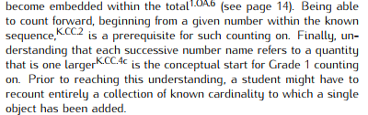  (See p. 5 in the CC/OA Progressions.)  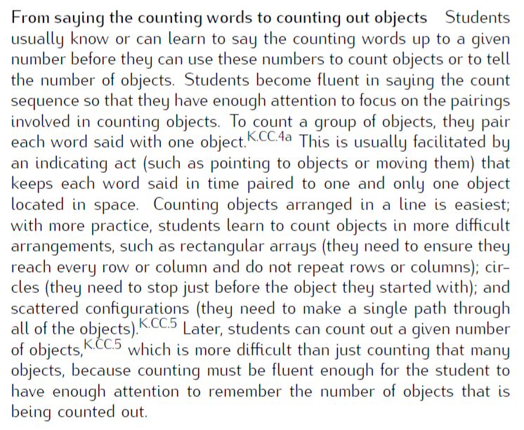  (See p. 4 in the CC/OA Progressions.)
Essential Question(s) | How can numbers to 20 be counted, read, written, and pictured to tell how many?
Anchor Tasks
Task | Explanation
9-4 Intervention Activity | Culminating activity which incorporates representing all numbers from 11-20.
9-6 Solve and Share | Allows for experience counting a large number of objects.
Topic Center: More or Fewer (p. 507M) | Allows students to use problem solving skills to add/subtract to reach the target number.

Topic Rules of Thumb
Rule | Why?
Students should be both counting and writing numbers during lessons 9-1 to 9-4. | Meet full expectations of K.CC.A.2 and K.CC.A.3, requiring students to both count and write.
Consistently use the language of ten ones, not a ten (especially with ten frame model). | “Children learn to view the whole numbers 11 through 19 as ten ones and some more ones…By working with teen numbers in this way in kindergarten, students gain a foundation for viewing 10 ones as a new unit called a ten in Grade 1.”  (See p. 5 in the NBT Progressions.)  In grade 1, students shift to conceptualizing ten ones as one unit of ten.  (See p. 6 in the NBT Progressions.)
Allow students to work with bins of materials instead of counting out the exact number of counters each student will need throughout the topic. | K.CC.B.5 requires students to count out sets of objects.

Assessment Guidance, Topic 9
→Topic Assessment
Performance Assessment
Item #/Action | Why?
- As Is
- As Is
- Delete | Item not aligned to K.CC.B.5.
- As Is
- Delete | Item not aligned to K.CC.A.2.
- As Is
- As Is

Grade K, Topic 10: Compose and Decompose Numbers 11 to 20

Standards addressed | Primary in this topic:  K.NBT.A.1: Compose and decompose numbers from 11 to 19 into ten ones and some further ones, e.g., by using objects or drawings, and record each composition or decomposition by a drawing or equation (such as 18 = 10 + 8); understand that these numbers are composed of ten ones and one, two, three, four, five, six, seven, eight, or nine ones.
Aspects of Rigor targeted by the standards | Primary in this topic:  Conceptual Understanding
Applicable information from the progression documents | 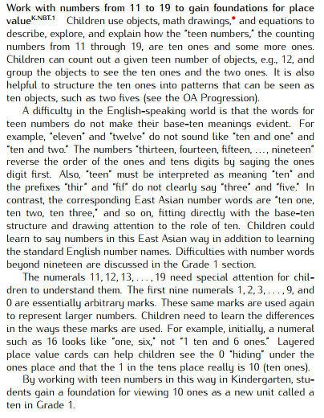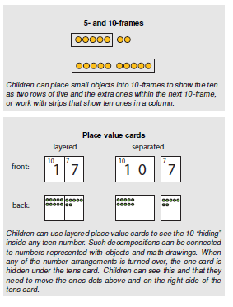  (See p. 5 in the NBT Progressions.)  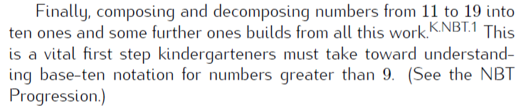  (See p. 11 in the CC/OA Progressions.)
Essential Question(s) | How do ten ones and some extra ones help you understand place value/how numbers work?
Anchor Tasks
Task | Explanation
10-4 Intervention Activity | Provides more opportunities for students to count to 10 since students are able to resort and recount.
10-5 Intervention Activity | Allows students to make the ten ones group and extras with actual objects.
Topic Centers: Movement Center (p. 563N) | Use after 10-6 since students will have experience with numbers 11–19.

Topic Rules of Thumb
Rule | Why?
Minimize the emphasis on writing equations. | 1.OA.D.7 requires students to understand the meaning of the equal sign; in kindergarten, emphasis should be on understanding the meaning of the operations (joining and separating).
Use multiple representations that illustrate teen numbers as 10 ones and some more ones. | K.NBT.A.1 suggests students use objects and drawings in addition to equations to compose and decompose numbers. “Math drawings are simple drawings that make essential mathematical features and relationships salient while suppressing details that are not relevant to the mathematical ideas.”  (See p. 5 in the NBT Progressions.)
Delete lesson 10-7. | The structure in the place value is about the 10, not about the number of ones. Not focused on decomposing and composing from standards K.NBT.A or K.NBT.A.1.

Assessment Guidance, Topic 10
→Topic Assessment
Performance Assessment
Item #/Action | Why?
- As Is
- As Is
- As Is
- Delete | K.NBT.A.1 requires students to decompose numbers into a ten and some ones. The hundreds chart does not make this clear.
- As Is
- As Is
- Delete | Repeats content from previous items.
- As Is

Grade K, Topic 11: Count Numbers to 100 (Deleted)
Note: The standards for Kindergarten require oral counting up to 100 and counting objects up to 20. Since the focus of this topic is counting objects beyond 20, it should be deleted.

Standards addressed | Primary in this topic:  K.CC.A.1: Count to 100 by ones and by tens.
Aspects of Rigor targeted by the standards | Primary in this topic:  Procedural Skill and Fluency  Secondary in this topic:  Conceptual Understanding
Applicable information from the progression documents | N/A
Essential Question(s) | N/A

Grade K, Topic 12: Identify and Describe Shapes

Standards addressed | Primary in this topic:  K.G.A.:1 Describe objects in the environment using names of shapes, and describe the relative positions of these objects using terms such as above, below, beside, in front of, behind, and next to.  K.G.A.2: Correctly name shapes regardless of their orientations or overall size.  K.G.A.3: Identify shapes as two-dimensional (lying in a plane, “flat”) or three dimensional (“solid”).  K.G.B.4: Analyze and compare two- and three-dimensional shapes, in different sizes and orientations, using informal language to describe their similarities, differences, parts (e.g., number of sides and vertices/“corners”) and other attributes (e.g., having sides of equal length).
Aspects of Rigor targeted by the standards | Primary in this topic:  Conceptual Understanding  Secondary in this topic:  Application
Applicable information from the progression documents | Students refine their informal language by learning mathematical concepts and vocabulary so as to increasingly describe their physical world from geometric perspectives, e.g., shape, orientation, spatial relations (MP4). They increase their knowledge of a variety of shapes, including circles, triangles, squares, rectangles, and special cases of other shapes such as regular hexagons, and trapezoids with unequal bases and non-parallel sides of equal length. Students also begin to name and describe three-dimensional shapes with mathematical vocabulary, such as “sphere,” “cube,” “cylinder,” and “cone.” Finally, in the domain of spatial reasoning, students discuss not only shape and orientation, but also the relative positions of objects, using terms such as “above,” “below,” “next to,” “behind,” “in front of,” and “beside.”  Students learn to name shapes such as circles, triangles, and squares, whose names occur in everyday language, and distinguish them from non-examples of these categories, often based initially on visual prototypes.  In the domain of shape, students learn to match two-dimensional shapes even when the shapes have different orientations. The need to explain their decisions about shape names or classifications prompts students to attend to and describe certain features of the shapes. That is, concept images and names they have learned for the shapes are the raw material from which they can abstract common features. They identify faces of three-dimensional shapes as two-dimensional geometric figures and explicitly identify shapes as two-dimensional (“flat” or lying in a plane) or three-dimensional ("solid").  (See p. 6 in the G Progressions.)
Essential Question(s) | How are shapes identified and described?
Assessment Guidance, Topic 12
Topic Assessment
→Performance Assessment
Item #/Action | Why?
- As Is
- As Is
- As Is
- As Is
- As Is

Grade K, Topic 13: Analyze, Compare, and Create Shapes

Standards addressed | Primary in this topic:  K.G.B.4: Analyze and compare two- and three-dimensional shapes, in different sizes and orientations, using informal language to describe their similarities, differences, parts (e.g., number of sides and vertices/“corners”) and other attributes (e.g., having sides of equal length).  K.G.B.5: Model shapes in the world by building shapes from components (e.g., sticks and clay balls) and drawing shapes.  K.G.B.6: Compose simple shapes to form larger shapes. For example, “Can you join these two triangles with full sides touching to make a rectangle?”
Aspects of Rigor targeted by the standards | Primary in this topic:  Conceptual Understanding  Secondary in this topic:  Application
Applicable information from the progression documents | 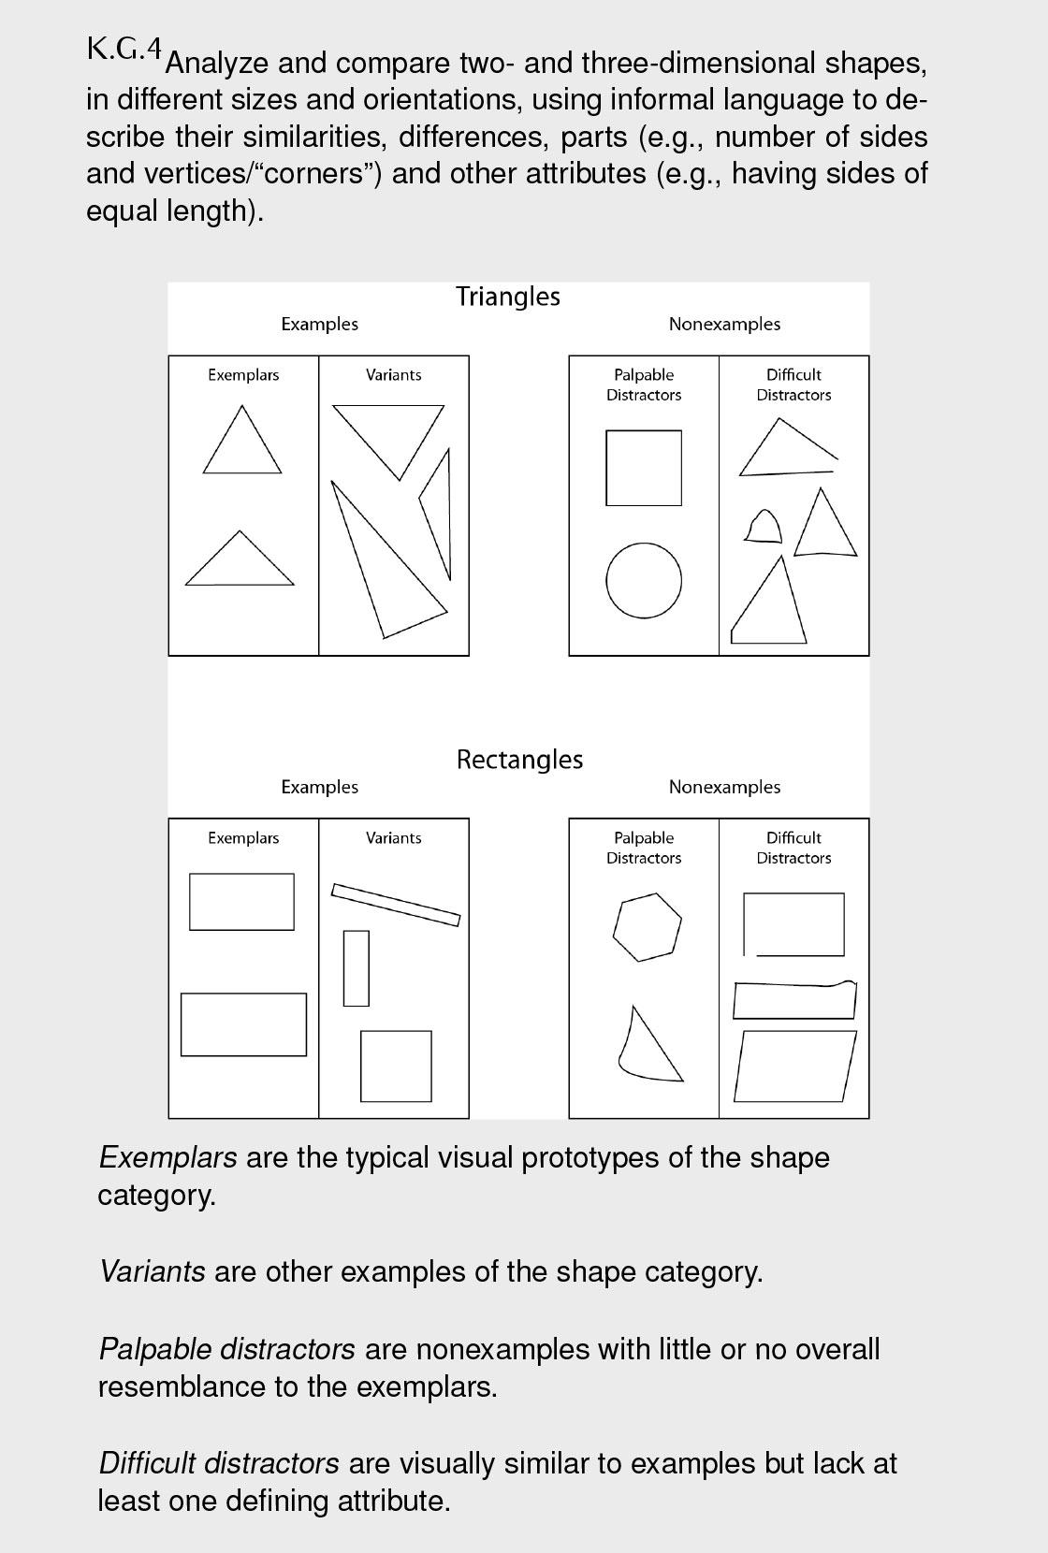  The need to explain their decisions about shape names or classifications prompts students to attend to and describe certain features of the shapes. That is, concept images and names they have learned for the shapes are the raw material from which they can abstract common features. This also supports their learning to represent shapes informally with drawings and by building them from components (e.g., manipulatives such as sticks). With repeated experiences such as these, students become more precise (MP6).  (See p. 6 in the G Progressions.)  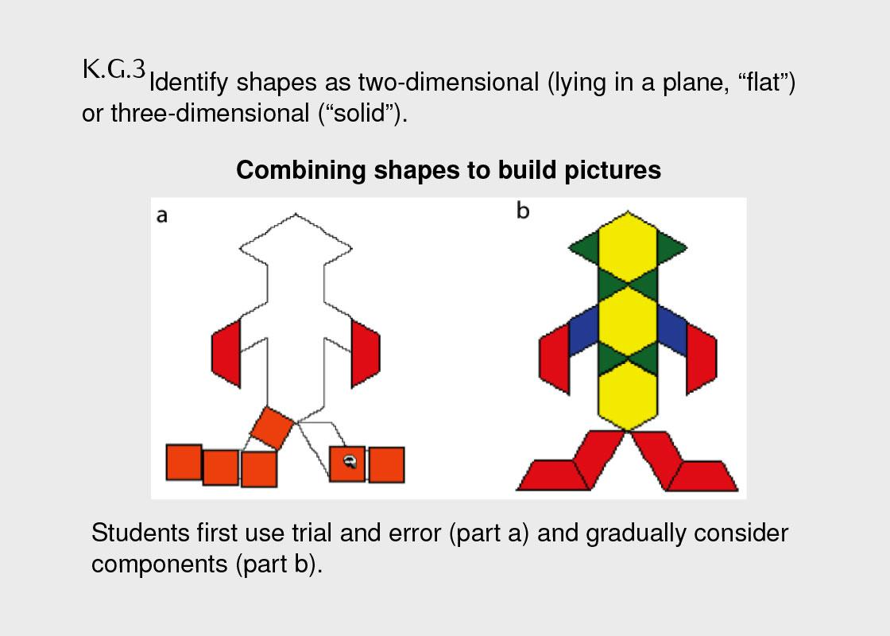  A second important area for kindergartners is the composition of geometric figures. Students not only build shapes from components, but also compose shapes to build pictures and designs. Initially lacking competence in composing geometric shapes, they gain abilities to combine shapes–first by trial and error and gradually by considering components–into pictures. At first, side length is the only component considered. Later experience brings an intuitive appreciation of angle size. Students combine two-dimensional shapes and solve problems such as deciding which piece will fit into a space in a puzzle, intuitively using geometric motions (slides, flips, and turns, the informal names for translations, reflections, and rotations, respectively). They can construct their own outline puzzles and exchange them, solving each other’s.  (See p. 7 in the G Progressions.)
Essential Question(s) | N/A

Assessment Guidance, Topic 13
Topic Assessment
→Performance Assessment
Item #/Action | Why?
- As Is
- As Is
- As Is
- As Is
- As Is

Grade K, Topic 14: Describe and Compare Measurable Attributes

Standards addressed | Primary in this topic:  K.MD.A.1: Describe measurable attributes of objects, such as length or weight. Describe several measurable attributes of a single object.  K.MD.A.2: Directly compare two objects with a measurable attribute in common, to see which object has “more of”/“less of” the attribute, and describe the difference. For example, directly compare the heights of two children and describe one child as taller/shorter.
Aspects of Rigor targeted by the standards | Primary in this topic:  Conceptual Understanding  Secondary in this topic:  Application
Applicable information from the progression documents | Students often initially hold undifferentiated views of measurable attributes, saying that one object is “bigger” than another whether it is longer, or greater in area, or greater in volume, and so forth. For example, two students might both claim their block building is “the biggest.” Conversations about how they are comparing—one building may be taller (greater in length) and another may have a larger base (greater in area)—help students learn to discriminate and name these measurable attributes. As they discuss these situations and compare objects using different attributes, they learn to distinguish, label, and describe several measurable attributes of a single object.  Kindergartners easily directly compare lengths in simple situations, such as comparing people’s heights, because standing next to each other automatically aligns one endpoint. However, in other situations they may initially compare only one endpoint of objects to say which is longer. Discussing such situations (e.g., when a child claims that he is “tallest” because he is standing on a chair) can help students resolve and coordinate perceptual and conceptual information when it conflicts.  (See p. 6 in the G Progressions.)
Essential Question(s) | N/A

Assessment Guidance, Topic 14
→Topic Assessment
Performance Assessment
Item #/Action | Why?
- As Is
- As Is
- As Is
- Delete | Item requires students to create objects for comparison.
- As Is
- As Is
- As Is
- As Is

Include groups with up to ten objects.
Limit category counts to be less than or equal to 10.

