Title/Author: Frida Kahlo and Her Animalitos, Monica Brown
Suggested Time to Spend: 5 Days
(Recommendation: two sessions per day, at least 20 minutes per day)
Lesson Objective: Students will be able to use reading, writing, speaking and listening skills to understand and explain who Frida Kahlo was and what she is known for.

Teacher Instructions

Before the Lesson
- Read the Big Ideas and Key Understandings and the Synopsis below. Please do not read this to the students. This is a description to help you prepare to teach the book and be clear about what you want your children to take away from the work.

Big Ideas/Key Understandings/Focusing Question
The main idea about this book is that it focuses on the work of the famous Frida Kahlo and gives children a gateway to the life of a leading artist.

Synopsis
A story in Spanish based on the life of one of the world's most influential painters, Frida Kahlo, and the animals that inspired her art and life. The fascinating Mexican artist is remembered for her self-portraits, her dramatic works featuring bold and vibrant colours. Her work brought attention to Mexican and indigenous culture and she is also renowned for her works celebrating the female form.
Brown's story recounts Frida's beloved pets—two monkeys, a parrot, three dogs, two turkeys, an eagle, a black cat, and a fawn—and playfully considers how Frida embodied many wonderful characteristics of each animal.

- Go to the last page of the lesson and review “What Makes this Read-Aloud Complex.” This was created for you as part of the lesson and will give you guidance about what the lesson writers saw as the sources of complexity or key access points for this book. Regardless, you will evaluate text complexity with your own students in mind and make adjustments to the lesson pacing and even the suggested activities and questions.

- Read the entire book, adding your own insights to the understandings identified. Also note the stopping points for the text- inspired questions and activities. Hint: you may want to copy the questions vocabulary words and activities over onto sticky notes so they can be stuck to the right pages for each day’s questions and vocabulary work.

The Lesson – Questions, Activities, and Tasks
The majority of questions, activities, and tasks should be based on the writing, pictures, and features unique to this text (be text specific). Questions that address text-to-self or text-to-world connections - what we like to call text inspired questions or activities - should be held until after the children have really gotten to know the book.
This template is designed to be flexible. Feel free to insert or delete rows as needed for additional questions, activities, or tasks. Questions, Activities, and Tasks are all aligned to the CCSS for ELA and can address any of the following through reading aloud rich selections:
  - Academic language exploration and learning (vocabulary and syntax)
  - Speaking and Listening activities
  - Writing activities
  - Language activities and questions
  - Creative performance tasks and activities that are text-specific or text-inspired
  - Foundational reading skills reinforcement where appropriate

Questions/Activities/Vocabulary/Tasks | Expected Outcome or Response (for each)
First Reading:  Read aloud the entire book (or chapter) with minimal interruptions. Stop to provide word meanings or clarify only when you know the majority of your students will be confused. | The goal here is for students to enjoy the book, both writing and pictures, and to experience it as a whole. This will give them some context and sense of completion before they dive into examining the parts of the book more carefully.
Second Reading:  Have students research and study Frida Kahlo's biography. There is a short biography at the end of the book. Students can paint a picture of Frida and her many animals. Then ask students to write some facts about Frida's life. This will help students make vocabulary connections when they do a second reading. | 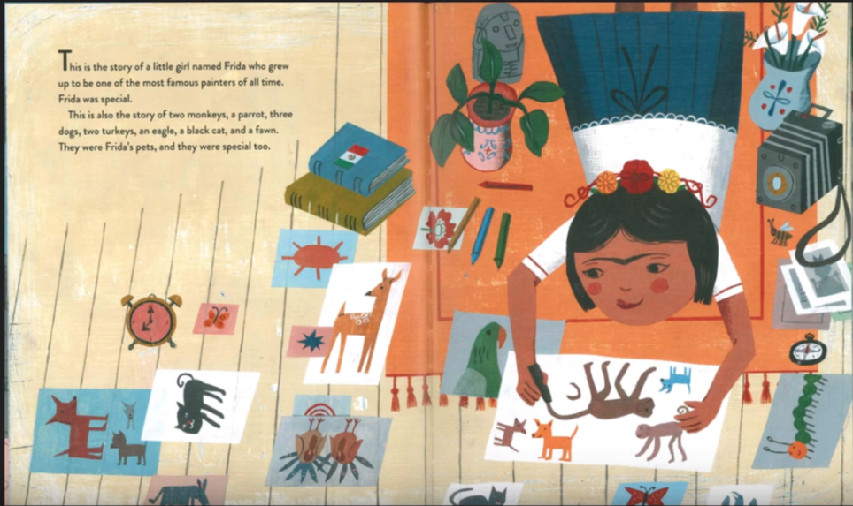
Third Reading:  This reading focuses on how Frida found unique characteristics for each animal and made those connections with herself. Frida uses art to express those characteristics and feelings.  Text-dependent questions:  - page 1: What pets did Frida Kahlo have growing up?  - page 3: What kind of clothes did Frida like to wear?  - page 5: What did Frida's father teach her to do?  - page 8: When Frida was sick for a long time, what did she do to be creative?  - page 9: Why did the students make fun of Frida?  - page 12: When Frida was 15, what did she do at school that got her into trouble?  - page 13: How did Frida's mother help her with her art after her terrible accident?  - page 16: What did Frida do when she felt lonely and sad?  - page 19: What did Frida's husband, Diego Rivera, build for her animals?  - page 24: When did Frida paint?  - page 29: What would you see if you visited La Casa Azul in Coyoacán today? | Possible answers:  - Frida had two monkeys, a parrot, three dogs, two turkeys, an eagle, a black cat, and a fawn.  - Frida wore clothing that represented her Mexican heritage.  - Frida's father taught her to see the world with curious eyes.  - Frida used her breath to draw things on the window.  - Frida's illness made one of her legs very different from the other leg, and the students made fun of her.  - Frida and her friends rode donkeys in the school hallways and fired firecrackers.  - Frida's mother made her a special easel and hung a mirror over her canopy bed so that she could paint.  - Frida would srap her arms around her Xolo dogs and they would comfort her.  - Diego built a pyramid for her animals to climb and roam freely.  - Frida painted when she was sick, hurting, happy, or sad.  - If I visited La Casa Azul, Frida's house today, I might hear a bird singing or see a black cat jumping from the pyramid.  Writing:  Ask students to write about how animals were like Frida in many ways.  For example:  Frida had a cat with shiny black hair, just like her long dark hair.  Frida had an imagination that can fly high like her eagle.

Final Day with the Book: Final Task
Draw a picture of all the different pets Frida had. Then tell me something about them, their name, how they looked, what they did, or a funny story with the pet and Frida.

Vocabulary
These words deserve less time  (These are concrete words and easy to explain/describe the events/processes, concepts, or experiences that students can relate.) | These words deserve more time  (These are abstract words and have multiple meanings or are part of a family of words with similar meanings.) These words are harder to process.
• page [5] - fawn: a very young deer.  • page [5] - microscope: an instrument that has lenses to see objects that are too small to be seen with the naked eye.  • page [8] – shiny – bright or glossy.  • page [12] - spider monkey: a type of small monkey from the Americas with long arms and legs, and a very long tail that they can use as a hand.  • page [16] - intelligent - quick to understand  • page [16] – sensitive – that cares for the feelings of others. | - page [3] – indigenous – original from a particular region or country  - page [3] – heritage - something that is handed down from the past, as a tradition.  - page [5] - curious - eager to learn or know.  - page [8] – imagination – create images in your mind.  - page [10] – independent - not controlled by others.  - page [17] spirited – active, sparkling, peppy, snappy.  - page [17] entertaining – liking to have fun.  - page [17] mischievous – playful, tricky, sly

What makes this a complex book?

- Qualitative Measures
Go to page http://www.lexile.com/ and enter the title of the book that you will read aloud or use the Quick Book Search that can be found in the right corner between the book that you will read aloud, enter the title of the book that you will read aloud. The majority of the books will have the measure:

780 L
Most of the texts that we read aloud in K-2 should be in the 2-3 or 4-5 band, more complex than the students can read themselves.
2-3 band 420-820L
4-5 band 740-1010L

- Qualitative Characteristics
Consider the four dimensions of the complex book shown below. Observe the specific examples of two opinions that are less complex.

The main idea about this book is that it focuses on the work of the famous Frida Kahlo and gives children a gateway to the life of a leading artist.
Non-fiction and a short biography at the end of the book.
Meaning/Purpose
Structure
Language
Knowledge Demands
There are many adjectives used to describe Frida and her animals, for example: curious, intelligent, mischievous, independent and many more that are found throughout the text.
It is important to develop prior knowledge about Frida Kahlo and her artwork. Students will also need to understand the adjectives that particularly describe Frida, for example curious, intelligent, mischievous, independent and many more that are found throughout the text.

- Reader and tasks to consider
What will challenge my students the most about this book? What support can I provide?
The academic vocabulary that focuses on the adjectives used to describe Frida and then also makes connections with the animals she loves and paints makes this text complex. The activity in which students write about and describe Frida will reinforce the connection of using the same adjective to describe one of her animals.

How will it help to enhance the knowledge of the world?
The main idea about this book is that it focuses on the work of the famous Frida Kahlo and gives children a gateway to the life of a leading artist.

- Level
At what level does this book belong?
It is appropriate for the Kindergarten.

For more information on the qualitative dimensions of text complexity, visit http://www.achievethecore.org/content/upload/Companion_to_Qualitative_Scale_Features_Explained.pdf

