TEXT SET TOPIC: You & Your Brain—The Limbic Brain

Grade-Level Recommendation: Grades 6–9

Key Focus Areas for Design:
Counternarratives Current Events Identity Language Perspectives Social Justice

Topic: This text set focuses on building student knowledge about the limbic system in the brain and its connection to learning processes

Context/Rationale/Reflections: This multimodal text set first supports students’ knowledge building about the limbic brain and learning from a scientific perspective. Through art, music and poetry, students are encouraged to extend their thinking about the brain. An additional goal is for students to self-reflect on their own brains and identities as learners.

Tasks: Check for Understanding & Individual Student Reflection

Texts: This text set includes a variety of resources including excerpts from books, infographics, interactive websites, videos, poetry, songs and art. The key resources that should be prioritized for instruction are:
- Culturally Responsive Teaching & the Brain excerpt
- Videos on The Limbic System (2-Minute Neuroscience, Edpuzzle: Limbic Videos 1 & 2)

After those resources have been used, feel free to mix and match remaining texts and resources based on the needs and interests of your students to reinforce and extend understanding of the limbic system, learning, and the brain.

Resources to build teacher background knowledge:

Exploring your own culture: This resource supports you in examining your own culture, an important prerequisite for engaging in culture work with students. Through a set of reflection questions, you’ll focus on surface culture, shallow culture, and deep culture. It’s critical to develop an understanding and awareness of your own culture to know how it will show up and influence the work you do with your students.
Retraining the Brain: This article provides an overview of the brain rules described in the excerpt from Zaretta Hammond’s book, Culturally Responsive Teaching & the Brain.
Culturally Responsive Teaching 101: This 10-minute video provides a clear picture of what culturally responsive teaching is and is not.

A note for multilingual students: 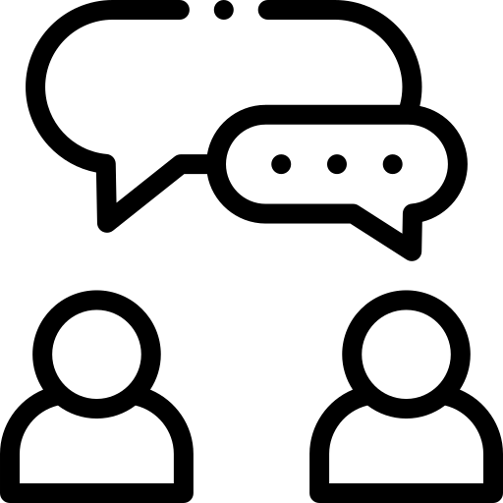
Text Sets are meant to support knowledge building! Support opportunities for student translanguaging while using this text set by encouraging students to write, discuss, and present in their home language(s), English, or a combination while they are learning.

In this text set, Tier 2 general academic vocabulary and Tier 3 domain-specific academic vocabulary should be explicitly taught and reinforced throughout lessons. Providing multiple opportunities for students to encounter and produce new language is critical to mastery. Marzano’s protocol is a useful resource for direct vocabulary instruction: Marzano's Six Steps to Effective Vocabulary Instruction

Text/ Resource | Author/  Creator | Brief Description/Notes | Why use this resource? | Considerations for using this resource
BOOK  Culturally Responsive Teaching & the Brain | Zaretta Hammond | A professional text that explicitly outlines the function of various parts of the brain (e.g., the limbic system) and the role they play (e.g., the limbic system) in learning. | This resource provides students with an opportunity to deepen their understanding of the brain and learning while directly connecting it to their own learning processes. | These texts can be read as a whole-class read-aloud or in a small-group jigsaw configuration using the entire text or excerpts.
VIDEOS  2-Minute Neuroscience: The Limbic System  Edpuzzle: Limbic Video 1  Edpuzzle: Limbic Video 2 | Neuro-  scientifically Challenged  Edpuzzle | Brief illustrated and narrated overview of the limbic system; two of which contain embedded questions. | The videos help students to build knowledge about brain functions in a quick and engaging way. | The videos can be viewed as a whole class or individually in a blended learning model.
ARTICLE  How Does the Brain Help us Understand Others? | Joyce Lysanne Van Zwet  Jule Schretzmeir  Sabine Hunnius  Tobias Grossmann  Marlene Meyer | This article introduces students to the idea of social cognition and how certain parts of the brain help people to develop social skills and networks. | The article expands students' understanding of how various parts of the brain work together to help people form and maintain relationships. This content bridges to further discussion of other parts of the brain that are important for learning. | These texts can be read as a whole-class read-aloud or in a small-group jigsaw configuration using the entire text or excerpts.
INFOGRAPHICS  3D Brain (brainfacts.org)  The Limbic System (ship.edu) | Dr. C. George Boeree | Labeled diagrams of the brain with accompanying text describing its functions. The first resource is 3-D and interactive. | The diagrams provide reinforcement of prior knowledge of the brain and its functions in a lower density text-based format. The first text allows students to interact with the material. | Excerpts from this text can be used as a whole-class read-aloud or in small-group configuration.
SONG  PARTS OF THE BRAIN SONG | Science Music Video - YouTube | Jam Campus | A song that describes parts of the brain and their functions.  The link starts the song at the 30-second mark when the parts of the limbic system are named, but feel free to use the whole song. | This resource adds the element of music to images and text and can serve as an engaging way for students to reinforce their knowledge. | Students can experience this text as a whole class, in a small group, or individually. This song can be a springboard for students' own musical compositions related to the brain and learning.
POEM  The Brain—is wider than the Sky by Emily Dickinson (poetry.com) | Emily Dickinson | A poem that depicts the intricacy and the expansiveness of the brain’s function. | This text allows students to consider the intricacy and vastness of the brain through Emily Dickinson’s poetic perspective. | Students can experience this text as a whole class, in a small group, or individually. The poem can be a starting point for students' own comparisons related to the brain and its functions.
ART  Dazzling Images of the Brain Created by Neuroscientist-Artist | Live Science  Giant Artwork Reflects The Gorgeous Complexity of The Human Brain | HuffPost Impact | Greg Dunn, Ph.D. | Paintings that capture the artistic aspects of the brain and its functions. | These resources can be used to expand students’ thinking on the brain and learning through the lens of art and science. | Students can experience this text as a whole class, in a small group, or individually. The artwork can be used to inspire students' own artistic representations of the brain and its parts.

