Social, Emotional, and Academic Development (SEAD)
Lesson Plan for Mathematics

GRADE LEVEL/COURSE AND MATH STANDARD(S)
Grade 5
5.G.A.2: Represent real world and mathematical problems by graphing points in the first quadrant of the coordinate plane, and interpret coordinate values of points in the context of the situation.

LESSON OBJECTIVE/GOAL
- Student objective: I can represent problems on the coordinate grid.

LANGUAGE OBJECTIVE(S)/GOAL(S)
- Student objective: I can describe the location of a point on a coordinate grid using mathematical vocabulary.

INTRODUCTION
The task was adapted from Illustrative Mathematics Grade 5, Unit 7, Lesson 12 and utilizes the lesson planning template from Stride 3: A Pathway to Equitable Math Instruction: Creating Conditions to Thrive (pages 13–14).

The lesson is intended to:
- Support development of mathematical identity by fostering a positive learning environment where students see themselves as mathematicians in a math community where discourse supports diverse perspectives and active listening.
- Create opportunities for students to discern structure when representing points on the coordinate grid

SEAD THEME

X | Identity
X | Discourse
 | Agency
X | Belonging

SMP(S) TO SUPPORT THE SEAD THEME

 | SMP 1: Make sense of problems and persevere in solving them.
X | SMP 2: Reason abstractly and quantitatively.
 | SMP 3: Construct viable arguments and critique the reasoning of others.
 | SMP 4: Model with mathematics.
 | SMP 5: Use appropriate tools strategically.
 | SMP 6: Attend to precision.
X | SMP 7: Look for and make use of structure.
 | SMP 8: Look for and express regularity in repeated reasoning.

STEPS
- Teacher presents learning objective and SMP of focus using SMP math posters.

- Teacher demonstrates a variety of coins including currency of the United States, Mexico, El Salvador, and Colombia. Teacher engages students to share their ideas in the routine “What do you know about __?”

- Teacher launches Task 1: Heads or Tails using the strategy 3 Reads with the following prompts below.
  - Read #1: “What is the situation about?” After a shared reading students describe the context.
  - Read #2: “What can be counted or measured in this situation?” After the second read, students list all the quantities.
  - Read #3: “What questions can we ask about this data?” Students discuss possible questions.
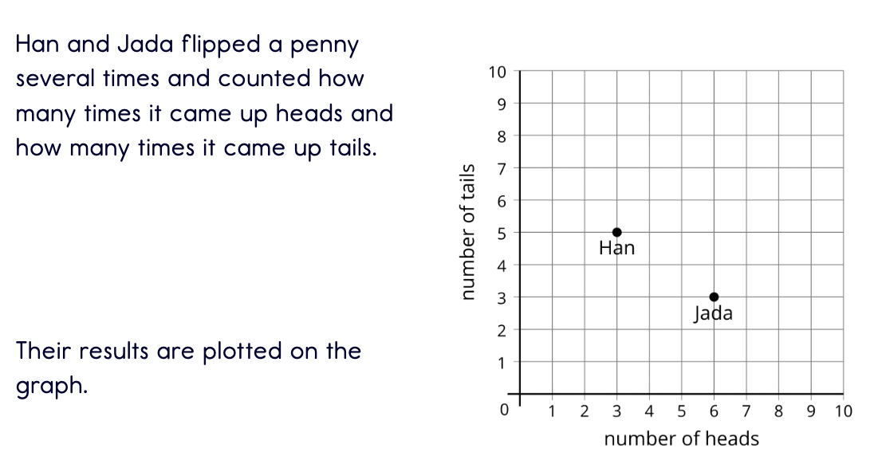
*The problem will be changed to include names of students in the class. The problem will be presented on an anchor chart poster.

- Students work on answering questions generated with a partner. Students also work on adding their own coordinates to the grid.

- After partners have had some time to answer the questions and graph their data, students will engage in a whole class discussion. The teacher will call on some students to plot their data on the class anchor chart.
Sentence stems for students to share their data:
  - The point that represents my flips is (____ , ____)
  - I/My partner graphed the point (____ , ____)

Sentence stems for classmates to engage in the data presented by their peers:
  - (____ , ____) represents …
  - If ______ plotted (____ , ____) that means …

- Teacher launches Task 2: Coin Values using the strategy: See, Think, Wonder
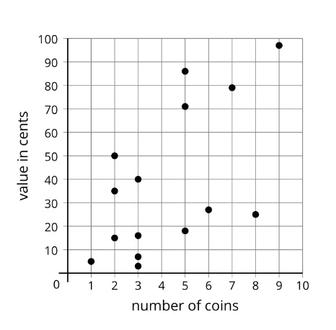
- Students then work with partners to answer questions about the data.
- Tyler has 1 dime, 3 nickels, and 2 pennies. Which point represents Tyler’s coins?
- Lin has 3 quarters, 1 dime, and 1 penny. Which point represents Lin’s coins?
- Diego has 1 quarter and 1 dime. Write the coordinates that represent Diego’s coins.
- Clare has 5 coins and does not have a quarter. Write the coordinates of the point that represents Clare’s coins. What coins might she have?

- Teacher synthesizes the activity by calling on volunteers to attend to the learning goal.
  - Say: “Today we represented data on the coordinate grid. Our learning goal was to describe the location of a point on the coordinate grid. Describe to your partner how the coordinate grid works. How can you explain the location of a point on the coordinate grid? ”

- Students will complete the exit ticket and evaluate themselves on the learning goal by submitting their exit ticket on a self-monitoring scale folder of 1-4.
Exit Ticket:
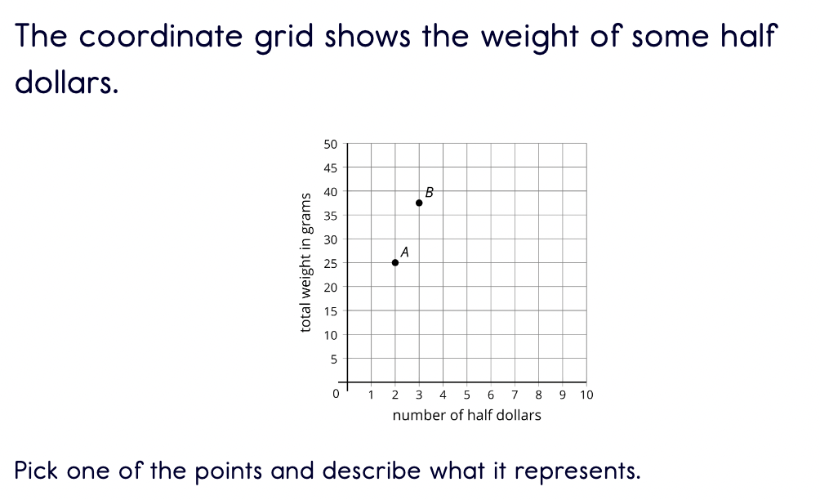
Self monitoring scale:
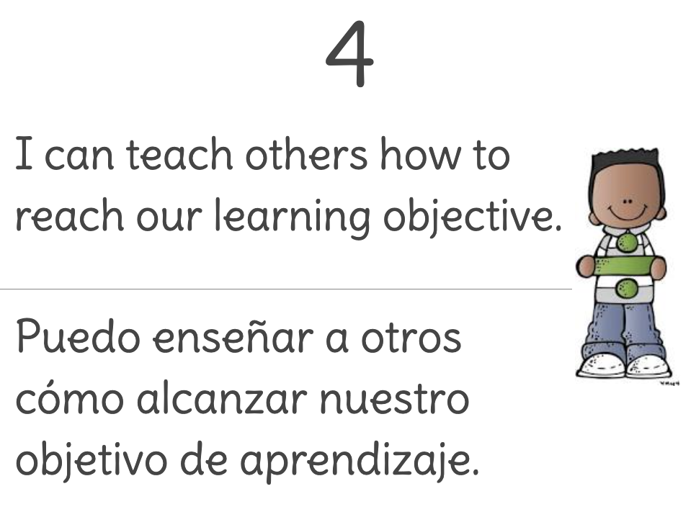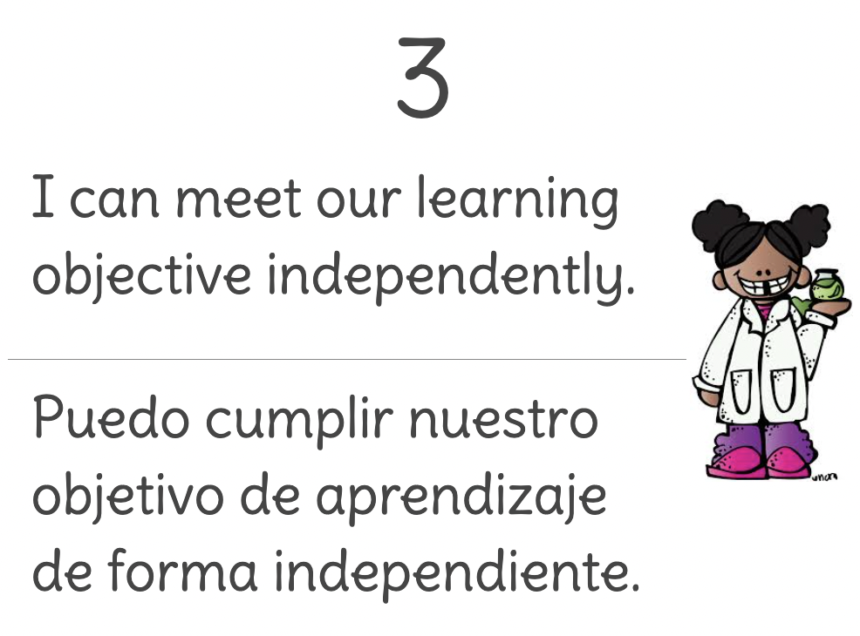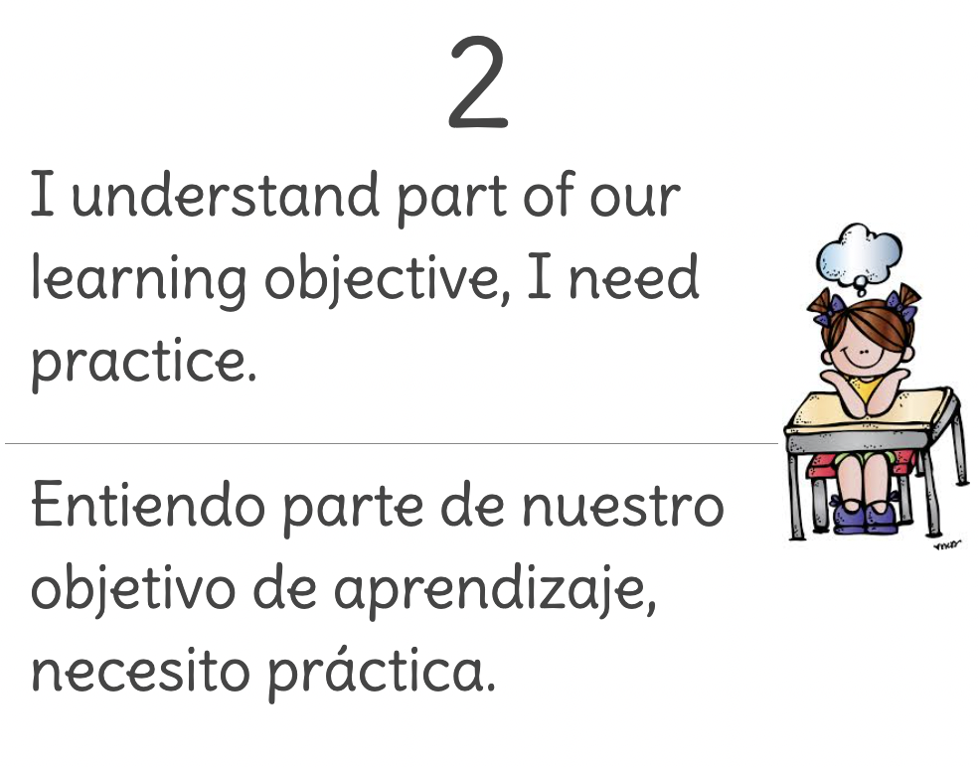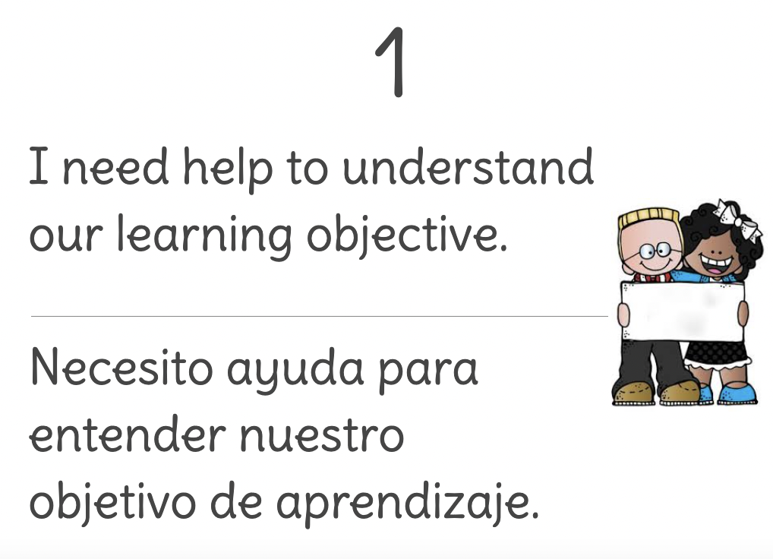

SUMMARY/REFLECTION OF LESSON

In this lesson students had the opportunity to plot on the coordinate grid throughout multiple activities as well as determine the meaning of the points on a grid. Students had a lot of excitement when we started the initial activity where I asked them, “What do you know about coins?”. I loved seeing the faces and reactions when they noticed pesos were part of the coin list. They were excited to share their ideas about what they knew about the different coins. Did not follow the warm up: addition and multiplication that addresses 5.OA.A.2; instead this warm up is the activity launch for activity 2 within the lesson with the added component of having pesos and centavos too.

When students worked on plotting coordinates on a grid many of them were successful. They were able to correctly plot their number of flips and mark a data point that represented their number of tails and heads. The second activity was a bit more challenging but many of them had success with talking out their ideas with their peers. Some needed support in understanding that each individual point represented several coins and their value. I think the addition of the Think See Wonder Routine to the lesson helped to ensure students understood that this grid represented different data. They shared excellent noticings and had some questions about the value which led to the activity.

In the exit ticket, I observed that some students had difficulty determining the structure and meaning of a point. To support these students I plan to do a gallery walk of different data represented on a coordinate grid and have students engage in peer conversations about what specific points mean.

The purpose of this lesson was to support development of mathematical identity where discourse supports diverse perspectives and active listening. I believe this was evident in the peer, group, and whole group discussions throughout the lesson. Many students used the sentence stems “I want to add on to _____” and “I agree with …” . This showed me they were being active listeners and participants during the discussions, fostering belonging in our learning together and their identity as mathematicians.

